Denefield School
SUCCESS FOR LIFE

Application Information

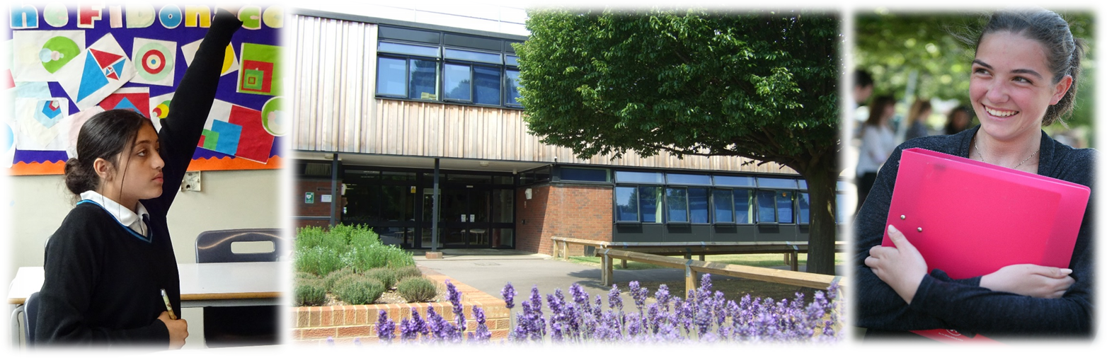

Welcome from the Headteacher

I am delighted to welcome you to Denefield School. Denefield is an ambitious and over-subscribed school located in the western Reading suburb of Tilehurst, with easy access to Reading, London, Oxford and Didcot.
I believe passionately that every young person should gain the qualifications and develop the character skills to have, as we say at Denefield, ‘Success for Life’. Our 2018 Ofsted report rated us as good in every area, but results dipped in both 2018 and 2019, with boys, SEND and disadvantaged students a particular area of focus. We have worked extremely hard on this: introducing standardised curricula in all subject areas; simplifying lesson structures through our ‘Lesson on a Page’; clarifying and improving assessment; moving to a three-year Key Stage 4, with GCSEs beginning in Year 9; renewing our focus on modern languages as we move towards more ambitious targets for Ebacc uptake; and, finally, remodelling our TLR system to produce three core and four foundation faculties. We have also worked hard to ensure that all students have the best facilities they can, from the £10m Science and DT block, to investment in computing facilities, to our proposal, currently at the planning permission stage, to build a floodlit 3G sports pitch to be shared by the school and the local community. There is still a very considerable amount of work to do in embedding these changes, in order to ensure that all subject areas perform as well as the very best, and that all groups of students – including boys, SEND and disadvantaged students – achieve well.
Covid-19 has had a considerable impact on Denefield School, as elsewhere. Staff have worked incredibly hard at embedding a full timetable of live lessons, based around our ‘Remote Learning on Page’ model, and feedback on remote learning from parents and carers, as well as students themselves, has been extremely positive. Attendance throughout the year, both at face to face lessons and live remote lessons, has been extremely high. We have remained extremely Covid-safe, have not yet had to send any year groups to self-isolate, and until December 2020 did not have to ask any groups of students or staff to self-isolate. That much said, students found our Covid-secure measures, which included year-group teaching zones, to be challenging at times, and we certainly did not make the strides with behaviour and conduct that we had hoped to. We have a new behaviour action plan that begins immediately students return, with both short and medium-term actions to ensure that all students are focused and ready to learn, and that they make the most of the opportunities Denefield presents to them.
The school’s catchphrase is Success for Life, and there is much in place to ensure that students maximise their own personal development, as well as academic achievement. We introduced discrete Success for Life lessons, based on the PSHE framework, at the beginning of the academic year, and supplement these with discrete and focused work on areas of specific significance, including knife crime and substance abuse. We are exceptionally proud of our house system, and while we have had to temporarily suspend our vertical tutor groups because of Covid-19, we have maintained the sense of pride and competition that the house system provides. Denefield normally runs an extensive range of extra-curricular clubs and activities, and we are looking to extend these from September 2021, and using this as an opportunity to provide further leadership opportunities for older students. We are in the process of enhancing our careers and higher education plans and are looking forward to developing partnerships between students and local employers and businesses as soon as we are able.
Denefield is an 11-18 school and we are extremely proud of our sixth form students. We have reversed the faltering trend of sixth form results, which by 2019 were well below what we would have expected. We have increased the focus on the quality of sixth form lessons, introduced compulsory independent study and community service, and are actively exploring collaboration with another local sixth form provider to jointly teach minority courses from September 2021. Our sixth form numbers are healthy and growing, and this year a record 65% applied to university, with 40% of those applying for places at Russell Group universities, including Oxbridge. A key focus from September 2021 will be ensuring that sixth form students make the most of their leadership opportunities, including acting as subject prefects, lunchtime monitors, mentors to lower school students, and running extra-curricular clubs.
The incoming Deputy Headteacher will therefore join the school at an exciting, and challenging, time. There is a definite job of work to do here. The leadership team has already been restructured, as has the TLR system. We are currently looking at the balance of responsibilities in the behaviour and pastoral team, to ensure that our behaviour systems balance the need to be both reactive and proactive. We have begun our overhaul of communications and our rebrand strategy is in place, with a new logo, website, and focus on social media to be in place by the summer of 2021.

The new Deputy Headteacher will be instrumental in all of the above aspects: quality of education, behaviour and welfare, personal development, sixth form and leadership and management. The new Deputy Headteacher will be expected to play a supportive yet challenging role in all roles, and it is likely they will lead on one or more of these areas, to be determined by the candidate’s experience and interests, along with the needs of the school and the Senior Leadership Team. The new deputy will be someone with experience, determination, sensitivity and drive. This is an exceptional opportunity for someone who wants to challenge themselves and reap the rewards, and is looking to develop the skills and experience for further promotion.
I would be delighted to meet you, initially on Zoom, to share more about the school. If you wish to take up this offer, please contact my PA, Mrs Sue Ellison on 0118 941 3458 or sen@denefield.org.uk
At Denefield we take safeguarding very seriously and consequently the successful candidate will be required to complete a DBS enhanced check for regulated activity. Please do not include CVs with your application as these will be disregarded for safeguarding purposes.

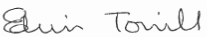

Mr E Towill MA (Oxon)
Headteacher

Our school

Denefield is a thriving and expanding school on the outskirts of Reading with nearly 1150 students on the roll, including 175 in the Sixth Form. The school has been serving the local community for over 40 years since its inception in 1976. It has steadily grown over the last few years reflecting our good reputation and the continued the support from our local community.
The school is a stand-alone academy trust having converted in January 2012. We have an active partnership with our local partner primary schools. Each year, we admit approximately 75% of students from our partner primary schools and the remaining 25% from the wider area. Our standard admission number is 180 students for entry into Year 7, however due to continual demand for places we have admitted, on average, an extra 20 students for the last four years and have also operated a waiting list during this time.
For further information about our school, and for copies of the job description, person specification and application form, please visit our website - www.denefield.org.uk Please note that the website is due to be replaced in the summer of 2021.

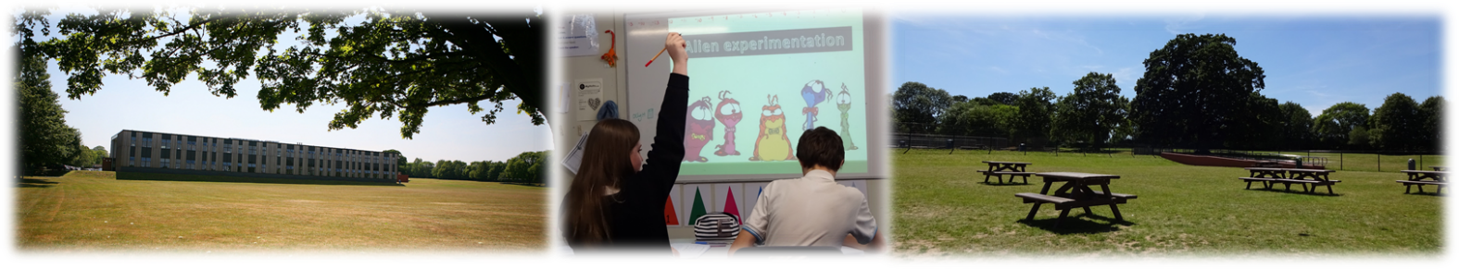

Our distinctive ethos

We are very proud of our distinctive ethos which is based on a set of CHARACTER values and a belief that every student deserves success for life.
Developing CHARACTER values is a key focus of our work and we encourage students to become: confident, happy, articulate, resilient, ambitious, courageous, tolerant, empathetic, and respectful individuals. We host annual CHARACTER Awards to recognise and celebrate students who have displayed CHARACTER values.
We strive to equip our young people with the skills, academic qualifications and personal attributes to thrive in the modern world. We passionately believe that our role is to prepare students for the tests of life and not for a life of tests.

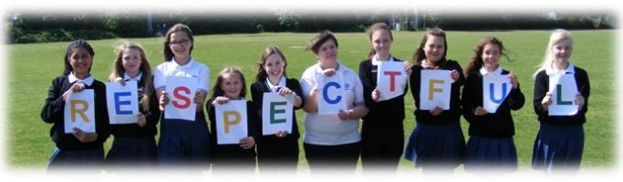

Our senior leadership team
Denefield has a team of six senior leaders, including the Headteacher, Deputy Headteacher and four Assistant Headteachers. Guided by a shared vision, the SLT is focused on delivering the present and long-term success of the school. We actively seek to learn and grow together, ensuring a high level of trust, transparency and support. We set the pace and tone for the wider staff body, building confidence and cooperation, whilst seeking to ensure accountability. We place the nurturing and education of our students at the core of our priorities.
The SLT oversees the management of the school, both academically and pastorally, and ensures the distinctive ethos permeates everything we do.
Our sixth form
We are immensely proud of our Sixth Form and their achievements. Many work extremely hard in school, and progress to high level apprenticeships, employment or to university. In 2019, 55% progressed to university, including to Russell Group universities, and overall 96.5% went into further education, employment or training, or took gap years abroad. We anticipate 65% going to university in 2021, with 40% of those going to Russell Group universities. Our students are welcoming and supportive, and in many cases already play a leading role in school or in the local community – most recently the excellent work they have done promoting the school’s CHARACTER values of tolerance, empathy and respect via LGBT History Month. Sixth Form students benefit from good facilities, including the Sixth Form common room and work room, and are well supported by their subject teachers and the Sixth Form pastoral manager. In addition, the Sixth Form curriculum, with over 25 subjects, is broad and inclusive. Students can study traditional, so-called ‘facilitating’ A Level subjects, such as English Literature, all of the three Sciences, Maths (including Further Maths) or History. They can study more practical A Level subjects such as Art or Business Studies. Or they can study vocational and BTEC subjects such as Health & Social Care, BTEC Business or BTEC Sport. These are extremely solid foundations to build upon.
Working at Denefield
We currently employ approximately 75 teaching staff and 70 support staff.
Professional development opportunities for staff in this school are outstanding. We have developed an exceptional in-house annual training programme enabling staff at all levels to follow a personalised programme linked to their performance management needs. Each year staff have the opportunity to review their work, to set targets at an annual appraisal meeting which is followed up with an interim review meeting part way through the year. We have a robust system in place for pay progression for both teaching and support staff.
Senior and middle leaders are supported to take part in recognised senior and middle-leadership qualifications with NPQSL and NPQH providers and the local authority.
Newly qualified staff are effectively supported and are provided with a reduced timetable, a planned induction programme and mentor support. We have welcomed a number of teachers from overseas with a supportive induction programme to help with transition to the UK.
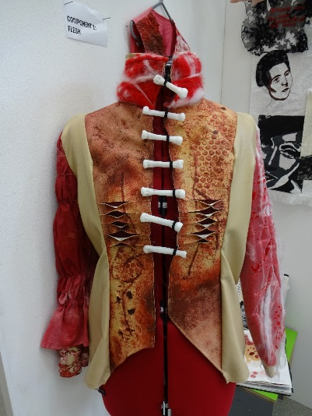
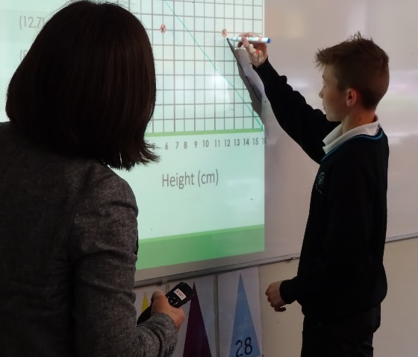
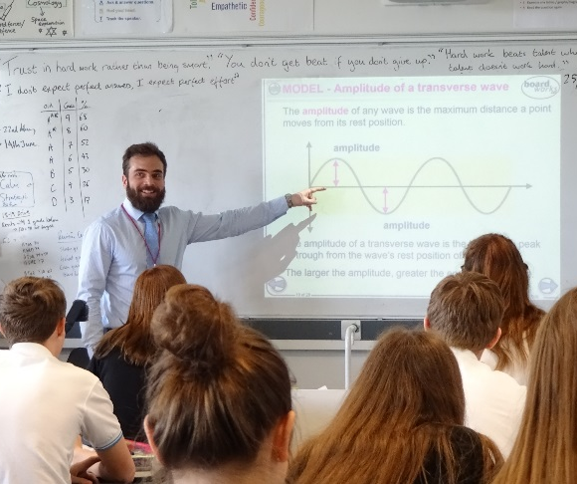

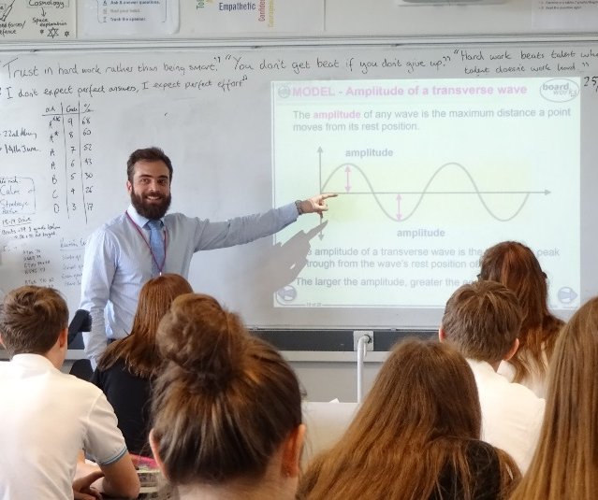
Facilities

The school is located in Tilehurst, a densely populated suburb of Reading, some four miles from the town centre. Our estate backs on to farmland and woods and is generous in size extending to some 23 acres and boasts well maintained buildings and grounds. A few years ago, the school received £9 million of government funding which was used to build a new science block, to provide state of the art design & technology and music classrooms, workshops, a recording studio, an art exhibition space, a community room equipped with a dance floor and a new Sixth Form common room and work areas.

Little Oaks Day Nursery operates on the school site providing care and education for up to 28 children aged 0 to 5 years.

Since academy conversion, we have successfully bid for £2.66 million of Government capital grants to improve the fabric and condition of our buildings. Past projects include: window replacement, new lighting and ceilings, heating controls, and a significant extension to our canteen and outdoor seating area. Our most recent successful project has seen the installation of electronic exit gates and new fencing, external doors and alarms, car park lighting, an extension to the outdoor student supervised area including a ramp for accessible access and classroom doors with viewing panels. Our latest project, which is well underway, is to gain planning approval and funding for a floodlit 3G sports pitch for school and community use.
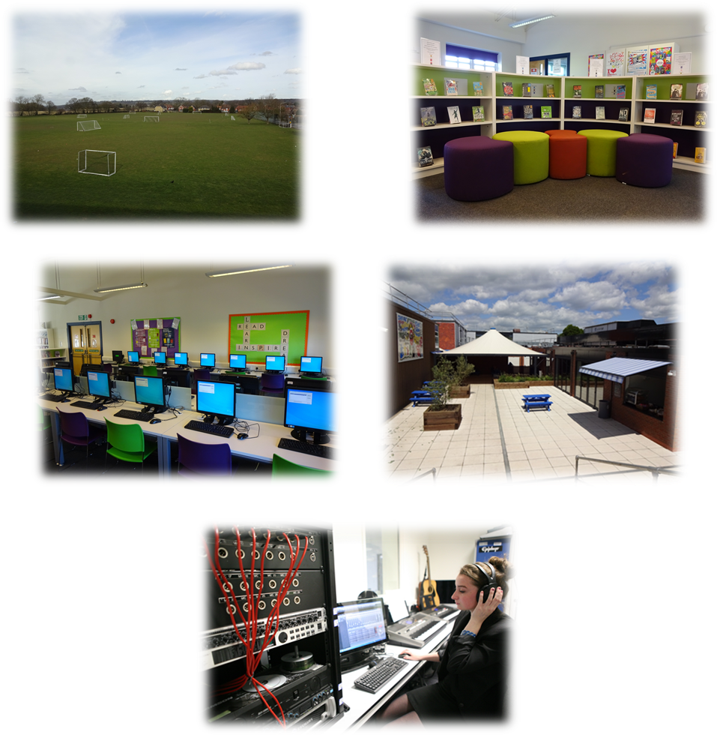

Staff benefits

Salaries and benefits
The school follows the pay and conditions for teaching staff as set out in the current School Teachers’ Pay and Conditions Document, and teaching staff are invited to enrol with the Teachers’ Pension Scheme (TPS). Pay and conditions of service for support staff are governed by the National Joint Council for Local Government Services and support staff are invited to enrol with the Local Government Pension Scheme (LGPS).
Wellbeing
Staff wellbeing is a key priority at Denefield and we are proud to offer a supportive workplace. There is no getting away from the fact that teaching is hard work, but we strive to foster a better work/life balance for our staff through a number of initiatives. These include: restricting when emails can be sent; encouraging staff to leave early on at least one evening a week; offering yoga classes, healthy eating and mindfulness training to staff; and by cultivating an environment where it is ok to say ‘I am finding this hard’. In addition, our training days end with a selection of wellbeing activities and we have introduced Wonderful Wellbeing activities during lockdown, which are likely to continue once the school returns to normal.
Child Care
A day care nursery operates from the site and provides places for children aged 0 to 5 years. The nursery, open all year around, offers term time only contracts and currently has space to accommodate 28 children.
Cycle to Work Scheme
Denefield partner with the Green Commute Initiative to offer all staff the opportunity to purchase a bike through our cycle to work scheme.
On-site parking
Free, on-site, parking is available to all staff.
Flu Vaccinations
During our October INSET day all staff are invited to have a free flu vaccination in school.
Tea and Coffee
Free tea, and coffee are available to staff, in the staffroom.
Joint Consultative Committee
Following academy conversion, the Trust Board implemented a Joint Consultative Committee (JCC) as a means of consulting with staff on an array of employment, pay and conditions issues. Members of the Trust Board attend meetings to discuss any new developments and work-related issues with staff representatives, trade union representatives and senior leaders.
Working and living in and around Tilehurst
Tilehurst railway station is located approximately a 15-minute walk from Denefield School. It has regular Great Western Railway services between Reading (5 minutes), London Paddington (40 minutes) Didcot (20 minutes) and Oxford (40 minutes)
The school is served by the number 16 Reading bus which operates up to four times per hour during peak times, providing a 20-minute journey into and out of the centre of Reading.
The vibrant town of Reading sits 5 miles east of Denefield with its thriving shopping centre, constantly evolving restaurant scene, museums and medieval abbey. With its great array of bars, pubs, comedy clubs, live music venues and theatres, there is a nightlife to suit everyone. For those who prefer to spend their free time in a greener, more natural, environment, there is plenty to choose from. Reading has the longest Thames frontage of any borough, most of which is formed by public parks, part of the Thames Path (a long distance walking route) and National Cycle Route 4.

