Job Description

Job Title | Digital Technologies Lecturer
Department | Digital Technologies & Professional Services
Reports to | Senior Head of School
Contract | Permanent
Location | East Ham, Stratford Campus and IoT

Our Vision & Values
“To develop the skills, confidence and qualifications for local people to lead rich lives and build great careers.“

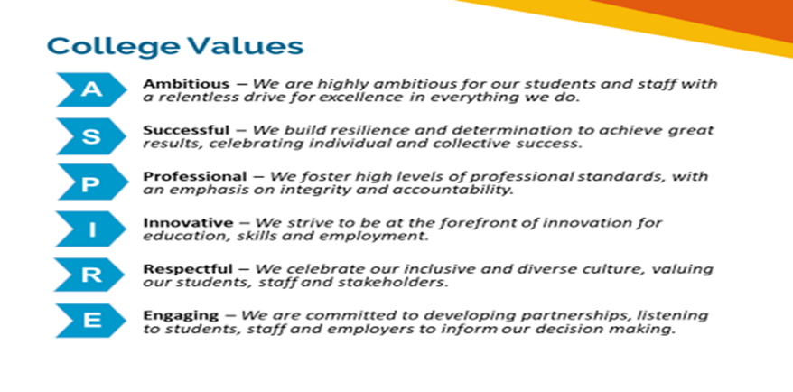

Equality of Opportunity
The college has a strong commitment to working towards the implementation of equality of opportunity in both service delivery and employment. The College's mission and strategic objectives directly support this aim. All employees are required to actively support the development, dissemination and implementation of this aim and related policies and programmes.

Safeguarding of Children and Vulnerable Adults
The College is committed to safeguarding and promotes the welfare of all learners and expects its staff to share this commitment. In addition, they will also state that the College is committed to safeguarding and promotes the welfare of all learners and expects its staff to share this commitment. All posts in the College are subject to an Enhanced DBS check and barred person’s list check.

Job Purpose

- To teach, assess learning and take an active role in the delivery of successful learning experiences of students which contribute to, increased retention, achievement and progression.
- To deliver on a range of courses, including TLevel, Computing, Digital and IT which include 14-19 study programmes and adult learners on courses ranging from level 1 to level 5.
- To develop the curriculum in line with national requirements, local community needs, and the needs of employment.
- To work effectively as a member of the team, reporting to the Senior Head of school and liaising with colleagues in the College.
- To take an active role in own professional development in relation to all aspects of the role.

Key Duties and Responsibilities
- To offer students a high-quality learning experience to achieve the goal or qualification for which they are studying.
- To teach effectively on a range of college courses and programmes relevant to Computing, Digital and IT.
- To be a personal tutor/course co-ordinator for a designated group of students within a range of courses.
- To contribute to the personal development of the students and to observe procedures for student monitoring, discipline and complaints in accordance with college polices.
- To develop course materials, schemes of work, lesson plans etc. and make these available through the colleges shared information system.
- To follow all college processes and College procedures related to the selection, interviewing, admissions, enrolment, induction and tracking of students.
- To follow all college processes relating to quality assurance, qualifications and examinations, including registration and submissions to validating bodies, liaison with the College Exams Officer, moderators and external verifiers in accordance with College Policy and validating bodies.
- To provide regular and timely feedback to students as identified in the College policy, and to give group and individual tutorial support to enable students to achieve maximum benefit from their programme of study.
- To work with others or act as a leader/member of appropriate teams and to liaise with colleagues in the design, delivery and evaluation of all aspects of the course
- To compile and maintain course and student records and associated administration.
- To carry out all duties and responsibilities with due regard to the College’s Single Equality Scheme.
- To make a significant contribution to marketing activities, curriculum development and course co-ordination.
- To liaise with employers and other agencies with respect of student placement supervision, course and assignment design, career and higher education opportunities.
- Participation in the observation of teaching, learning and assessment, including receiving and acting upon associated feedback.
- To be appraised as part of the College Appraisal Scheme.
- Complete a minimum of 30 hours continuing professional development every year or pro rata equivalent subject to a minimum of six hours.
- Maintain a record of the CPD undertaken and make that record available
- To attend external courses and conferences as relevant to the work of the Programme.
- To co-operate with the College to ensure his/her own health and safety and that of students and colleagues.
- Where applicable, achieve the requisite type of qualifications required for the teaching post within the relevant time as prescribed.
- Keep up to date, and comply with the relevant College’s Policies, including Health & Safety, Safeguarding, Prevent, Data Protection Policy, including the General Data Protection Regulation (GDPR) 2018, and Equality & Diversity.
- Where applicable, the job holder must warrant their entitlement or the right to work in the United Kingdom without any additional approvals and to notify the College immediately if this right or entitlement is ceased during their employment with the College.
- An enhanced check of the Disclosure and Barring Service’s (DBS) children’s and adults’ barred lists (lists of individuals who are barred from working with children or vulnerable adults).

General
The scope of this profile reflects the needs of the College at the present time; it is not intended to be a fully inclusive or exhaustive list. The post holder may therefore be expected to work flexibly and perform such other duties other than those given in the job description.

The duties and responsibilities attached to the post may vary from time to time without changing the general character of the duties or the level of responsibility entailed. The profile will be subject to continuous review as the needs and requirements of the College change over time.

Person Specification
The following qualities are all deemed essential to the requirements of the post. The College will, therefore, be seeking evidence of these in the selection process, which will include application form, an assessment centre, interview(s) and references. The College is seeking to appoint highly skilled, dynamic, flexible, and committed people with the potential to help us realise our mission and strategic objectives. The appointing panel will, therefore, require sufficient evidence of ability and achievement in each of the following areas to make an appointment.

Qualifications:
 | Essential | Desirable
To be qualified or working towards teaching qualification. | ×
An honours graduate, or relevant final professional qualification, or equivalent experience (note: in certain circumstances a specific subject or professional qualification may be required). | ×
Minimum Level 2 English, Maths and ICT. | ×

Knowledge and experience:
 | Essential | Desirable
Experience of teaching and or training in the field of Computer Science, Cyber Security, Digital Skills, Graphics & Animation, Games Design & Development, Networking, Programming, Project Development & HCI, Software and Apps Development and Web Development digital technology and media - including data types, analysis interfaces and programming is a must. | ×
Knowledge, understanding and a sound practical experience in the Digital, IT and Computing. | ×
A knowledge and understanding of current thinking and practice in the field of Digital, IT and Computing. | ×
Willingness to contribute to the development of new courses e.g. T-levels and Higher Technical qualifications. | ×
An awareness of the needs of students from a variety of backgrounds and the ability to respond to those needs positively and sensitively as a course and personal tutor. | ×

Ability:
 | Essential | Desirable
To teach enthusiastically and professionally. | ×
To stimulate and promote effective learning among diverse and challenging learners. | ×
Effective communication skills with customers (both as learners and as corporate clients), and professional colleagues. | ×
Effective and flexible teamwork within a professional environment.
Ability to provide student feedback in a manner which supports and promotes high quality learning. | ×
To utilise flexible work methods (including application of information and communications technology) as a learning, assessment and administrative tool. | ×

Skills and competencies:
 | Essential | Desirable
Evidence of sustained high-quality teaching. | ×
The ability to articulate clearly and to be understood in teaching and making presentations to class groups. | ×
Teaching/training and assessment within the specialisms of the post | x
Experience of teaching learners aged 16-19 and adults. | x
Team player with good communication skills to interact effectively with colleagues, students, parents and external bodies. | ×
Efficient administration skills to support good student record keeping. | ×
Skills in working as a member of a team and motivating colleagues | ×
Energy and enthusiasm for working in a rapidly changing environment and ability to demonstrate flexibility in working practices. | ×
The use of a wide range of teaching aids, including ILT as applicable. | ×

Other qualities:
 | Essential | Desirable
The College is committed to safeguarding and promoting the welfare of children and young people and expects all staff and volunteers to share this commitment. | ×
Ability to work safely always, in accordance with the College and departmental/ team risk assessment procedures and to contribute to the development of risk assessments as periodically directed by line managers. | ×
Prepared to operate in accordance with the College’s Health and Safety Policies. | ×
An understanding of and commitment to, the College’s Equality and Diversity policies. | ×
A commitment to continuous professional development at both personal and team levels. | ×

Review Details
Job Title | Digital Technologies Lecturer
Date Created | 26/04/2024
Date Issued to Employee by Line Manager | Peter Theori
Version | 1

