El Limonar International School (ELIS)
Murcia and Villamartín

Part of the Cognita Global Group of Schools

780 students (Murcia) 500 students (Villamartín) | 40+ nationalities | 3 sites

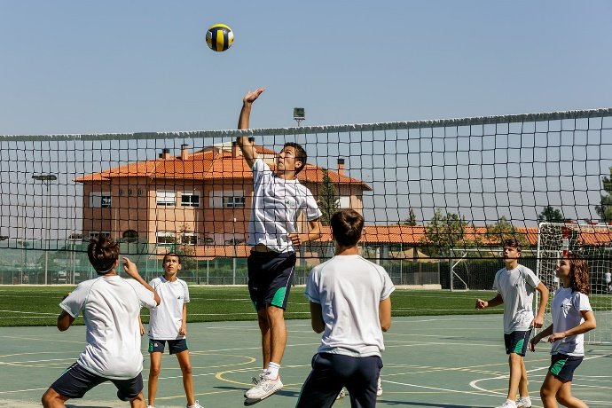
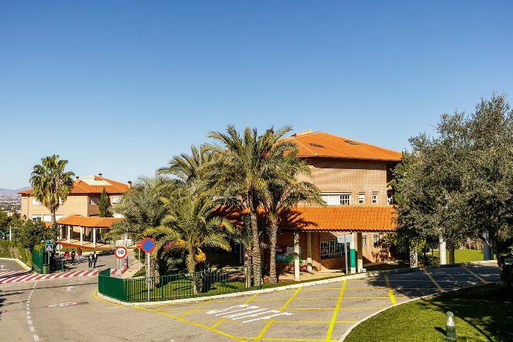
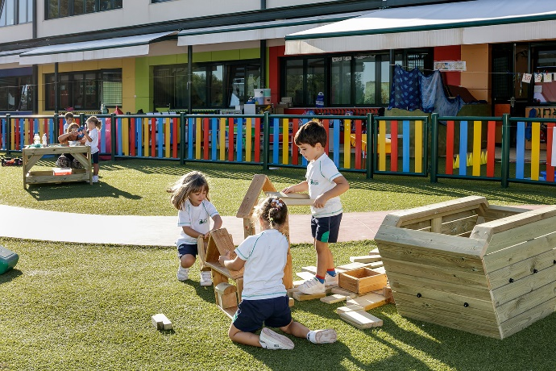

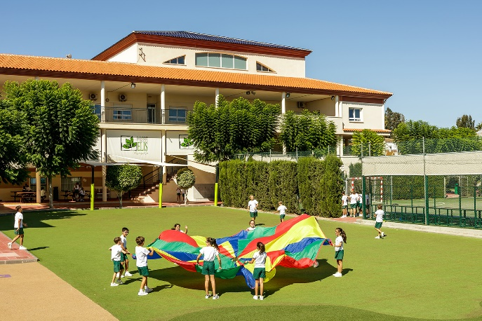
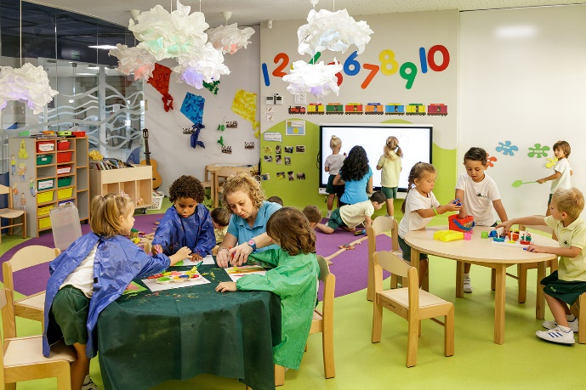

El Limonar International School (ELIS) is always looking to recruit high-quality staff into our dynamic learning communities. ELIS schools are growing schools: committed to improvement, CPD and a positive work-life balance

We are looking for someone who is passionate about teaching and is excited to teach in the best international schools in their respective regions. Candidates will hold a relevant degree and a UK-approved PGCE or international equivalent. Candidates need to have both understanding and experience of the British National Curriculum, with knowledge of, and time spent teaching both 16+ and 18+ examinations where relevant.

Contract type & term
Full time. Permanent

Start date
By September 1st

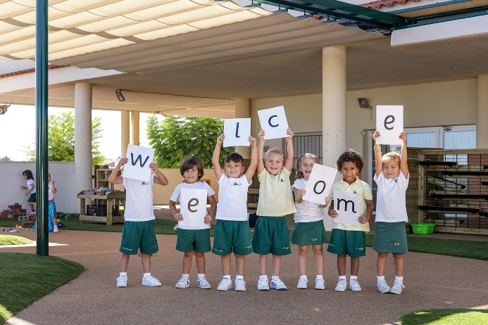
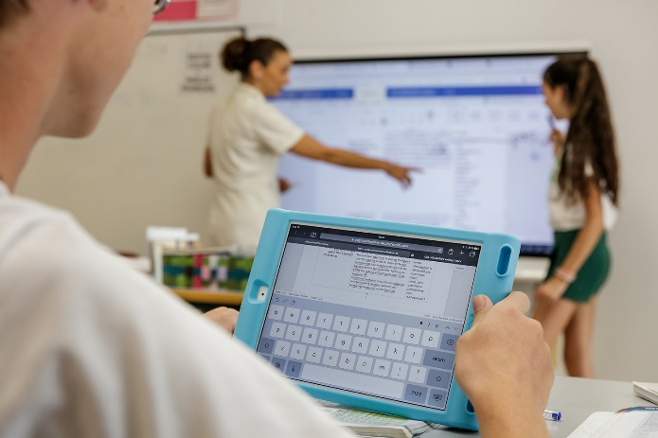
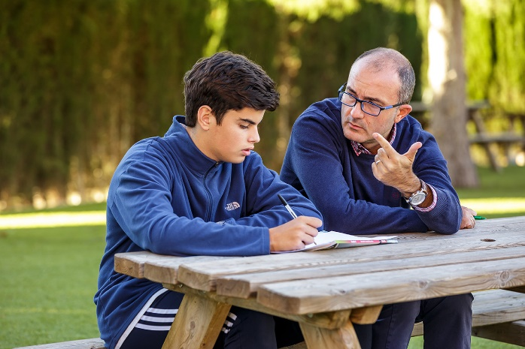
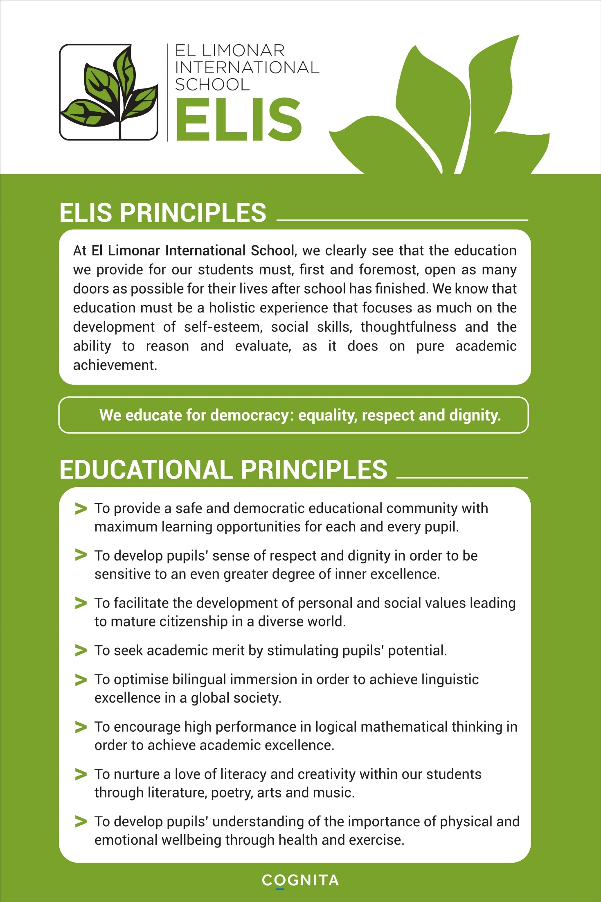

Achieve more than you believe possible

ELIS aims to provide a high-quality education within a culture of care. They are schools which have been growing steadily for the last few years. Both schools offer a programme based on the National Curriculum for England and Wales, IGCSE and IAL Level courses, as well as the Spanish Baccalaureate programme. El Limonar is authorised by the British Council to run as a British curriculum school in Spain through inspection by the National Association of British Schools in Spain (NABSS). Furthermore, ELIS is recognised by the Spanish Ministry of Education and is an approved examining centre for Cambridge International Examinations, Pearson Edexcel and AQA examinations The school is part of the Cognita Schools Group’s European division and has been a member of the prestigious Council of British International Schools (COBIS). The school is now undertaking the the process of obtaining the world-class Council of International Schools (CIS) membership and accreditation: This is a two-year process that will be completed in 2022. ELIS Murcia in particular has been expanding rapidly and in September 2020 we opened a state-of-the-art additional Secondary and Sixth Form school at the Montevida residential development, adjacent to the Buenavista site, for an additional 400+ students. This new school is by far the most modern and innovative educational facility in the region and keeps ELIS very much where it belongs: at the vanguard of educational provision in Spain.

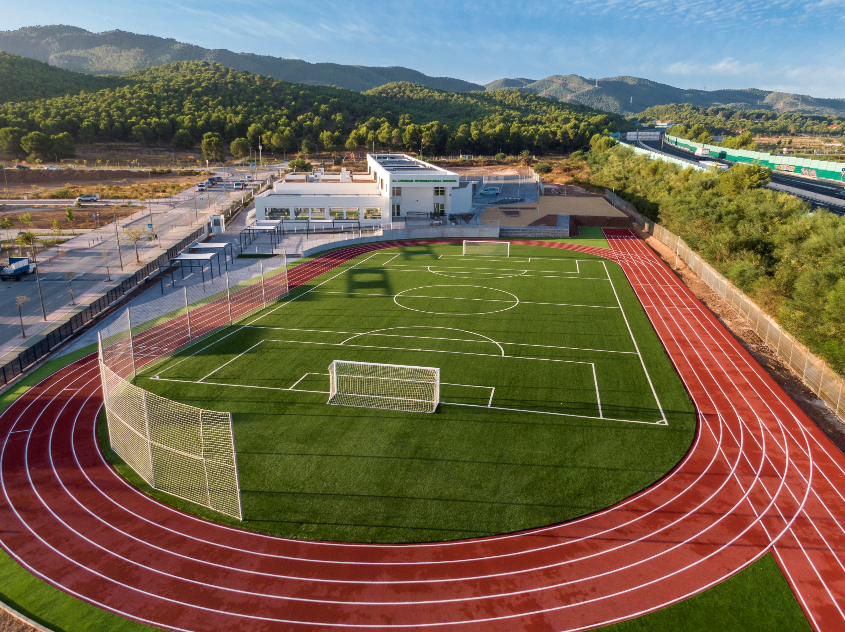

The new ELIS Murcia school for Secondary and Sixth Form

About the Murcia and Orihuela Costa Areas

Most teachers who come to our region choose to stay as it offers a superb quality of life with wonderful weather, culture, sport, food and people (something for everyone!). It is a great base from which to explore southern Spain and with two international airports in close proximity to the schools, it is an excellent place for both cheap travel to and from the UK and for exploring the rest of Europe and North Africa. Candidates should do their own research, but it should be remembered that the cost of living in both Murcia and the Orihuela Costa regions is significantly below that of the UK or northern Europe (at around 80% of the UK average)

We offer a competitive salary and 100% remission for staff children on tuition fees for staff on 0.75+ FTE contracts

Murcia City Centre

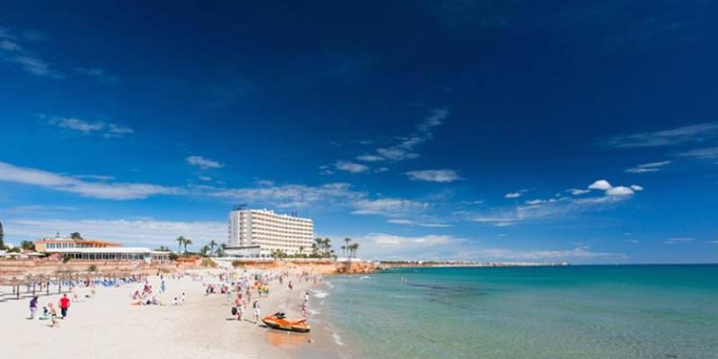

Orihuela Costa

Working at Our Schools:

The schools follow the academic year September to June as published by the Spanish Ministry of Education. There are normally just over two weeks’ holiday at Christmas, two weeks at Easter and nine weeks in the summer. It should be noted that although there are many ‘bank holidays’ in Spain, there are no long half-term holiday periods like in the UK education system. Teaching staff work between 180 and 183 days per year (including training and non-teaching days).

The school day runs from 9.00 to 16.30 at both ELIS schools, with staff meetings and extra-curricular activities after school. There are six (Villamartín) to seven (Murcia) teaching periods of between 50 and 60 minutes each day depending on the Key Stage and site. The maximum teaching load for a class teacher is up to 27 classes a week out of 35 at ELIS Murcia and 25 classes a week out of 30 at ELIS Villamartín, although most teach less. Staff also stay in school for a one and a half hour long meeting each week as well as between two and three 10-minute morning briefings per week. Three or four times a term they stay for an additional two hours for parents’ evening meetings or whole-school staff meetings. Staff with coordination or other specific responsibilities receive additional pay and teach less hours per week.

Class sizes vary according to the subject taught and vary between 20 and 26 in EY; 15 to 26 in Primary; and 3 to 24 in Secondary and Sixth Form. Class sizes have been smaller during 2020-21 due to government requirements as a consequence of Covid-19.

We are all completely aware of the challenges that the Covid-19 pandemic has brought to education over the last year. It is important to note that the ELIS schools have remained open to all year groups at all times since September 2020 and that we are rightly proud of the significant investment in reducing student-teacher ratios, in air purifying equipment and other enhanced hygiene measures; as well as in IT hardware and software to facilitate remote learning when required.

All vacancies published have stated closing dates, but early applications are encouraged as we reserve the right to appoint prior to this deadline. Further details will be sent to short-listed candidates only. Interviews are usually held initially via Skype/Teams/Zoom, with the interview process always involving at least two interviews and a sample lesson where possible.

- Safeguarding: Cognita schools are committed to safeguarding and promoting the welfare of children and young people and expects all staff, volunteers and other third parties to share this commitment. Safer recruitment practice and pre-employment checks will be undertaken before any appointment is confirmed.

- Diversity: Cognita’s success depends on our people. With 70+ schools in eight countries and our employees representing over 30 nationalities, the scope of our difference is a source of pride. We believe this diversity positively promotes global citizenship and reflects the value of contribution irrespective of one’s personal characteristics and/or background.

- Equal opportunities: Cognita is committed to preserving and promoting equality of opportunity in all aspects of the conduct of its business. No member of staff or any applicant for employment with Cognita will be discriminated against, harassed or victimised because of their personal characteristics. Cognita expects all staff to comply with the letter and the spirit of its policy.

- Wellbeing: Cognita is fully committed to the protection, promotion and enhancement of the wellbeing of all sections of our community: There is a Group and school-based programme for the promotion of mental health; of management of stress and workload; and for physical health and wellbeing.

