Head of Psychology Maternity Cover



**St Andrew’s Senior School, Turi**

As Head of St Andrew’s Turi, I welcome applications for this middle leadership position within our school. If you are someone with experience of delivering high quality and exciting provision for able and talented students, then it is my hope that I can interest you in a wonderful opportunity to not only contribute to our fantastic school, but also to tempt you to consider living in a beautiful location in the Rift Valley of Kenya.

This is an exciting opportunity for an ambitious teacher of Psychology to acquire a wide range of leadership experience in a successful, independent, full boarding school. This is a fixed term 5 month contract from 1 November 2025 to 31 March 2026.

The successful candidate will inherit a thriving department, achieving excellent results at A level and (I)GCSE. They will be expected to teach from Y10 to Y13. They will also be involved in the outstanding Sports and Outdoor Education provision.

The Head of Psychology reports directly to the Head of Social Sciences Faculty.

As a full boarding school, St Andrew’s is committed to providing a vibrant co-curricular and boarding program to which all staff contribute. The successful candidate will be an academic tutor and attached to a specific boarding house for duties.

If this position excites you, apply, and I look forward to hearing from you and ask that you bring your passion, energy and innovative ideas that could contribute to our school community. In return, we will offer a warm and committed staffroom of highly professional colleagues who delight in guiding our students to seek their highest and students who are committed to improving themselves. We will offer you a home in a safe, beautiful and rural situation within Kenya – a country that demands to be explored – with easy access to countryside, wildlife, culture and the Indian Ocean.

Start date – 1 November 2025

Finish date – 31 March 2026

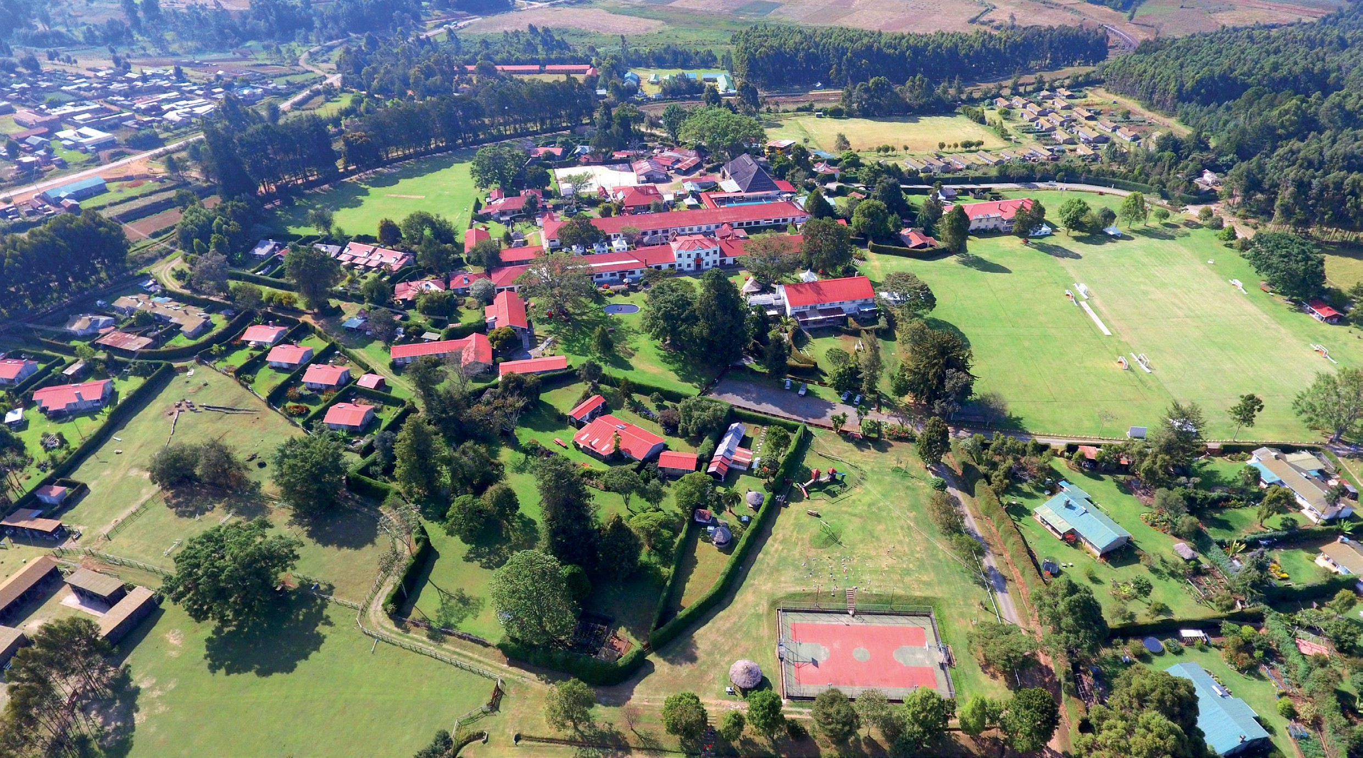

# The School

St Andrew’s, Turi is one of the leading international schools in Africa. Founded in 1931, it has grown to comprise both Preparatory and Senior Schools. St Andrew’s is a full boarding school, situated on a beautiful 450- acre site on the western slopes of the Rift Valley, North West of Nairobi, and at an altitude of 2500m (making it malaria free) where the wonderful climate makes it one of the most sought-after places to live in Kenya.

St Andrew’s has a strong Christian foundation and ethos, which continue to define and govern the nature and work of the School. The Senior School has over 365 students (The Prep School has 230 students) from over 25 nations, with the majority hailing from Africa. The School’s distinctive Christian character is evident in all aspects of School life, with children from all faith backgrounds welcome.

# Person Specification

Working at St Andrew’s, Turi, is an exciting and dynamic experience. Our desire is to recruit committed and resourceful staff, who are looking to develop their skills and leadership capacities and who desire to embrace new experiences and challenges.

# Knowledge and Experience

|  |  |  |
| --- | --- | --- |
|  | **ESSENTIAL** | **DESIRABLE** |
| Qualifications | A good degree and relevant teaching experience (minimum 3 years) | Relevant post graduate study |
|  | A teaching qualification | An additional qualification of educational management |
| Knowledge | A clear understanding of and affinity for the school’s ethos | Knowledge of the requirements and operation of ISI or equivalent inspectorate. |
|  | An understanding of effective leadership and management in relation to outstanding academic provision | Data analysis experience including using ALPS |
| Experience | Leadership experience, including energy, resilience, and a track record of enthusing and motivating others (does not necessarily have to be in education) | Working as an examiner |
|  | A proven track record of supporting students with a range of abilities, leading to improved academic results | Relevant experience of working in an independent school and/or boarding school |
|  | Evidence of good management which incorporates detailed planning, successful implementation and effective monitoring and evaluation strategies | Experience of teaching non-parametric statistical tests |
|  | Evidence of creating engaging and inspiring lesson material within a structured scheme of work |  |

**Skills and Attributes**

The successful candidate should have:

* Experience in the outstanding delivery of the Psychology curriculum and assessment materials
* A sense of purpose, the highest standards of personal integrity, someone who seeks the highest in all they do
* A strong personal empathy with the School’s Christian ethos
* Outstanding understanding of the collection, analysis and use of data to improve student outcomes
* A professional demeanor that is supportive, encouraging, compassionate and inclusive
* Impressive personal presence and presentation
* High literate and numerate skills, excellent in the use of IT and with a keen eye for detail
* High work standards evidenced by a consistently thorough detailed and organised approach
* The presence, intellect, tact and credibility to represent the School at all levels and to a variety of audiences
* Vision, creativity and imagination combined with the ability to operate at a strategic level
* First-class oral and written communication, and presentation skills
* High levels of discretion and confidentiality
* The ability to manage and prioritise a diverse workload, to meet deadlines and to work calmly under pressure

# Responsibilities

The overarching responsibilities of the role include:

* Promoting the Christian ethos of the school
* Establishing and developing a culture of excellence
* Ensuring delivery of excellent Psychology provision at the Senior School
* Developing and delivering outstanding assessment for learning, in line with school policy
* Ensuring accurate reporting data and identifying trends to improve academic outcomes for all

Beyond the above, we want staff who are committed to allowing students to thrive; first-class communicators; passionate about education and the students they teach; creative and diligent in their planning; and, given life in a full boarding school (in a remote location), are adaptable, energetic and resilient.

Above all, what matters is a commitment to help us provide a world-class education for our students.

In the most recent ISI inspection, the Senior School was assessed to be “Excellent” in the quality of both the pupils’ “learning and achievement”, and, “personal development”. We are an active member of HMC, the Society of Heads, COBIS, KAIS and Round Square.

Our mission is to be the leading international school in Africa, transforming the hearts, minds, bodies and souls of tomorrow’s leaders. Students in the Senior School are prepared for iGCSE and A-level exams and move on to top universities in the UK, United States, Canada, and many other parts of the world.

St Andrew’s staff are characterised by the highest professional standards, and they form a vibrant and industrious community, integral to the culture of excellent professional development within the context of a full boarding school.

**Terms and Conditions**

# Remuneration

There is a generous overall remuneration package as detailed below:

·  **Salary:** The successful applicant will receive a salary commensurate with their experience and qualifications

·     **Accommodation:** Suitable rent-free accommodation on site will be provided as a taxable benefit. Domestic and gardening help is arranged by the School, but paid for, at local rates, by the applicant.

·      **Medical care:** All members of staff, their spouses and up to 3 dependents below 18 or in full time education at St Andrew’s, Turi, are covered under a comprehensive insurance scheme.

* **Pension:** The School operates a defined contribution pension scheme in which the employer and employee each contribute 6% of the monthly salary. For employees leaving Kenya at the end of their contract, the full value of the contributions, plus accumulated interest, can be withdrawn from the scheme.

·       **Relocation:**

* + **Staff joining from outside Kenya -** Outward and return flights for the applicant, and for his/her spouse and dependent children [up to the age of 18].
  + **All staff -** a freight allowance, at the beginning and end of the contract period, totaling a month’s gross salary, is paid for by the School on the production of relevant receipts.

·     **Meals:** These are provided during term time as a taxable benefit.

·     **Facilities:** Extensive recreational facilities are open to use by staff and their families. The onsite Phoenix Club, serving a wide range of food and beverages, acts as a wonderful social hub for the staff community and their families throughout the year.

# Hours of work and holiday entitlement

The contract is for 5 months, commencing on 1 November 2025 and finishing on 31 March 2026. The role is full-time and includes working in the evening and at weekends as required. The successful applicant will be expected to take a full and active part in the boarding provision of the school.

# Safeguarding

St Andrew’s School, Turi, is committed to safeguarding and promoting the welfare of students and expects all staff and volunteers to share this commitment. You will undertake your role and responsibilities in accordance with St Andrew’s School’s Safeguarding and Child Protection Policy and Guidelines. The successful applicant will be required to undergo all checks relevant to post.



# Application Procedure

## To find out more please contact the Senior School Head’s PA, Ms Roberta Mulli, to arrange a phone call with Mrs Lucy Hemsley, Senior School Deputy Head Academic.

**Tel: +254 (0) 20 2025709 • Email: execassistantsenior@turimail.co.ke**

Applications should be submitted via the school website [St. Andrews Turi Career Opportunities - St. Andrews Turi (standrewsturi.com)](https://www.standrewsturi.com/working-at-turi/career-opportunities/) and include: a completed application form, and a brief covering letter.

If your application is successful, we will contact you within three working days of the closing date.

Early applications are encouraged.

* + **Closing date for applications:** 0800hrs (EAT) Thursday 31 July 2025
  + **Preliminary interviews:** w/c Monday 4 August 2025
  + **Final Interviews** w/c Monday 1 September 2025
  + **Start Date:** 1 November 2025