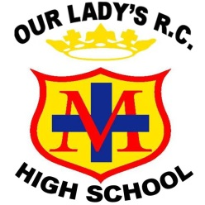
LEAD TEACHER OF RELIGIOUS EDUCATION
Start date: Easter / September 2020
Salary: L1 – L8 (point dependent upon experience)
Contract term: Permanent. Contract type: Full Time

We are seeking to appoint an enthusiastic and highly motivated Lead Teacher of RE to assist the Head of Faculty with the next step in the department’s development. The right candidate will be an exceptional teacher of RE with a commitment to academic excellence and inspiring a love of Theology in young people. They will play a pivotal role in securing the very best outcomes for the faculty. We are looking for someone who will be significantly involved in providing an enriched curriculum and opportunities to stretch and challenge all students.
We offer a vibrant and diverse community with students who are highly motivated and take responsibility for their learning. The building is modern, with a purpose built chapel and our parish church is within walking distance. The RE staff are committed to ensuring student success and the new Lead Teacher will be actively involved in building upon this success.
Our Lady’s is a heavily oversubscribed successful Catholic school with a “Good” judgement from Ofsted and an excellent reputation across the Diocese of Salford. We strive for academic excellence whilst also offering students a vast array of enrichment opportunities to help them discover and nurture their talents. We pride ourselves on meeting the needs of each individual and ensuring positive outcomes for young people of all abilities. The successful candidate will benefit from:
- A supportive and nurturing working environment that provides high quality, professional, developmental experiences and opportunities for career progression.
- Joining a team of four highly skilled individuals, who consistently deliver high quality lessons.
Prospective candidates are encouraged to visit the school to witness our vibrant community. To arrange an informal visit contact Sally Royle (PA to Headteacher) on 0161 507 9670 or s.royle@olsc.manchester.sch.uk
On behalf of our students, thank you for your interest in our school.
Closing date: Friday 24th January at 9.00am. Interviews are anticipated for week commencing Monday 27th January.

