FINHAM PARK 2
TEACHING ASSISTANT

GRADE 3 £24,404 - £25,584 FTE
(Actual Salary - £20,318 - £21,300)
35.5 hours per week Term Time only plus 5 Teacher Training Days
Starting as soon as possible – Permanent role

We are delighted to announce that we are recruiting a professional and enthusiastic individual who will work both independently and alongside teachers, providing valuable support for Teaching and Learning activities, and eventually develop their own initiatives. The successful candidate will provide support in lessons but will also mentor students and teach small groups having the potential to help students through some of the most difficult stages of their education and lives. They will also use specialist knowledge for planning lessons and developing support materials, and provide care and supervision to young people.

The role will work across all subjects and year groups but the successful candidate will also have the opportunity to work with students of all abilities. The role will need to develop relationships with these students to maximize their learning potential over their school career.

Finham Park 2 is an exciting, friendly and supportive 11-19 co-educational comprehensive school based on the West side of Coventry near the border of Solihull and close to Warwick University. We opened in September 2015 with 120 students and have grown year on year, including our 6th form, which opened in 2020.

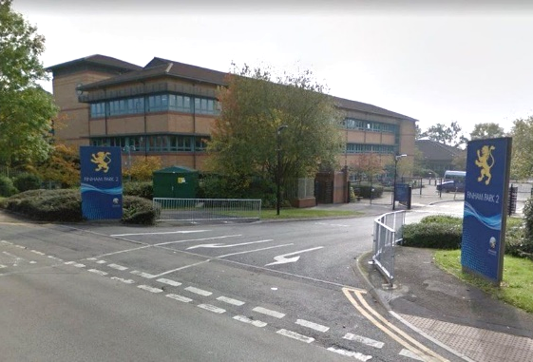
In September 2016 we moved to our new building- a light and spacious, high quality refurbishment with superb facilities including a brand-new sports hall. We are fully staffed with a positive, supportive, forward thinking team. We continue to be heavily oversubscribed each year. Our last Ofsted (November 2023) described Finham Park 2 as a good school in all areas with “a purposeful atmosphere around the school”, “a calm and orderly manner” and “a highly ambitious curriculum”, where “leaders carefully consider staff workload which staff are appreciative of.”

Finham Park 2 is a truly comprehensive school with almost 700 students on roll. The vast majority of our students are happy, well-behaved, friendly, inquisitive, polite and wear their uniform with pride. On entry students are broadly in line with national averages with approximately 85+% middle or higher prior attainment.


We offer an exciting curriculum that provides opportunities for all students to ensure they all achieve and make the best progress they are capable of, no matter what their starting points; a curriculum that nurtures every child’s talents and provides exceptional opportunities for students to have the ‘time of their lives’.


Finham Park 2 is supported by and proud to be part of Finham Park Multi Academy Trust. As part of the Multi Academy Trust, we enjoy working in collaboration with the other MAT schools. This provides fantastic opportunities for both our staff and students.

To apply, please read our pack before providing a full application form along with the equal opportunities form. Please ensure your supporting statement sets out why you feel that you are suitable for this role.

Details of our interview arrangements, will be provided to the shortlisted candidates.

Closing date: Tuesday 18th March 2025 at 00:00

Interview date: TBC

How to Apply

Applications are submitted through our Every Candidate Portal. Click the link below to take you directly to the site.

https://candidates.every.education/Vacancies/Details?advertKey=49c5def9-7824-4282-bb8d-90304bfacf17

Alternatively, you can click on the ‘application form’ on our careers website which will direct you to the application page.

To request any of the documents in an accessible format, or to request an application form via email please contact apply@finhampark.co.uk or call 02477 180000 and select option 2 for HR.

If you are a new user to our portal, you can click on ‘Register’ to complete your candidate profile. If you want to apply directly for this role and not save your data for any future vacancies, you can click on the ‘Apply Now’ button at the bottom of the Every page.

For further information on this role and other opportunities within the MAT, please visit https://careers.fpmat.co.uk

Finham Park Multi Academy Trust requires all applicants to be eligible to work in the UK with no restrictions as we are unable to offer sponsorship/work visas. You will be required to provide proof of Right to Work at interview stage and if you are offered a job position with us.

Online Checks
In line with KCSIE (Keeping children Safe in Education) 2023 we will complete online searches as part of our due diligence on all shortlisted candidates. If anything is identified as part of these checks they will be discussed with you at interview. If any safeguarding concerns are identified we reserve the right to withdraw your application.

Finham Park Multi Academy Trust is committed to safeguarding and promoting the welfare of children and young people and expects all staff and volunteers to share this commitment.

