

JOB DESCRIPTION

JOB TITLE: Human Resources Administrator

REPORTS TO: Senior Human Resources Officer

AREA: Human Resources

GRADE/SALARY: Support Staff Scale 3, points 18 to 19, £22,107 to £22,844 per annum

POST NO: SS131

CLOSING DATE: Sunday 12th November 2023

DBS: Enhanced DBS check with children’s barred list check

PURPOSE:

To work as part of a busy team and provide administrative support to the Human Resources function.

PRINCIPAL DUTIES:

- To support the general administration function of the Human Resources Team undertaking office duties e.g. filing, photocopying, answering telephone queries, ordering stationery etc., as and when required

- To effectively administer office systems particularly in relation to the following:
- Hourly paid contracts
- Support relevant employment checks e.g. right to work, DBS, qualification verification
- References
- Recruitment

- To effectively support administration processes in place for the recruitment of hourly paid staff and process notification paperwork to the Payroll Office in order to ensure all changes are actioned meeting all payroll deadlines.

- To process Disclosure and Barring Service application forms ensuring that all required evidence is in place.

- To ensure that all staff records are accurately maintained and relevant paperwork is completed in a timely fashion in line with HR service standards.

- To provide a professional front line reception point for all general enquiries into the Human Resources Office ensuring that an excellent service is provided to all customers.

- To work flexibly and contribute to a range of personnel administrative functions as required e.g. covering for staff absences and supporting other team members during peak period of activity.

- To be responsible for the high quality of service for all users of the office.

- To adhere to policies, procedures and values of Solihull College & University Centre.

- To undertake all mandatory training in a timely manner as required e.g. Safeguarding, Prevent.

- To actively promote equality, diversity & inclusion and to champion anti-racist practice.

- To support the college to become a Sustainable Net Zero organisation by 2030 and support the delivery of its Sustainability Strategy.

- To undertake necessary Health and Safety responsibilities, duties and training as required by this post.

- To undertake any necessary Data Protection responsibilities, duties and training as required by the post.

- Such other duties as required which are broadly consistent with the general functions and grading of this position.

EQUAL OPPORTUNTIES:

Solihull College & University Centre is committed to a comprehensive policy of Equal Opportunities. All employees are required to abide by this policy and ensure its compliance throughout the College.

SAFEGUARDING:

Solihull College & University Centre is committed to ensuring a safe environment for all students and expects all staff to engage fully with this commitment.

CORE VALUES:
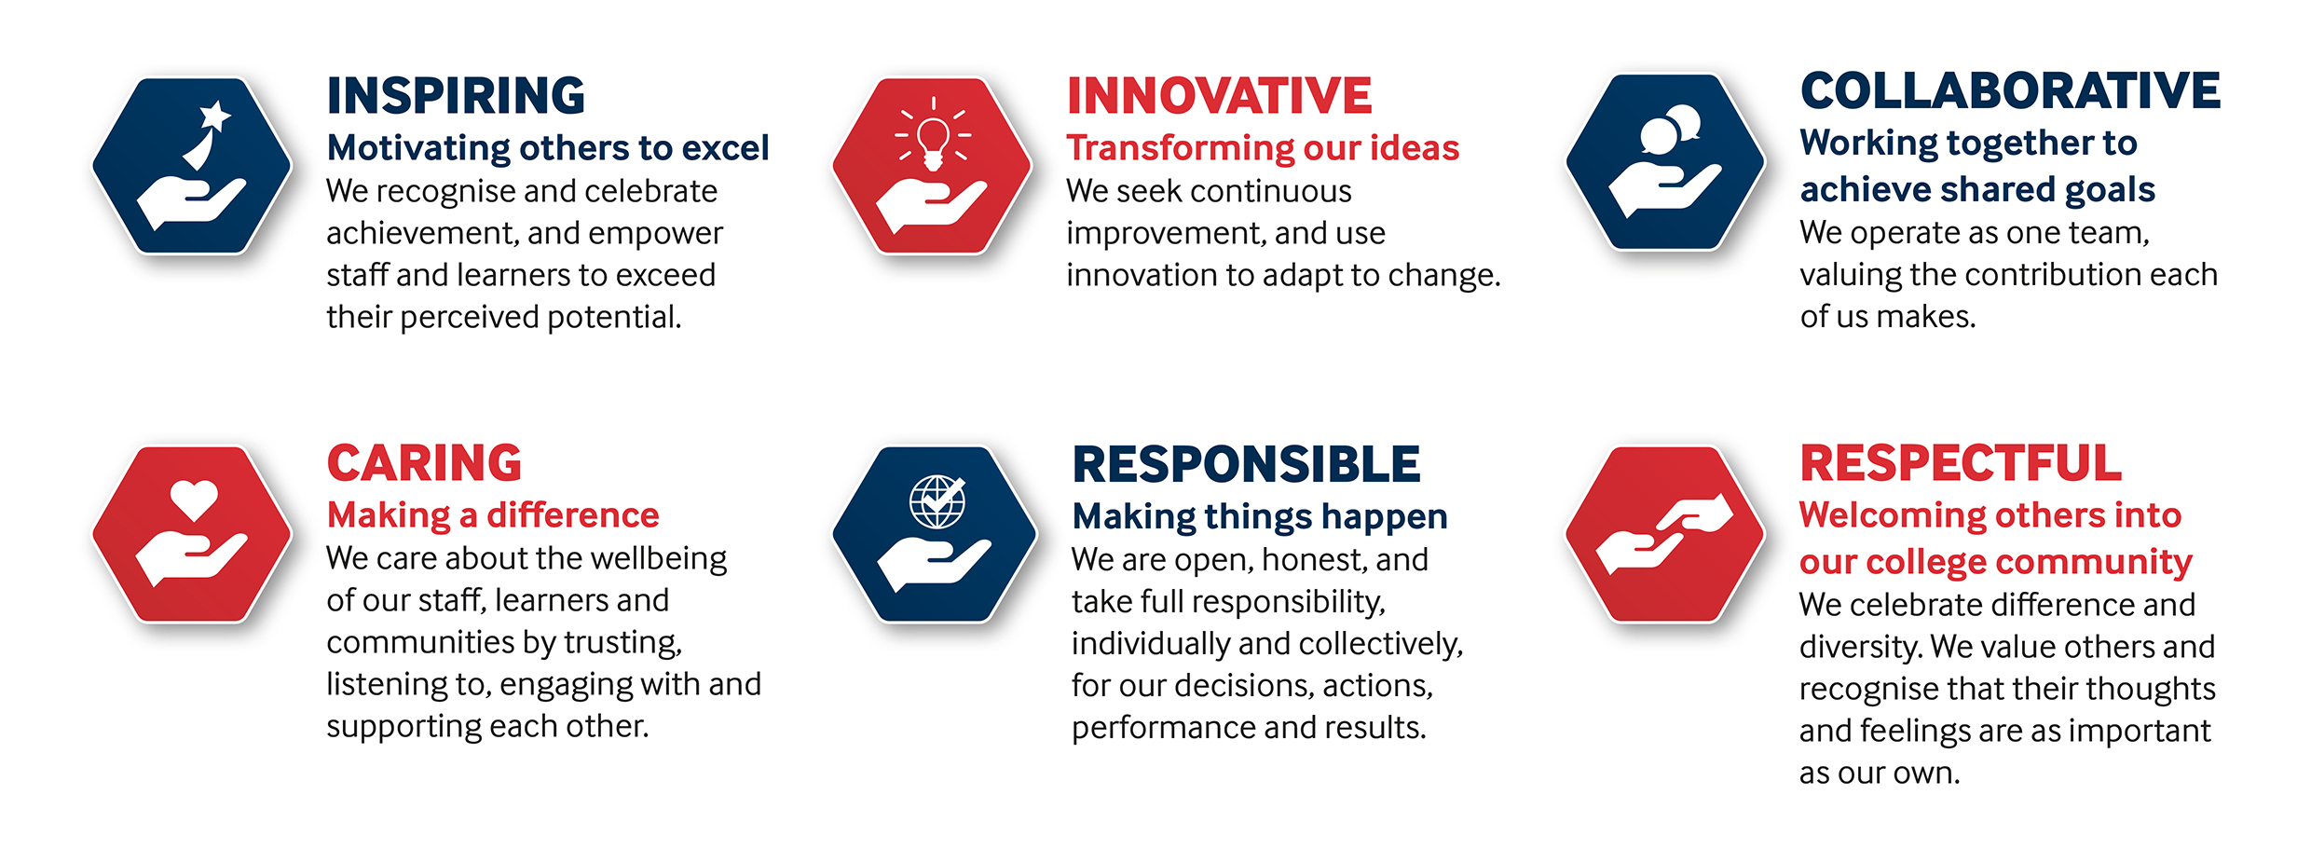

SOLIHULL COLLEGE & UNIVERSITY CENTRE
PERSON SPECIFICATION

JOB TITLE: Human Resources Administrator

SALARY: Support Staff Scale 3, points 18 to 19, £22,107 to £22,844 per annum

POST: SS131

SPECIFICATION | ESSENTIAL | DESIRABLE
EDUCATION /  TRAINING | Good general education  Level 2 English and Maths qualification | Level 3 qualification (i.e. A Level)  Level 3 Human Resources qualification e.g. Human Resources Practice Foundation Certificate, CPP or equivalent
RELEVANT  EXPERIENCE | Experience using Microsoft Office packages (Word, Excel etc.)  General office experience, including data entry, correspondence, filing, photocopying  Experience of working within a customer focussed environment | Experience of working within a HR team
SKILLS /  APTITUDES | High level of accuracy skills  Excellent organisational skills  Good team player  Excellent communication skills  Motivated and enthusiastic  Committed to giving excellent customer service
OTHER  REQUIREMENT | Ability to work under pressure  Ability to use own initiative  Flexibility to respond to the changing needs of the service throughout the academic year  Experience of handling confidential information  Strong commitment to Equal Opportunities  A commitment to the Safeguarding of Young People and Vulnerable Adults and an awareness of the Government ‘Prevent’ strategy  Commitment to the College’s Values | Willingness to undertake personal development  General awareness of cultural diversity

