



Vice Principal
Job Description

Salary: L16 – 22 £57,077 - £66,017

Overview

The Vice Principal will lead academically and pastorally the Primary stages of the Academy as well as having other agreed significant whole Academy responsibilities, based on the needs of the Academy and skills/experience of the candidate appointed. Whole Academy responsibilities may change over time to help provide the candidate with further experiences and skill development to support career development and promotion opportunities. This role provides an outstanding range of experiences and skill development, that will help facilitate further promotion.

As a full member of the Senior Leadership Team, the Vice Principal – Head of Primary, will also share the corporate responsibility necessary to ensure the continued outstanding operational provision of the Academy and will also play a major role in determining future strategy for the Academy.

Job Description

The Vice Principal at Atlantic Academy, Portland shall carry out the professional duties as described in the School Teachers Pay and Conditions document.

The Vice Principal is directly accountable to the Principal, for ensuring the educational success of Atlantic Academy, Portland within the overall framework of the Aspirations Academies strategic plan as well as the individual Atlantic Academy Portland strategic plan. The Vice Principal is responsible for contributing to the effective day to day operation of Atlantic Academy, Portland, fully supporting the Principal as part of a cohesive and highly effective Senior Leadership Team. The Vice Principal will be fully supported by Principal in every aspect of the management and organisation of the Academy. The Vice Principal should support the Principal to create a culture of constant improvement and be an inspirational leader, committed to the highest achievement for all in every area of the Academy’s work. Main aspects of the role:
- Carry forward the Aspirations Academies Trust vision
- Drive the continuous and consistent Aspirations Academies Trust-wide focus on raising achievement and improving student outcomes
- Ensure the Aspirations framework is embodied in every aspect of Atlantic Academy Portland
- Focus primarily on the development of teaching and learning aiming to ensure that it is of the highest quality at all times
- Provide effective academic and pastoral support for all students
- Strategic and operational leadership of agreed whole Academy responsibilities
Purpose:
- To be responsible for the academic success and pastoral support of all students in the Primary years of the Academy
- To raise standards of student attainment and to monitor the effectiveness of teaching and learning
- To strengthen the Academy’s organisational capacity by contributing to its effective day-to-day management.
- To develop a safe, secure and healthy environment within the Academy as a whole.
- To participate in regular Faculty and whole Academy self-review and to strive for continuous improvement in all aspects of the Academy’s work.
- To implement and deliver an appropriately broad, balanced, relevant and differentiated curriculum for students within Primary and across the Academy – particularly focusing on year 7 and 8 to avoid dips in attainment.
- To monitor and support the overall progress and development of students in the Faculties.
- To establish successful raising achievement plans and intervention programmes for all year groups within Primary.
- To establish successful intervention programmes to help close the gap, with particular focus on specific groups.
- To facilitate and encourage a learning experience which provides students with the opportunity to achieve their individual potential.
- To work towards raising the aspirations of all the students.
- Provide strategic and operational leadership of agreed whole Academy responsibilities.

Responsible for:
- Leads of subject areas, teaching staff, other relevant personnel and students within the Academy with a focus on the primary stages.

Operational and Strategic duties:
- To supervise and lead all staff to ensure the effective operation.
- To line manage areas of responsibility within Primary and throughout the Academy.
- To oversee and guide the development of appropriate syllabuses, resources, schemes of work, marking policies, assessment and teaching and learning strategies within the faculties.
- To work with SLT to ensure the effective deployment of staff and physical resources.
- To work with SLT to monitor the overall coherence and relevance of the Faculty’s contribution to the needs of students and to the aims, objectives and strategic plans of the Academy.
- To ensure that the work done in the Faculty and Academy fully reflects the distinctive philosophy of the Aspirations Academies Trust.
- To ensure that Health and Safety policies and practices, including risk assessments, are in-line with national requirements and are updated where necessary, therefore liaising with the Academy’s Health and Safety Manager and SLT as appropriate.
- Provide strategic and operational leadership of agreed whole Academy responsibilities.

Curriculum Duties:
- To ensure the provision of a broad and balanced curriculum for all students as part of the Academy’s Senior Leadership Team.
- To lead and manage the work of SLT to ensure the delivery of an appropriate, comprehensive, high quality and cost-effective curriculum programme which complements the vision of the Academy and creates a whole through ethos.
- To lead and encourage innovation in curriculum development by all Faculty teaching staff.
- To be aware of wider curriculum developments across all Key Stages and to be proactive in raising these as part of the Academy’s Senior Leadership Team.
- To work with SLT to maintain accreditation with the relevant examination and validating bodies.

Staff Development Responsibilities:
- To work with SLT to ensure that staff development needs are identified and that appropriate programmes are designed to meet such needs.
- To monitor the efficient and effective deployment of the Faculty’s technicians/support staff (where appropriate).
- To undertake Performance Management Review(s) and to act as reviewer for a group of staff within Faculties.
- To participate in the interview process for teaching posts when required and to work with SLT to ensure effective induction of new staff in line with Academy procedures.
- To promote teamwork and to motivate staff to ensure effective working relationships.

High Standards Maintenance:
- To ensure the effective operation of Academy review and monitoring systems.
- To ensure the process of effective target setting within the Academy and to work towards their achievement.
- To contribute to the Academy’s procedures for lesson observation, subject review and quality assurance.
- To work with SLT to monitor and evaluate the work of the Faculty’s subject areas, in line with agreed Academy procedures including evaluation against quality standards and performance criteria.
- To lead and monitor modification and improvement where required.

Management Information Responsibilities:
- To make use of analysis and evaluate performance data provided.
- To identify and take appropriate action on issues arising from data, systems and reports; setting deadlines where necessary and reviewing progress on the action taken.
- To produce reports within the quality assurance cycle for the Academy/Faculties.
- To provide the Local Governing Body with relevant information relating to the Faculty’s and Academy’s performance and development.

Managing Effective Communications:
- To ensure that all members of each Faculty are familiar with the Academy’s philosophy, vision, aims and objectives.
- To ensure effective communication/consultation as appropriate with the parents of students.
- To liaise with partner schools, higher education, industry and other relevant external bodies.
- To lead Faculty assemblies.

Resource Management:
- To work with SLT to manage the available resources of space, staff, money and equipment effectively and efficiently in order to maximise the educational provision for students.

Student Support Duties:
- To monitor and support the overall progress and development of students within the Faculties, by liaising with SLT, personal mentors and support staff.
- To contribute to and implement the Academy policy on rewards and support.
- To ensure the Behaviour Management system is implemented in the Faculties so that effective learning can take place.
- To monitor student behaviour at all times throughout the Academy and to work with duty staff to intervene as necessary.

Teaching Duties:
- To undertake an appropriate programme of teaching in accordance with the duties of a standard scale teacher.
- To assist in the development of appropriate syllabuses, resources, schemes of work, marking policies and teaching strategies in the curriculum area and subject area.
- To contribute to the curriculum area and subject area’s Improvement Plan and its implementation.
- To attend all appropriate meetings.
- To plan and prepare courses and lessons.
- To teach students according to their educational needs, including the setting and marking or work to be carried out by the student in the Academy and elsewhere.
- To assess, record and report on the attendance, progress, development and attainment of students and to keep such records as are required.
- To provide, or contribute to, oral and written assessments, reports and references relating to individual students and groups of students.
- To ensure a high quality learning experience for students which meets internal and external quality standards - to aim to be an outstanding teacher.
- To maintain discipline in accordance with the Academy’s procedures and to encourage good practice with regard to punctuality, behaviour, standards of work and homework.
- To undertake assessment of students as requested by external examination bodies, subject area and Academy procedures.

Other Duties:
- Provide strategic and operational leadership of agreed whole Academy responsibilities.
- To adhere to the Academy’s Dress Code.
- To engage actively in the performance review process.
- To continue personal development as agreed at appraisal.
- To undertake any other duty as specified by School Teachers’ Pay and Conditions Body (STPCB) and the Principal not mentioned in the above.
- To play a full part in the life of the Academy community, to support the distinctive aim and ethos of the Aspirations Academies Trust and to encourage staff and students to follow this example.
- To show a record of excellent attendance and punctuality.

General:
Employees will be expected to comply with any reasonable request from a manager to undertake work of a similar level that is not specified in this job description.

Employees are expected to be courteous to colleagues and provide a welcoming environment to visitors and telephone callers.

The Academy will endeavour to make any necessary reasonable adjustments to the job and the working environment to enable access to employment opportunities for disabled job applicants or continued employment for any employee who develops a disabling condition.

Vice Principal
Person Specification
Assessed by application (A) Assessed by the recruitment process (R)

Person Specification

Post Title: Vice Principal – Head of Primary

Assessed by application (A) Assessed by the recruitment process (R)

Criteria | Essential | Desirable
Knowledge and Qualifications
Degree or equivalent. | A
Qualified Teacher Status. | A
Exemplary, outstanding practitioner. | A,R
Evidence of professional development relevant to Senior Leadership. |  | A, R
Professional Experience
Outstanding secondary teaching experience up to and including A Level. | A,R
Outstanding Middle Leadership experience. | A,R
Proven experience of consistently good and outstanding teaching, delivery outstanding student attainment/progress over time. | A,R
Experience of reflecting on and improving teaching practice to increase student achievement. | A,R
Experience of being involved in raising levels of student attainment/achievement across at least two Key Stages at KS3, 4 and 5. | A,R
Experience of continually improving teaching and learning through schemes of work, assessment, intervention and extra-curricular activities. | A,R
Form tutoring or mentoring learners. | A,R
Leadership of whole school development priorities and initiatives. |  | A,R
Experiences of providing professional development to teachers, including coaching, mentoring and training. |  | A,R
Experience of leading some aspects of whole school KS4 or KS5 Raising Achievement strategies. |  | A,R
Teaching and Learning
Excellent classroom practitioner – ensures that their own classroom practice models best practice. | A,R
Effective and systematic behaviour management, with clear boundaries, sanctions, praise and reward. | A,R
Demonstrates resilience, motivation and commitment to driving up standards of achievement. | A,R
Excellent communication, planning and organisation skills. | A,R
Acts as a role model to staff and students. | A,R
Commitment to regular and on-going professional development and training to establish outstanding classroom practice. | A,R
Leadership
Leadership skills already developed as a Middle or Senior Leader. | A,R
Effective leader and team member. | A,R
High expectations for accountability and consistency. | A,R
Clear vision on how to help move to academy to the next level of performance. | A,R
Vision aligned with the Trust’s aspirations. | A,R
Genuine passion and a belief in the potential of every student and the ‘no excuses’ philosophy. | A,R
Motivation to continually improve standards and achieve excellence. | A,R
Commitment to the safeguarding and welfare of all students. | A,R
Specialist Knowledge
Outstanding understanding of effective KS3, 4 and 5 Raising Achievement strategies. | A,R
Knowledge and application of data used to drive raising student achievement. | A,R
Experience of strategic marketing and promotion. |  | A,R
Ability to present to and inspire large audiences. | A,R
Excellent understanding of the OFSTED framework and what constitutes outstanding teaching, learning, achievement and leadership. | A,R
Understanding of the strategies needed to establish consistently high aspirations and standards of results and behaviour. | A,R
Knowledge of the latest educational research, findings and best practice. | A,R
Disposition/Attitude
A passion for education and making a difference to student’s life chances. | A,R
Vision and the ability to implement it. | A,R
Ability to work as a member of a team. | A,R
The ability to command respect from colleagues, parents, governors and the local community. | A,R
Excellent attendance and punctuality record. | A,R
Energy, enthusiasm, commitment, integrity, good sense of humour. | R
Prepared to listen to others and share ideas. | R
Developing successful relationships with pupils, staff, parents and Governors. | A,R
Hardworking, imaginative and adaptable. | A,R
Determined and resilient and doing whatever is needed to get the job done. | A,R
Commitment to Equal Opportunities; the ability to support and develop the Academy’s Equal Opportunities policies. | A,R
Willing to take part in and lead extra-curricular activities. | A,R
Willingness to undertake training. | A,R
Other
Commitment to safeguarding and welfare of all students. | A,R
Display a commitment and support for the aims of the Aspirations Academies Trust in all its Academies. | R
Exhibit a belief in the values of the Aspirations Academies Trust and in the value of research in school improvement. | R

The Aspirations Academies Trust
The Aspirations Academies Trust (AAT) as a sponsor of primary and secondary age academies in
England, is committed to raising students’ aspirations so that all young people reach their fullest
potential and achieve the success they want for themselves.

The Aspirations Academies Trust in England benefits from QISA’s (The Quaglia Institute for Student Aspirations) remarkable record of more than 30 years of research and experience working with students, educators, and schools.

Aspirations is the ability to dream about the future while being inspired in the present to reach those
dreams. The Aspirations Academies Trust was set up in England with the vision to combine the thirty
years of educational research by Dr. Russ Quaglia on student aspirations with effective and
innovative school improvement techniques in order to create truly outstanding schools that would
fully prepare students to succeed in this exciting world.

Central to the philosophy of the Aspirations Academies Trust is the innovative Aspirations Framework developed by the Quaglia Institute for Student Aspirations (QISA) which outlines the belief that for all students to have high Aspirations, three Guiding Principles must be present: Self‐Worth, Engagement, and Purpose. These Guiding Principles direct the development of educational experiences from the individual classroom to the entire school building. The Three Guiding Principles, in turn, are lived out through 8 Conditions that emphasise relationships, active and engaging teaching and learning, and a sense of responsibility over one's own aims and goals.

The 8 Conditions are: Belonging, Heroes, Sense of Accomplishment, Fun & Excitement, Curiosity & Creativity, Spirit of Adventure, Leadership & Responsibility & Confidence to Take Action. Students who have high aspirations believe in themselves, are meaningfully engaged in their learning and the life of the school and work with intention toward their goals.

Our Aspirations Academies have a commitment to make certain that all young people achieve their
fullest academic potential and become responsible citizens. To achieve this goal we are dedicated to
promoting and putting into practice the Three Guiding Principles and 8 Conditions that foster student
aspirations. Each Academy strives to ensure that all students have the opportunity to discover and
appreciate their endless promise for a successful future.

The Aspirations Academies Trust considers that its beliefs and principles are applicable and effective with students from age 3 to 18. Each stage of a child’s education is extremely important ‐ pre‐school, primary and secondary ‐ and should, where possible be coherent across the phases of education in the practice of developing the principles and conditions central to the beliefs and aims of the Aspirations Academies Trust. For this reason, we support primary, secondary and, where possible, all through (Ages 3‐18) academies.

At whatever stage a child joins an Aspirations Academy, whether it is at the age of three or sixteen, the aim is to provide each individual child with the best possible life chance. This is done through the achievement of the highest level of qualifications, the development of skills essential to success in an interconnected and highly competitive world, as well as encouraging the highest aspirations, expecting every student to gain a place at university or enter skilled employment.

Our Academies

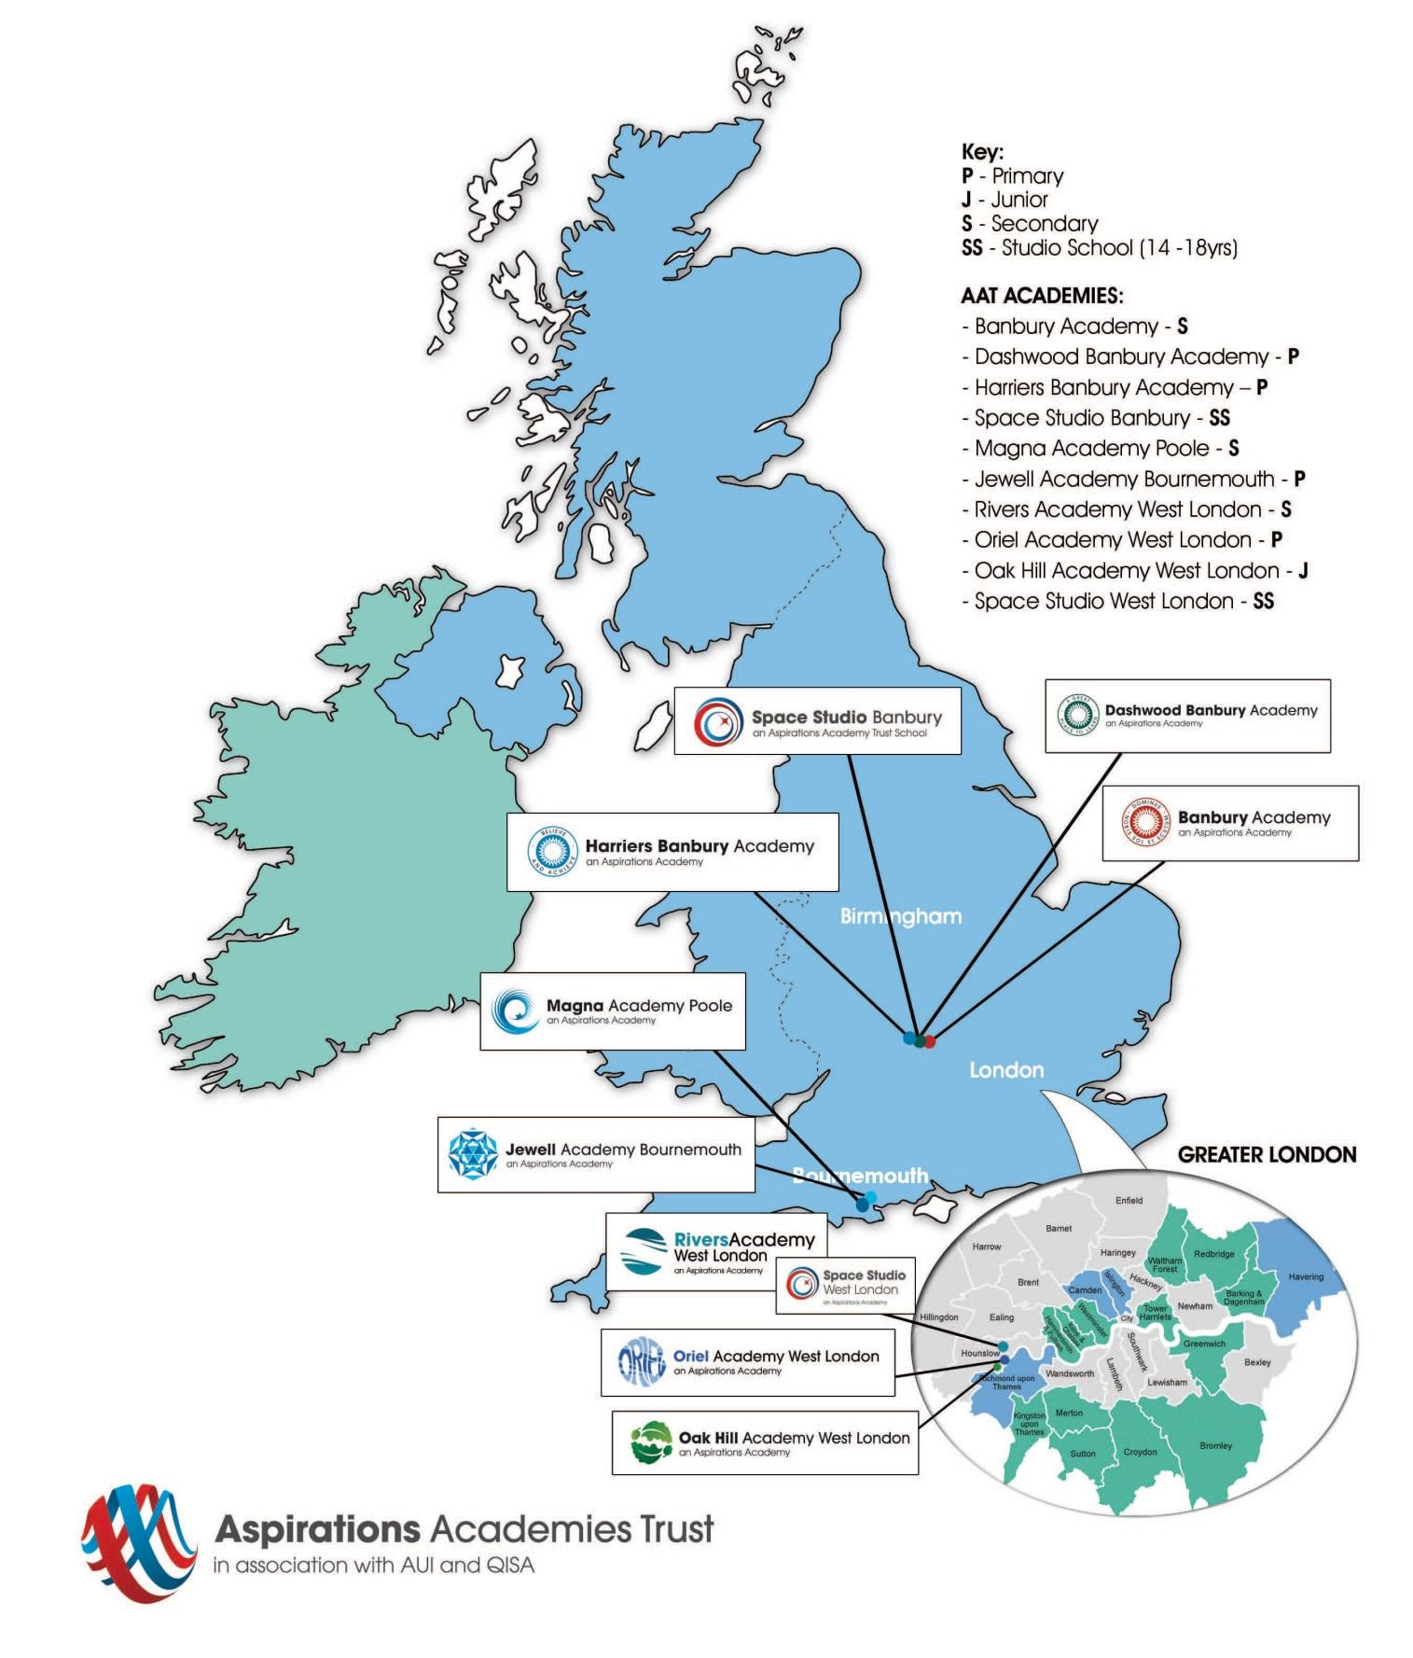
(2015)

Safe Recruitment Procedure

The AAT is committed to safeguarding and promoting the welfare of children and young people in its academies. In order to meet this responsibility, its academies follow a rigorous selection process to discourage and screen out unsuitable applicants. This process is outlined below, but can be provided in more detail if requested.

Disclosure
This post is classified as having substantial access to children, and appointment is subject to an enhanced police check of previous criminal convictions (DBS). Applicants are required, before appointment, to disclose any conviction, caution or binding over including ‘spent convictions’ under the Rehabilitation of Offenders Act 1974 (Exemptions) Order 1975. Non-disclosure may lead to termination of employment. However, disclosure of a criminal background will not necessarily debar individuals from employment – this will depend upon the nature of the offence(s) and when they occurred.

Shortlisting
Only those candidates meeting the relevant criteria indicated in the personal specification will be taken forward from application.

Interview
Longlisted candidates may be subject to a screening interview. Those shortlisted will take part in an interview with questions relating to the job description and person specification and may also have to take part in a selection exercise such as a lesson observation.
Where necessary, candidates will be asked to address any discrepancies, anomalies or gaps in their application form.

Reference checking
At least two references will be requested, normally from the previous and current employers. These may be contacted before the interview and in all case before an offer of appointment is confirmed.

