‘I would not go to any other primary school in the world’ Year 6 pupil

COPPETTS WOOD SCHOOL
HEAD TEACHER
INFORMATION PACK
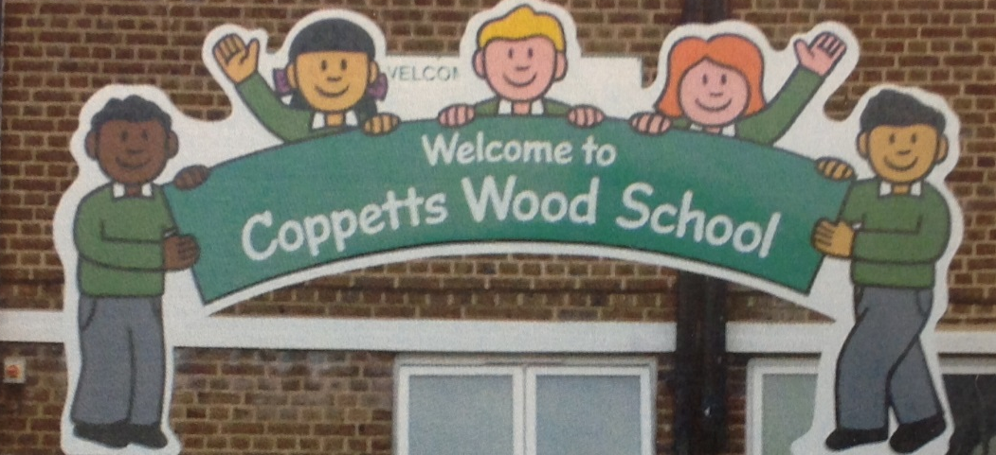

‘It is a place that feels like home. ’ Year 6 pupil

February 2023

Dear Candidate,

Thank you for taking the time to consider applying for the role of Headteacher at Coppetts Wood Primary School and Children’s Centre.

We are very proud of our school and its well earned reputation for diversity, inclusion and a creative approach to learning. The school was rated as outstanding by Ofsted in our last inspection. Our staff team have worked hard to build on that success and we are now looking for an outstanding leader to help us deliver the next stage of development.

If you have a passion for teaching and learning and a track record for building and leading teams who can deliver a great learning experience for children from a diverse range of backgrounds, then we would love to hear from you.

Pay us a visit and see for yourself what makes Coppetts Wood special. You will find children who are enthusiastic about learning, together with a committed staff team and governing body who are focused on the continued development and improvement of the School.

We look forward to receiving your application.

Yours sincerely,

Anna Kendall

Chair of Governors

HEADTEACHER JOB DESCRIPTION
Based on the National Professional Standards for Headteachers

The Headteacher will provide professional leadership for the school and children’s centre to secure its success and improvement. By working with the governing body, motivating and supporting all staff and managing the day-to-day operation of the school, s/he will ensure that all our pupils benefit from high quality education and achieve high standards.

The Headteacher will be responsible for:
....

A Shaping the future.
S/he will:

Ensure the vision for the school and children’s centre is clearly articulated, shared, understood and acted upon effectively by all

Work within the school community to translate the vision into agreed objectives and operational plans which will promote and sustain school improvement. Demonstrate the vision and values in everyday work and practice.
Motivate and work with others to create a shared culture and positive climate

Ensure creativity, innovation and the use of appropriate new technologies to achieve excellence

Ensure that strategic planning takes account of the diversity, values and experience of the school and community at large

B Leading learning and teaching
S/he will :

Ensure a consistent and continuous school-wide focus on pupils’ achievement, using data and benchmarks to monitor progress in every child’s learning
Ensure that learning is at the centre of strategic planning and resource management

Establish creative, responsive and effective approaches to learning and teaching
Ensure a culture and ethos of challenge and support where all pupils can achieve success and become engaged in their own learning
Demonstrate and articulate high expectations and set stretching targets for the whole school community

Implement strategies which ensure high standards of behaviour and attendance
Determine, organise and implement a diverse, flexible curriculum and implement an effective assessment framework

Take a strategic role in the development of new and emerging technologies to enhance and extend the learning experience of pupils

Monitor, evaluate and review classroom practice and promote improvement strategies
- Challenge underperformance at all levels and ensure effective corrective action and follow–up

C Developing self and working with others
S/he will :
- Treat people fairly, equitably and with dignity and respect to create and maintain a positive school culture

Build a collaborative learning culture within the school and actively engage with other schools to build effective learning communities

Develop and maintain effective strategies and procedures for staff induction, professional development and performance review

Ensure effective planning, allocation, support and evaluation of work undertaken by teams and individuals, ensuring clear delegation of tasks and devolution of responsibilities
- Acknowledge the responsibilities and celebrate the achievement of individuals and teams

- Develop and maintain a culture of high expectations for self and for others and take appropriate action when performance is unsatisfactory
- Regularly review own practice, set personal targets and take responsibility for own personal development
- Manage own workload and that of others to achieve an appropriate work/life balance
D Managing the organisation

S/he will :
Create an organisational structure which reflects the school’s values and enables the management systems, structures and processes to work effectively in line with legal requirements

Produce and implement clear evidence-based improvement plans and policies for the development of the school and its facilities

Ensure that, within an autonomous culture, policies and practices take account of national and local circumstances, policies and initiatives

Manage the school’s financial and human resources effectively and efficiently to achieve the school’s educational goals and priorities

Recruit, retain and deploy staff appropriately and manage their workload to achieve the vision and goals of the school
Implement successful performance management processes with all staff Manage and organise the school environment efficiently and effectively to ensure that it meets the needs of the curriculum and health and safety regulations
Ensure that the range, quality and use of all available resources is monitored, evaluated and reviewed to improve the quality of education for all pupils and provide value for money
Use and integrate a range of technologies effectively and efficiently to manage the school
Work with Governors to manage the implementation of the pay policy

E Securing accountability
S/he will :
Fulfil commitment arising from contractual accountability to the governing body
Develop a school ethos which enables everyone to work collaboratively, share knowledge and understanding, celebrate success and accept responsibility for outcomes

Ensure individual staff accountabilities are clearly defined, understood and agreed and are subject to rigorous review and evaluation

Work with the governing body (providing information, objective advice and support) to enable it to meet its responsibilities
Develop and present a coherent, understandable and accurate account of the school’s performance to a range of audiences including governors, parents
Reflect on personal contribution to school achievement and take account of feedback from others
F Strengthening Community
S/he will :
Build a school culture and curriculum which takes account of the richness and diversity of the school’s communities

Create and promote positive strategies for challenging racial and other prejudice and dealing with racial harassment

Ensure learning experiences for pupils are linked into and integrated with the wider community
Ensure a range of community-based learning experiences

Collaborate with other agencies in providing for the academic, spiritual, moral, social, emotional and cultural well-being of pupils and their families

Create and maintain an effective partnership with parents and carers to support and improve pupils’ achievement and personal development

Seek opportunities to invite parents and carers, community figures, businesses or other organisations into the school to enhance and enrich the school and its value to the wider community

Contribute to the development of the education system by, for example, sharing effective practice, working in partnership with other schools and promoting innovative initiatives
Cooperate and work with relevant agencies to protect children

HEAD TEACHER PERSON SPECIFICATION
The criteria below will form the basis for the short-listing and interview process, and candidates are requested to respond accordingly.
Qualifications |  | Essential/  Desirable | How this will  be assessed
1. | Educated to degree level or equivalent | Essential | A
2. | UK Qualified Teacher Status | Essential | A
3. | National Professional Qualification for Headteachers | Desirable | A
 | (NPQH) if not already a Head Teacher*
4. | A record of recent professional development that | Essential | A
 | prepares for this post.
Experience
1. | A track record of substantial and successful leadership | Essential | R
 | and management experience at a senior level.
2. | Substantial and proven successful primary teaching | Essential | R
 | experience
3. | Experience in more than one appropriate key stage | Desirable | A
4. | Experience of monitoring and evaluating performance | Essential | A
 | and practice
5. | Experience of coaching, guiding and mentoring | Essential | A
 | individuals and teams
6. | Experience of innovation and leadership and | Essential | A
 | management of organisational change/improvement
7. | Experience of developing and implementing initiatives | Essential | A
 | which have had a positive impact on Equality Diversity
 | and Inclusion
8. | Experience of managing a budget | Essential | A
9. | Experience of managing and/or working with a | Desirable | A
 | Children’s Centre
10. Experience of working with children who have SEN or EAL |  | Essential | A

 | Professional Knowledge
 | 1. |  | Extensive knowledge and experience of primary | Essential | A
 |  |  | education and the issues and challenges facing the sector
2. |  | A sound understanding of how children learn, how teachers |  | Essential |  |  | I
 |  | can best teach, and how to raise standards through careful
 |  | monitoring and target setting.
3. |  | An understanding of strategies for increasing teachers’ |  | Essential |  |  | I
 |  | effectiveness, and securing school improvement.
4. |  | Knowledge of the statutory frameworks and good |  | Essential |  |  | I
 |  | practice for curriculum delivery and assessment
5. |  | High expectations of pupil behaviour and the effective |  | Essential |  |  | I
 |  | use of behaviour management strategies
Professional Skills
1. |  | The ability to take the role of leader, provide clear |  | Essential |  |  | I/R
 |  | direction, manage change and enthuse and motivate others
2. |  | Excellent analytical, problem solving, negotiating and |  | Essential |  |  | T
 |  | decision making skills
3. |  | The ability to communicate a clear vision for the School |  | Essential |  |  | T
 |  | and how it will develop over the next five years.
4. |  | The ability to create and implement a strategic school |  | Essential |  |  | T
 |  | improvement plan, based on effective self review
 |  | which identifies priorities and targets, ensuring that all
 |  | students are included, achieve high standards, and
 |  | make progress
5. |  | The ability to build effective relationships with a wide |  | Essential |  |  | R
 |  | variety of people – staff, learners, senior leaders
 |  | governors and other stakeholders
6. |  | The ability to motivate and enable all staff to carry out |  | Essential |  |  | R/I
 |  | their respective roles to the highest standard through
 |  | performance management and continuing professional
 |  | development.
7. |  | The ability to provide objective support and advice to |  | Essential |  |  | I
 |  | the Governing Body, to enable it to meet its responsibilities.
8. |  | The ability to ensure that parents and pupils are well- |  | Essential |  |  | I
 |  | informed about the curriculum, attainment and progress, and
 |  | about the contribution they can make to achieving the
 |  | School’s targets for improvement.
9. |  | The ability to prioritise, evaluate and manage financial |  | Essential |  |  | I
 |  | and human resources to achieve educational goals
10. Good communication skills, both written and oral |  |  |  | Essential |  |  | A/I

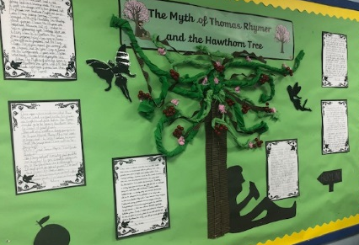
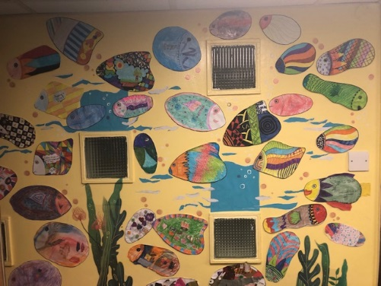
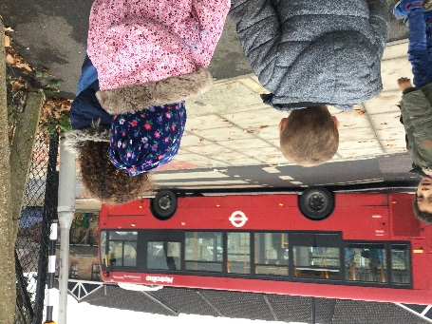

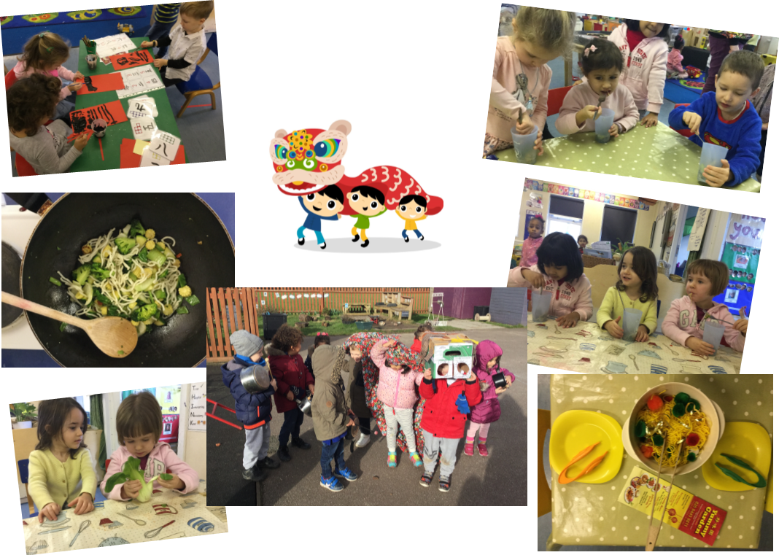
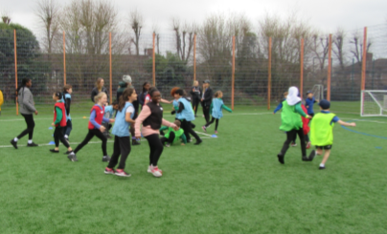

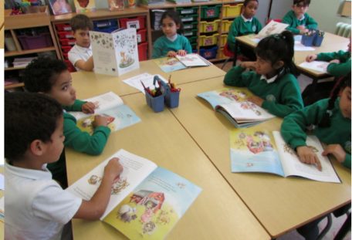

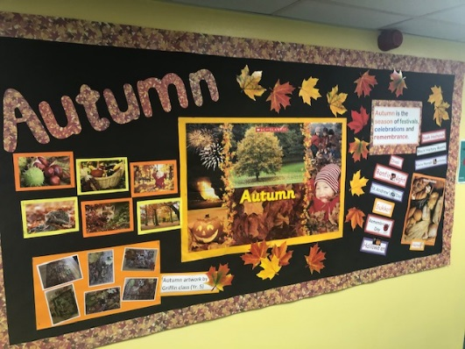
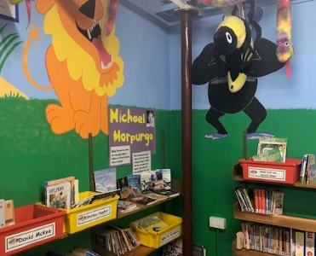
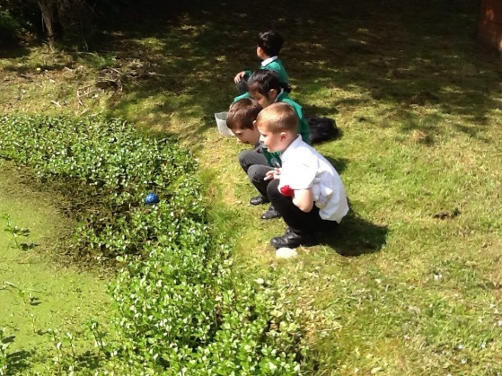

Information about the school
Coppetts Wood is a very friendly, calm, inclusive school located in a diverse and vibrant area of North London. Despite our central location, we have the most extensive and amazing school grounds including a wooded area, green fields and a range of play areas to be explored. We are a one form entry school with a nursery, pre nursery, Children's Centre and an additional resource provision (ARP) for pupils with autism as their primary need. Currently, there are approximately 277 pupils on roll. Our extended school provision is well attended with a breakfast club and out of school hours learning as well as an after school club run by an external provider.
Our children are encouraged to become confident learners and are motivated to achieve their full potential. We believe that our children have a right to an outstanding education that will prepare them for their next steps in education and for their life in the twenty-first century.
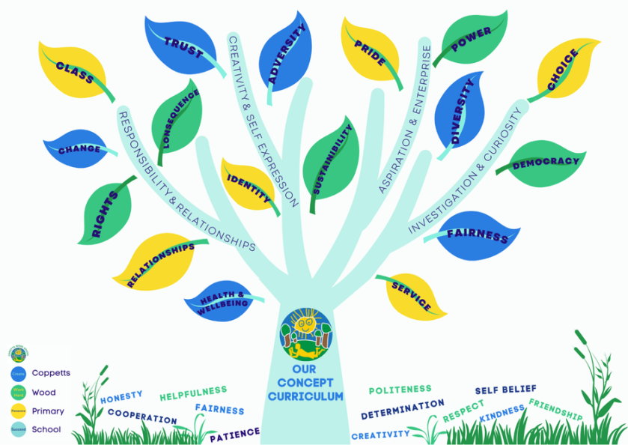
Enjoyment and achievement are at the core of this vision. Our dedicated, caring and hardworking staff team are committed to the school's vision and expectations are high and achievement and successes of all kinds are celebrated. Learning here is creative, stimulating and fun with plenty of challenge, collaboration and outdoor experiences. We hope that all our children enjoy their time at Coppetts Wood and leave with the skills and tools they need to become lifelong learners who are independent, responsible, respectful members of their community.
In our last Ofsted Inspection (September 2011), our school was judged as Outstanding. We have achieved the Inclusion Quality Mark for the second time, the Primary Games Mark (Gold), the Primary Science Quality Mark (Silver Level) and Gold for our Travel Plan!
Our curriculum is designed with and for our children. It is knowledge rich and concept driven; we believe that learning should be purposeful, memorable and apply subject-specific skills every single day. We want our children to be culturally literate and to have a wealth of rich learning experiences throughout their school journey. Ultimately, we want our children to leave Coppetts Wood equipped with the skills to deal with challenges of modern life and ready to fully embrace the diverse world around them.
‘My teachers have encouraged me to work hard and push myself harder. I have always been encouraged to persevere when I find something difficult. Thanks to my amazing teachers I have learnt to never give up’ Year 6 pupil

The curriculum at Coppetts Wood has, at its ‘roots’, in our school values which were chosen by our children. They are embedded in their behaviour every single day. Branching from this, we have our 4 key drivers that were chosen by our parents. These signify what they most want for their
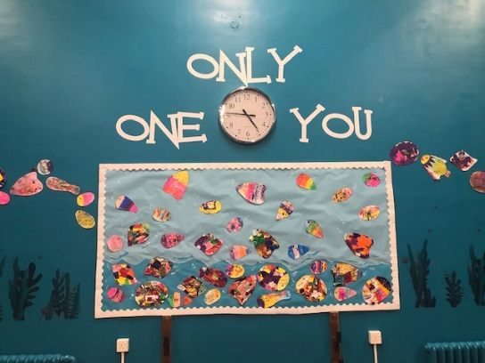
children by the end of their journey at Coppetts Wood. Finally, the leaves of our tree are the 20 core concepts that underpin our curriculum. These have been carefully chosen from the National Curriculum and are taught through a variety of interesting and exciting topics and themes. Our children are exposed to these again and again on their journey through school, from Nursery through to Year 6.

2022 SCHOOL DATA HEADLINES
 | 2022 National Average | School Teacher  Assessment Data 2022
Achieved a ‘Good Level of Development’ (GLD) at the end of the Early Years Foundation Stage | 65% | 61%  72%
Passed the Y1 Phonics Screening Check | 75% | 61%  72%
Passed the Phonics Screening Check in Y2 | TBC | 0%
Multiplication Timetable Check in Yr4 | TBC | Mean is 17.24 & Median is 19

Key Stage One SATs | 2022 National Average |  | School  Teacher Assessment Data 2022
Key Stage One SATs | At or Above the  Expected Standard | Above the  Expected Standard | At or Above the  Expected Standard | Above the  Expected Standard
Reading | 70% | 18% | 72% | 14%
Writing | 58% | 8% | 66% | 7%
Maths | 68% | 15% | 79% | 17%
Combined:  Reading, Writing & Maths | 53% | 6% | 55% | 3%

Key Stage Two SATs | 2022 National Average |  | Assessment Data 2022
Key Stage Two SATs | At or Above the  Expected Standard | Above the  Expected Standard | At or Above the  Expected Standard | Above the  Expected Standard
Reading | 74.5% | 28% | 79% | 29%
Writing | 69.5% | 13% | 59% | 9%
Spelling, Punctuation &  Grammar (SPaG) | TBC | TBC | 79% | 29%
Maths | 71% | 22.5% | 82% | 29%
Combined:  Reading, Writing &  Maths | 59% | 7% | 59% | 6%
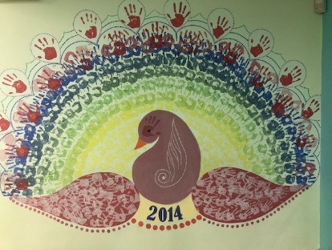
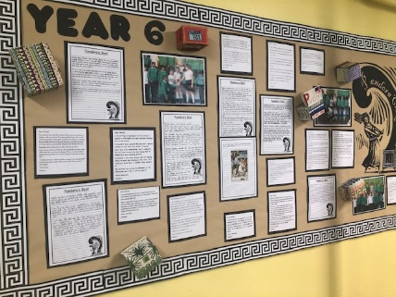
We strongly believe in providing a well-rounded educational experience for our children. We are committed to providing a broad curriculum and ensuring our children have a rich learning experience with access to opportunities they might not otherwise have. In planning our curriculum we recognise that our families come from a wide range of backgrounds - as a school, we have a high number of children entitled to pupil premium funding and who speak English as an additional language. We also have a high number of children with SEND including those placed in our Additional Resource Provision.
‘Coppetts has amazing and wonderful TAs and teachers here. They all have made learning fun’ Year 6 pupil
Our curriculum aims to help children develop their understanding, skills and knowledge as well as providing opportunities to make the children’s learning vivid, real and exciting and to develop vocabulary and creativity. Teachers plan trips or invite visitors into school to bring class work to life. Examples of places we visit are: the British Museum, the Postal Museum, The Arts Depot Theatre. We also have themed events/weeks where classes come off timetable and focus either for a day/two days or even a week. Examples of this include: International Week, Healthy Living Week, Anti-bullying Week, Online Safety Week, etc.
Our school finances are rigorously managed. Although the school faces financial pressures and uncertainty, we are in a better position than many schools moving forward.

KEY INFORMATION
99% of our parents who completed our questionnaire said their child was happy at our school.
100% said they would recommend the school to other families.
Pupils on roll | 277
Pupil Premium | 30%
SEN | 31%
EHCP | 14.6%
EAL | 44%
Awards include | Inclusion Quality Mark
Awards include | Primary Games Mark - Gold
Awards include | Heathy Schools London - Silver
Awards include | Primary Science Quality Mark - Silver
Awards include | Travel plan - Gold
Our website | www.coppettswoodprimary.org.uk

On our website you will find much more information including our policies, staffing structure, governing body and performance tables.
‘Coppetts Wood is the best school ever’ (Year 6 pupil)
- we hope you will want to join us and keep us being the best school!

