


Residential Houseparent
Candidate Information Brochure

ABOUT DLD COLLEGE LONDON

DLD College London is a unique 21st century 14-19 co-ed boarding and day school, situated on the Southbank opposite the Palace of Westminster, and is one of the most modern and well-equipped schools in the UK. London is our classroom and the boarders, who come from over fifty different nationalities, have the chance to access and learn not only in the outstanding classrooms, but also by visiting the world class museums, galleries, theatres, and entertainment opportunities available in one of the most exciting cities in the world.
Winner of the 2021 BSA Award for mental health and wellbeing, as well as the 2020 Independent School of the Year (Special Judge’s Award), Independent Boarding School of the Year and the ISA Award for Innovation in Student Voice, DLD College is an innovative, internationally minded school focused on ‘Developing the next generation of Leaders to take their place in a challenging and Diverse world.’ We strive for our students to become confident, independent, resilient, and successful, enabling them to access a wide range of degree courses at top universities. With fifteen floors of luxury en-suite rooms, our Central London school with boarding is all under one roof. Our team of boarding staff are focused on providing support for our diverse group of boarders. The boarders are organised into houses, each run by a dedicated, experienced Houseparent who oversees their wellbeing and boarding life. One of the areas of development in the coming years is to strengthen our ties between the boarding and academic sides of the school.
DLD College London, is a member of the Abbey DLD Group. The Abbey DLD Group is a network of three independent colleges, uniquely placed to offer students from the United Kingdom and around the world an education tailored to meet their requirements. The colleges have a long-standing reputation for delivering premium quality programmes, including GSCE, A Levels, IFP (International Foundation Programmes), BTEC and the Academic Preparation English Course.
All the colleges share a similar approach to learning: rigorous but supportive teaching, small class sizes, strong pastoral care. Abbey DLD’s expert staff have the interests of each student at the heart of everything they do.


THE ROLE

Requirement
The school is looking to invite candidates to apply for a Houseparent role in this unique and exciting central London day and boarding School. As a member of the Boarding Team, you will lead one of our boarding ‘houses’, looking after the welfare of students within boarding. This requires the postholder to:
- help maintain a boarding ethos and identity
- provide a presence in the boarding areas of the College
- support and embody the values of the College
- be available to support students reactively and proactively

Houseparents are expected to work in a collegiate way with other members of the pastoral team, including the Assistant Principal (Pastoral and Boarding), Housemaster/mistresses and other key staff to monitor the boarders, ensuring that they are maximising their potential and develop into caring, thoughtful, confident members of society. Ambitious and confident yet not arrogant, generous in spirit, interesting, interested, and able to respect and communicate effectively with people of all backgrounds.

The role includes some overnight duties, and as such, single person accommodation will be provided in the boarding house.
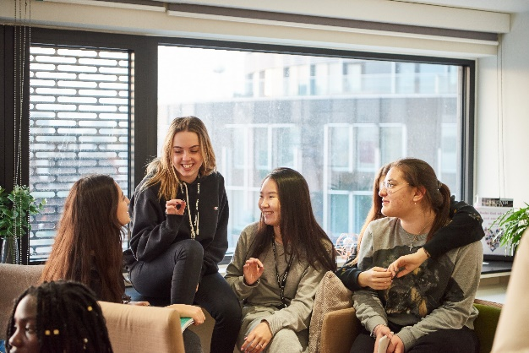

All staff are expected to be active in promoting the College’s aims and supporting an ethos that encourages achievement and high standards for all students.

DLD College London is committed to safeguarding and promoting the welfare of our students and Houseparents are expected to undergo advanced safeguarding (Child Protection) training.

Knowledge, skills, and traits

- Strong pastoral care
- The ability to keep calm under pressure
- Proven track record of working with young people.
- Excellent communication and IT skills
- Effective judgement and decision-making abilities
- Effective problem-solving skills
- First aid trained
- Calm and diplomatic
- Well-presented and professional attire
- Good health record
- Punctual time-keeper
- Flexibility and willingness to accept additional responsibilities
- Good interpersonal skills
- Team player, but also able to work autonomously
- Ability to use initiative
- Good English language written and verbal skills

Line management
Houseparents are line managed by the Director of Boarding.

Key qualities
- Experience of working within a boarding or residential environment
- Working knowledge of Child Protection (Safeguarding), the National Minimum Standards for Boarding and ISI regulations and guidelines
- Certified at the enhanced DBS level (check undertaken prior to employment)
- High quality written and verbal communication skills, including public speaking
- Strong organisational skills, including use of educational MIS
- Experience of effectively managing teams
Desirable
- Level 3 Safeguarding Trained
- BSA Accredited Boarding Practitioner Level 2
- BSA Advanced Certificate
- Undertaken Applied Suicide Intervention Skills Training (ASIST) training
- Mental Health First Aid Youth champion
- Experience or qualification in coaching
- Experience of working in a boarding school context
- Current First Aid certificate (Training to be provided)

General responsibilities
- To aim at providing “the gold standard experience” for all students
- To build and maintain positive and constructive relationships with students, in order to provide them with the best possible care and support.
- To play an active role in ensuring the students welfare and personal development, building and maintaining strong relationships with parents, guardians and agents
- To promote and safeguard the welfare of young people and young persons by adhering to and ensuring compliance with the School’s Safeguarding and Child Protection Policy at all times.
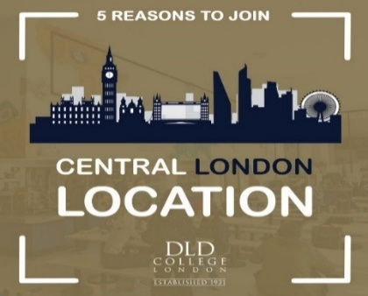

Role specific

- To actively promote the key values of the school: respect; tolerance and kindness
- To work collaboratively as part of the boarding team and the wider college body.
- To work according to the boarding house rota including a combination of days, weekends and nights as required.
- To implement college policies including those pertaining to Safeguarding (Child Protection) & behaviour.
- To ensure the highest standards of supervision, support and care for boarders.
- To work within and to apply the National Minimum Standards (NMS) for Boarding together with ISI guidance.
- Provide medical assistance for minor illnesses & first aid, maintain accurate medical records for students and liaise with the Nurse and local medical services where necessary
- Maintain student files to a high degree of accuracy including records of behaviour, sanctions, rewards, medical history, medical assistance given, etc.
- Record sanctions.
- Ensure the smooth running of daily service including laundry, cleaning, maintenance & catering
- Ensure that students are awake and leaving for lesson on time, report any illness or un/authorised attendance to college/personal tutor
- Ensure that students are in the boarding house and follow procedures if students are late/missing at curfew
- Supporting a culture of warmth, community & support within boarding

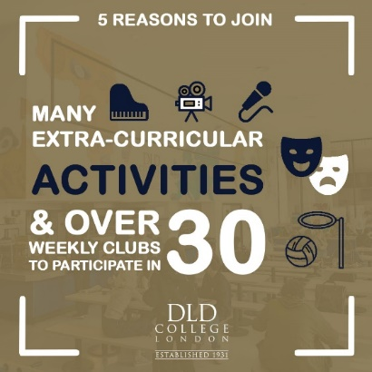

Benefits and duties

The school places great emphasis on the professional development of its entire staff. Staff at DLD College London enjoy a significant range of professional benefits. A comprehensive schedule of continuing professional development and INSET training, both internal and external, is provided for all staff. Access to complimentary Health Assured Assistance to support staff wellbeing and all meals are provided whilst on duty. An interest-free loan for a travel season ticket is offered to all staff on application to the Finance Manager. Children of staff are offered a reduction in school fees. Other benefits include:

- Competitive salary
- Single-bed studio in central London location
- Employee assistance programme
- Working in one of the most vibrant and exciting locations in the UK
- Group pension scheme
- Access to onsite gym and pool
- Eligible for Cycle-to-work scheme
- Access to Star Card employee benefits as a worker on the Southbank
Click here to find out more (starcardlondon.com)

Candidate Profile

The candidate will have strong personal skills and experience and a genuine interest to work with young people in an educational context. The ideal candidate will be a confident communicator, providing key dialogue between the School and Parents, Guardians & Agents.

They will have demonstrated continuing professional development throughout their career, particularly with aspects of academic management and pastoral care. Experience in coaching is desirable as is the ability to offer a sport and a variety of evening activities both on and offsite. The candidate will be required to accompany various trips throughout the year.

Most importantly they will possess the skills and ability to lead students in an inclusive and supportive manner, so that all can best fulfil the school’s values of respect, tolerance and kindness. It goes without saying, that the candidate will have excellent interpersonal and communication skills, and an ability to achieve high standards in delivering support to students from a wide variety of countries.


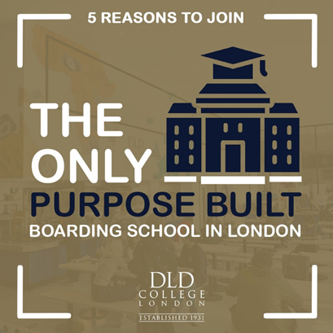


APPLICATION INFORMATION

Starting Date
September 2025.
Closing Date
The closing date for applications is Tuesday 5th May 2025. We reserve the right to interview candidates prior to this deadline. We therefore encourage early applications.
All candidates will be screened and shortlisted on the same criteria prior to the deadline.
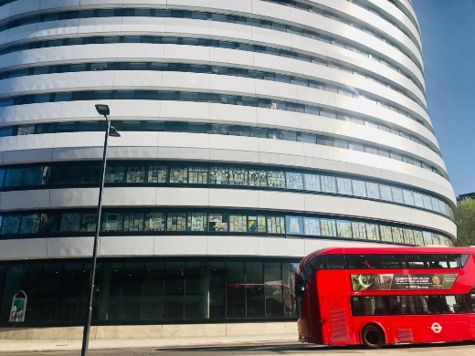

How to Apply
If you wish to apply for this exciting position, please click on our careers page link here and apply through the careers portal.
Further Information
Should you require any further assistance, please contact us by emailing: staffrecruitment@dld.org

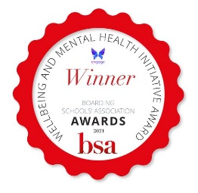
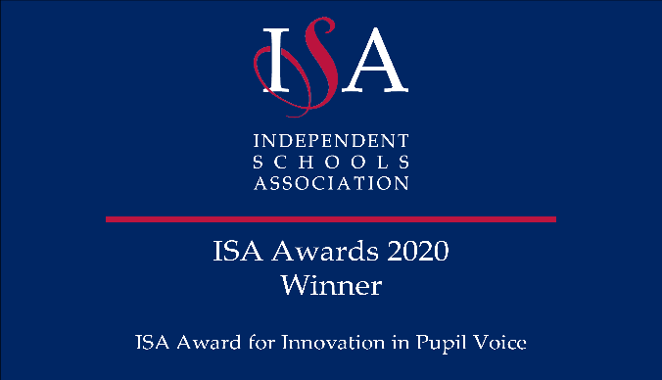
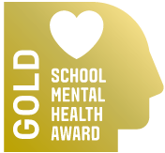
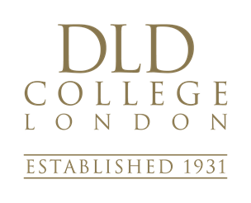


DLD College London


199 Westminster Bridge Road
London SE1 7FX
020 7935 8411
dld@dld.org

www.dldcollege.co.uk

