
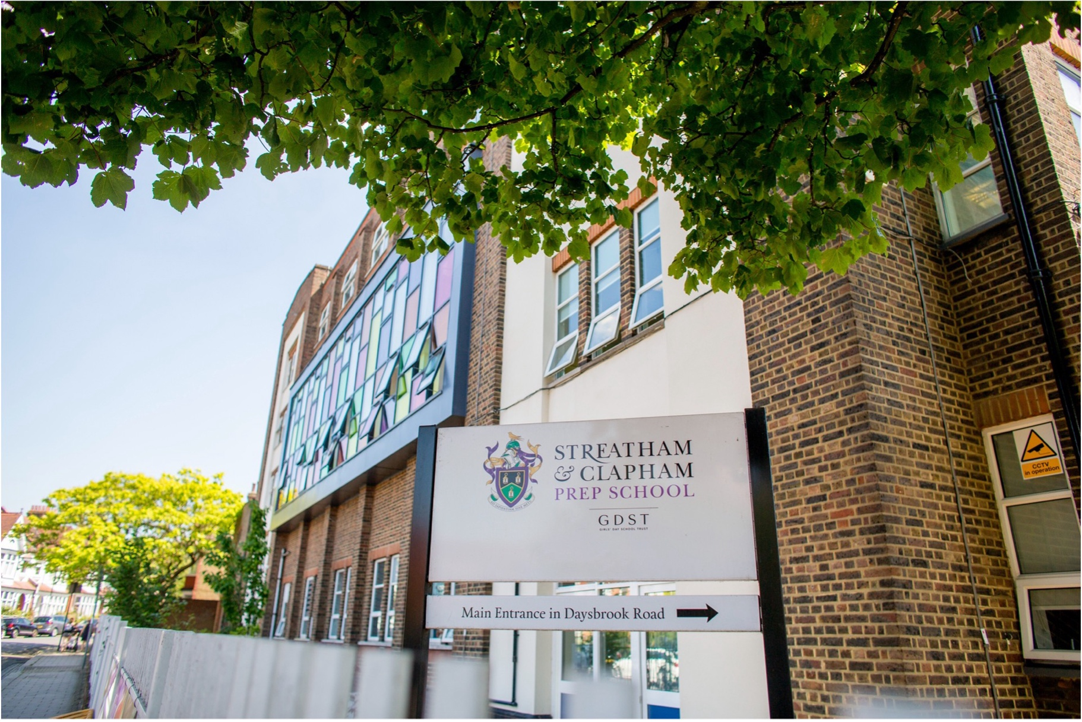
From September 2024
Job Application Information

Computing Teacher & Digital Lead (0.4 FTE – 2 days)
Contents
Executive Summary | 1 | Pastoral Care | 9
About Streatham & Clapham High School | 2 | Role Description | 10
Prep School (IAPS) | 4 | Person Specification | 15
Aims and Ethos | 5 | Terms of Employment and How to Apply | 16
Academic Life and Life Beyond the Classroom | 7
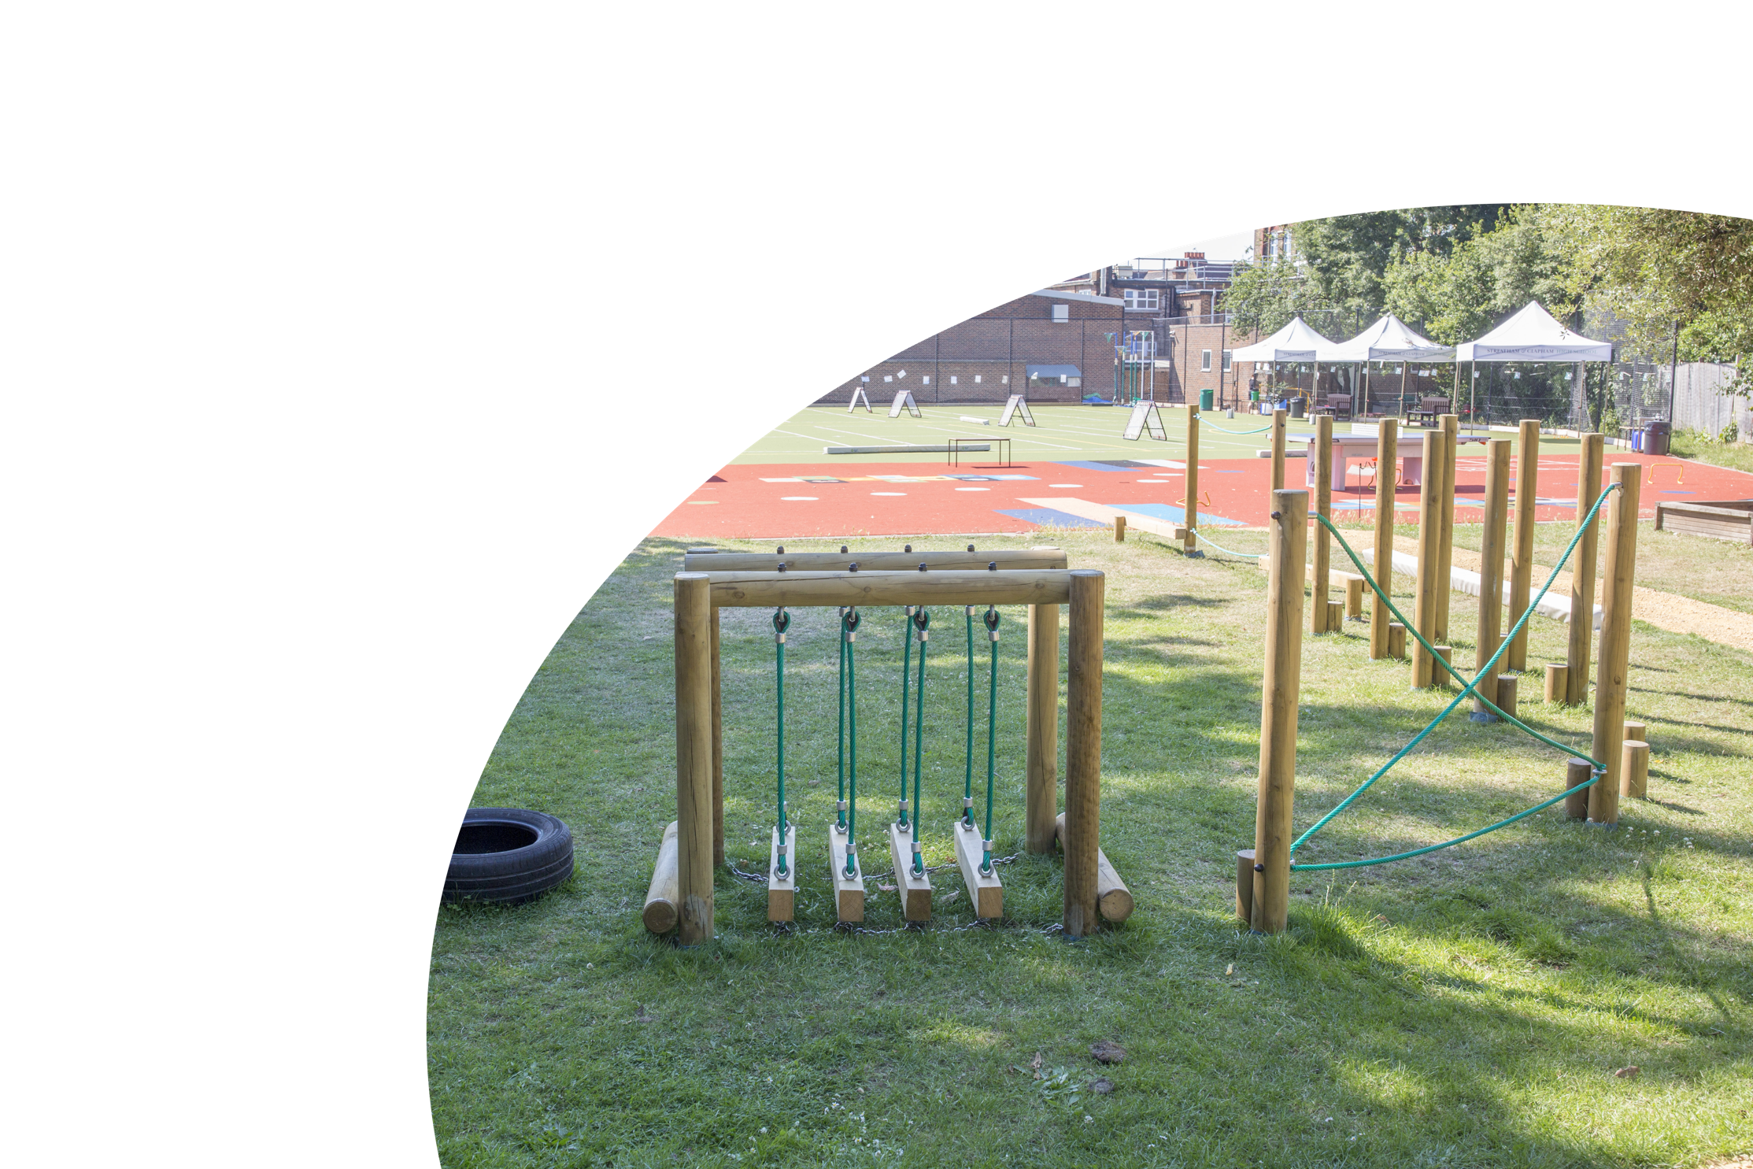
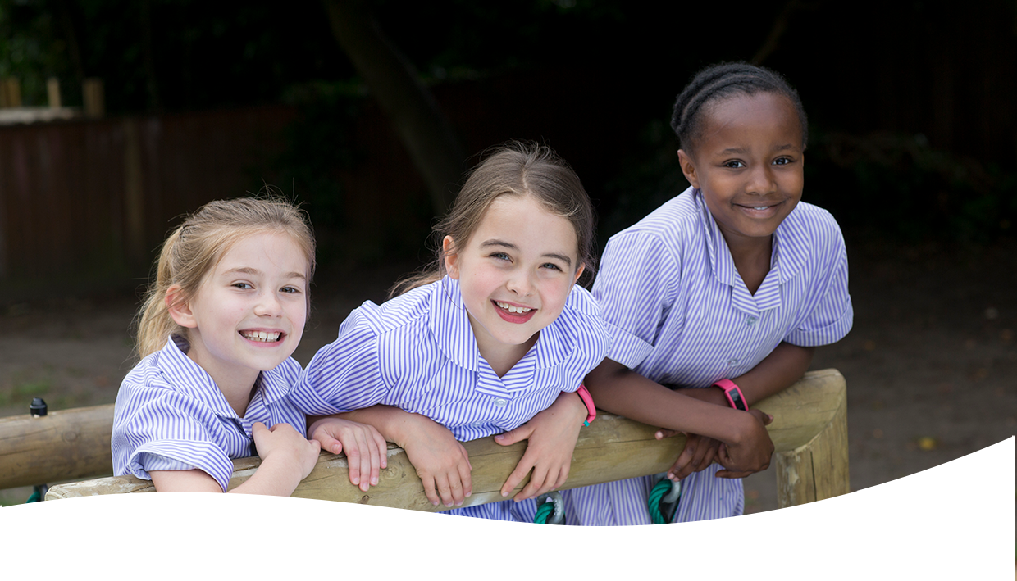
The successful candidate will be educated to degree level and have qualified teacher status. They will have experience of teaching in KS2 and be able to demonstrate a proven track record of raising expectations and standards. They will have a strong interest in primary computing, as well as an ability to coordinate and lead in this subject area. They will oversee the teaching of the KS2 computing curriculum. Additionally, the successful candidate will be responsible for the development and implementation of policies for the teaching of computing throughout the Prep School, in order to optimise pupil progress and the delivery of computing subjects. They will lead on our Digital Strategy, in partnership with the Leadership team.
Streatham & Clapham High School seeks to appoint a dynamic and innovative teacher to coordinate and lead the Computing teaching across the Prep School and to support and lead on the Digital Learning.

Executive Summary
The post commences in September 2024.

The post-holder is line managed by the Prep Deputy Head (Academic) and accountable to the Head of Prep.


Streatham & Clapham High School is an independent, academically selective school for girls aged 3–18. There are over 880 pupils on the roll across the Prep and Senior Schools.
We are one of the UK’s leading private girls’ schools, educating pupils from Nursery through to Sixth Form. Pupils prosper in a vibrant setting that provides challenge and width of opportunity. They thrive on account of the school’s family ethos, and they draw strength from the school’s rich social and cultural mix.

About Us
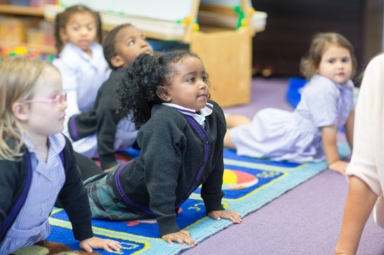
Girls aged 3-11 attend the Nursery and Prep School, located in spacious buildings with outstanding facilities in Streatham Hill. The Senior School inhabits a four-acre site focused on an imposing 1930s building in a delightfully tranquil and leafy oasis of south London.
The school is a distinguished historical foundation. It was founded, as Brixton High School, in 1887 by the Girls’ Public Day

School Trust as one of its earliest member schools.
We are proud of our heritage and founding principles of breadth, fearlessness, inclusiveness, and a focus on developing the individual to achieve her potential.
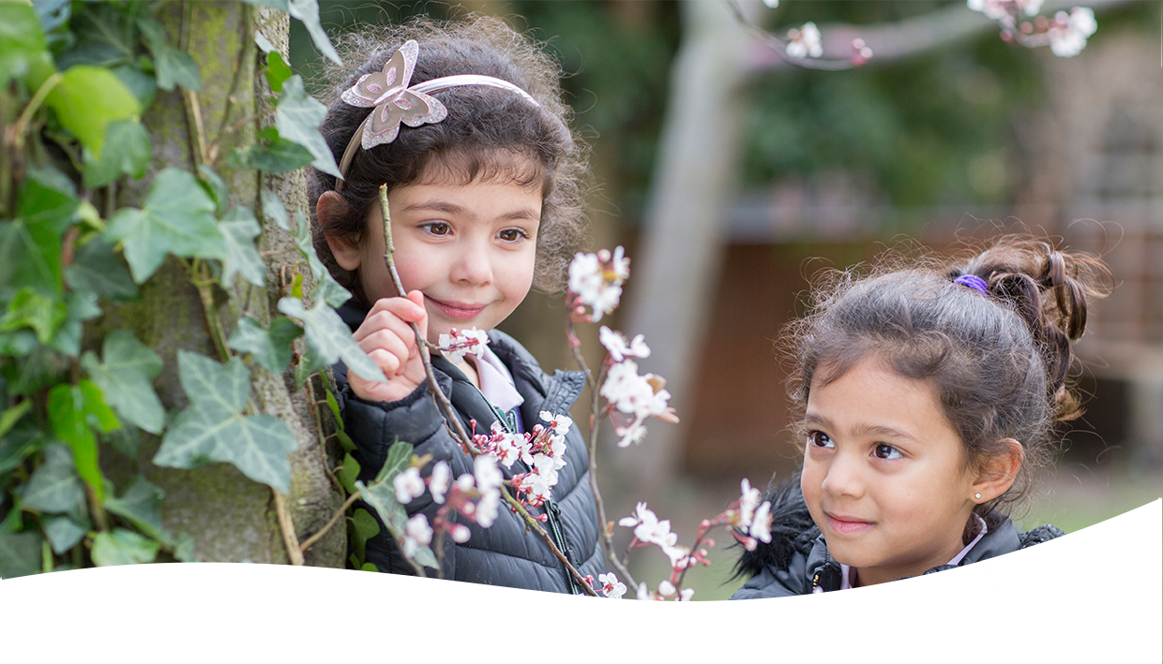
SCHS holds true to its Founders’ mission. At SCHS this means an exciting and challenging curriculum, a broad range of sporting, artistic, social, and cultural opportunities and an environment which is specifically created to inculcate the values of independent learning, responsibility for others and the enjoyment of challenge.
About Us continued
Pupil experience is at the heart of all that we do, and this is characterised by a culture that is warm, supportive, and positive. This helps build pupils confidence, self-fulfilment, resilience, and happiness.
This is underpinned by a rich diverse culture with generosity, opportunity, and social responsibility at its heart, combining a global outlook with a sense of local belonging.
The school has first-class facilities for learning, providing an environment that enables pupils to develop their interests and strengths both inside and outside the classroom. The school keeps up to date with new teaching methods and innovative techniques.
The School is part of the GDST, the leading network of independent girls’ schools in the UK, founded in 1872.
The school was successful in 2021 in its HMC application, and the Head of Prep is a member of IAPS.
For more information, please visit the school website.



The Prep School, offers an inspiring and challenging academic education for its pupils in a lively, vibrant, and supportive environment. The family ethos of Streatham & Clapham High School enables the staff to know, value and nurture each pupil as an individual.
Prep School (IAPS)
The school celebrates diversity and draws strength from its rich social and cultural mix. The aim is to create a safe, happy, and secure learning environment so that each child achieves her or his maximum potential in all aspects of school life and daily endeavour. When pupils move on, the School wants them to be confident, responsible global citizens with a love of learning and a desire to contribute positively to society.
The School’s priority is always for the individual child, and it seeks to encourage both academic and personal development through structured, meaningful, and enjoyable activities.
We are proudly inclusive of a range of academic abilities and judge success by development and progress. Our promise is that every girl will exceed beyond expectation.

The school’s pupils thrive in a family atmosphere where learning is fun; each day has exciting opportunities that encourage each pupil to develop her own strengths and nurture her extra- curricular interests. The academic ethos of the School is firmly underpinned by its strong and supportive pastoral care, which enables its pupils to feel secure in trying new activities and to understand that making mistakes is part of their learning journey. The principles of care, courtesy and respect are central to the School, and it is through these values that all members of the school community thrive.

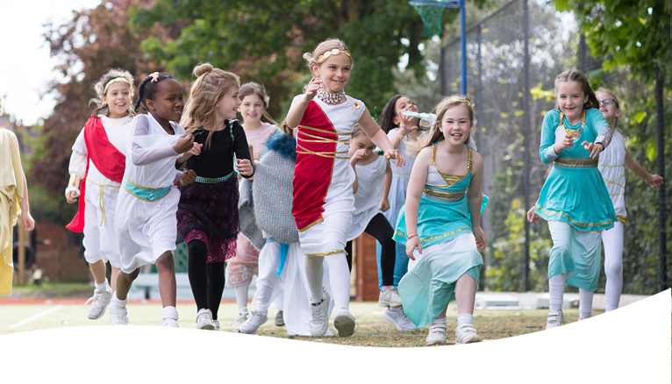
The school offers an inspiring, enlightened, and intellectually challenging education for its pupils in a lively, vibrant, and warmly supportive environment. Our family ethos School enables us to know, value and nurture each pupil as an individual. We celebrate diversity and draw strength from the school’s rich social and cultural mix.
Aims and Ethos
Our vision is to be unrivalled in empowering our girls to discover, nurture and project their unique identities and character.
This reflects the school’s belief that all members of the school community should be inspired to outperform expectations on a daily basis.
The pursuit of excellence is thus the school’s defining feature. It nurtures pupils to attain success across the widest spectrum of activity, extending far beyond the conventional ‘academic’ horizon.
The school’s pupils, whether they are very able or late developers, learn to navigate the landscape of the human spirit and achieve beyond the realms of expectation.
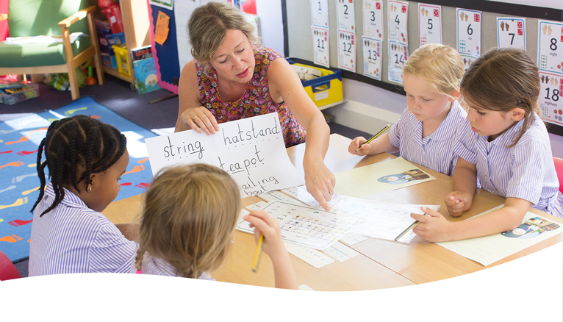
Aims and Ethos continued

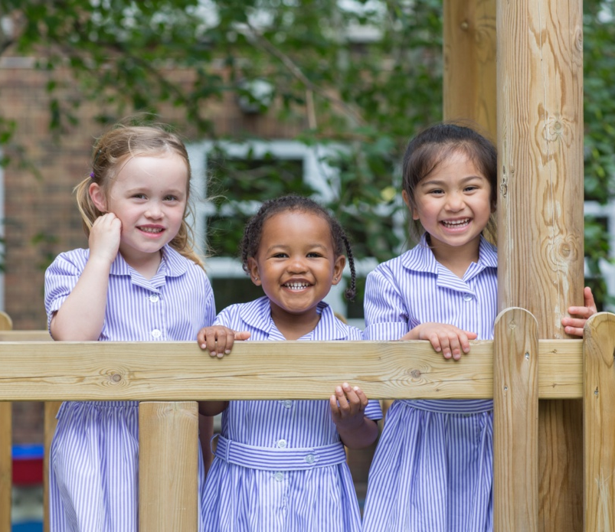
• We are pioneers in and the shapers of girls’ education
• Our curricular specialisation from an early age
• Our trailblazing and innovative approach, supercharging our girls with life skills enabling them to embrace and instigate change
• Our family, not factory, environment supporting individual families’ needs
• Our buzzy, diverse community, celebrating difference and drawing strength from all that is great about London
Our purpose is to enable every girl to achieve beyond the bound of expectation on a daily basis, across the spectrum of endeavour.
Academic Life and…
All children from Nursery to Year 6 benefit from specialist language, music, and PE lessons. Our curriculum is independent, engaging, and inspiring.
…life beyond the classroom

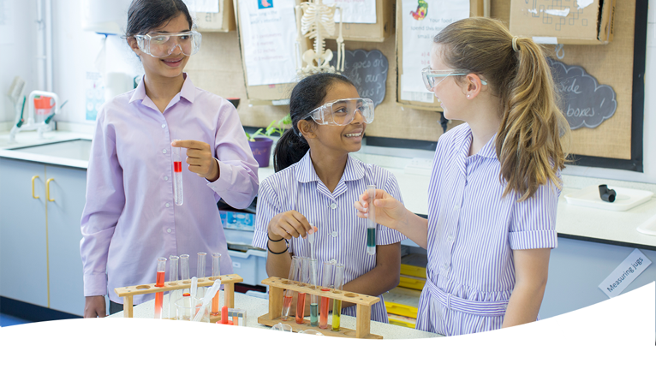
The Prep School aims to ensure that all learners benefit from a rich, broad, balanced curriculum presented in an interesting, exciting, and imaginative manner with opportunities for first-hand experience, practical work, investigation and learning through play.
Children are confronted with relevant experiences both inside and outside the classroom which provide opportunities to observe, investigate, experiment, and predict. A variety of technological, creative and aesthetic skills is also developed.
We have rigorous academic standards and focus on the core subjects of English,

Mathematics, Science and Computing. We also expand our girls’ minds by teaching specialist subjects such as Mandarin, coding, and philosophy with significant outdoor learning components.
All of the lessons on our Prep School curriculum are carefully crafted and presented in accordance with each girl’s learning styles. We personalise the learning experience of every girl so each can understand and articulate her own specific goals.



The Prep School has its own site and enjoys close links with the Senior School. Pupils benefit from outstanding facilities, far larger than one might expect in a primary school. These include a well-resourced library, full-sized Sports Hall, all-weather sports surface, excellent Science, Computing, Art and PE facilities, a newly developed Outdoor Learning Space, and a great deal of space, both inside and out. We have an extensive co-curricular programme made up of clubs and societies. These offer our girls a diverse range of activities to pursue their interests and inspiring further achievement beyond the classroom and range from the arts to quizzes, debates, and dance.
Being part of the GDST network and IAPS gives us a competitive opportunity to play with schools from across the country.
Our clubs and societies provide an ideal foundation for girls to develop a life-long love of learning for its own sake; a principle that lies at the heart of the ethos of both the Prep and Senior Schools.


Our pastoral care and personal development are of paramount importance and involve all children and adults who participate in the daily life of the school. We place strong emphasis on the creation of a supportive atmosphere, and we encourage our girls to strive to achieve their personal, social, and academic goals.
Pastoral Care
From the chef in the dining room to the PE teacher on the playing field, all of our staff know our girls. Each teacher offers his or her girls day-to-day support and communicates frequently with parents, through an informal chat at the end of the day or via email, a phone call, or a note in the girl’s diary.
We encourage our girls to take a ‘can do’ approach to their school lives and find that pastoral care encourages character-building. The girls become increasingly familiar with facing challenging situations with greater confidence when they apply the personal strategies they have been encouraged to adopt to their daily lives.
“Pupils are highly respectful of each other and exhibit qualities which reflect their concern for justice.”
ISI Report, 2019
On entry to the school, each girl is allocated to one of four Houses. This creates four, smaller ‘family’ units within the school community to which the girls develop a strong affinity.
Older girls play a responsible role whilst remaining accessible and familiar to other children. They are then better equipped to develop and foster relationships and to find the causes of conflict and seek appropriate responses.


Job Purpose
Role Description
To lead the computing teaching across the school, with a focus on KS2 and to provide direction and development for all digital learning within the Prep.

KEY TASKS AND RESPONSIBILITIES
Strategic Direction and Development of Digital Learning and Computing.
- Be responsible for the development, monitoring and implementation of policies for the teaching of computing throughout the Prep School, in order to optimise
  - Pupil progress and attainment
  - Staff understanding, skills and knowledge in the delivery of computing.
- Alongside the Senior School, develop and promote an accessible development plan for digital learning. Keep this under regular review to ensure that digital learning developments are aligned with the school’s changing needs and are appropriate to the full range of pupils’ needs.

Teaching & Learning
- To work closely with colleagues to undertake medium and short-term planning and the implementation of agreed schemes of work to ensure that the children experience a broad, balanced, relevant and stimulating curriculum.
- To ensure a close match between the learning experiences offered, and the individual needs of the children in the class, so as to give each child an opportunity to achieve to the maximum of her capability. To be flexible, creative

and adept at designing learning sequences within and across lessons.
- To build on the prior knowledge and attainment of those you teach in order that learners meet learning objectives and make sustained progress

- To make appropriate educational provision for children with additional educational needs and communicate with the SLN and pupil welfare leader when needed. Support staff and pupils to enable challenge for the most able and support for the less able.
- To design opportunities for learners to develop their ICT and thinking and learning skills appropriate to the phase and context in all areas of the curriculum.
- To promote the teaching of computing and Digital Learning throughout the school, according to the requirements of the school’s curriculum and any other new initiatives (as appropriate):
  - Develop/review existing schemes of work to ensure they are inclusive of current knowledge and best practice to develop the potential of all pupils.

  - Take responsibility for maintaining and evaluating all material resources with a system of easy accessibility. Consult colleagues and be responsible for ordering resources within an agreed budget in full consultation with the Head Teacher
Role Description continued
  - Offer support and advice to colleagues.
- Promote excellence and inspiration in learning and teaching by being a lead practitioner.
- Monitor, evaluate and review classroom practice; celebrate excellence; advise and update the Academic team on the progress of Computing delivery, including underperformance of pupils and staff.
Assessing Monitoring & Giving Feedback
- To assess children’s progress, maintain records and communicate and share written reports to parents and carers in accordance with school guidelines about children’s progress and attainment.
- Monitor and assess pupil progress in computing through a variety of strategies including the use of performance data, benchmarks, learning walks and lesson observations, and produce reports as required.
- Make effective use of performance benchmark data in for monitoring, evaluating and assessing aspects of the school’s work in the phase to ensure continuity, progression and the achievement of consistently high standards.
- Participate in the school’s monitoring and evaluation cycle, providing constructive feedback and targets in order to:
  - Raise standards across subjects
  - Develop individual skills to teach Computing effectively.
- Support and guide learners so that they can reflect on their learning and identify the progress they have made
- Mark work in accordance with the marking policy
Learning Environment
- To create a secure, happy and stimulating classroom environment, maintaining the highest standards of organisation and discipline
- To maintain a high standard of learning focused display both in the classroom and in other areas of the school
- To arrange for resources, equipment and materials to be available in such a way that they are properly cared for, easily accessible and will encourage the children to become more responsible for their own learning
- Identify and use opportunities to personalise and extend learning through out-of-school contexts where possible
- Promote learners’ self-control, independence and cooperation through developing their social, emotional and behavioural skills

Extra-curricular Activities
- Promote the extra-curricular activities programme through helping and attending events such as workshops and competitions as appropriate
- Participate in at least one extra-curricular activity each week
- Organise termly visits/visitors to widen children’s knowledge of topics and enrich the curriculum
- Carry out lunch and playtimes duties as necessary.

Team Working & Collaboration
- Work as a team member and identify opportunities for working with colleagues, managing their work where appropriate and sharing the development of effective practice with them
Culture
- Help create a strong school community, characterised by consistent, orderly behaviour and caring, respectful relationships
- Help develop a school culture and ethos that is utterly committed to achievement.
- To foster each child’s self-image and esteem and establish relationships which are based on mutual respect

Marketing & External Links, including Public Occasions
- Build effective partnerships with parents to ensure: a shared understanding between school and home about pupil progression, and how parents can support their child; an excellent local reputation for the school through the promotion, profile and success of the phase; extra-curricular activities that enrich the timetabled curriculum experiences
- Promote the reputation of the school through public occasions (parents’ meetings, open days, workshops, etc.)
- Develop links outside the school in order to increase opportunities for sharing good practice, learning opportunities for pupils, etc.)
Training & Development of Self & Others
- Regularly review own practice, set personal targets and take responsibility for own development
- Ensure that training needs of colleagues across the Prep are identified, appropriately met, and that
all members of the teaching staff are active in their own personal and continuous professional development
- Lead/co-ordinate/organise subject-related INSET initiatives to offer support, guidance, innovation and motivation to colleagues (as appropriate)

Management of Resources
- Ensure that appropriate, well-maintained resources are available for the teaching of Computing and identify future subject-related resource needs and aspirations for consideration in the school budget planning process.
- Liase with IT technical staff to ensure that digital infrastructure is well maintained and input into whole school digital development plan.
- Maintain a high standard of appearance in the Prep School Digital Hub.
- Co-ordinate the annual set-up of software passwords for pupils and ensure that appropriate links are available.
- Manage the Prep School Firefly content to ensure high standards and a consistent approach.
General Requirements
All school staff are requested to:
- Work towards and support the school vision and the current school objectives outlined in the School Development Plan.
- Contribute to the school’s programme of extra-curricular activities.
- Support and contribute to the school’s responsibility for safeguarding students.
- Work within the school’s health and safety policy to ensure a safe working environment for staff, students and visitors
- Work within the GDST’s Diversity Policy to promote equality of opportunity for all
- students and staff, both current and prospective.
- Maintain high professional standards of attendance, punctuality, appearance, conduct and positive, courteous relations with students, parents and colleagues.
- Engage actively in the performance review process.
- Adhere to policies as set out in the GDST Council Regulations, GDST Hub and GDST circulars.
- Undertake other reasonable duties related to the job purpose required from time to time.
- Show awareness of and comply with policies relating to child protection, confidentiality and data collection, reporting all concerns to a nominated person


Qualifications
Person Specification

Qualified to degree level or above
Qualified to teach in the UK
Qualified teacher status
Experience

Experience of teaching KS2
Experience of teaching Computing
Experience of raising the attainment of all pupils
Evidence of continually improving the teaching and learning in their subject area through schemes of work, assessment and extra-curricular activities etc
Some experience of leading INSET/supporting colleagues/professional development
Professional Knowledge & Understanding

An excellent understanding of curriculum and pedagogical issues relating to learning and teaching
An interest and strength in ICT
Familiarity with age appropriate assessments
Knowledge of current ICT teaching related developments
Good working knowledge of common ICT applications, with a clear understanding of, and enthusiasm for, the potential for ICT in enabling more innovative and effective approaches to learning and teaching.
Teaching & Learning

Excellent classroom practitioner
Effective and systematic behaviour management, with clear boundaries, sanctions, praise and reward
Good communication, planning and organisational skills
Resilience, motivation and commitment to driving up standards of achievement
Ability to be a role model to staff and pupils
Commitment to regular and on-going professional development and training to establish outstanding classroom practice
An interest or experience in using AI to support classroom teaching
Ability to create links across the whole school
Personal Qualities

A willingness to engage parents in order to encourage their close involvement in the education of their children
A flexible approach and a willingness to work as part of a team.
An openness and willingness to address and discuss relevant issues, allied with an ability to inspire and challenge others
A willingness and ability to contribute to whole school INSET
A willingness to share expertise, skills and knowledge and ability to encourage others to follow suit
Tact and diplomacy
A positive approach to change
Approachable and helpful attitude towards colleagues


Person Specification continued

Terms of Appointment &
How to Apply
The role will attract a competitive salary in line with qualifications and experience, and the successful candidate will also be entitled to an interest-free season ticket and computer loan, and free lunches during term time.

Any candidate wishing to seek additional information about the post or to discuss any related matter should contact the HR, Compliance & Recruitment Manager, Mrs Angela Bolton via email a.bolton@schs.gdst.net. Applications should be received no later than noon on Friday 19th April and candidates should use the following link:
https://my.corehr.com/pls/gdstrecruit/erq_jobspec_version_4.jobspec?p_id=035028
Interviews
Interviews will take place during the week 22nd April though the school reserves the right to appoint an exceptional candidate at any stage of the application process.
All candidates invited to interview must bring original documents confirming any educational and professional qualifications that are necessary or relevant for the post (e.g. the original certificates). Photocopies or certified copies are not sufficient.
If original certificates are not available for the successful candidate, written confirmation of the relevant qualifications must be obtained from the awarding body. All candidates invited to interview must also bring with them:

- An original passport and/or other appropriate document proving your eligibility to work in the UK
- One other form of identification, such as a driving licence or birth certificate;
- Two other documents, such as utilities bills, TV licence, bank, building society or credit-card statements confirming your current address.
- Documents confirming your educational and professional qualifications.
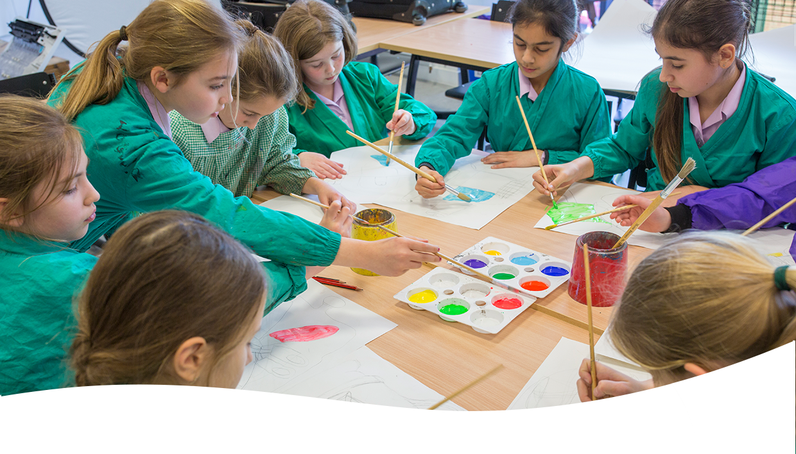
- Please note that candidates must bring originals of the above documents. Photocopies or certified copies are not acceptable
Terms of Appointment &
How to Apply Continued
Appointment
Any offer to a successful candidate will be conditional upon:
- Receipt of at least two references, satisfactory to the school (if not already received), prior to appointment;
- Verification of identity and qualifications;
- A satisfactory DBS Disclosure at the enhanced level;
- Where the successful candidate has worked or been resident overseas in the previous five years, such checks and confirmations as the school may require in accordance with statutory guidance;
- (for teaching posts) Verification of medical fitness in accordance with DfES Circular 4/99 - Physical and Mental Fitness to Teach of Teachers and Entrants to Initial Teacher Training;
- Satisfactory completion of the probationary period and any other pre-employment checks as relevant such as an online search.

Senior School  42 Abbotswood Road  London, SW16 1AW  020 8677 8400  seniors@schs.gdst.net | Nursery & Prep School  Wavertree Road  London, SW2 3SR  020 8674 6912  prep@schs.gdst.net
https://schs.gdst.net

