Job Title: English Secondary Teacher

Hours: Full time role

In a world that has become exponentially reliant on technology, it is important that all young people
not only know how to consume technology but are given the knowledge, insight and the relevant skills to create their own technology. Livingstone Academy Bournemouth will be an Academy fit for the Digital Age in which we live.

Livingstone Academy Bournemouth (LAB) opens with Reception and Year 7 pupils in September 2021. It will be located in the Lansdowne area of Bournemouth in both new and refurbished buildings. The current plan is to open a small sixth form in 2022. Eventually LAB will have over 1,500 pupils.

Are you a teacher for the digital age?

As LAB grows to full capacity over the next few years we are looking to recruit professionals who have the mindset to deliver and model an education fit for this fast changing world. We will appoint teachers who are prepared and able to teach outside of their own subject, plan learning in teams and who are excited about being trained in computational thinking. Essentially LAB teachers and leaders need to be creative and flexible.

We have developed a curriculum, along with systems and structures, that will ensure LAB students get off to a great start next September. However, the curriculum will continue to evolve and develop over the coming years and we want our teachers to be fully involved in this process. Our aim is to fully prepare young people with the skills and knowledge required for personal success in this fast changing world, whilst at the same time achieving the highest possible qualifications. We believe both these aims are compatible, provided the educational we deliver is both challenging and engaging.

Teaching at LAB

What will it be like to teach at LAB? Here are some of the highlights:
- Teachers will act like a ‘CEO of the classroom’, in the words of Conrad Wolfram ’It’s not that teachers know necessarily how to do everything, but that they have experience of how to get it done (including getting help from others and know-how of problem-solving methodologies) and confidence that it can be done or understanding of when it’s not going to work. Diagnostic capability is also key.’
- Teachers will plan in small teams using the No Limits curriculum planning toolkit
- The aim is for all teacher planning to be conducted during the working week
- Marking will be in class on a regular basis and limited to a half-termly student assignment
- Teachers will mainly teach in one main phase, primary or secondary, although there will be some overlapping.
- Teachers will play their part in the continued evolution of a curriculum fit for this fast-changing world.
- Teachers will work alongside employees from companies, particularly those from digital technologies.
- In a growing school and Trust there will be career development opportunities.
- Woven through all aspects of the curriculum will be computational thinking and art (creativity).
- There will be regular staff CPD to continually update teacher skills.

The Curriculum at LAB

Livingstone Academy Bournemouth will fully embrace and further develop the ‘No Limits curriculum’ developed by Aspirations. The curriculum* developed is a unique combination of single discipline and trans discipline learning. It is designed to achieve high levels of attainment and progress in examinations, whilst at the same time meeting the needs of employers, both today and in the future, by developing essential future skills. The ‘No Limits Curriculum’ involves:

- Computational thinking development approaches
- School day, week, year structural ideas and systems
- Learning sessions (lessons) planning tools
- Actual planned trans discipline assignments
- Learning resources
- Teacher CPD (virtual and in person)
- The Aspirations Employability Diploma

The curriculum of Livingstone Academy Bournemouth also aims to reflect the local community and the particular needs of its pupils. The curriculum structure and aims are driven by:
- The Early Years curriculum requirements, and the National Curriculum in Key Stages 1, 2, 3 and 4.
- Trust wide KS2 and KS3 curriculum development, the ‘No Limits: Education for success in the 21st century’,
- The EBacc GCSE academic programme at KS4
- The Aspirations Employability Diploma (Aspirations ED.) programme at Post-16 level

The ‘No Limits Curriculum’ is designed to reflect the knowledge and skills, and the local social and employment context that students need in order to take advantage of opportunities, responsibilities and experiences of later life.

The aim is for young people to experience a very different type of education, centred on the development of knowledge and skills, delivered through a partnership between the school and local industries. There is a creative and innovative approach to teaching and learning in order to develop the range of skills that many employers consider are currently lacking in school leavers. These include the range of ‘future skills’ developed by Aspirations Academies over recent years. These are highlighted below.

The key features of the ‘No Limits Curriculum’ are:
- A relevant, engaging and applied curriculum - with a strong focus on literacy, numeracy, science, computing and creativity.
- The teaching of computational skills is delivered throughout the curriculum.
- The teaching of art is viewed as an important creative skill for future employment and all pupils will maintain an annual portfolio of Art work.
- Programming skills, the use of development software and Digital Literacy are also delivered through the broad and balanced curriculum.
- An entrepreneurial mindset.
- Creativity
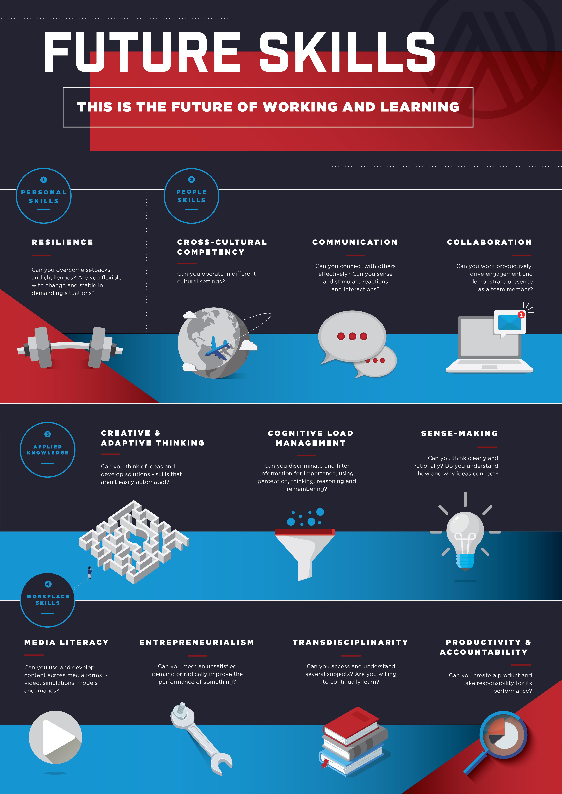
- Problem solving and Project Based Learning utilising contacts with the real world of creative and digital technologies.
- High quality teaching and learning - all teachers are expected to work towards being outstanding practitioners. Every teacher need to be trained in computational thinking.
- Planning in teacher teams is essential
- High standards, high expectations, high aspirations.
- Achievement - work towards high levels of achievement and go beyond expectations.
- Aspirations culture - the Aspirations three Guiding Principles and 8 Conditions would be alive in the culture.
- A range of teaching and learning styles used in school
- On-line learning blended with in school learning.
- Presentation and performance skills are highly valued.

The diagram below visually describes the outline of the curriculum. Students develop and apply knowledge to solve problems and deal with issues.

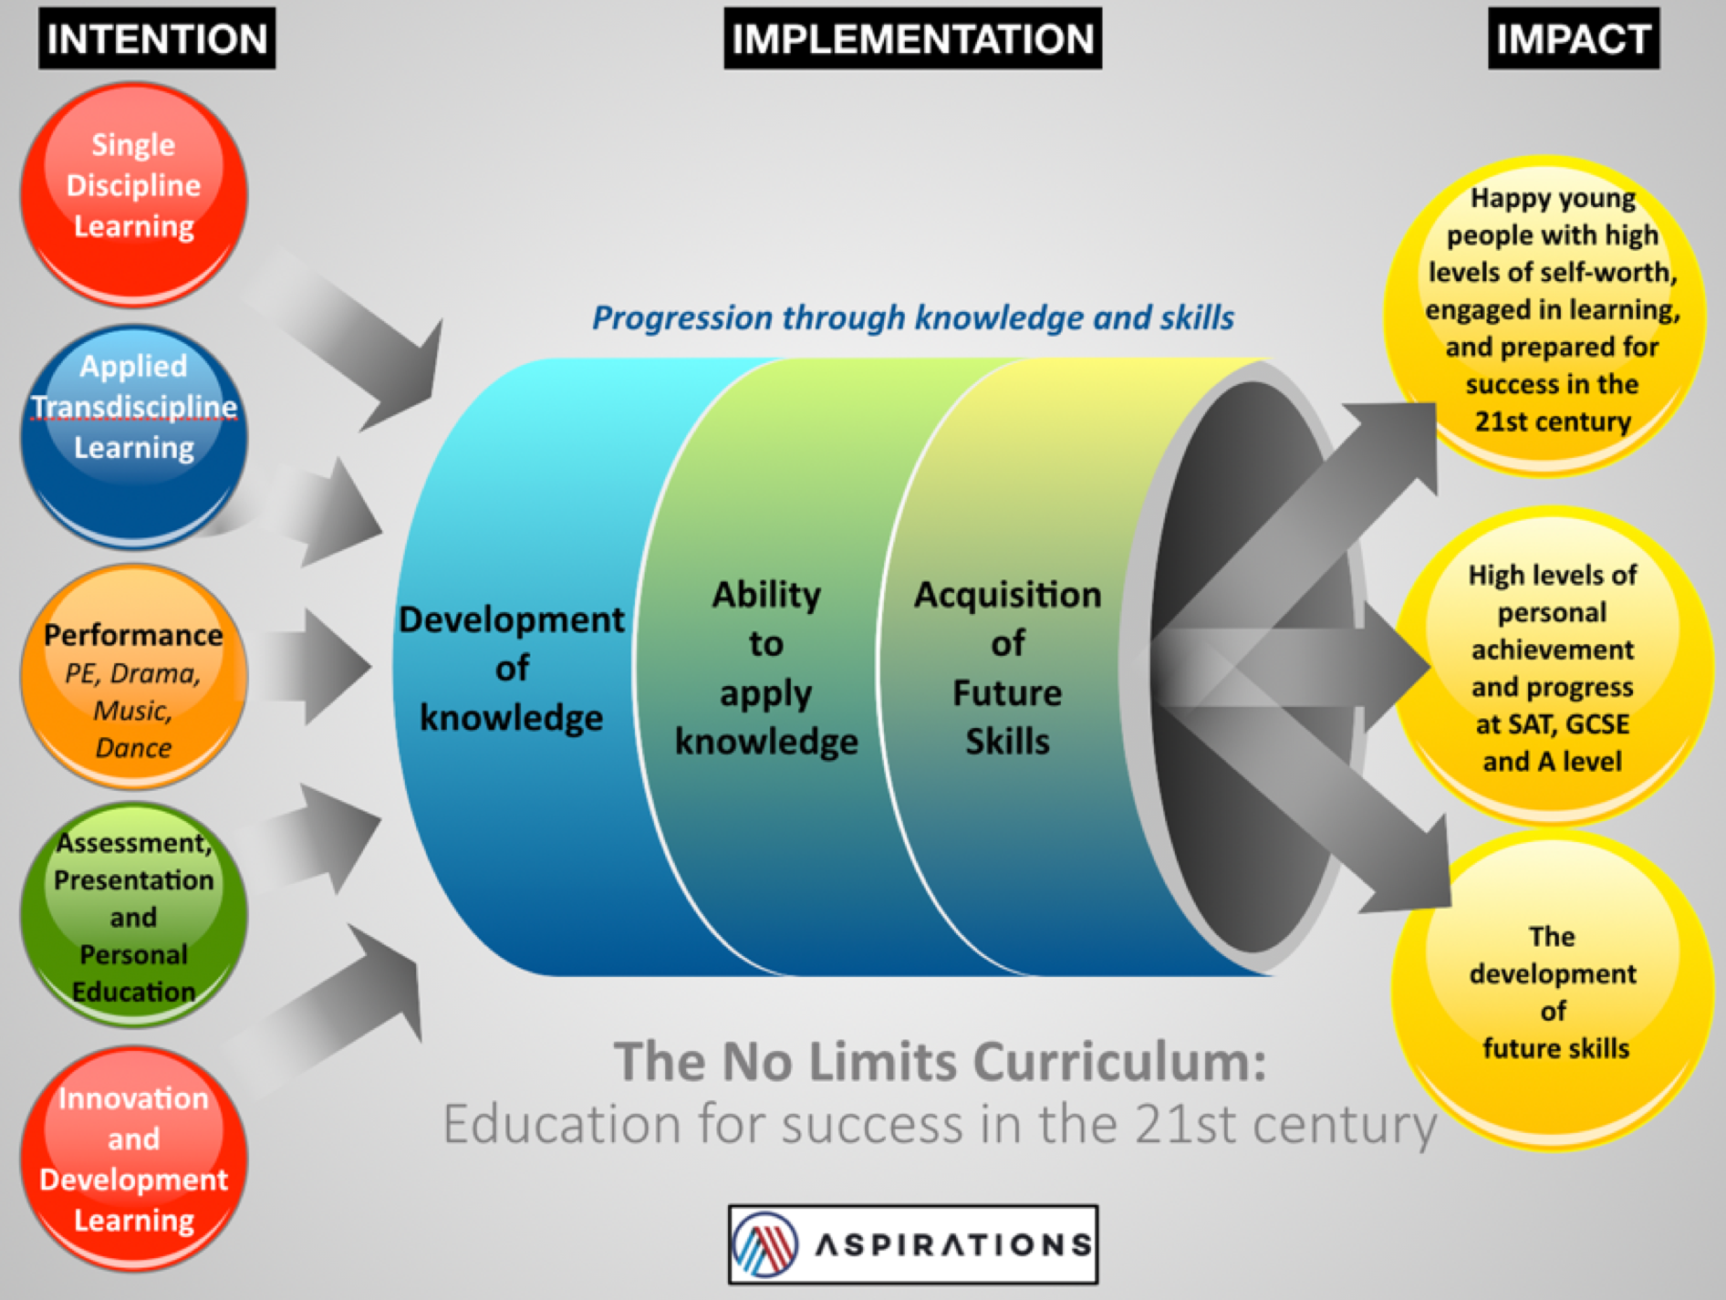

LAB critical thinking

Employers today require young people to be skilled critical thinkers. We believe there are two core elements to this:
- Logical technical thinking: Logical thinking is the process in which one uses reasoning consistently to come to a conclusion. Problems or situations that involve logical thinking call for structure, for relationships between facts, and for chains of reasoning that “make sense.”
- Creative thinking: Creative thinking is the ability to look at things differently, and find new ways of solving problems. Creative thinking skills are definitely not just for 'creative types' like artists and musicians. Everyone can benefit from creative thinking from time to time

To develop both these elements LAB will develop in all aspects of the curriculum two main areas:
- Computational thinking
- Art

The importance of computational thinking
Computational thinking allows us to take a complex problem, understand what the problem is and develop possible solutions. We can then present these solutions in a way that a computer, a human, or both, can understand.

Computational thinking includes many different skills. The list below shows some of the skills that can be categorised as computational thinking:
- Breaking a complex problem into smaller, more comprehensible steps
- Creative problem-solving
- Debugging
- Logical thinking
- Conditionals (if this, then that)
- Recognising patterns

Computational thinking is important. Through it students learn which sequence of steps is most efficient to solve a certain problem, how specific their instructions must be to reach a desired goal, and how to solve unexpected errors by efficient debugging and creative problem solving.

The mastering of the skill of computational thinking allows people to tackle more difficult problems, offering many opportunities for future technologies. Furthermore, computational thinking is not only useful for writing code, but also in many other aspects of life. Once people master the skill of breaking complex problems into smaller, more comprehensible steps, they can apply this in any other situation.

The importance of art
Art education teaches students to observe the world more closely. This process of observation and study helps students to more closely observe and analyse the world around them, developing skills that make up the bedrock of critical thinking. In all our year groups artistic skills will be taught through workshops, ATL assignments will involve the study of art, and all students will keep an annual portfolio of their art work from Year 1. At GCSE and A level all students, if they have the aptitude, will be encouraged to combine a maths GCSE and A level course with art GCSE and A level.

The ‘No Limits Curriculum’ problem solving process

Computational thinking and creative thinking are integral to our problem solving process, and, as a result, is built into all styles of learning in the ‘No Limits Curriculum’. The problem solving process is:
- Clarify the Driving Question (DQ). In relation to the DQ: What do students know? What do they need to know? Where or how can this new knowledge be found or learnt?
The use of the Driving Question
The Driving Question is central to effective learning. The DQ helps to initiate and focus the inquiry. This should be a focused action, and focused inquiry; the goal is to ensure the students are focused. The DQ also captures and communicates the purpose of the assignment in a succinct question. When reading the driving question, the teacher and student should be clear on what the overall assignment is as well as its purpose.

The opening assignment session or start of a lesson should be about clarifying the DQ. It is important to explore three knowledge based questions:
          - What do they know? What do the students already know about the DQ issues, their subject knowledge, etc?
          - What do they need to know? Based on what they already know, and this may vary amongst the students, what else do the students need to know in order to effectively respond to the DQ?
          - Where or how can this new knowledge be found or learnt? Where can the students find the additional knowledge they need?
- Define the problem: Students need to investigate the question:
      - Ask ‘why?’ in order to get to the heart of the problem
      - Do research to fill gaps
      - Differentiate fact from opinion
      - Specify underlying causes
      - Consult each faction involved for information
      - State the problem specifically
- Complete the Abstraction process: Once we have recognised patterns in our problem, we use abstraction to gather the general characteristics and to filter out of the details we do not need in order to solve our problem. This allows us to create a general idea of what the problem is and how to solve it. The process instructs us to remove all specific detail, and any patterns that will not help us solve our problem.
- Generate alternatives: Generate alternative solutions. Postpone the selection of one solution until several problem-solving alternatives have been proposed. The skills which help in discovering alternatives are holistic and logical thinking to comprehend the situation, as well as creative skills in generating the options which fit the situation. Knowledge of what is feasibly possible in the particular environment and the subject matter pertinent to the problem are important.
- Compute (evaluating and selecting alternatives): Solving problems is the core of computer science. Either:
  - If you have the relevant skills, use computers to help students solve the problem, by evaluating and selecting the best alternative. Programmers must first understand how a human solves a problem, then understand how to translate this "algorithm" into something a computer can do, and finally how to "write" the specific syntax (required by a computer) to get the job done. It is sometimes the case that a machine will solve a problem in a completely different way than a human.
  - Evaluate and select an alternative without using computers. Evaluate both proven and possible outcomes. State the selected alternative explicitly.
- Implementing the solution: Plan and implement the solution:
          - Commit to the chosen solution.
          - Accept responsibility for the decision.
          - Identify who will implement the solution.
          - Resolve to carry out the chosen solution.
          - Explore the best possible means of implementing the solution.

The ‘No Limits curriculum’ styles of learning
School leaders have a duty to prepare our young people for success in this world both today and tomorrow. In order to ensure the development of a curriculum that ensures a depth of knowledge, the application of knowledge and the development of future skills, the central feature of the ‘No Limits’ model is the development of a curriculum that fully embraces both single-discipline learning and Applied Trans-discipline Learning (ATL). Both have a place in the curriculum. We believe that students cannot successfully progress to inquiry-based methods without a strong foundation of knowledge, gained through teacher-directed learning.

The Applied Transdiscipline Learning (ATL) assignments are all centred on a problem or issue and relate to several different but related subject areas. Students work in teams to develop their skills and the outcome is a high-quality presentation. Each assignment last for several weeks and is accompanied by an informative poster:

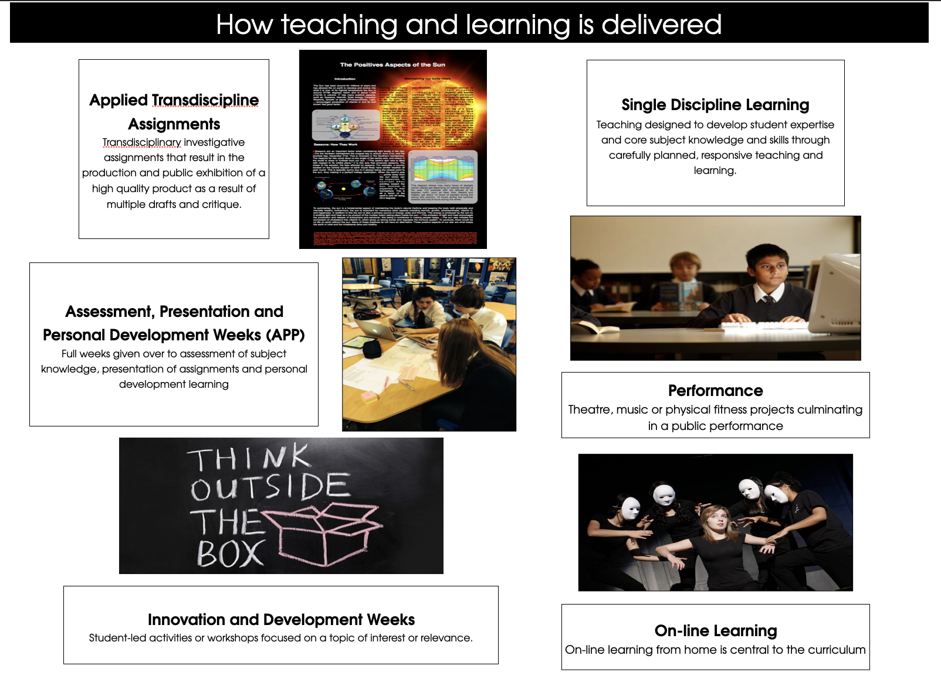
The ‘No limits curriculum’ is based on highly effective teacher planning in teams using the challenge and engagement toolkit and a range of planning materials. The teaching week is varied with several different approaches to learning, the use of on-line learning and specific APP weeks every six weeks. The styles of learning are highlighted here:
Early Years

The curriculum in the Early Years will fully comply with the EYFS requirements for Reception. The classrooms in Reception will be set out according to the 7 different areas of learning: Personal, Social and Emotional Development, Physical Development, Communication and Language, Literacy (Reading and Writing), Mathematics, Understanding the World and Expressive Arts and Design. We will take a topic based learning approach to enable students to find relevance in their learning; making it meaningful and purposeful. Students will be given the opportunity to choose the topics they would like to learn about linked to their current interests. Phonics will be taught using the Read Write Inc. scheme, supplemented with Letters and Sounds and Jolly Phonics. Pupils are taught set 1 and 2 sounds in the Early Years. They learn set 3 sounds (alternative versions of the long vowels) during Key Stage 1. The general approach to learning to be introduced in Reception will be through ‘Learn and Play’. This encourages creativity, decision–making and problem-solving as well as the softer skills such as team work. The teachers model the learning of phonics, numeracy, routines, etc., around this approach.

The curriculum for older students - The Aspirations Employability Diploma
At the ages of 16-18 all students will follow level 3 national qualifications plus the Aspirations Employability Diploma (AED).

What is the Aspirations Employability Diploma?
The Aspirations Employability Diploma is designed to help post 16 students prepare for employment and success in a fast-changing world. The award aims to train students to be work ready for the 21st century.

What is its purpose?
This is a totally unique programme as it involves students not only developing their individual future skills, but also working with employers on actual problems, enabling them to understand and experience the nature of work in the 21st century.

How does it work?
- The Aspirations Employability Diploma involves students working in teams of 4 or 5 alongside employees on live projects. In Year 12 students follow 4 projects (for 4 hours a week), each lasting six weeks.
- The projects mainly relate to employment in a wide range of industries including health and medicine, education, and engineering/technology.
- Students then prepare an individual VIVA - an oral presentation outlining their understanding of their skills and personal development - to present to a panel of employers.

What is the value of the Aspirations Employability Diploma?
- The diploma is validated by over 100 employer sectors in the UK. These employers all regard it as an excellent measure of individual employability and personal skills development and employment readiness.
- Following the VIVA students are awarded a bronze, silver, or gold diploma. In each academy one platinum award is made each year.
- Students use their diploma in employment or university applications.

The Trust

Aspirations Academies Trust operate 15 schools in the south of England ranging from primary through to post 16. Over recent years the trust has developed an exciting approach to education determined to provide young people with the tools to succeed in this fast-changing world: ‘No limits: Education for success in the 21st century’.

‘Our vision is for an authentic education for the 21st century for children from the age of 4 to 18. We want all students to achieve high levels of success in a broad range of examinations at a variety of ages, whilst at the same time equipping them with the knowledge and skills required to play an active and successful role in today’s highly competitive, fast-changing world’.

More Information
Further information on LAB can be found here:
https://www.livingstone-aspirations.org/

Further information on Aspirations can be found here:
https://www.aspirationsacademies.org/

What next?

We hope that you have found this information to be useful. We also hope that you can see yourself teaching at LAB. Please read on for the principal attributes and person specification for these posts and also details of the Trust’s safer recruitment procedures.
If you can see yourself in one of these exciting new roles, please complete and submit the application form specifying the particular role you are interested in and send to: jobs@aspirationsacademies.org
Also, as LAB will grow year on year, you may wish to express your interest in a teaching role for the future. Please do this by contacting: office@livingstone-aspirations.org

Principal Attributes and Person Specification:
Essential requirements are those, without which, the candidate would not be able to do the job. It is expected that the post holder will have the knowledge and qualifications indicated or equivalent qualifications and experience.

 | Essential | Evidenced through
Knowledge and Qualifications | Hold a good relevant degree or equivalent qualification.  Hold a recognised full teaching qualification (including the holding of qualifications of at least Level 2 in appropriate teaching subject and English).  Knowledge of curriculum developments related to the post. | Application/CV  Documentary Evidence  Interview
Skills | Ability to use recent developments to inform own and others practice.  Proficient in Microsoft Office applications (Word, Excel, PowerPoint, Internet and email) and in using student record information systems.  Good understanding of how children learn and how to raise standards of achievement.  Ability to interpret and act on a wide range of key data.  Sound organisational, time management and administrative skills. | Application/CV  Interview  References
Personal attributes | A passion for education and making a difference with demonstrable commitment to achieving the highest possible standards for all learners and a proven record of enabling learners to fulfil their potential.  Excellent interpersonal skills and the ability to communicate effectively, both orally and in writing, with all stakeholders demonstrating the ability to command respect from students, parents, colleagues’ governors and other members of the community. | Interview/references

Safer Recruitment Procedure
The Aspirations Academies Trust is committed to safeguarding and promoting the welfare of children and young people in its academies. In order to meet this responsibility, its academies follow a rigorous selection process to discourage and screen out unsuitable applicants. This process is outlined below, but can be provided in more detail if requested.
Disclosure
This post is classified as one that undertakes regulated activity, and appointment is subject to submission of an enhanced check undertaken by the Disclosure and Barring Service that is considered satisfactory by the Trust. Applicants are required, before appointment, to disclose any conviction, caution or final warnings that are not “protected” as defined by the Rehabilitation of Offenders Act 1974 (Exceptions) Order 1975 (as amended in 2013 by SI 2013 1198). Convictions that are defined in the legislation as “spent convictions” but not “protected” would need to be declared. Non-disclosure may lead to termination of employment. However, disclosure of a criminal background will not necessarily debar individuals from employment – this will depend upon a range of factors including the nature of the offence(s) and when they occurred.
Shortlisting
Only those candidates meeting the relevant criteria indicated in the person specification will be taken forward from application.
Interview
Those shortlisted will take part in an interview with questions relating to the job description and person specification and may also have to take part in a selection exercise such as a lesson observation.
Where necessary, candidates will be asked to address any discrepancies, anomalies or gaps in their application form.
Reference checking
At least two references will be requested, normally from the previous and current employers. These may be contacted before the interview and in all case before an offer of appointment is confirmed.

