Netball Coach (Maternity Cover)
Job Description

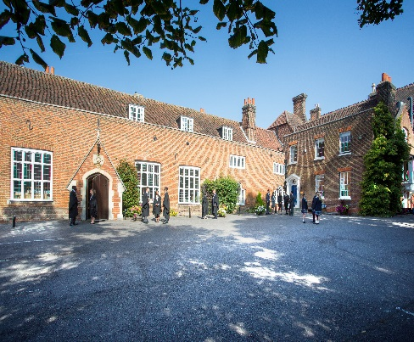

Introduction

An opportunity exists for an enthusiastic, qualified graduate to coach girls’ netball for a maternity cover and be part of a school that is not only highly successful academically but also in sport, music, and drama. The School offers excellent sport facilities and netball is main sport with a comprehensive and challenging inter-school fixture list throughout the autumn and spring terms. We aim to provide the opportunity for all to participate in netball in an enjoyable environment and the development of excellence in those who choose to pursue the sport to a higher level. This role is part time, term time only. The successful candidate will be required to attend sports fixtures and training on Saturdays during term time.
Background
Founded in 1629 by Samuel Harsnett, the son of a Colchester baker who went on to become Archbishop of York, Chigwell School stands on it original site with the original school building still in use. However, whilst Chigwell of today is conscious of its long-standing history, it is a forward-looking, ambitious, co-educational independent school of 930 pupils aged four to eighteen. It enjoys excellent facilities, a dedicated staff, bright and hardworking pupils, and a site of 100 acres.

Chigwell School is located in the picturesque village of Chigwell just over ten miles from central London and on the Central Line. The extensive, beautiful grounds are close to the edge of Epping Forest and it is rare for a school to have so much space and yet be so close to the centre of the Capital. Most pupils are day pupils but in the Sixth Form, there is a small community of international boarders, roughly thirty from sixteen countries, and these live in four small boarding houses.

As well as being an academic school, Chigwell has the reputation for providing a rich and full education, with plenty of opportunities for all pupils who are enthusiastic, co-operative and able. Chigwell is a caring and friendly school, with a close sense of community, not least between colleagues. As the 2015 Good Schools Guide reports: Academically, pupils are put through their paces but it all seems to be done in such a civilised and pleasant manner that you are more likely to hear pupils talk about opportunities and prospects than pressure and stress. “Anyone who wants to do well here, will do well” said one student, and I can’t think of a nicer place to succeed.”

The School Development Programme

Over recent years, the School’s facilities have been extensively developed in order to enhance the educational experience that pupils receive. The development programme has included the following additions:
- 2008 Wilson Building teaching block
- 2008 Floodlit AstroTurf pitch
- 2009 Junior School library extension
- 2010 Complete redevelopment of catering facilities
- 2010 Sixth Form coffee shop
- 2010 Harsnett’s and Church House converted into boys’ boarding houses
- 2012 The Old Chigwellian Club and land was incorporated into the school estate
- 2013 Pre Prep School built and opened
- 2013 Two new science labs created
- 2014 Drama Centre balcony extended to provide additional music and drama rehearsal space
- 2016 The Risham Sarao Sixth Form Centre was completed

Currently, the extension of the Dining Hall is underway and in the future the plan is to:
- Renovate the Chapel
- Develop the Sports Centre
- Expand our music facilities
- Further expand our provision of bursaries

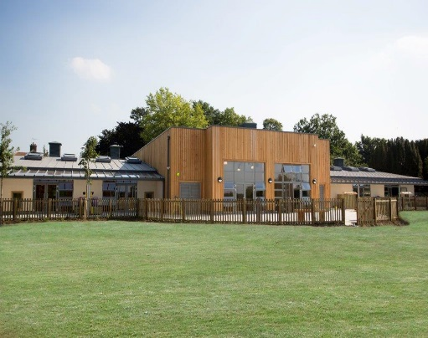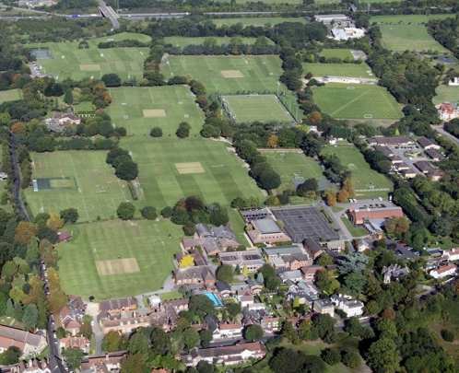

The School

Some pupils join in Reception and there are two classes in each of the three Pre Prep year groups. A small number of other children join the Junior School at 7+ (Year 3) and there are two or three classes in each of the KS2 year groups. At 11+ (Year 7), there is a further entry with four classes making up Years 7 to 11. Again, there is a small entry into the Sixth Form. Entry at each stage is selective and although there are three main sections to the School (Pre Prep, Junior School and Senior School) these sections work closely together and there is a common ethos running throughout.

There are over a hundred teachers and together with the support staff, there is a friendly, mutually-supportive atmosphere. All teaching staff contribute to the extra-curricular programme.

The Role
We are looking to recruit an experienced part time, term time Netball Coach to deliver high quality netball coaching sessions across the School.

Sports plays an important part in the life of the School. We aim to give all pupils the opportunity to play games in a positive, fun and safe environment where the pupils’ development is the main focus. We have excellent sports facilities. Netball has developed considerably over recent years at Chigwell and is a main sport in the Michaelmas and Lent term with a comprehensive and challenging inter-school fixture list. The School is very fortunate to have fantastic courts and is able to host up to 9 fixtures at one time. The teams play both independent and state schools, entering the local Redbridge league, IAPS tournaments, the Schools National competition and the Independent Netball Schools Cup. We have a number of pupils representing the Essex County Academy squad, leading to the Regional squad as part of the England Excel programme and pupils who have been selected to attend national screening England trials. The U16 and U14 girls have just returned from the Disney, Orlando Netball Tour, held at the ESPN area, with both teams finishing third in their respective age groups.

This is an exciting opportunity for an individual who wants to ensure that netball continues to be a major sport here and to capitalise on the success that has been achieved already.

Key responsibilities

- To help develop the playing of girls' netball at all levels and all abilities

- To liaise with the Head of Girls' Games/Netball as appropriate

- To develop a love of sport so that pupils may want to continue to participate after they leave school

- To coach to a high standard

- To instil high standards of behaviour when Chigwell pupils are playing the sport, here or away and to ensure they are dressed appropriately, both smartly, and safely

- To be aware of national recommendations with regard to netball

- To be willing to take fixtures on most Saturdays during the season

- To implement the School First Aid Policy

- Participate in training, other learning activities and be committed to ongoing professional development

- Attend staff meetings, assemblies and functions as appropriate.

- Be aware of and comply with policies and procedures relating to child protection, equal opportunities, health and safety, confidentiality and data protection

- Commitment to the protection and safe-guarding of children and young people

- Embody the aims and values of the School and support its ethos

- Carry out any other duties as may be reasonably required appropriate to the post

Employees must be aware of the responsibility placed on them under the Health & Safety at Work Act (1974) to ensure that agreed safety procedures are carried out to maintain a safe environment for employees, pupils and visitors.

This job description is not exhaustive and will be subject to periodic review. It may be amended to meet the changing needs of the School.

Person Specification

Requirement | Essential or Desirable?
Qualifications / Education / Training:  - Hold a current Netball Coaching Qualification- at least Level 1  - First Aid qualified | Essential  Desirable
Experience:  - Experience of coaching children in the 7—18 years age range  - Experience of working in a school environment  - Experience of monitoring an evaluating impact of sessions/programmes | Essential  Essential  Desirable
Skills  - Ability to develop and implement high quality, varied and creative coaching sessions focusing on an athlete-centred approach  - Ability to inspire, motivate and encourage young people through sport  - Ability to adapt sessions appropriately dependent on the need of young people | Essential  Essential  Essential
Personal Attributes:  - Dynamic in nature with a passion for teaching  - Excellent communication and interpersonal skills; the ability to communicate with people at all levels  - Excellent planning and organizational skills  - Self-motivated and able to use own initiative  - A willing and flexible approach to work  - Team player  - Commitment to equal opportunities | Essential  Essential  Essential  Essential  Essential  Essential  Essential

Salary: Competitive

Hours: This post is a maternity cover, part time during term time only. The hours of work will be 12.30pm to 5.30pm Monday to Friday with a requirement to attend sports fixtures and training on Saturdays during term time.

Benefits of working at Chigwell School include:

- A competitive salary  - Access to the School Pension Scheme  - Free lunch and refreshments during term time  - Childcare Vouchers  - Personal Accident Cover  - Employee Assistance Support Programme  - On site parking and cycle racks  - Use of School Library | - Medical Centre on site  - Free use of School’s sports facilities outside of the School day  - Commitment to professional development  - A supportive community of highly motivated students and staff  - A beautiful working environment- 100 acres site beautifully landscaped with a number of listed buildings

Applications

Applicants should complete the teaching staff application form which can be accessed directly from our website: www.chigwell-school.org (Vacancies) and sent to the Headmaster’s P.A.: hmpa@chigwell-school.org. The Headmaster, Mr Michael Punt, will be happy to answer any questions; he can be contacted at the School by telephone 020 8501 5701 or by e-mail to mpunt@chigwell-school.org

The closing date for this application is 16 October 2017

Chigwell is committed to safeguarding and promoting the welfare of children and young people and expects all staff and volunteers to share this commitment. Applicants must be willing to undergo child protection screening including checks with past employers, prohibition orders and enhanced DBS.

