Specialist Teaching Assistant

Candidate Briefing Pack
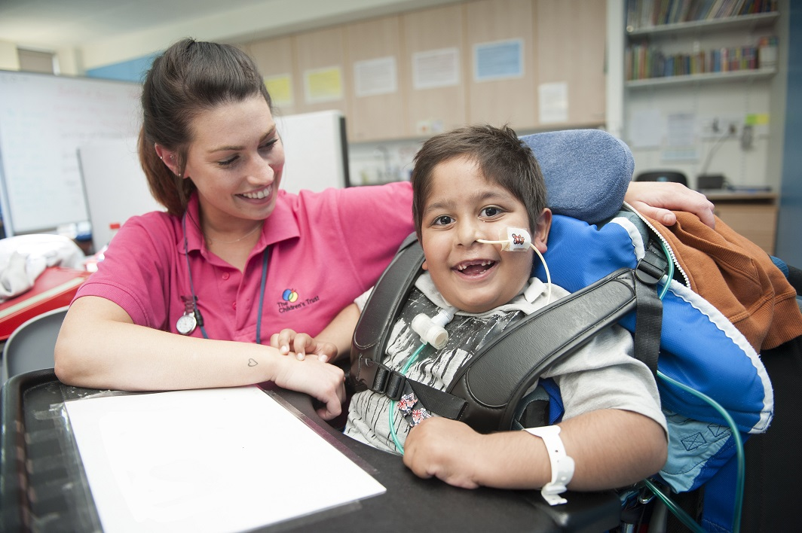





Dear Candidate
Thank you for your interest in becoming a Specialist Teaching Assistant at The
Children’s Trust. School !
The Children’s Trust School our aim is to provide high quality education and expertise to meet each pupil’s individual special needs and to celebrate all achievements in a happy environment.
As a non-maintained special school, we pride ourselves on seeing each individual as a ‘whole’ and delivering integrated, holistic education, therapy and care for pupils with profound and multiple learning difficulties. We provide day and residential education for pupils aged 3-19 years old. For children with disabilities aged 0-5 years we also offer ‘Taddies’, a weekly run parent and child group that offers support and planned opportunities to learn through sensory play and fun!

We offer individualised learning opportunities relevant to each pupil to support the development of their communication, language and literacy skills, their cognitive development, physical skills, environmental control and social, emotional and personal well-being. We focus on developing pre-intentional learning to intentional and formal stages with an aim of supporting pupils to develop a sense of agency and understanding of the world around them.

Our services include play therapy, music therapy, physiotherapy, occupational therapy, speech and language therapy, paediatric nursing and access to health services including GPs, consultants and clinics such as orthotics. We aim to provide the best educational opportunities and unparalleled expertise in order to deliver significant outcomes.

Samantha Newton - Headteacher & Director of Education.
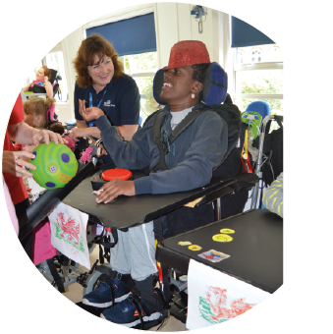

Want to find out more?

Visit thechildrenstrust.org.uk/school
The Children’s Trust School
Tadworth Court, Tadworth, Surrey
KT20 5RU
01737 365810
school@thechildrenstrust.org.uk
thechildrenstrust.org.uk
facebook.com/childrenstrust
twitter.com/childrens_trust
Registered charity number 288018.

Job Description
Job Title | Specialist Teaching Assistant (STA)
Reports to | Class Teacher / Senior Teaching Assistant  The Headteacher and Deputy Headteacher have overall responsibility for all staff.
Location | The Children’s Trust School, Tadworth, Surrey.  (Specialist Teaching Assistants may be required to work in a single class or in different classes in order to meet the needs of all pupils)
Working Hour | Full time (Monday – Friday)  37.5 hours per week across 48 weeks, 9am – 5pm.
Salary | £16,571 - £21,474
Scale Range | Surrey Pay S4/5
Annual Leave | 35 days per annum (inclusive of bank holidays), increasing to 36 after 5 years’ service.  4 weeks of annual leave to be taken during school closure.
DBS | Enhanced with Child & Adult Check.

Job Purpose

Your role will be:
  - To safeguard all children and young people, raising any concerns.
  - To carry out a range of duties to given standards under supervision of a class teacher or senior Teaching Assistant in providing relevant support for pupils with severe learning difficulties (SLD), profound and multiple learning difficulties (PMLD) and complex therapeutic, medical and health needs.
  - You will be able to plan and organise their own workload, on a day-to-day basis within clear procedures and routines prepared by the classteacher and senior.
  - You will understand and support integrated and holistic objectives of lessons/interventions sufficiently to allow you to support the work of pupils and those delivering education, health and care effectively which may be through some relevant work experience or specialist skills from previous settings.
  - Support and implement agreed strategies and programmes that provide access to learning and maximises the engagement of pupils.
  - Provide general support to the teacher, senior teaching assistant and other team members in the management of pupils.
  - To work with the multidisciplinary team providing high quality support to children/ young people and their families, supervised by professionally qualified staff.
  - To contribute to the ongoing assessment and planning of pupils learning.
  - To work as a positive team member in an identified class. However, be flexible and move to other classes to support the needs of pupils when required.
  - Uphold relevant policy and guidelines as directed.

Main Duties and Responsibilities

This job description describes the way the post holder is required to complete and perform the duties set out above. The job description can be reviewed at any time in order to better meet the needs of pupils at the discretion of the head teacher and following consultation with you.
This job description does not form part of the Contract of Employment.
Working at S4 level | Working at S5 level – staff will demonstrate all of S4 plus aspects below. | What this means at our school.  Please note that training and competencies maybe class and skill dependent.
Safeguarding:  - To have regard to and comply with safeguarding policy and procedures | Safeguarding:  - To have regard to and comply with safeguarding policy and procedures | Safeguarding:  - Act in the best interests of the child/young person, at all times ensuring they remain safe.  - Adhere to all relevant Children’s Trust/School Safeguarding Children and Young People’s Policy and Procedures.
Support delivery:  • Provides specialised support /interventions for individuals or groups. • Use of specialised equipment/powered tools. • Monitoring and assist with routine tasks such as cleaning equipment, tidying up and maintaining supplies of materials and equipment.  - Maybe required to undertake manual handling and physically demanding work when trained. | Support delivery:  • Monitoring and maintaining a programme of activities e.g. wider curriculum support, maintaining supplies of materials and equipment. • Use of specialised equipment with minimal support.  - Trained in manual handling  • Trained to carry out personal care routines as appropriate.
Planning & Organising  • Plan and organise own work to meet given priorities.  • Assess the range and volume of work to be undertaken for the days or weeks ahead and plan to ensure it is completed to time and to an appropriate standard. | Planning & Organising  • Plan and organise own work and work of other members of the team (where appropriate) to meet given priorities as directed by the teacher / senior. • Contribute to broader activities by providing specialist support and effective resourcing, coordination and monitoring of those activities. • Assess the range and volume of work to be undertaken for the days ahead and plan to ensure it is completed to time and to an appropriate standard. | Planning & Organising:  - Support a stimulating, accessible and age appropriate school environment.  - Support the class teacher and senior specialist teaching assistant in delivery of intended learning.
Teaching & Learning: To work towards the identifies standards  - To understand and carry out role in line with agreed standards, expectations & qualifications. | Teaching & Learning:  - To understand and carry out role in line with agreed standards, expectations & qualifications. | Teaching & Learning:  - Deliver personalised plans in a high quality manner.  - Know and actively demonstrate and model the ‘Pupils Charter’ and ‘Ethos of curriculum delivery’ supporting learning in routines.  - Undertake relevant training to ensure that pupils are ‘Prepared to Learn’ appropriate to their individual needs including manual handling, positioning.  - Support a Total Communication environment by ensuring that pupil’s modes of communication are known and used consistently.  - Support a culture of change around new ventures eg lunchtime activities positively.  - Support planned opportunities for pupils to learn in out-of-school contexts in line with school’s policies and procedures. e.g. trips and visits. Undertake Risk Assessor training as delegated by line manager if deemed necessary  - Support education, heath and care interventions throughout the day.
Resources :  • Operate and check equipment is safe to use and properly adjusted, carry out appropriate maintenance and use equipment in the correct and safe manner when trained in its use.  - Competent in range of IT tools | Resources:  • Deliver a range of practical services in support of existing systems or processes to agreed standards, to maximise service quality and continuity.  - Be trained in equipment used by the pupils for education, health and care needs and be competent in it. | Resources:  - Organise and safely manage the appropriate learning environments and resources.  - Ensure that the staff team are well deployed and maximising learning opportunities.  - Recognise, promote and positively reinforce team and pupil achievement.  - Ensure that the learning environment is organised to promote best access for pupils.Promote the drive to consolidate and progress learning.  - Be accountable for supporting Information Governance, Data Protection and Confidentiality at all times.
Analysis, Reporting and Documentation:  • Maintain and submit records following relevant school policies & procedures. | Analysis, Reporting & Documentation:  • Assist in the delivery of relevant assessments/ evaluations.  • Ensure information and records are processed and stored to agreed procedures.  • Ability to store data and carry out basic analysis. | Analysis, Reporting & Documentation:  - Evaluate pupils’ progress through a range of assessment activities as led by the class teacher and senior support staff.  - Monitor pupils’ engagement, participation and progress.  - Assist in maintaining and analysing records of pupils’ progress.  - Contribute to pupil progress meetings.  - Provide ‘pointed praise’ as constructive feedback in a way appropriate to the individual pupils in relation to their progress and achievement.
Work with others:  • Respond to individual needs and/or answer simple queries politely and ask for assistance where necessary.  • Report any concerns, problems or incidents, e.g. safeguarding, behaviour in accordance with relevant reporting procedures. • Liaise and work in partnership with key leads for other activities that may impact on own areas of responsibilities.  • May carry out personal care routines as appropriate. | Work with others:  - Receive and respond to everyday enquiries from customers to provide a timely, courteous and efficient service.  • Develop strong relationships with partners and stakeholders to deliver a timely and efficient service.  - Confidently integrate multi disciplinary working. | Work with others:  - Foster and maintain constructive and supportive relationships with pupils, parents/carers, Houses, the multi-disciplinary team and exchange appropriate information.  - Maintain appropriate boundaries with pupils, parents and carers.  - Ensure that information / queries about pupils are directed to the class teacher / senior teaching assistant.  - Work positively as part of a team.  - Raise incidents of racism, bullying, harassment, victimisation and any form of abuse of equal opportunities, ensuring compliance with relevant school policies and procedures and making sure the individual/s involved understand it is unacceptable.
Duties for all Values:  - To uphold and demonstrate the ethos, values and behaviours of the organisation. | Duties for all Values:  - To uphold and demonstrate the ethos, values and behaviours of the organisation. | Duties for all Values:  - Uphold and demonstrate the Code of Conduct.  - Drive cultural change to achieve a culture of learning for pupils and staff.  - Seek liaison with other educational establishments to promote learning best practise, approaches to learning, progression and curriculum developments.  - Uphold the school’s policies.  - Participate in the school’s appraisal scheme.  - Take part in a staff induction programme, and pursue other training as required.  - Take part in staff development days, class team meetings, departmental meetings, whole staff meetings and other occasional meetings held in working hours.  - Take part in performance management working towards agreed organisational and professional development targets.  - Participate in The Children’s Trust development programme or School Development programmes for shift leaders.  - Share knowledge and skills with other members of the inter- professional team.
Equality & Diversity:  - To work inclusively, with a diverse range of stakeholders and promote equality of opportunity. | Equality & Diversity:  - To work inclusively, with a diverse range of stakeholders and promote equality of opportunity. | - Be aware of and support all pupils to have equal access to opportunities to learn and develop.
Health, Safety & Welfare:  - To maintain high standards of Health, Safety and Welfare at work and take reasonable care for the health and safety of themselves and others. | Health, Safety & Welfare:  - Adhere to established processes, standards of service delivery and use of equipment to support any associated regulatory or technical compliance requirements | Health, Safety & Welfare:  - Promote safeguarding of children at all times and be confident to raise any concerns implementing school child protection procedures and comply with legal responsibilities.  - Carry out the duties and responsibilities of the post, in accordance with the school’s Health and Safety Policy and relevant Health and Safety Guidance and Legislation.  - Be competent in completing IRARs or supporting others in their completion.  - Be clinically competent to work across the range of needs in the class in which they work.  - Read and be aware of risk assessments / care plans / programmes.  - Be competent in assisting personal needs eg dressing, toileting, eating, drinking, caring for sick children / young people.  - Ensure that daily evaluations are completed for day and residential pupils.  - Comply with Infection Protection and Control Policy and Procedures.  - Take care of own personal health, safety and wellbeing.
Educational Qualifications:  - Basic numeracy  - Basic literacy  - Ability to work towards educationally recognised vocational qualifications at level 2. | Educational Qualifications:  - English GCSE or equivalent (preferably A-C)  - Maths GCSE or equivalent (preferably A-C)  - At least 1 other GCSE or equivalent (preferably A-C)  - Educationally recognised vocational qualification/s at level 2  - Ability to work towards level 3 educationally recognised qualification.  - Undertake Risk Assessor training as delegated by line manager if deemed necessary | Educational Qualifications:  Form the basis alongside experience as to where applicants will be placed on the salary scale.
Training / competencies / experience :  Minimum expectations are:  - Staff have previous experience - albeit maybe limited if new to childcare in education.  - All staff new to role will be expected to complete the site induction.  - All staff new to role will be expected to complete the School induction.  - All staff new to role will be expected to successfully complete a 6 month probation period.  Please see training plan attached for more details. | Training / competencies / experience :  Minimum expectations are:  - Staff have a minimum of 2 years previous experience preferably in special education.  - All staff new to role will be expected to complete the site induction.  - All staff new to role will be expected to complete the School induction.  - All staff new to role will be expected to successfully complete a 6 month probation period.  - City and Guilds accreditation upon completion of Competency days L1 / L2 / L3  Please see training plan attached for more details. | Training / competencies / experience :  We can provide a training plan and competency framework according to class needs and individual skill level.

Organisation and Structure

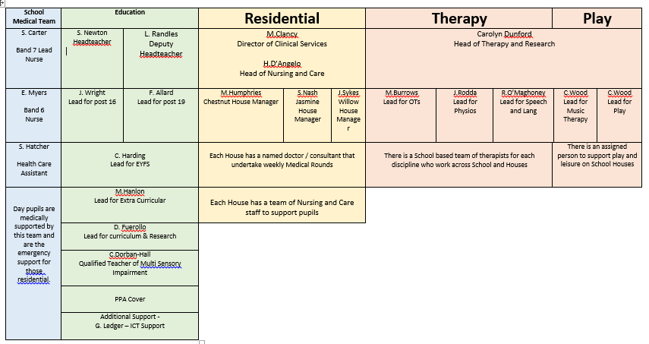

The class teacher and Senior Assistants:
  - Be responsible for direct line management on a day to day basis.
  - Deploy specialist teaching assistants to undertake the required roles and responsibilities, identifying pupils / groups of pupils that they are required to support.
  - Be responsible for the specialist teaching assistants ‘Performance, Development Review’ (PDR) including identification of training needs to ensure relevant competencies.

We want all of our Specialist Teaching Assistants to work towards / demonstrate the following standards:

Professional standards for teaching assistants (June 2016)
Teaching and learning
Teaching assistants are expected to:
- Demonstrate an informed and efficient approach to teaching and learning by adopting relevant strategies to support the work of the teacher and increase achievement of all pupils including, where appropriate, those with special educational needs and disabilities.
- Promote, support and facilitate inclusion by encouraging participation of all pupils in learning and extracurricular activities.
- Use effective behaviour management strategies consistently in line with the school’s policy and procedures.
- Contribute to effective assessment and planning by supporting the monitoring, recording and reporting of pupil performance and progress as appropriate to the level of the role.
- Communicate effectively and sensitively with pupils to adapt to their needs and support their learning.
- Maintain a stimulating and safe learning environment by organising and managing physical teaching space and resources.
Professional standards for teaching assistants (June 2016)
Personal and professional conduct
Teaching assistants should uphold public trust in the education profession by:
- Having proper and professional regard for the ethos, policies and practices of the school in which they work as professional members of staff.
- Demonstrating positive attitudes, values and behaviours to develop and sustain effective relationships with the school community.
- Having regard for the need to safeguard pupils’ well-being by following relevant statutory guidance along with school policies and practice.
- Upholding values consistent with those required from teachers by respecting individual differences and cultural diversity.
- Committing to improve their own practice through self-evaluation and awareness.
Professional standards for teaching assistants (June 2016)
Working with others
Teaching assistants are expected to:
- Recognise and respect the role and contribution of other professionals, parents and carers by liaising effectively and working in partnership with them.
- With the class teacher, keep other professionals accurately informed of performance and progress or concerns they may have about the pupils they work with.
- Understand their responsibility to share knowledge to inform planning and decision making.
- Understand their role in order to be able to work collaboratively with classroom teachers and other colleagues, including specialist advisory teachers.
- Communicate their knowledge and understanding of pupils to other school staff and education, health and social care professionals, so that informed decision making can take place on intervention and provision.
Professional standards for teaching assistants (June 2016)
Knowledge and understanding
Teaching assistants are expected to:
- Share responsibility for ensuring that their own knowledge and understanding is relevant and up to date by reflecting on their own practice, liaising with school leaders, and identifying relevant professional development to improve personal effectiveness.
- Take opportunities to acquire the appropriate skills, qualifications, and/or experience required for the teaching assistant role, with support from the school/employer.
- Demonstrate expertise and skills in understanding the needs of all pupils (including specialist expertise as appropriate) and know how to contribute effectively to the adaptation and delivery of support to meet individual needs.
- Demonstrate a level of subject and curriculum knowledge relevant to their role and apply this effectively in supporting teachers and pupils.
- Understand their roles and responsibilities within the classroom and whole school context recognising that these may extend beyond a direct support role.
Professional standards for teaching assistants (June 2016)
Knowledge and understanding
Teaching assistants are expected to:
- Share responsibility for ensuring that their own knowledge and understanding is relevant and up to date by reflecting on their own practice, liaising with school leaders, and identifying relevant professional development to improve personal effectiveness.
- Take opportunities to acquire the appropriate skills, qualifications, and/or experience required for the teaching assistant role, with support from the school/employer.
- Demonstrate expertise and skills in understanding the needs of all pupils (including specialist expertise as appropriate) and know how to contribute effectively to the adaptation and delivery of support to meet individual needs.
- Demonstrate a level of subject and curriculum knowledge relevant to their role and apply this effectively in supporting teachers and pupils.
Understand their roles and responsibilities within the classroom and whole school context recognising that these may extend beyond a direct support role.

Assistants will be expected to work with a range of pupils in their class and may be requested to work with others across the School.

PePerson Specification

The table below, identifies the person specification for this role.
In your letter of application, explain concisely your understanding of each, your ability to undertake the role with reference to relevant experience, competencies and skills that you have to illustrate this.
Qualifications & Experience
Essential | Desirable
For entry at S4 / S5 please see relevant qualifications section
Skills, Knowledge & Abilities
Essential | Desirable
Personal Qualities
Essential | Desirable
Safeguarding
Essential | Desirable
Display a commitment to the protection and safeguarding of children and young people, and have an up-to-date knowledge of relevant legislation and guidance in relation to working with, and the protection of, children and young people
Ability to form and maintain appropriate relationships and personal boundaries with colleagues, children and young people.
Ability to comply with policies and procedures relating to child protection, health & safety and security, confidentiality, data protection and equal opportunities
Appointment is subject to an enhanced DBS (Disclosure and Barring Service)
Eligibility to work in the UK
Additional Duties for 1:1 Specialist Teaching Assistant (STA)
To support needs of children and young people (CYP) in the residential setting including child specific;
personal hygiene routines, personal care, administration of medication and medical procedures, feeding programmes, therapy programmes.

To support CYP at medical appointments e.g.Doctor, dentist and optician.

To support CYP in hospital or in residential setting if unwell.

Safeguarding

The Children’s Trust is committed to safeguarding and promoting the welfare of children and young people. To achieve our commitment, we will ensure continuous development and improvement of robust safeguarding processes and procedures that promote a culture of safeguarding amongst our workforce.

Applicants for this post will be subject to an Enhanced Disclosure from the Disclosure and Barring Service (DBS) (previously Criminal Records Bureau). The Children’s Trust operates within the Disclosure and Barring Service Code of Practice. The Children’s Trust has a policy on the recruitment of ex-offenders, a copy of which is available on request. A criminal record will not necessarily be a bar to obtaining a position at The Children’s Trust. This post is, however, exempt from the provisions of Section 4(2) of the Rehabilitation of Offenders Act 1974 by virtue of the Rehabilitation of Offenders Act (Exemptions) Order 1975. Applicants are, not therefore, entitled to withhold information about convictions, however long ago these occurred, including those which for other purposes are ‘spent’ under the provisions of the Act. In any event of employment, any failure to disclose such convictions could result in dismissal or disciplinary action by the Trust.

Equality and Diversity

The Children’s Trust recognises the value of diversity and is committed to equality of opportunity. We expect staff to be treated with dignity and respect and solely on the basis of their merits, abilities and potential regardless of age, sex, sexual orientation, marital or civil partnership status, disability, race, nationality, ethnic origin, religion or belief as stated in the Equality Act 2010. We expect all staff to share this commitment and promote equality and diversity amongst their teams.

Values

The Children's Trust is the UK's leading charity for children with brain injury. Our vision is for all children with brain injury to have the opportunity to live the best life possible. Our ambition is to provide a professional service where the children and families are at the centre attention to what we do.

For us to be able to use this opportunity and to achieve this vision & ambition, we require all of our staff to be actively promote and share our values that bring us closer to achieving our goal.

Our values are: Child and family focused, collaborative, can do, fun, caring and supportive.

