
JOB DESCRIPTION
JOB TITLE: Lecturer Carpentry and Multiskills

REPORTS TO: Deputy Head of School of Construction and the Built
Environment

LOCATION: Woodlands Campus

AREA: Construction and the Built Environment

GRADE/SALARY: Lecturers Scale, points 6 to 14 £29,736 to £40,551 per annum
Level 5 Teaching Qualified up to £44,661 per annum

CLOSING DATE: Sunday 27 April 2025

DBS: Enhanced DBS check with children’s barred list check _______________________________________________________________________

PURPOSE:

To promote the efficient running of a successful provision by providing teaching, training and assessment to learners working in the Centre across a range of construction and related qualifications.

PRINCIPAL DUTIES:

- To teach on a range of programmes within the specified area.

- To act as course tutor.

- To be course co-ordinator for agreed programmes.

- To contribute to curriculum development.

- To contribute to the marketing of programmes, recruitment and interviewing.

- To actively support student induction and enrolment within the School of Construction.

- To play an active part in the development of the flexible curriculum and the learning materials to support this including the College’s virtual offer.

- To develop external contacts and promote industry-based work including work experience placements where applicable.

- To ensure that employability and employer engagement activities are embedded into the programmes

- To contribute to the co-ordination and administration of identified programmes.

- To be proactive in maintaining and developing quality standards, including internal verification, on all programmes and demonstrate a commitment to quality improvement.

- To be an ambassador of Solihull College & University Centre and the Construction curriculum area in all dealings with external partners.

- To embed sustainability within the curriculum.

- To adhere to policies, procedures and values of Solihull College & University Centre.

- To undertake all mandatory training in a timely manner as required e.g. Safeguarding, Prevent.

- To actively promote equality, diversity & inclusion and to champion anti-racist practice.

- To support the college to become a Sustainable Net Zero organisation by 2030 and support the delivery of its Sustainability Strategy.

- To undertake necessary Health and Safety responsibilities, duties and training as required by this post.

- To undertake any necessary Data Protection responsibilities, duties and training as required by the post.

- Such other duties as required which are broadly consistent with the general functions and grading of this position.

EQUAL OPPORTUNITIES:

Solihull College & University Centre is committed to a comprehensive policy of Equality. All employees are required to abide by this policy and ensure its compliance throughout the College.

SAFEGUARDING:

Solihull College & University Centre is committed to ensuring a safe environment for all students and expects all staff to engage fully with this commitment.

CORE VALUES:
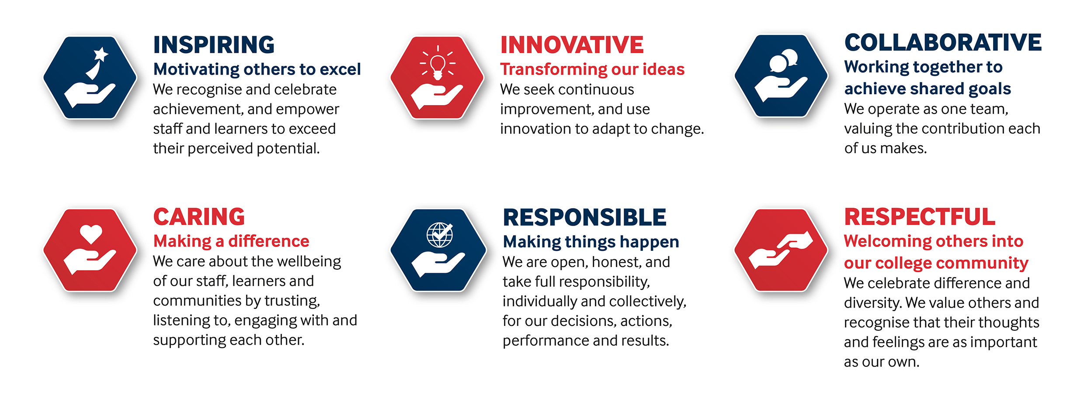

SOLIHULL COLLEGE & UNIVERSITY CENTRE

PERSON SPECIFICATION

JOB TITLE: Lecturer Carpentry and Multiskills

SPECIFICATION | ESSENTIAL | DESIRABLE
EDUCATION /  TRAINING | Level 2 qualification in Carpentry  Relevant Level 5 teaching qualification (or committed to work towards in line with contractual requirements)  Level 3 Assessor Award or equivalent (or committed to work towards in line with contractual requirements)  Level 2 English and maths | Hold an appropriate Degree or equivalent  Level 4 Award in Internal Quality Assurance of Assessment Processes & Practices (or equivalent)
RELEVANT  EXPERIENCE | Proven Industry related work experience  Experience in commercial, industrial and domestic electrical work | Teaching experience on related programmes  Curriculum development experience
SKILLS /  APTITUDES | Strong digital competencies  Excellent organisational and communication skills  Focused on team working  Flexible and adaptable attitude to working with students of all ages  Resilient  Flexible and well-motivated, able to work on own initiative  Have a proactive approach and willing to modernise the curriculum  An awareness of sustainability and climate change and how it applies to FE and can be embedded into the curriculum
OTHER  REQUIREMENTS | Awareness of cultural diversity  Strong commitment to Equal Opportunities  A commitment to the Safeguarding of Young People and Vulnerable Adults and an awareness of the Government ‘Prevent’ strategy  Commitment to the College’s Values

