

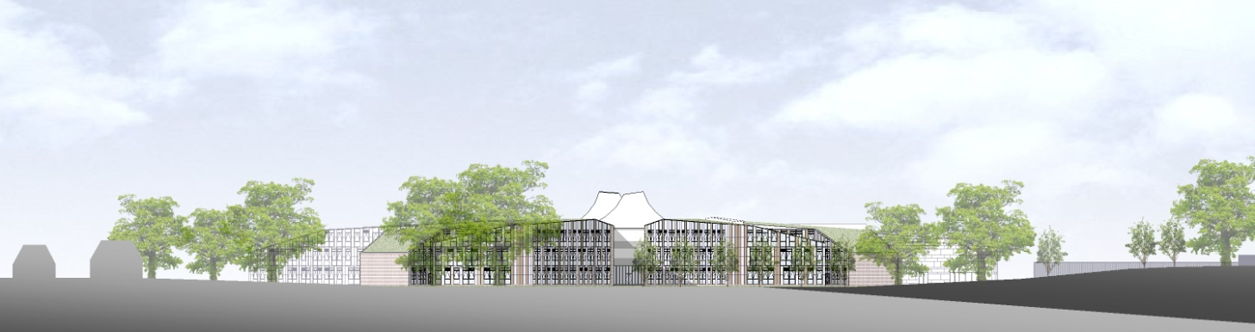

**ST BARTHOLOMEW’S SCHOOL**

**HUMAN RESOURCES ADMINISTRATOR**

**PART-TIME, PERMANENT**



**Andover Road**

**Newbury**

**Berkshire**

**RG14 6JP**

**Tel: 01635 521255**

**Email:** [**recruitment@stbarts.co.uk**](mailto:recruitment@stbarts.co.uk)

**Website:** [**www.stbarts.co.uk**](http://www.stbarts.co.uk)

**The Faculty**

**The Department**

The Human Resources department is made up of 3 part-time staff and forms part of the Administration function, including the Catering, Facilities, Finance, ICT and Premises teams.

**The Post**

* We are seeking to appoint a Human Resources Administrator reporting to the HR Manager, starting as soon as possible on a permanent basis.
* The position is part-time, 30 hours per week to be worked Monday to Friday, term-time plus 5 days pro rata during the school holiday and 5 training days pro rata.

**The Salary**

* The successful candidate will be paid in accordance with the national APT&C scale, point 3 - 4 (currently £18562.00 to £18933.00 per annum full-time equivalent). This equates to a starting salary of £13161.73 gross per annum or £9.62 per hour. Staff will be appointed to the start point of the advertised scale unless there is a specific experience reason for the Headteacher to agree an alternative point within the range.
* All leave must be taken during school holidays. Your annual salary will be calculated to include payment for your leave entitlement. Your annual salary will therefore be 45.6 weeks pay, to be paid in 12 equal monthly amounts.

**How to Apply**

Full post details, an application form and instructions on how to upload your completed application are available via the Jobs & Training / Job Opportunities section on the School’s website:

[**www.stbarts.co.uk**](http://www.stbarts.co.uk)

(Please note that curriculum vitae and covering letters cannot be accepted)

Successful candidates will be subject to a DBS enhanced check along with other relevant employment checks.

## Closing date: Sunday 26 September 2021

Thank you for considering St Bartholomew’s School, we look forward to hearing from you.