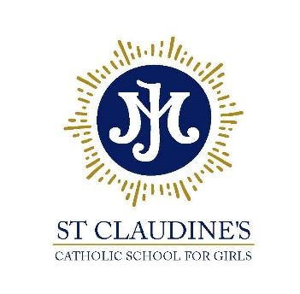

Diocese of Westminster Academy Trust

St Claudine’s Catholic School for Girls
Crownhill Road, London NW10 4EP
Tel: 020 8965 2986 | email: office@stclaudines.co.uk
Headmistress: Dr L McGowan, BMus (Hons) MA EdD NPQH FRSA

“Championing excellence and equality in all-girls’ education”

Cleaning Supervisor

Pay Scale 4, Point 7-11, Part-Time, Permanent Contract

Required for: ASAP
Interviews: Immediately

*******

St Claudine’s Catholic School for Girls is a highly-successful Catholic girls’ comprehensive school (ages 11-18) in the northwest London Borough of Brent.
Learning at St Claudine’s is rooted in the Gospel values in a warm, supportive and nurturing community. Even though we are a Catholic School, it is not a requirement to be Catholic and our international community welcomes staff and students of all faiths and none.
We are seeking a hardworking and a candidate with good organisational skills to join our busy school. Applicants for the role must be able to work as part of a team and be IT competent.
We are seeking a cleaner to work alongside our premises team. Candidate should be hardworking and conscientious with excellent organisational skills. Applicants for the role must have energy, enthusiasm and pride in a meticulous approach to work.

Candidates must also be reliable and punctual.

Further details of this post and about the school are available on the school website: http://www.stclaudines.co.uk/joining-us/vacancies/

As part of our commitment to safeguarding and promoting the welfare of children you will be required to undertake a DBS check.

All staff are expected to be positive spokespeople for the school and to role model the professional behaviours and attitudes we expect to see in the students

