Job Description
Data Systems’ Manager (Full time/Permanent)

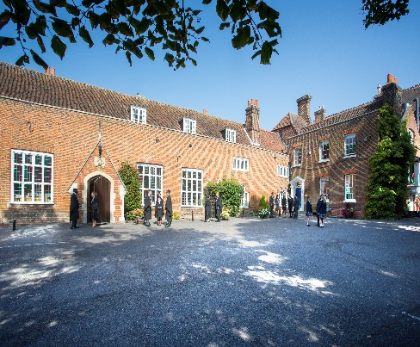

Introduction

Chigwell School is looking to appoint an enthusiastic and experienced data systems’ manager to join our expanding ICT Team to oversee the development and use of the School information systems. The successful candidate will be required to have proven experience as a data manager with excellent understanding of data handling ,SQL and PowerShell programming and knowledge of school systems including ,ideally, iSAMs.

This is a full-time position working for the full calendar year, with twenty eight days holiday. The working hours will be 8.30am to 5pm daily.

Background
Founded in 1629 by Samuel Harsnett, the son of a Colchester baker who went on to become Archbishop of York, Chigwell School stands on it original site with the original school building still in use. However, whilst Chigwell of today is conscious of its long-standing history, it is a forward-looking, ambitious, co-educational independent school of 930 pupils aged four to eighteen. It enjoys excellent facilities, a dedicated staff, bright and hardworking pupils, and a site of 100 acres.

Chigwell School is located in the picturesque village of Chigwell just over ten miles from central London and on the Central Line. The extensive, beautiful grounds are close to the edge of Epping Forest and it is rare for a school to have so much space and yet be so close to the centre of the Capital. Most pupils are day pupils but in the Sixth Form, there is a small community of international boarders, roughly thirty from sixteen countries, and these live in four small boarding houses.



As well as being an academic school, Chigwell has the reputation for providing a rich and full education, with plenty of opportunities for all pupils who are enthusiastic, co-operative and able. Chigwell is a caring and friendly school, with a close sense of community, not least between colleagues. As the Good Schools Guide reports: Academically, pupils are put through their paces but it all seems to be done in such a civilised and pleasant manner that you are more likely to hear pupils talk about opportunities and prospects than pressure and stress. “Anyone who wants to do well here, will do well” said one student, and I can’t think of a nicer place to succeed.”

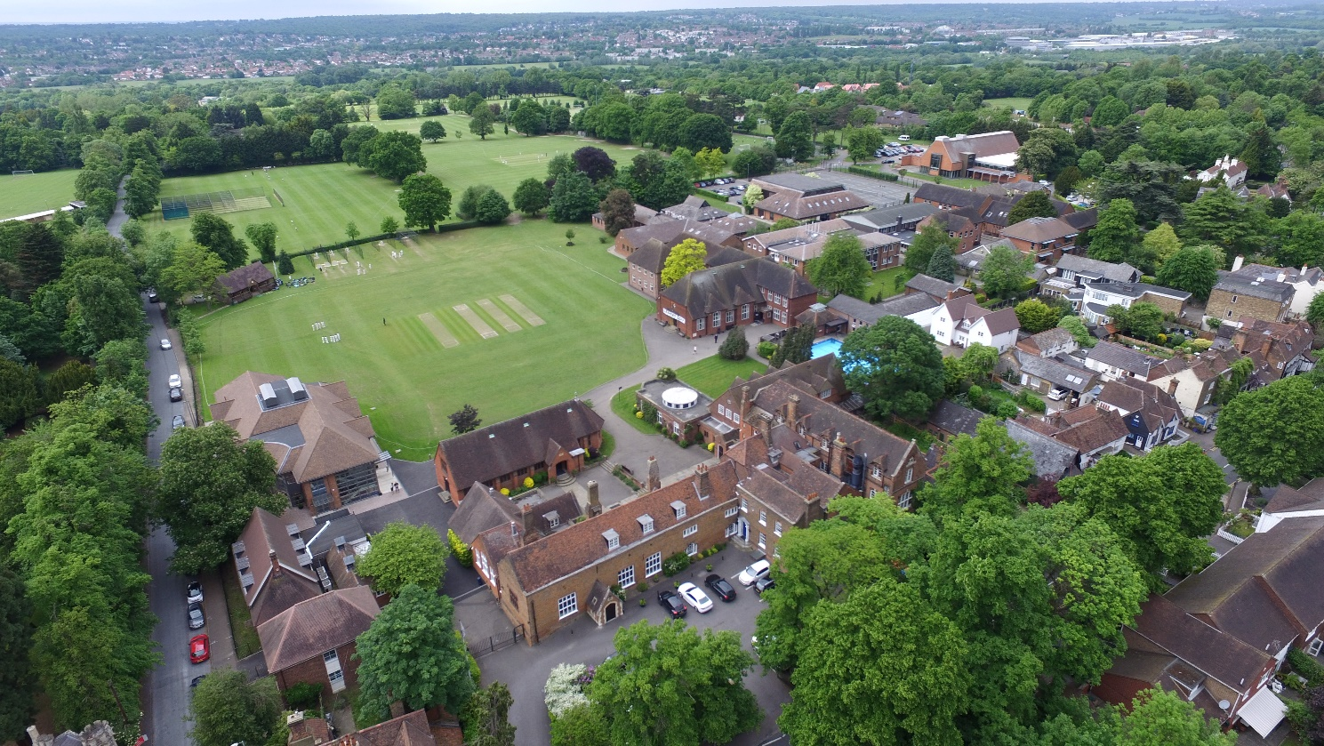

The School Development Programme

Over recent years, the School’s facilities have been extensively developed in order to enhance the educational experience that pupils receive. The development programme has included the following additions:

- 2008 Wilson Building teaching block
- 2008 Floodlit AstroTurf pitch
- 2009 Junior School library extension
- 2010 Complete redevelopment of catering facilities
- 2010 Sixth Form coffee shop
- 2010 Harsnett’s and Church House converted into boys’ boarding houses
- 2012 The Old Chigwellian Club and land was incorporated into the school estate
- 2013 Pre Prep School built and opened
- 2013 Two new science labs created
- 2014 Drama Centre balcony extended to provide additional music and drama rehearsal space
- 2016 The Risham Sarao Sixth Form Centre was completed

Currently the extension of the Dining Hall is underway and in the future the plan is to:

- Renovate the Chapel
- Develop the Sports Centre
- Expand our music facilities
- Further expand our provision of bursaries

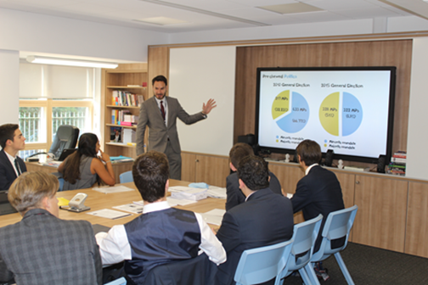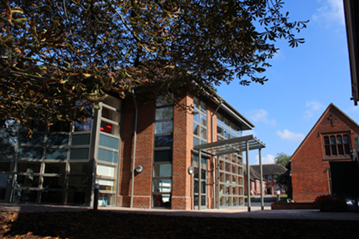

The School

Some pupils join in Reception and there are two classes in each of the three Pre Prep year groups. A small number of other children join the Junior School at 7+ (Year 3) and there are two or three classes in each of the KS2 year groups. At 11+ (Year 7), there is a further entry with four classes making up Years 7 to 11. Again, there is a small entry into the Sixth Form. Entry at each stage is selective and although there are three main sections to the School (Pre Prep, Junior School and Senior School) these sections work closely together and there is a common ethos running throughout.

There are over a hundred teachers and together with the support staff, there is a friendly, mutually-supportive atmosphere. All teaching staff contribute to the extra-curricular programme.

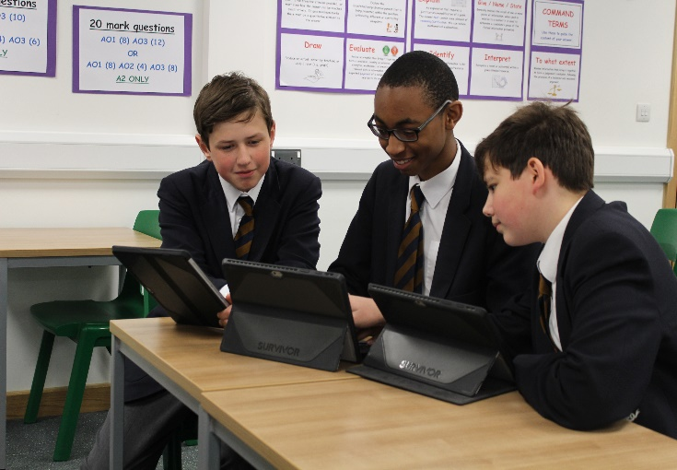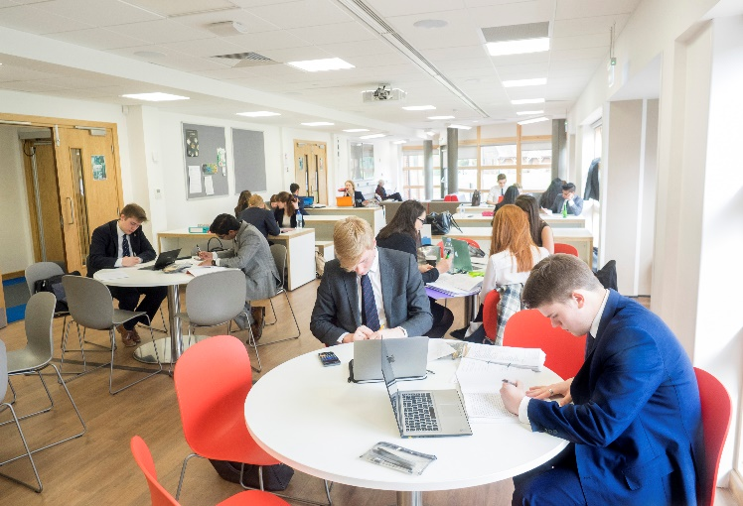

The Role

The successful candidate will report to the Deputy Head (Staff & Systems) and will be expected to manage the main school management system (iSAMS) as well as develop the use of our school Alumni system (Raisers Edge), the library system (Oliver), and pupil/parent online gateway (Firefly). The primary focus will be on data management (including use of SQL Server Reporting Services) with some programming in SQL/PowerShell.

In liaison with the Deputy Head (S&S) and the Director of Studies, the Data Systems’ Manager will oversee, develop and maintain the use of data across the School, providing clear, concise and accurate information reports to raise standards of pupil performance and ensure that data runs are accurate and on time. You will be working with the Pre Prep, Junior and Senior Schools. The successful candidate will require knowledge of Microsoft SQL Server Reporting Services. Training will be provided as required.

This is a whole-school role which links closely with middle management. The role is focused on all aspects of the data and systems of the School. The Data Systems’ Manager will ensure the integrity of the school data and functions as the key data and systems analyst, manager and report writer for this information. He/she will make the data accessible and easy to understand, and work in conjunction with other ICT to ensure the security of the data. The role will involve some training of staff and ICT technicians to enable them to further enhance teaching, learning and administration.

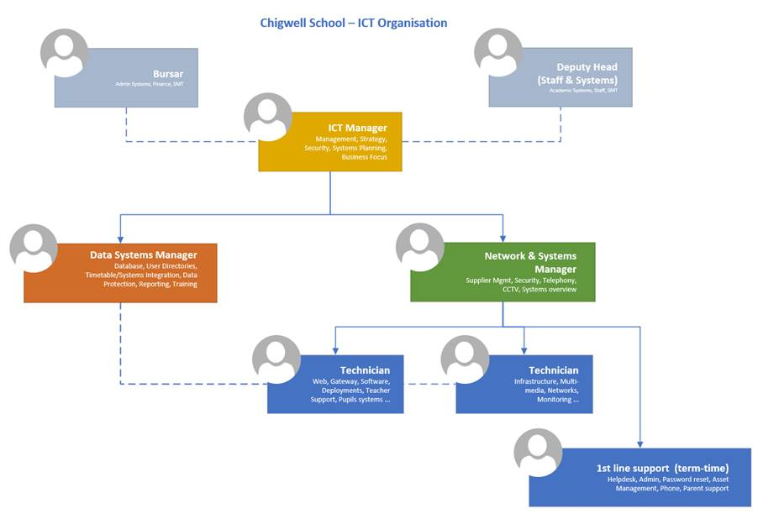
General Responsibilities/Accountabilities
- Maintain a detailed working knowledge of all areas of the current MIS system (iSAMS), together with its supporting systems and services. Look out for and inform the ICT department about any version changes to these products.
- Provide advice and input to the overall Systems strategy for the School, ensuring that any new systems fit the overall goals of improving teaching and learning, reducing administration and enhancing communications to staff, pupils and parents.
- Maintain a working knowledge of our Alumni System (Raisers Edge), Fees (SIMS) and Library System (Oliver) to ensure integration between them works smoothly.
- Maintain a clear understanding of the General Data Protection Regulation (GDPR) and the implications that it has for managing school data, and help to ensure that the School complies with all applicable data protection regulations.

Data Provision & Maintenance
- Undertake all necessary preparatory and provision of the system for each academic year, to include importing new users, timetable, event and meeting data. Set up required class lists, groups etc. for academic and activity use. Undertake all ongoing revisions to data such as timetable changes, including a mini-timetable alteration in the summer term. Liaise with the Director of Studies to organise parents’ evening appointments using the ParentsEve system.
- Integrate user accounts with active directory and Office 365 accounts and ensure new users are set up in accord with agreed naming conventions, and enable new users and any staff undertaking revised roles to receive all required system permissions relating to their academic and activity functions.
- Ensure that regular maintenance tasks such as backups and a monthly archive (Independent Schools Inspectorate requirement) are being carried out.
- Undertake the annual rollover of data and the archiving of staff leavers (in liaison with the Bursary, Deputy Head (S&S) and ICT).
- Provide the export of data required by internal sources and external organisations (e.g. data files for photographers) and import of required externally supplied data (e.g. pupil and staff photos).

Reporting
- Work to the School's reporting schedule, prepare all markbooks, tracking sheets, report templates etc. needed, including UCAS reference forms and the school list. Monitor completion of data entry stages by all relevant participants, undertake any necessary amendments of markbooks, reports etc. and prepare internal grade distributions for checking by Heads of Department, SMT, House Masters/mistresses and Tutors.
- Work with the respective Directors of Studies to create output reports (such as reports for parents etc.) and upload pupil data to the iSAMS parent portal.
- Amend and develop report formats and templates as requirements change.

System Maintenance
- Audit and document the system configuration, to ensure correct allocation of functions and permissions and undertake annual data integrity checks to ensure system accounts match AD accounts. Document the workflow procedures for the yearly use of the MIS system and amend with any revision or changes.
- Liaise with users and iSAMS/Raiser Edge/Oliver/FireFly about any errors, development requests, and problems encountered, and undertake troubleshooting of MIS system software and services.

Development
- Promote new features currently unused in iSAMS. Consider if and when to implement new features in consultation with appropriate stakeholders. Attend MIS system User Group meetings.
Training
- Undertake the induction of new staff in the use of the MIS System, and provide in-house training and support for staff in using iSAMS including creating appropriate training materials and resources for new staff induction and to cover new system features being deployed.
- Help to develop ICT technicians in data management skills and understanding.

Responsibilities in Relation to the Staff in the School
- Support staff use of ICT throughout the School and, in particular, the MIS as and when required.
- In the event of a major incident or disaster, you may be required to provide assistance, in whatever capacity necessary and participate in any training to ensure the School is fully prepared.
- Carry out such duties that may be reasonably required by your line manager including the Headmaster, Deputy Head (S&S), Network & Systems Manager and Director of Studies.
- Provide 3rd line technical support.

 | Essential | Desirable | Assessment
Education and Qualifications | - Strong technical expertise, ideally including an understanding of SQL and PowerShell programming  - Report Development experience using Microsoft SQL Server Reporting Services | - Microsoft Certified Database Administrator or  - Microsoft Certified Solutions expert: Business Intelligence or  - Microsoft Certified Solution Expert: Data Platform | - Application Form  - Certification
Experience | - Previous experience of MIS data management  - Willingness to work as part of a team | - Experience of administering SQL databases  - Experience of writing custom reports/modules for end user presentation  - Experience of working in a school environment  - Experience of producing accurate data for reporting and assessment | - Application form  - Interview  - Previous experience
Skills and Abilities | - Confident  - Diligent  - Cooperative  - Team worker  - Practical  - Enthusiastic  - Innovative  - Ability to communicate with non IT literate colleagues in a sympathetic manner  - Skilled in time management with an ability to work to strict deadlines |  | - Application form  - Interview  - Previous experience

Salary: Competitive and commensurate with experience

Benefits of working at Chigwell School include:

- A competitive salary  - Access to the School Pension Scheme  - Free lunch and refreshments during term time  - Childcare Vouchers  - Personal Accident Cover  - Employee Assistance Support Programme  - On-site parking and cycle racks  - Use of School Library | - Medical Centre on site  - Free use of School’s sports facilities outside of the School day  - Commitment to professional development  - A supportive community of highly motivated students and staff  - A beautiful working environment- 100 acres site beautifully landscaped with a number of listed buildings

Further details can be found on the School website (www.chigwell-school.org).

Application is by a form which can be completed online or downloaded from our website (select Vacancies) and submitted to the Headmaster’s PA: hmpa@chigwell-school.org not any later than Friday 12th January 2018.

Closing date: Friday 12th January 2018. Early applications are welcome.

Chigwell is committed to safeguarding and promoting the welfare of children and young people and expects all staff and volunteers to share this commitment. Applicants must be willing to undergo child protection screening including checks with past employers, prohibition orders and enhanced DBS.

