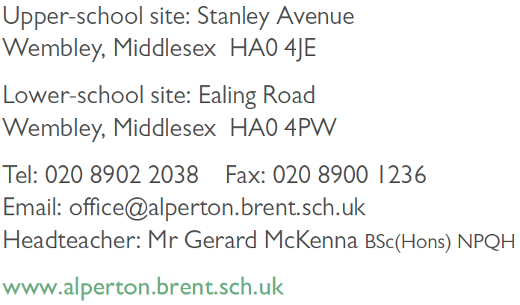

JOB DESCRIPTION

Post Title: Science Laboratory Technician

Conditions of Service: NJC

Hours of Work: 36 hours per week, term time only - 39 weeks per annum

Reports to: Laboratory Manager/Science Technician
Teaching and Learning Leader for Science

Responsible to: Relevant Senior Leadership Team member with responsibility
The Headteacher
The Governing Body

Job Purpose

To assist teaching staff and students learning through efficient and effective organisation/maintenance of materials and equipment. To be a Technician in the School and to assist in the science areas as required and where appropriate use ICT. To contribute to the development of an ethos of learning throughout the school.

Main Duties and Responsibilities

The postholder will provide assistance to the Science Teaching Staff (as designated) in relation

- To ensure science laboratories and prep rooms are maintained to comply with Health and Safety requirements and safety checks as detailed in relevant check lists.
- To be aware and regularly updated on Health and Safety regulations to check that Risk Assessments are carried out in prep rooms and workshops.
- To be aware of Alperton School Health and Safety Policy and the implementation of the Science Department Safety Policy.
- Preparation, maintenance and safe storage of apparatus both for demonstration and practical work in the courses taken in the school or department to which the Assistant is allocated and providing the resources required for lessons including photocopying, collation, typing, filing, etc.
- General maintenance of each laboratory or room, including the care and maintenance of services, stores, laboratory workshop equipment, drainage systems, working surfaces etc., reporting any repairs required to the appropriate person for action.
- Maintain a standard of good cleanliness and tidiness throughout the laboratories and prep rooms e.g. work benches, whiteboards, glassware, sinks etc.
- Maintenance of stock to meet requirements, requisitioning to the approved standards, receipt and storage of new materials, including materials requiring special care i.e. toxic chemicals, radio-active materials, the return of empty bottles and containers.
- Keeping stock records, breakage records and other such records as are required and informing the Manager when stocks are running low.
- The construction of apparatus for general or demonstration use, and the repair of apparatus.
- The reduction of laboratory risks, first aid treatment in the laboratory in accordance with the school procedures.
- Implementing the safe storage and handling of hazardous chemicals and radioactive sources.
- In Biology, Assistant must be capable of caring for insects and plants kept for observations and experimental purposes and will be required to supervise long term experiments and keep accurate records. To maintain the micro-organism master culture without contamination and collect live specimens in the field.
- Assisting in class with demonstrations of practical techniques and activities
- The setting up visual and aural aids as required for use in science classes.
- Practical exams – to set up a required by appropriate exam board.
- To invigilate in public examinations, ensuring a professional service in accordance with Exam Guidelines and Procedures.
- Attendance at Technician Meetings, contributing to improvement in technical support throughout the school.
- To be a fully trained First Aider and to undertake medical needs training and administering of medication.

General Overview
- To take part in the school performance review process
- The post holder will be expected to undertake such tasks, which are commensurate with the position at the direction of the head teacher.
- To support the Governing Body in its whole-hearted adoption of the School’s policies and aims.

PERSON SPECIFICATION
The method of assessment for each criterion is shown with an asterisk (*) denotes essential. Shortlisting for an assessment and interview will be based solely on whether the candidate indicates on their application form that they meet shortlisting criteria*.

Experience and Qualifications

- Good general education up to at least GCSE Grade C or equivalent in Maths and English *
- Laboratory/Scientific qualification,*
- Minimum of 1 years relevant experience *
- Maintenance of stock chemicals
- Excellent Excel and Word *
- School experience

Skills/Abilities/Knowledge

- Organising and prioritising work *
- Working under pressure and meeting tight deadlines*
- Good oral and written communication *
- Confident and self-motivated *
- Good interpersonal and negotiation skills *
- Attention to detail *
- Maintain a positive and flexible attitude *
- Health & Safety procedures in laboratories *
- Ability to work effectively both independently and as a member of a team*
- First Aid – willingness to be trained as a First Aider *
Commitment

- To support the Governing Body in its whole-hearted adoption of the School’s aims & policies.*

- To providing a welcoming and friendly reception for anyone making contact with the school.*

