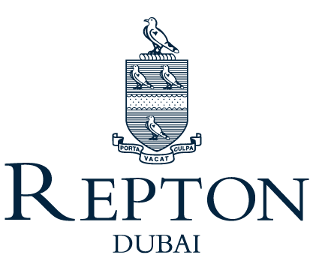

Position Description

Position Title: Head of Primary Music

Reporting to: Assistant Head of Academics

PURPOSE

The Head of Primary Music leads and manages the primary music team in order to promote the effective development of all individuals in our learning community.

SPECIFIC RESPONSIBILITIES

- Lead the strategic development of Junior School music curriculum, planning & assessment, moderation and evaluation
- Lead the department by effective teaching, maintain and developing schemes of learning and assessing students, catering for students of determination, Emiratis, Able, Gifted and Talented and EAL students
- Monitor the quality of planning, teaching & learning as assessment in the department
- Line management of the Junior School music team and oversee external music programs
- Teaching music classes across the Junior School and potentially some Key Stage 3
- Coordinate and oversee Junior School concerts, recitals and performances including before school, lunch time and after school rehearsal
- Coordinate Music Extra-Curricular Activities including Junior School Band, Choir, Orchestra, Drama and Instrument clubs
- Plan and support/lead the annual Primary Musical
- Work with Heads of Year to support the termly in school performances
- Participate in weekly assemblies through coordination and communication with the Primary Leadership Team
- Support/Lead whole school music events including Winter, Spring & End of Year Concerts in liaison with the Head of Secondary Music

