Consilium Academies Recruitment Pack

2nd in Department for English
Ellesmere Park High School
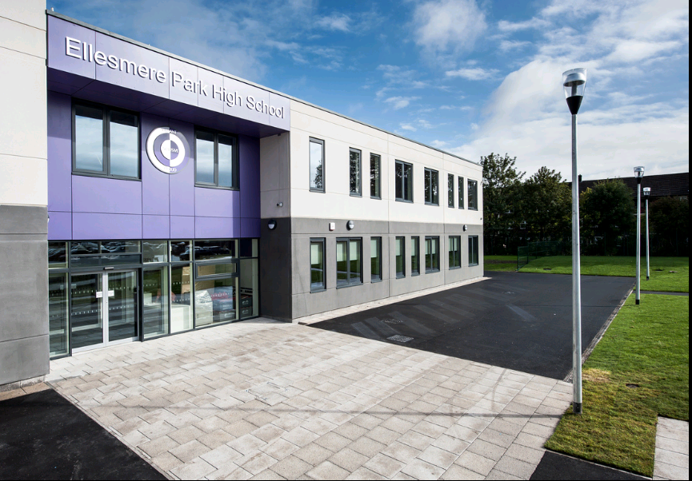
Welcome from the Headteacher
Dear Candidate,

Thank you for your interest in the position of 2nd in Department for English at Ellesmere Park High School.

Our aims as a school are founded on the values that are encapsulated by our motto ‘Vibrant, Inclusive, Proud’. We will ensure that all of our students experience the fullness of life by:

• Providing them with an exciting, engaging and rich education;
• Recognising and celebrating the unique nature of every child in our community;
• Celebrating the successes of our school and our community to the full.

I am very clear in what I want our school to deliver to our current and future students: the education that they deserve in a school that prepares them for successful and enriching lives. They deserve the very best education that can be provided. My leadership of the school will be defined by a desire to deliver this, to serve our community and to help make the ambitions of our community and young people a reality.

We are seeking to appoint a qualified, creative and enthusiastic 2nd in Department for English to join and help lead our motivated team in a School that is committed to offering a warm, friendly and purposeful setting for all our students to flourish.

I can’t think of a better time to join Ellesmere Park High School as we look forward to an exciting and bright future.

I look forward to hearing from you.

Kind regards,

J I Ross
Headteacher

About the School
Ellesmere Park High School is a co-educational academy, part of Consilium Academies, based in Salford, with approximately 750 students on role.
Our values of Vibrant, Inclusive, Proud are at the core of everything we do.
Vibrant: Our school is a vibrant school, where all are encouraged to be expressive, creative and enjoy their learning in a positive atmosphere.
Inclusive: Our school is an inclusive school, where all are valued and thrive in a safe, caring and supportive environment. We welcome everyone to our diverse community and encourage friendly and mutually respectful relationships.
Proud: Our school is a proud school, where all aspire to be successful in whatever they do. We strive to enable all to be lifelong learners, equipped to fulfil our dreams.
We aspire to make education lively, memorable and exciting. Ellesmere Park welcomes and nurtures people from diverse backgrounds with wide-ranging talents and abilities, and we actively strive to remove barriers.
Ellesmere Park High School will always strive to fulfil each child’s potential and provide our students with a broad and balanced curriculum which will enable them to move on to college or work with the right skills and qualifications needed to maximise their life chances.

About the Trust
The Consilium Mission
‘Consilium Academies will provide and inclusive partnership within our Trust and with our communities, where lives are enriched by providing care, experience and opportunity, and where every student benefits from the same opportunities to succeed’

The Consilium Mission

“Partnership, Opportunity and Integrity”
Consilium Academies Trust is a Multi Academy Trust of 8 schools based across 3 hubs in Salford, South Yorkshire and the North East of England.
Consilum Academies believes in inclusivity, both in the schools and communities we serve. We are committed to working with our academies to ensure that our ethos is realised on a daily basis. The lives of our young people should be enriched by care, experience and opportunity. This is achieved by;
- helping children and young people to succeed to their potential academically, socially and emotionally;

- instilling a passion for lifelong love of learning and continued improvement so that our academies, staff and students can grasp their aspirations and ambitions;

- creating a family of academies that are inclusive and embrace diversity, where all members of the community feel supported, inspired and empowered to succeed;

- ensuring that all stakeholders are seen as partners in our work within the communities we serve.

The Trust operates a small central team which is led by the recently appointed CEO, David Clayton. The team provide direct services to our schools as well as Trust level accountability, leadership and management. We operate a strong partnership model and our partner schools are instrumental in the continual growth and development of the trust. The Trust works with its schools and academies in a supportive way that does not detract from the individual identity of a school.

About the Role
2nd in English | Ellesmere Park High School
Start date: September 2020
Grade: MPS/UPS + TLR 2b

Are you passionate about English and determined to make a real difference? We are seeking to appoint a qualified, creative and enthusiastic 2nd in Department for English.
We are looking for an outstanding teacher who is ambitious and wants to further their career. Candidates will have the drive and motivation to continually improve the department, whilst understanding the importance of developing a positive culture.
At Ellesmere Park High School we aim to offer students an exciting curriculum and a huge range of extra-curricular opportunities within a safe, secure and encouraging environment. Candidates will have high expectations of their students and be committed to maximising rate of progress.
If you feel you share our values, have the vision and drive for excellence and want to be part of an enthusiastic and dedicated team, committed to ensuring that students fulfil their potential, then we would like to hear from you.
The closing date for applications is Sunday 19th April 2020.
Interview dates to be confirmed.
Applications are invited from experienced staff with a proven track record, post not suitable for NQT’s.
To apply please complete the online application form through our TES careers site.
For any questions regarding this role please contact Laura Byron at laura.byron@salford.gov.uk
Visits to the school are welcome and encouraged.
Consilium Academies and Ellesmere Park High School are committed to safeguarding and promoting the welfare of children and young people and expects all staff and volunteers to share this commitment. Appointments are made subject to an Enhanced DBS Check.
The trust is an equal opportunity employer. We celebrate diversity and are committed to creating an inclusive environment for all employees.

Job Description
Job Title: | 2nd in Department for English
Reports to: | Head of English
Based at: | Ellesmere Park High School
Grade: | MPS/UPS + TLR 2b
Main purpose of the Role
- To deliver a curriculum to students according to their educational needs, including the setting and marking of work.
- To assist and support student academic progress and emotional development.
- To work with colleagues as appropriate to raise standards of achievement and attainment.
- To support the Head of English
- To lead the development of the assigned curriculum.
Core Responsibilities & Tasks
Main Duties
- To maintain the highest professional standards as set out in the Teachers’ Standards document.
- To teach students according to their educational needs, including the setting and marking of work to be carried out by students in school and elsewhere.
- To be accountable for leading, managing and developing the curriculum area.
- To review, develop and refine schemes of work and encouraging links with other subjects where appropriate.
- To assess records and reports on the attendance, progress, development and attainment of students, and produce such records as are required.
- To monitor progress against the targets and ensuring appropriate action plans are in place where issues are identified.
- To provide and/or contribute to oral and written assessments, reports and references relating to individual students and groups of students.
- To ensure that English subject specialism are reflected in the teaching and learning experience of students.
- To use a variety of delivery methods, which will stimulate learning appropriate to student needs and demands of the syllabus.
- To provide a positive, conducive and safe learning environment, encouraging high standards in punctuality, presentation or work and relationships.
- To set high expectations for students’ behaviour and maintain a good standard of discipline through well focussed teaching, fostering positive relationships and implementing the schools Behaviour for Learning Policy.
- To set appropriate work for use by supply or substitute staff in the event of staff absence
Operational/Strategic Planning
- To assist in the development of appropriate syllabus, resources, schemes of work, marking policies and teaching strategies at Ellesmere Park High School.
- To contribute to the department’s development plan and its implementation.
- To plan and prepare courses and lessons.
- To be responsible for continuously improving the quality of teaching and learning within the department.

Staffing
- To take part in the school staff development programmes, by participating in arranged training for professional development.
- To continue personal development in the relevant areas, including subject knowledge and teaching methods.
- To ensure the effective and efficient deployment of classroom support.
- To hold staff accountable for their teaching and outcomes.
- To work as a member of a designated team and to contribute positively to effective working relationships within the school.

Quality Assurance
- To help implement school quality procedures and to adhere to those.
- To contribute to the process of monitoring and evaluation within the department area in line with agreed school procedures; including evaluation against quality standards and performance criteria. To seek, implement modification and improve where required.
- To monitor and evaluate the teaching in the department, take the initiative in identifying strategies to support consistency of practice and be a lead practitioner in the team.
- To review from time to time methods of teaching and programmes of work.
- To take part, as may be required, in the review, development and management of activities relating to the curriculum, organisation and pastoral functions of the school.

Management Information
- To maintain appropriate records and to provide relevant accurate and up-to-date information to SIMS – registers, behaviour log etc.
- To compete the relevant documentation to assist in the tracking of students.
- To track student progress and use information to inform teaching and learning.

Communication and Liaison
- To communicate effectively with the parents/guardians of students as appropriate.
- Where appropriate, to communicate and cooperate with persons or bodies outside the school.
- To follow agreed policies for communication in the school
- To take part in parents’ evenings
- To work closely with the SENCO to ensure appropriate subject targets are set, and to match curricular materials and approaches to pupil needs.
- To contribute to the development of effective subject links with external agencies.

Management of Resources
- To contribute to the process of the ordering and allocation of equipment and materials.
- To lead the department to identify resource needs, and to contribute to the efficient/effective use of physical resources.
- To cooperate with other staff to ensure a sharing and effective usage of resources to the benefit of departments and students.

Pastoral System
- To be a Form Tutor to an assigned group of students.
- To promote the general progress and wellbeing of individual students.
- To liaise with the Pastoral Team/Head of Year to ensure the implementation of the school’s pastoral system.
- To register students, accompany them to assemblies, encourage their full attendance at all lessons, and their participation in other aspects of school life.
- To evaluate and monitor the progress of students and keep up-to-date student records as may be required.
- To contribute to the preparation of action plans and progress files, and other reports.
- To alert the appropriate staff of issues/concerns/problems concerning students and to make recommendations as to how these may be resolved.
- To communicate as appropriate, with the parents/guardians of students, and with persons/bodies outside the school concerned with the welfare of individual students, after consultation with the appropriate staff.
- To contribute to PSHE and citizenship, and enterprise according to school policy.
- To apply the Behaviour for Learning Policy so that effective learning can take place.
- To ensure that appropriate safeguarding procedures are in place and applied.

School Ethos and Other
- To play a full part in the life of the school community, to support its distinctive mission and ethos, and to encourage staff and students to follow this example.
- To ensure that appropriate safeguarding procedures are in place.
- To participate in the school extra-curricular programme.

Corporate Responsibilities
- The Trust is committed to safeguarding and promoting the welfare of children and young people and expects all staff and volunteers to share this commitment
- To pursue and promote the achievement and integration of diversity and equality of opportunity throughout the Trust’s activities
- To plan, monitor and review health and safety within areas of personal control
- To participate in the Trust’s Performance Management process and engage in continuous professional development and networking to ensure that professional skills and knowledge are up to date
- To maintain high professional standards of attendance, punctuality, appearance, conduct and positive, courteous relations with students, parents and colleagues

Additional Notes
- The job purpose and key statements remain indicative and by no means exclusive. Given the evolving needs of the Trust, flexibility among staff is very important. All staff may be required to undertake other such reasonable duties as may be required from time to time in line with the grade of their post.

- An Enhanced DBS Check will be requested on successful application to a position at the Trust or Academy.

- The Trust operate a no smoking policy.

Person Specification
 | Essential/ Desirable | Method of Assessment
Qualifications
Qualified Teacher Status; degree level or higher | E | AP/I/R
Honours Degree | E | AP/I
Awareness of current GCSE syllabus development | D | AP/I/R
Behaviour & Safety
Suitability to work with young children | E | AP/I/R
Able to form and maintain appropriate relationships and personal boundaries with children and young people | E | AP/I/R
Emotional resilience in working with challenging behaviours | E | AP/I/R
Positive attitude and authority in maintaining discipline within both the practical and classroom environment | E | AP/I/R
Experience
Able to enthuse, motivate and discipline students | E | AP/R/I
Experience of teaching across the full age and ability range of an 11-16 school | E | AP/R/I
Other Attributes | E | AP/R/I
Ability to teach to KS3 and GCSE | E | AP/R/I
To be committed to ensuring that every pupil is given the opportunity to achieve their potential and meet the high expectations set for them | E | AP/R/I
Enthusiasm to inspire in students a desire to learn and participate | E | AP/R/I
Ability to have the vision to plan ahead and to get things done | E | AP/R/I
Efficient manager and administrator | E | AP/R/I
Good, up-to-date, subject knowledge and skills | E | AP/R/I
Full working knowledge of the National Curriculum requirements for English | E | AP/R/I
To be able to work as a member of a team | E | AP/R/I
To be able to work effectively with pupils, staff, parents and members of the community | E | AP/R/I
To make a significant contribution to extra-curricular sports clubs | E | AP/R/I
Interest in innovation in the classroom including interactive whiteboard skills | D | AP/R/I
To be able to assist in the planning and organisation of school trips/visits | D | AP/R/I

