 | ‘With Christ as our guide, learning together, loving God and each other, becoming the best we can be’ | 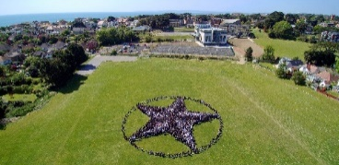

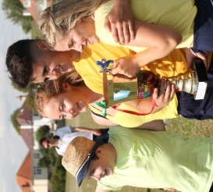 | 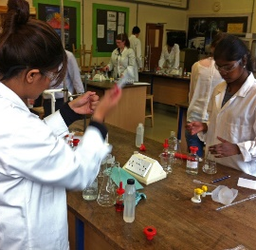 | 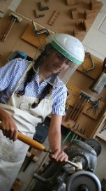 | 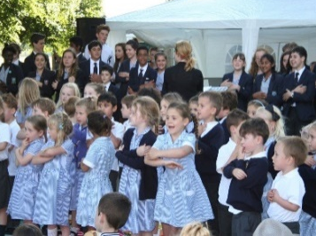 | 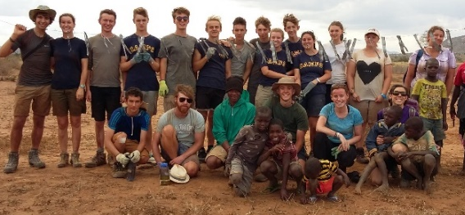 | 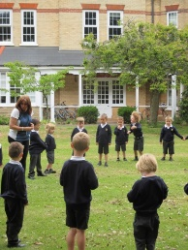 | 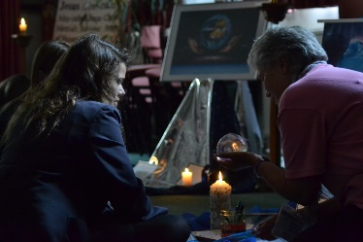

The Vision  St Peter's School is proud of its history and its heart. We are a Catholic School in the Diocese of Portsmouth, founded on the life, teaching and example of Jesus and the 350 year tradition of De La Salle education.  The School works tirelessly to provide a safe, supportive and spiritual environment, in order that its young people and staff thrive and become the people God wants them to be, where all our brothers and sisters love to learn and learn to love. | St Peter’s is a school where young people…  - Continually develop their personal relationship with God  - Respect, appreciate and care for others within and beyond their community  - Are independent and collaborative learners  - Develop their knowledge, understanding, skills, creativity and imagination  - Are inquisitive, ambitious and excel in all that they do  - Do their best and aspire to be their best  - Are persistent, not afraid to make mistakes and learn from them  - Are actively involved in their lessons so, in class, they work even harder than their teachers | St Peter’s is a school where staff…  - Appreciate that their role is a vocation and they are passionate about touching and winning the hearts of the young people, recognising the Christ within them  - Create a safe, supportive and spiritual environment  - Develop professionally and have the opportunity to develop spiritually  - Enable young people to be prepared for learning and for life beyond school  - Encourage great aspirations  - Plan and teach engaging lessons that effect deep learning and thus exceptional progress for every young person

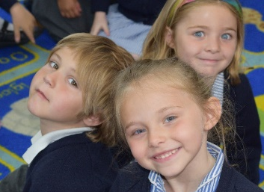 | 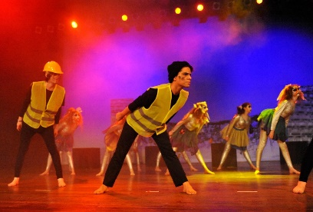 | 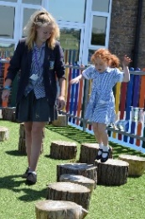 |  | 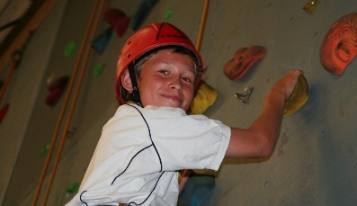 | 