Biology Teacher (part time c45-60% timetable)

Required from September 2019

We are looking for a well-qualified and dynamic Teacher of Biology to join our successful Biology department on approximately a 45-60% timetable. The ability to teach Biology to GCSE level and the ability or potential to teach to A level are essential. The successful candidate will work with the department to promote a love of science both inside and outside the classroom. A willingness to contribute to the extra-curricular activities of the School will also be required.
Applications are equally welcome from newly qualified teachers (for whom statutory induction would be provided) or from more experienced applicants.
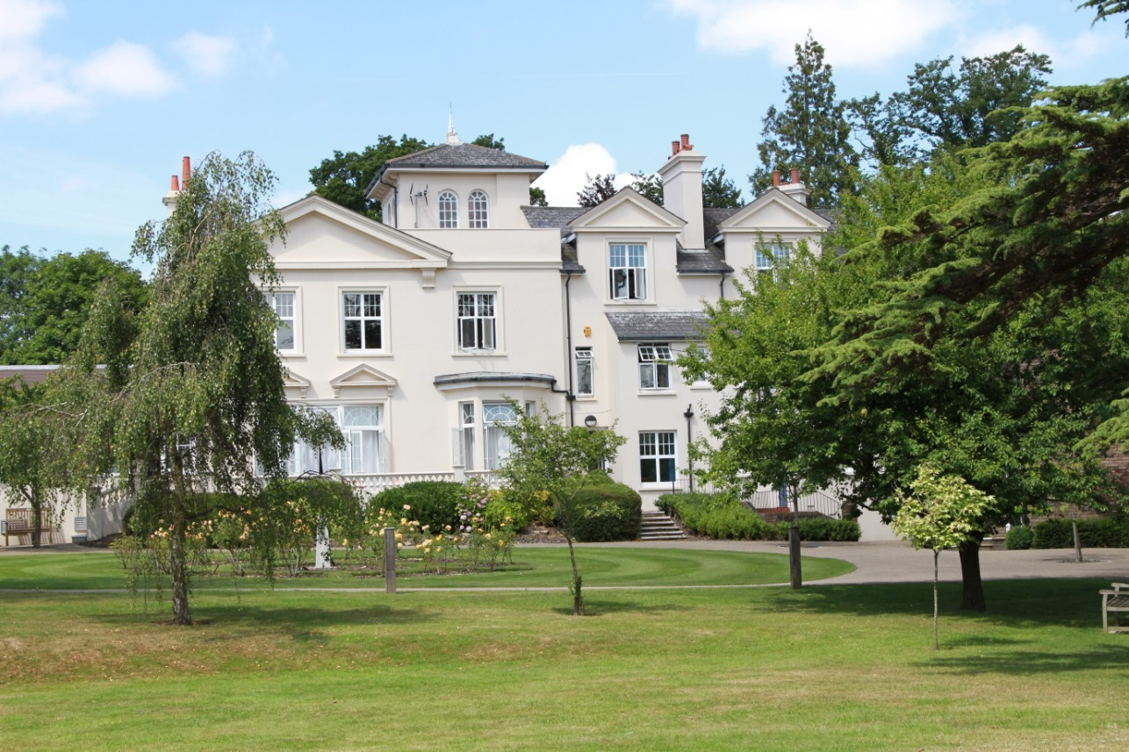

ABOUT THE SCHOOL

Burgess Hill Girls is a GSA day and boarding school, with 450 students aged between 3 and 18 years. The majority of students are of above average ability and the school has an outstanding record of academic success at both GCSE and A level. Last year, nearly all pupils obtained at least 9 or more GCSE passes at Grade 4 or above and the vast majority of sixth formers proceeded to Higher Education. The School offers a full range of GCSE and A-Level courses in preparation for university entrance.

The School is situated in a very pleasant thirteen acre site in the conservation area of the town. Burgess Hill is a medium sized town with its own theatre, orchestra, cinema and leisure centre. Burgess Hill is approximately ten miles from Brighton and Lewes, fifteen miles from Crawley and fifty miles from the centre of London. It is well served with fast roads – the M23 and M25. The school is three minutes’ walk from the railway station.

Facilities
The School is a blend of Victorian buildings and ultra modern facilities and there has been a steady development of the facilities.

Pastoral care
Our pastoral system is designed to encourage and support the development of each individual student from the moment she arrives in school until the time she leaves. We want to provide each student with the skills and confidence to help her to make the most of her time with us, at university and beyond. Implicit in the School aims is the expectation that every teacher will accept responsibility for the development in each pupil not only of the highest academic standards, but also of the confidence and self-esteem, which comes from being valued as an individual within a community.

Co-curricular and extra-curricular activities
We believe that education is about giving young people the chance to be successful in as wide a range of areas as possible, and to feel a sense of pride in their achievements. Extra-curricular activities give each student wonderful opportunities to explore her own talents and develop her individual skills to her full potential. The successful applicant will be expected to work effectively as part of the science team and play a full part in the wide range of co-curricular and extra-curricular activities with which the department is involved. They will be encouraged to draw on their own interests and expertise to assist the department in continuing to promote a positive image of the sciences throughout the school.

Science Departments

The Science Department has within it Biology, Chemistry and Physics Departments, each managed by a Head of Department.

There are currently eight members of staff teaching within the Faculty and three technicians providing technical support. There is a good team spirit amongst the staff with much co-ordination and sharing of ideas.

The Departments are very well resourced with six purpose built laboratories, two each for Physics, Chemistry and Biology all equipped with interactive whiteboards.

Biology Department

FACILITIES

The Biology Department is situated on the lower floor of the Science wing of Webb House. There are two modern, well-equipped laboratories and a preparation room. Developing respect for and an awareness of living organisms is an important part of Biology and the department keeps living specimens of warm-water, and cold-water fish.

The Science area also has two suites of ten laptop computers, with wi-fi connection to the internet and school intranet. All laboratories are furnished with interactive whiteboards. Technical support is outstanding.

LOWER SCHOOL CURRICULUM
Year 7
The three sciences are taught by one teacher in Year 7 with an allocation of five 40 minute periods of Science per week, taught in their mixed-ability Tutor Groups. The Biology topics studied include Cells and Tissues, Human Reproduction and Diet and Digestion.
Year 8
Biology is part of a co-ordinated Science programme, with pupils placed in sets, to enable work to be targeted more effectively and to provide a more appropriate pace. Biology is taught as a separate subject, for two periods per week. Pupils continue their studies with topics in Plant Nutrition, Circulation, Health and Disease and Genetics.
Practical work is included in as many topics as possible throughout the Lower School.

UPPER SCHOOL CURRICULUM
Years 9-11
All pupils take GCSEs in the sciences. In September 2016 we began the AQA GCSE courses. Pupils taking Combined Sciences - Trilogy (specification 8464) are taught Biology, Chemistry and Physics separately, by three subject specialists. They have nine 40 minute periods of science per week.

Triple Science
Students with a strong interest in the sciences can choose to take Biology, Chemistry and Physics as independent subjects. GCSE Biology (specification 8461) is taught by a subject specialist. The combined time allocation for all three separate science subjects is fourteen 40 minute periods per week.

A variety of teaching and learning methods are employed with an emphasis on practical work carried out in small groups.

SIXTH FORM

Sixth Form students study the OCR Biology (A) A level Syllabus, specification H420. Each year, several of our students go on to study veterinary science, dentistry, medicine and science-related degrees.

Teacher of Biology

Duties and Responsibilities

- Implement and deliver an appropriately broad, balanced, relevant and differentiated curriculum for pupils within the Science Department
- Undertake a designated programme of teaching up to A level
- Teach pupils according to their educational needs, including the setting and marking of work
- Assess, record and report on the attendance, progress, development and attainment of pupils and keep such records as are required
- Undertake assessment of students as requested by external examination bodies, departmental and school procedures
- Provide, or contribute to, oral and written assessments, reports and references relating to individual pupils and groups of pupils
- Ensure a high quality learning experience for pupils which meets internal and external quality standards
- Prepare and update subject materials
- Use a variety of delivery methods which will stimulate learning appropriate to pupil needs and demands of the syllabus
- Ensure that school aims related to ICT, literacy and numeracy are reflected in the teaching and learning experience of the pupils
- Maintain discipline in accordance with the school’s procedures and encourage good practice with regard to punctuality, behaviour, standards of work and homework
- To play a full part in the life of the school community, to support its distinctive mission and ethos and to encourage staff and students to follow this example
- To promote actively the school’s corporate policies
- To comply with the school’s Health and Safety Policy and undertake risk assessments as appropriate
- Undertake any other reasonable duty as specified by the Head

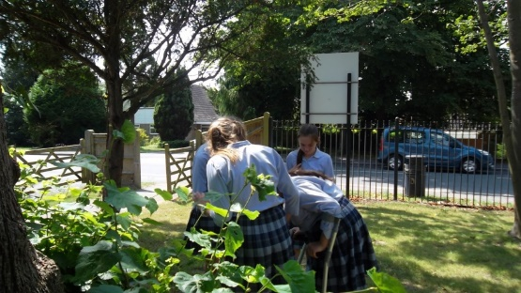

REQUIREMENTS FOR THE POSITION

- We are seeking an innovative, lively teacher of Biology

- Honours degree

- Experienced teacher or new to profession

- The role will suit someone with the ability to teach to A level, with a talent for teaching a mix of abilities.

- The successful applicant will be expected to work effectively as part of the team and play a full part in the wide range of curricular and extra-curricular activities with which the department is involved. He/she will be encouraged to draw on their own interests and expertise to assist the department in continuing to stimulate a positive image of science throughout the school.

RECRUITMENT PROCESS

Candidates are required to submit an application form with supporting letter and details of two referees. One reference should be able to comment on the teaching skills of the candidate. References will be taken up prior to interview.

Closing date for applications is 5.00pm on Tuesday 19th March 2019

Short-listed candidates will be contacted by telephone and interviews will take place on Wednesday 27th March 2019.

Candidates who have not heard from the School by the end of March should presume that we will not be taking their application further.

Candidates will be required to teach a short lesson on a topic to be decided and attend an interview. They will also meet with key staff and be offered a tour of the School.

All appointments are made in accordance with our equal opportunities policy and applicants should let us know of any special needs they may have.

The School is committed to safeguarding and promoting the welfare of children and applicants must be willing to undergo child protection screening appropriate to the post, including checks with past employers and the Disclosure and Barring Service.

