CLL

May 2019

Dear Candidate

Thank you for your interest in the post of Student Support Assistant. Please download all the information you need to apply for the job:

- Application form
- Notes to assist with the completion of the application form
- Job description
- Person specification

References will be taken up for all short listed applicants. The successful applicant will be required to undertake enhanced DBS clearance.

Completed application forms should be returned with your letter of application to
Caroline Collings, PA to the Headteacher, at the school, by the closing date
Wednesday 22 May 2019 at 9.00 am. Interviews will be held on Friday 24 May 2019.

Please make sure you add sufficient postage, we have received applications after the appointment has been made resulting in disappointed applicants.

Applicants who have not been called for interview, within 7 working days following the closing date, should assume that their application has been unsuccessful.

I would urge you to find out more about the school by exploring our website. We are very proud of our achievements and have a committed and talented staff team.

Southfield School is committed to safeguarding and promoting the welfare of children and equal opportunities in employment

Kind regards

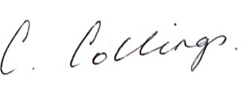
Caroline Collings
PA to the Headteacher

