0

Fulneck School
Information for Candidates
In Essentials Unity,
In Non-Essentials Liberty,
In All Things Charity

SCHOOL INFORMATION

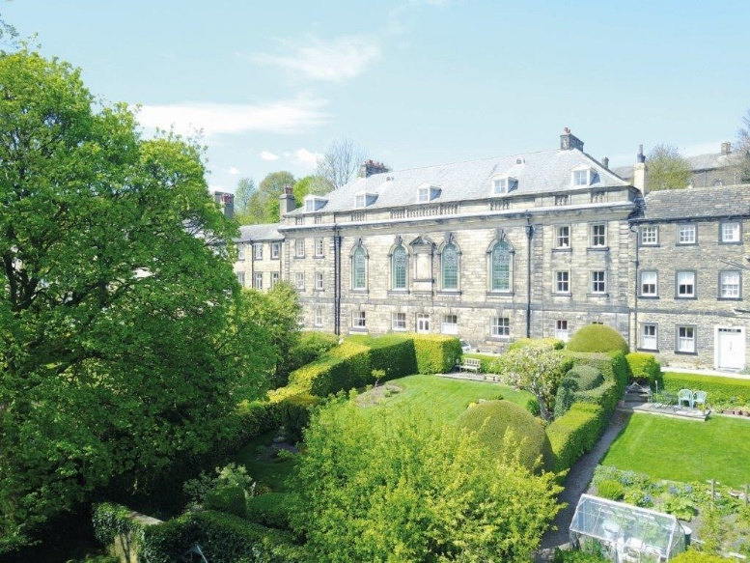

The School

Fulneck School is an independent day and boarding school for boys and girls aged 3-18. We are situated in a traditional English village just 5 miles from Leeds city centre. With easy access by air, rail and road, yet set in the beautiful Yorkshire countryside, Fulneck School is an ideal choice for parents looking for a day or boarding school for their children.

We pride ourselves on setting high expectations for every individual, instilling good manners and fostering an ethic of hard work. Our community is enriched by the cultural diversity of our pupil body, with day pupils coming to us from across Yorkshire and boarders from all over the world. Pupils experience outstanding opportunities inside and outside the classroom, learning how to work in a team and how to provide the leadership that our society needs.

We are a small school and therefore offer a more personalised education than many other schools. Parents choose us for our small class sizes, focus on individual needs, whether that be an Oxbridge education or additional support in our award-winning Learning Support Unit, and the warmth of our environment.

The Junior School is housed in the main east building of the School. There are a number of separate teaching blocks including those for Science, Sixth Form, Creative Arts and Design and Technology. Other departments are housed in the main buildings. A separate Learning Support Unit offers specialist help with dyslexia for both Junior and Senior School pupils. In addition, the school has an EAL unit to assist overseas students for whom English is not their main language.

There are two boarding houses; the boys’ house is located in the main west building and the girls’ house in the main east building. There is a large gymnasium and there are several tennis courts, together with extensive playing fields. Pupils also make use of the facilities at the local leisure centre for swimming and other sports activities.

A continuous programme of upgrading and enhancing facilities has resulted in the creation of new Junior and Senior libraries, a fifth ICT facility, a new suite of classrooms, a newly refurbished Sixth Form Centre, as well as the extension and refurbishment of the boarding houses during the last four years. The Senior Leadership Team and Governors are currently exploring new initiatives to further enhance the facilities.

The School underwent an Inspection under the new Independent School Inspectorate (ISI) format in 2017. The judgements of excellent and good for pupils’ personal development and achievement confirmed that the school is thriving. The Inspection Reports are available on the school’s website.
Staff

There are over 50 members on the teaching staff. Support staff includes the Estates, domestic and catering teams, Librarians, ICT and laboratory technicians, boarding house staff, School Nurse and secretarial personnel.

Pupils

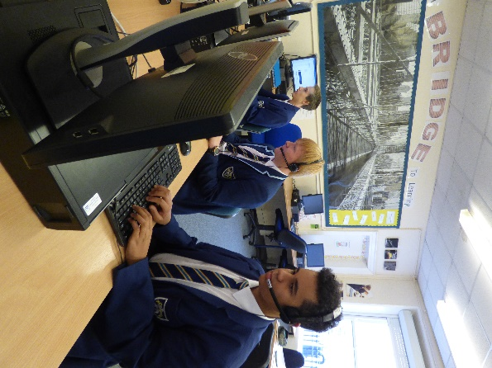
On the current roll there are approximately 300 pupils aged 3-18. Of these, around 200 are in the Senior School, with 50 full or weekly boarders. Over half of the Senior School pupils enter through our Junior School, with the remainder joining us from feeder schools after the entrance examination each year.

As the school is largely non-selective there is a broad ability range with pupils who are academically more able, as well as those with Additional Learning Needs, particularly dyslexia. A proportion of the boarders also receive support with English as an Additional Language.

Governing Body

The School comes under the authority of the Moravian Church through its Provincial Board, the members of which act as the Trustees of the School. The Board of Governors consists of local men and women from a variety of professions including education.
The Board of Governors meets at least twice per term and its committees more frequently.

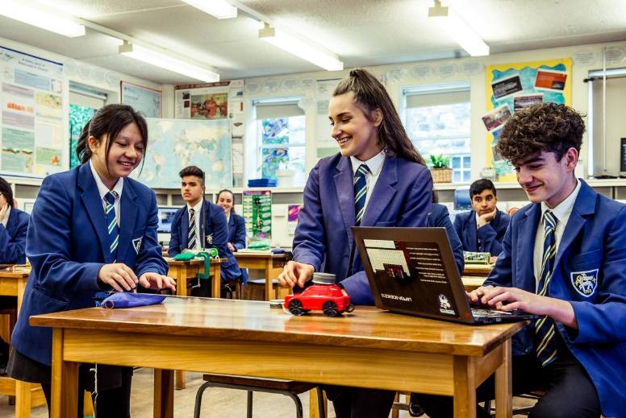
School Philosophy

Our Core Values: In essentials UNITY, in non-essentials LIBERTY, in all things CHARITY.

We emphasise:
The value of each individual, by encouraging the development of intellectual, physical and spiritual qualities to the full; the importance of the highest personal standards of integrity; self-discipline and scholarship.

We aim to send out students who are:
- Justifiably proud of their academic achievement

- Mature, confident and capable young men and women

- Generous in spirit, tolerant and sensitive to the needs of others

- Aware of the responsibilities of adulthood and parenthood

- Positive in attitude about their contribution to the wider community.

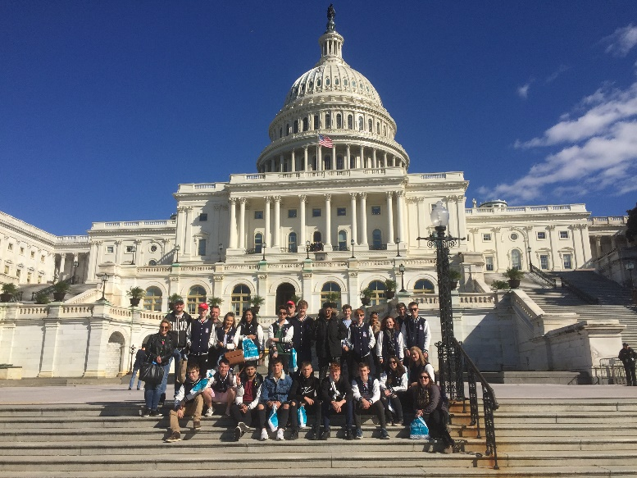

In order to achieve our aims, we are committed to a particular school profile:

- We shall remain a comparatively small school. In this way we can know each individual well and maintain the quality of our pastoral care.

- We provide for all-round academic achievements, with a curriculum encompassing numeracy, literacy, languages, creative arts, humanities, sciences, technology and physical education, preparing students for higher education and adult life.

- We appreciate family loyalty; we are pleased to accept sisters and brothers of school pupils unless there are special educational needs which we cannot meet

- We balance the academic and social needs of the boys and girls in the various stages of their school careers.

- We encourage all pupils to participate in extra-curricular activities.

- We have a constructive and positive attitude to discipline; our expectations of appearance, courtesy and behaviour are high and we implement a firm but fair policy in which self-discipline can develop.

- We provide appropriate opportunities for co-operation, self-reliance and leadership throughout school life.

- We value the part the school can play in the life of the Fulneck Settlement and in the local community and we encourage links which strengthen these relationships.
- Candidates should be in sympathy with the school’s philosophy and Christian ethos and be comfortable attending Assemblies in our Church.

Further details of the school are available on our website
www.fulneckschool.co.uk

Working at Fulneck School
We are a small and warm community which is looking to move forward and ensure that we are providing an education that prepares pupils for the exciting yet challenging world that awaits them.
Members of staff at Fulneck School receive free car parking, use of our dining room and 75% remission on school fees (80% if more than one child).
Fulneck School is committed to safeguarding and promoting the welfare of children. Child protection screening will apply to this post, including checks with past employers and the Disclosure and Barring Service. Candidates should be aware that provision of false information is an offence and would result in the rejection of the application or summary dismissal if the applicant has started their employment at the school. In such a case, the individual may be referred to the police and the DCSF Children’s Safeguarding Operations Unit.

