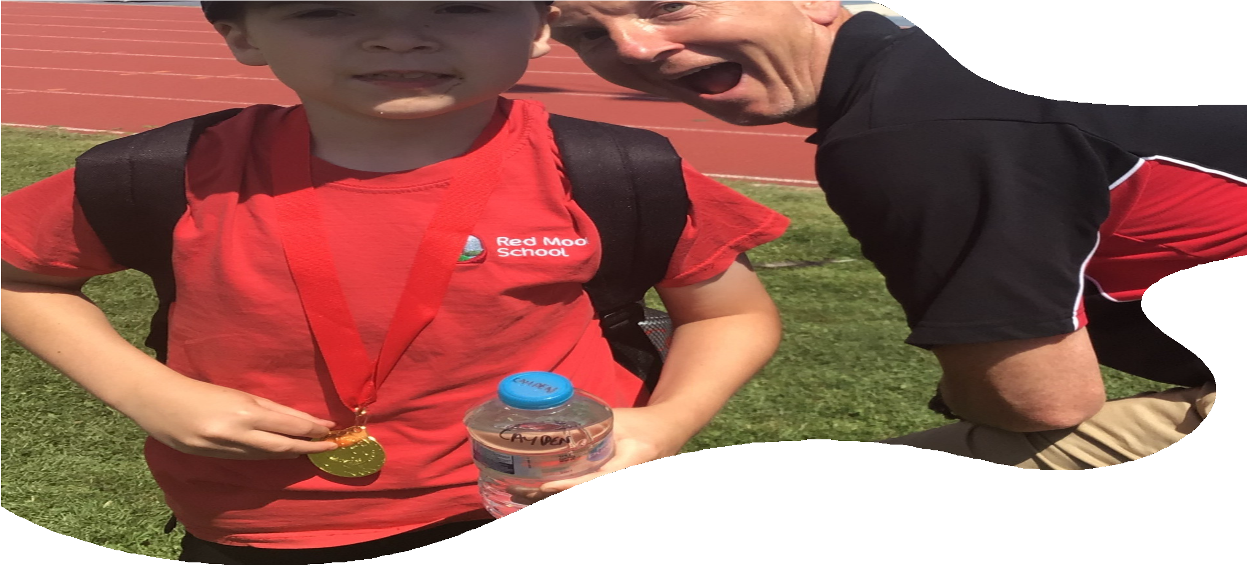

RED MOOR SCHOOL
The Best Education for Every Child

INFORMATION FOR PROSPECTIVE CANDIDATES

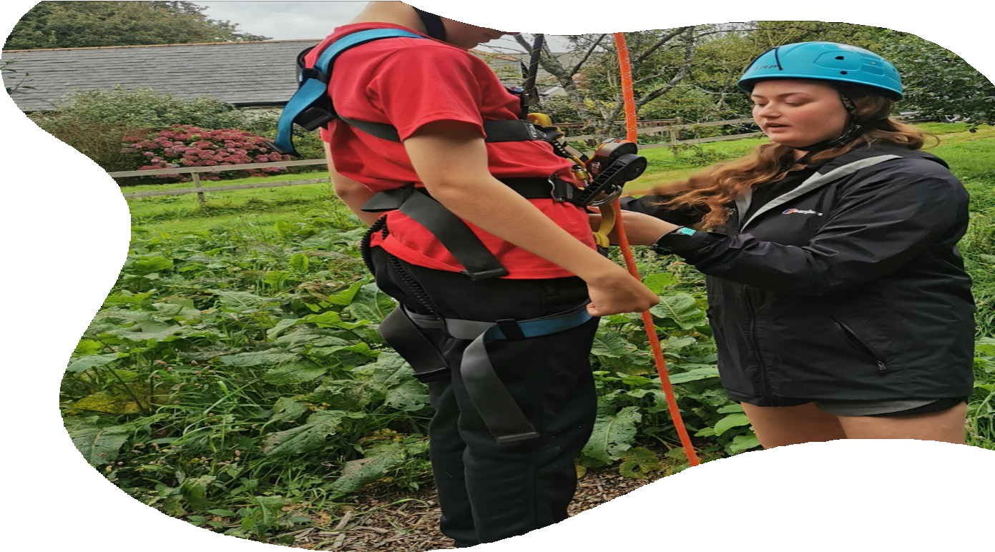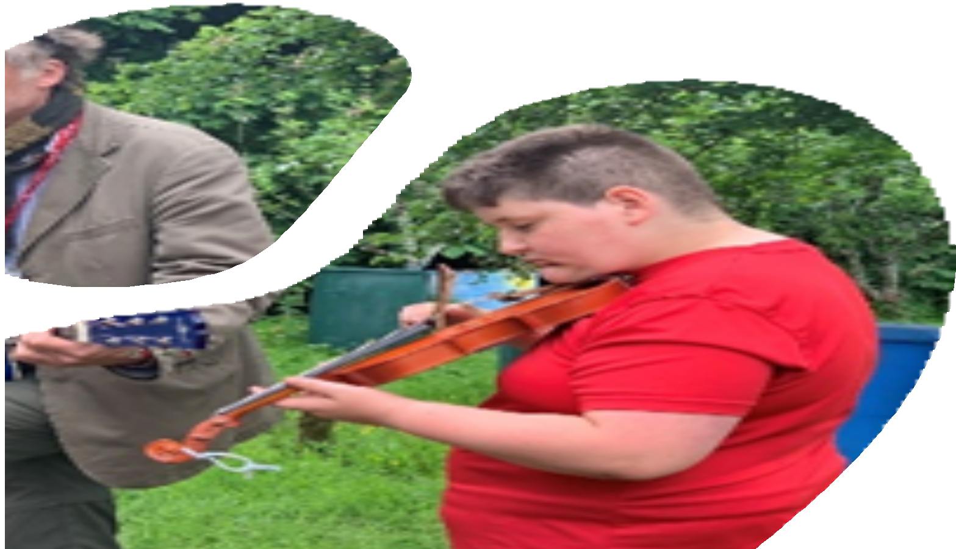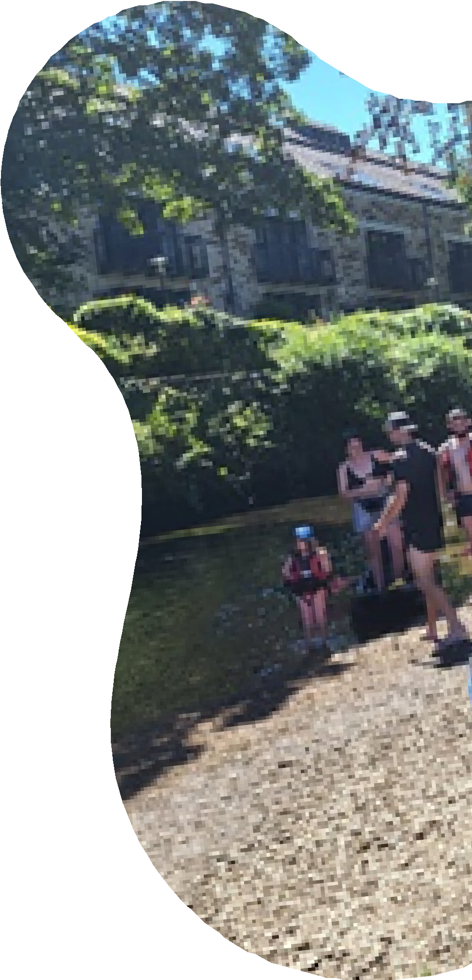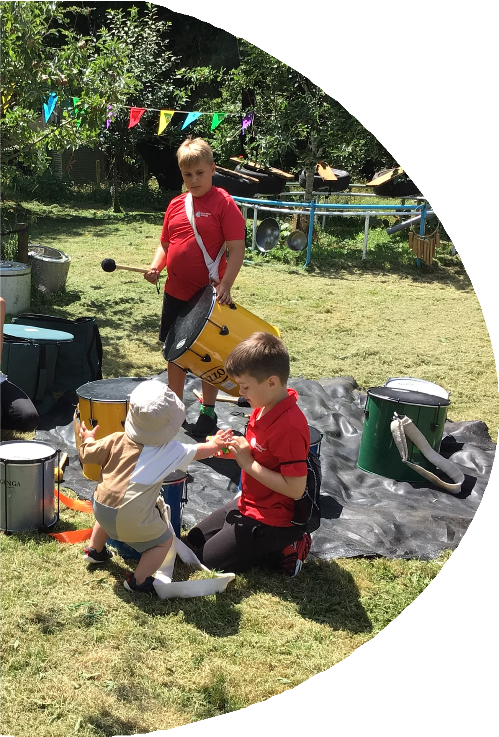

2


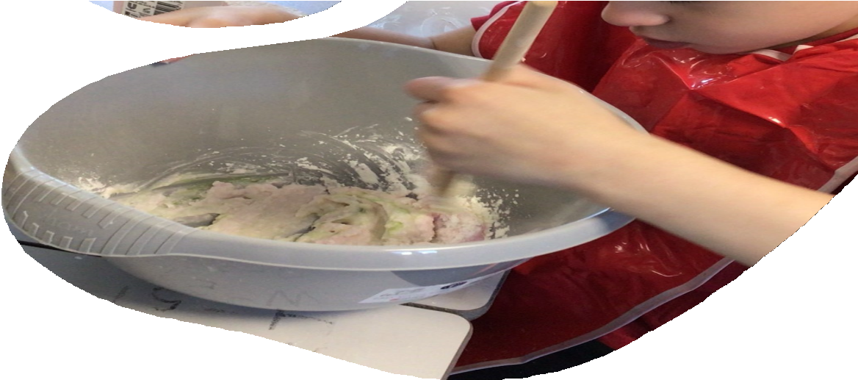WHAT IS RED MOOR SCHOOL LIKE?
Red Moor School is a school like no other in Cornwall. We take children from across the county who have consistently struggled in education due to a wide range of needs.
The majority of our students have an Education Health Care Plan where the primary need is identified as Social, Emotional, Mental Health needs, and around 50% of our students have a diagnosis of autism and related conditions. Our students range in age from 5 to 18 years old. We have expanded over the last three years, so that we are now registered to take up to 80 students so that we can help more young people from across Cornwall to access the BEST education!
We work on a relational model with our students, their families and any members of a wider professional team around them, to ensure that we help to restore their faith in education and are able to thrive once again and meet their potential.

The school is set in beautiful grounds in Lanlivery, near Bodmin. As well as a range of well-resourced teaching spaces, we have a dedicated Science Lab, DT and Art block, Catering classroom, Performing Arts Hall, MUGA, Outdoor Classroom, Vocational Area, Dining Hall, Outdoor Education Workshop, Immersion Room and suite of therapeutic spaces at our disposal. In addition to our fantastic building and facilities, we have a large outdoor area, incorporating a lake and pond area that is an area for development for us, an adventure playground, including a climbing tower, zip line and network of tunnels. We are looking to continue the development of this further in the coming years to ensure that we maximise the use of every space at our disposal.

3


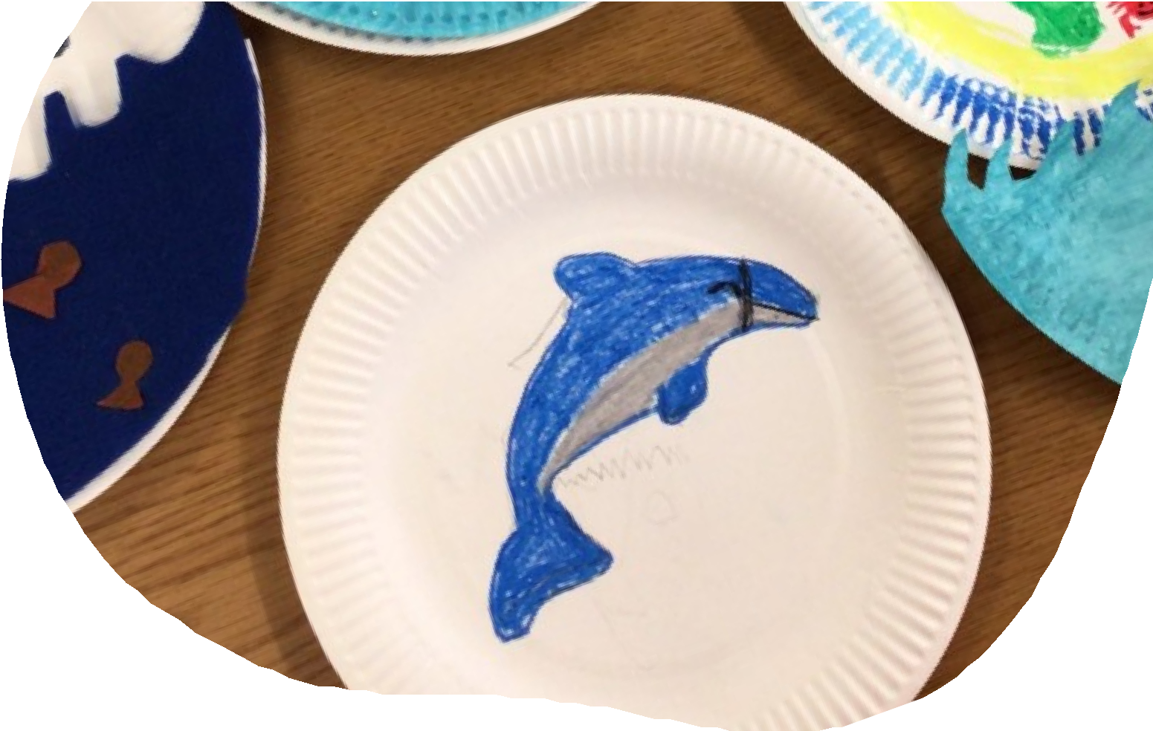WHAT DO OUR STUDENTS SAY ABOUT US?

[Red Moor School] staff don’t really do it for the money, they care about the students.

“I feel like this school has its own soul. It feels so human here. The teachers don’t act; it’s like a mini family.

BEST. SCHOOL. EVER
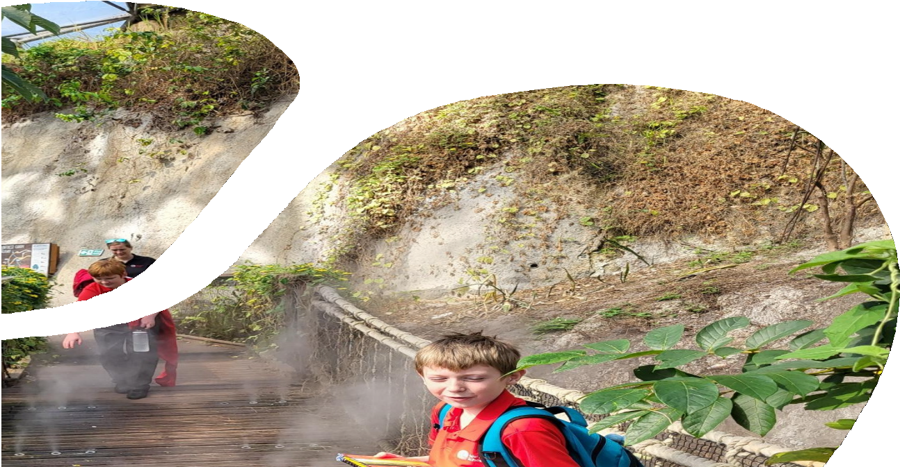The school helps me dealing with being anxious. I couldn’t cope when shut and my tics were worse, they are better now I am here
The schools helps me because the staff tell people to stop if they are picking on me and they help me with my work

THE SCHOOL HELPS
ME WITH EVERYTHING, DAYS
TO DAY LIFE
7


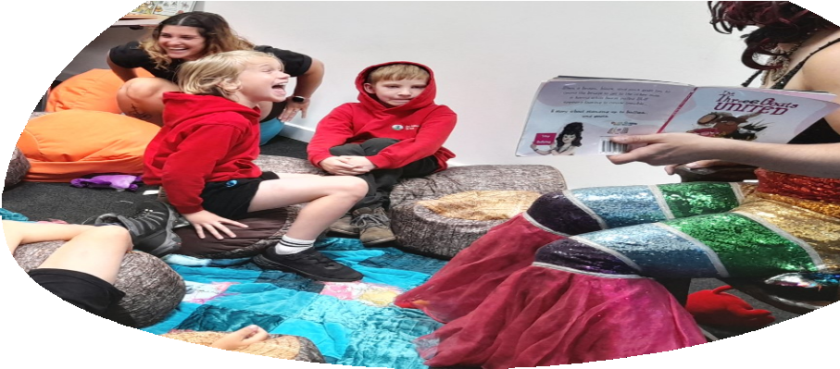
WHAT THREE WORDS - THE STUDENT EDITION!

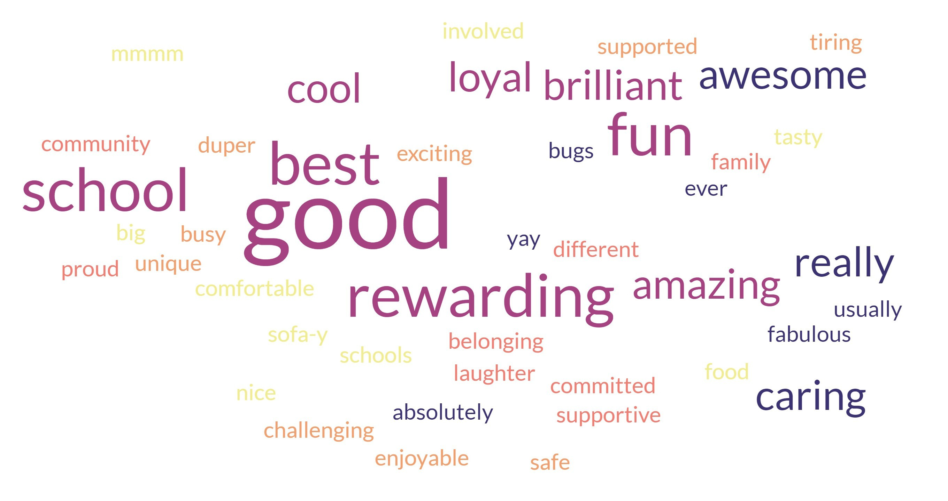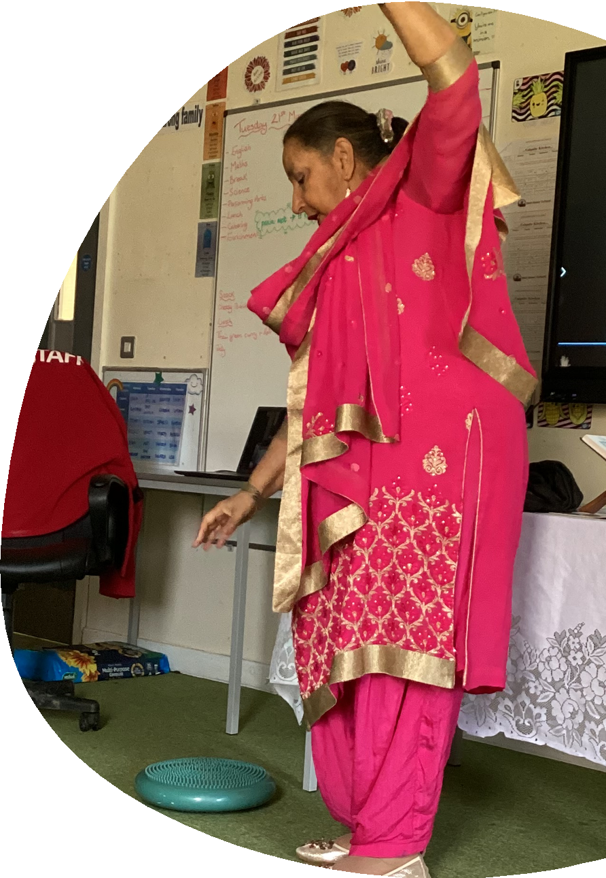We asked our students to share what three words they would use to describe the school...here are some of the highlights!

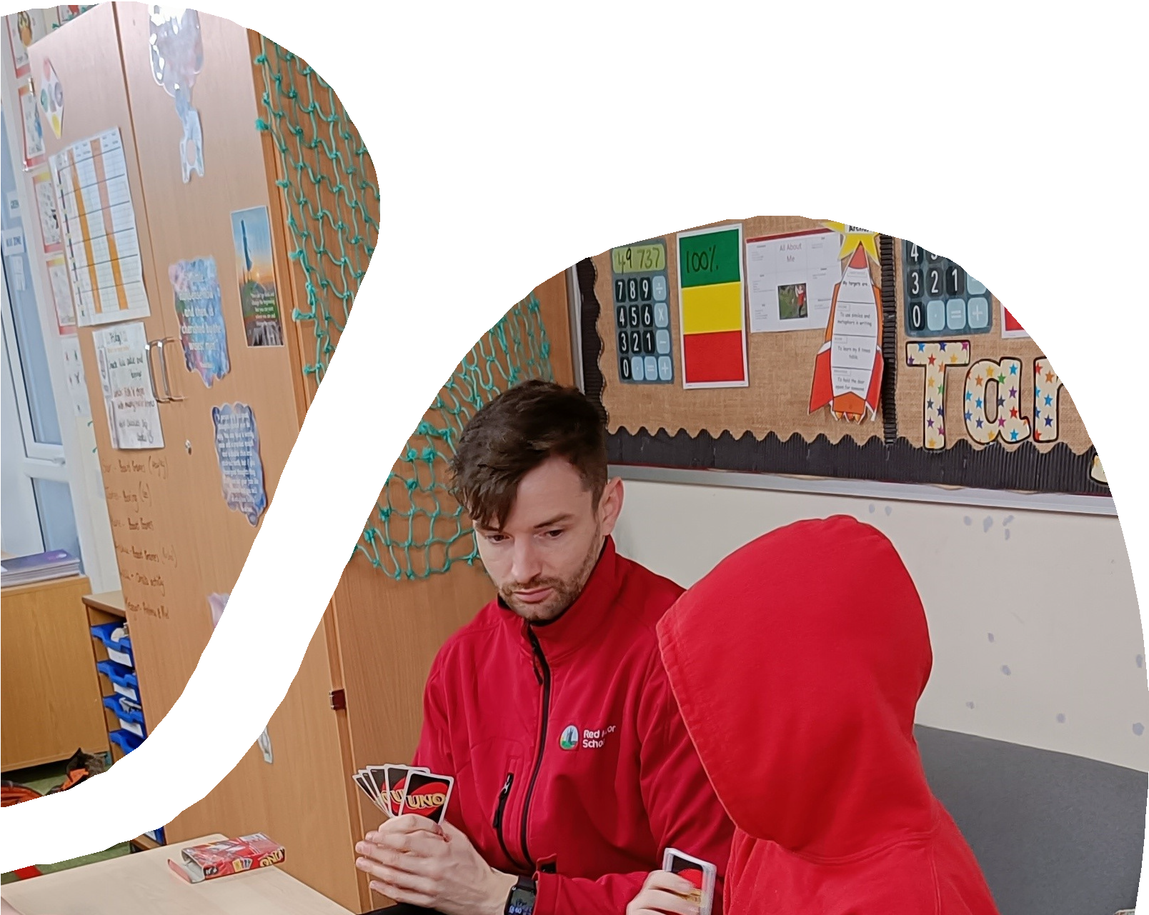8


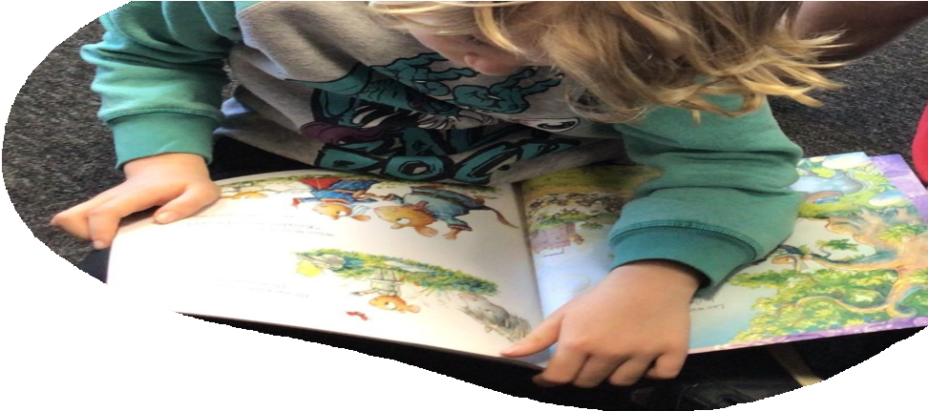WHAT DO OUR PARENTS SAY ABOUT US?

We have been amazed how far he has come with his learning and how much he has achieved in such a short time.

I AM VERY PLEASED TO HAVE [MY CHILD] AT THIS SCHOOL. YOU ALL GO ABOVE AND BEYOND TO HELP THE STUDENTS AND THE
PARENTS.
IIT IS THE BEST PLACEMENT WE HAVE EVER HAD.

I would definitely agree that you have made a positive impact upon [my child] and we don’t want that to change
I’m so grateful to the whole Red Moor Team for everything they have done and continue to do.

IT’S SO NICE FOR [MY CHILD] TO FINALLY BE WHERE HE IS UNDERSTOOD BETTER AND NOT JUST CLASSED AS A NAUGHTY CHILD. THE FACT HE ACTUALLY WANTS TO GO TO SCHOOL
NOW IS A HUGE IMPROVEMENT.

I HAVE SAID IT BEOFRE, AND I WILL SAY IT AGAIN: ALL OF YOU AT RED MOOR REALLY DO CHANGE LIVES FOR FAMILIES LIKE OURS
I am overwhelmed with emotion every time I think about how far
[my son] has come over the past two years

I can’t thank you enough for what you have done for our family and getting together to help us at a time of need. You have all gone above and beyond, we will be forever grateful.

9


WHAT IS IT LIKE TO WORK HERE?

In the same way as it is for our students, no two days are the same for our staff! You will also access the full curriculum we offer to our students – so you could equally be assisting students learning maths through archery and then heading off to climb Helman Tor, before helping to run ay of a wide range of enrichment activities at the end of the school day – the only limit to our offer and your experience is your own imagination!

We want to offer our students every possible experience, so if you have a skill set you would want to share with them – whether it is circus skills, carpentry, game keeping or knitting, we want to know and make use of all of your skills to help nurture and inspire our students to make the most of every opportunity!

The staff team here is incredible – they are really supportive of one another and cerate the amazing positive atmosphere of our school. In our recent Great Place to Work survey, 100% of our staff said Red Moor School is a great place to work – which speaks for itself!
We take the emotional wellbeing and mental health of our staff seriously. We work with some of the most challenging young people in Cornwall, and this means we ensure that there are appropriate levels of support in place for our staff.

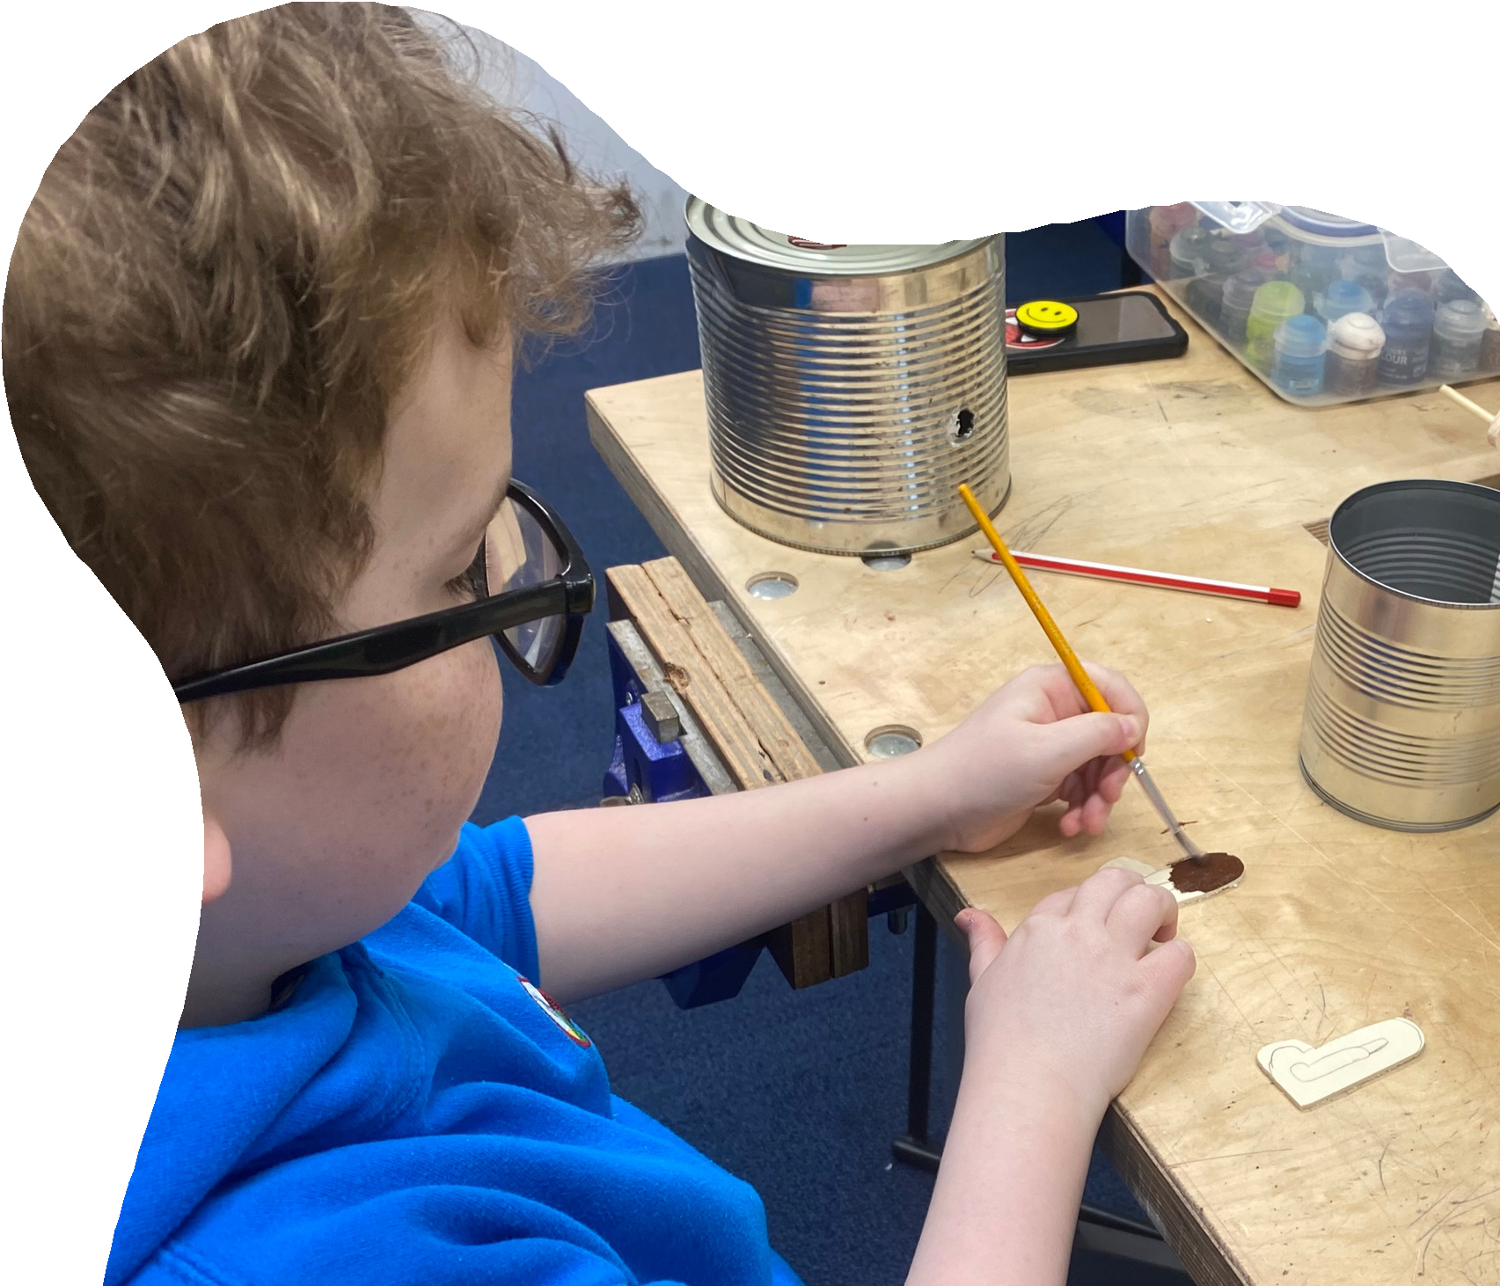From regular training to help you meet the needs of our students, to access to a full therapy team for advice and guidance, supervision and a healthy approach to staff social events, we have staff wellbeing at the heart of what we do. You will also have access to a whole range of discount schemes and benefits from the wider company – have a look at the additional information included with this advert to see the kinds of things you can access as a member of staff at the Outcomes First Group!
15


WHAT DO O STAFF SAY ABOUT US?

NEVER A DULL MOMENT!

Red Moor school is a great place to work, with a great team.

REALLY GOOD WORKING RELATIONSHIPS WITH BOTH STUDENTS AND STAFF.

THE BEST WORKPLACE FOR SUPPORT FROM BOTH SENIOR LEADERSHIP AND OTHER STAFF MEMBERS. STUDENTS ARE ALSO AMAZING, NO DAY IS EVER THE
SAME.
I am so grateful for the opportunity to work in such an incredible school like Red Moor. I thoroughly enjoy my role and the team around me. I could not think of working anywhere else now. Thank you all so much!

I REALLY ENJOY WORKING AT RED MOOR SCHOOL AND I AM PROUD TO TELL OTHER PEOPLE WHERE I WORK.

In my 10 years+ working in special education I have never worked somewhere were staff and students are as supported and cared for as at Red Moor. There is a massive family feel and everyone has everyone's back.

I think it says a lot that, even in a relatively challenging environment, the team are still positive, cheerful, and enthusiastic. All staff go out of their way to help and
support each other, which is great!

16

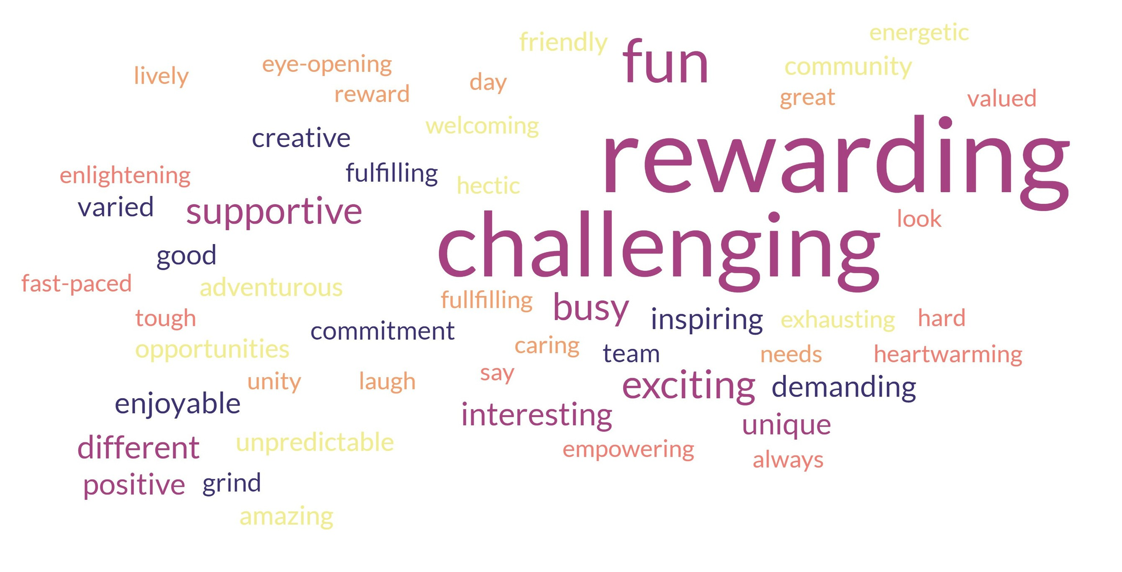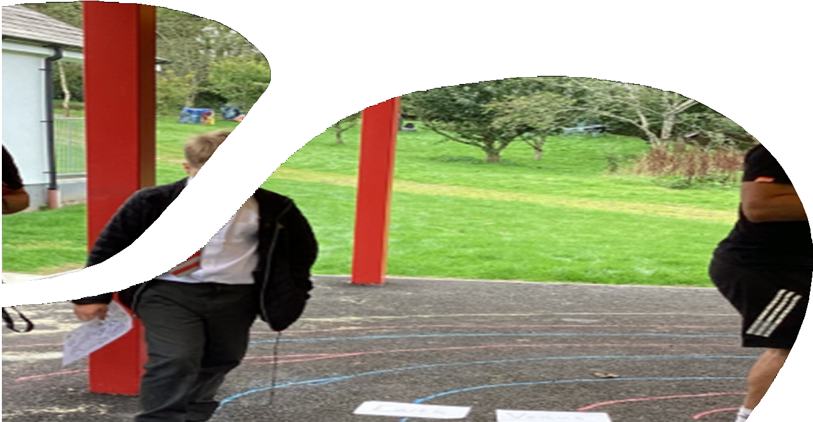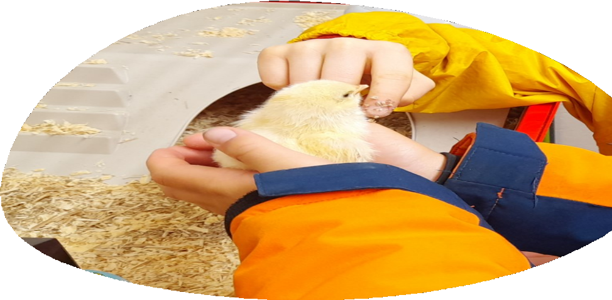


WHAT THREE WORDS - THE STAFF EDITION!

When asked to give three words to describe what it is like to work at Red Moor, here is what our staff said!

22

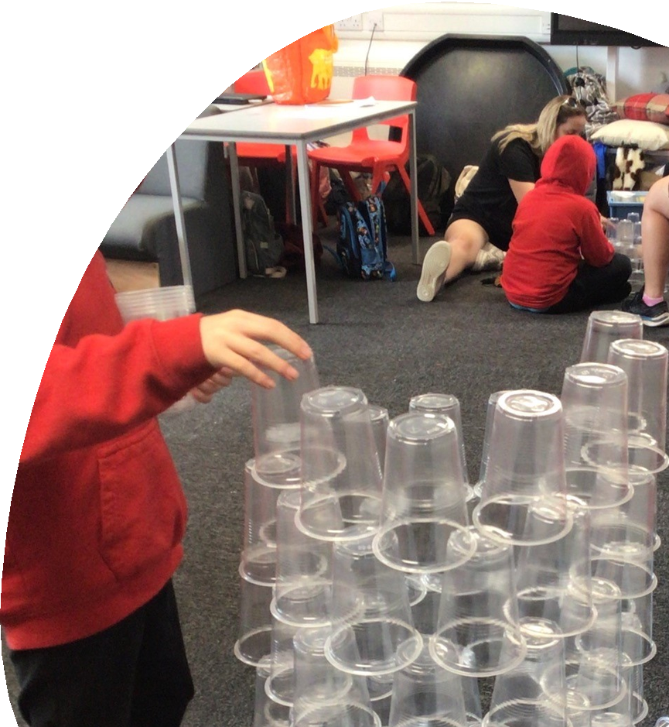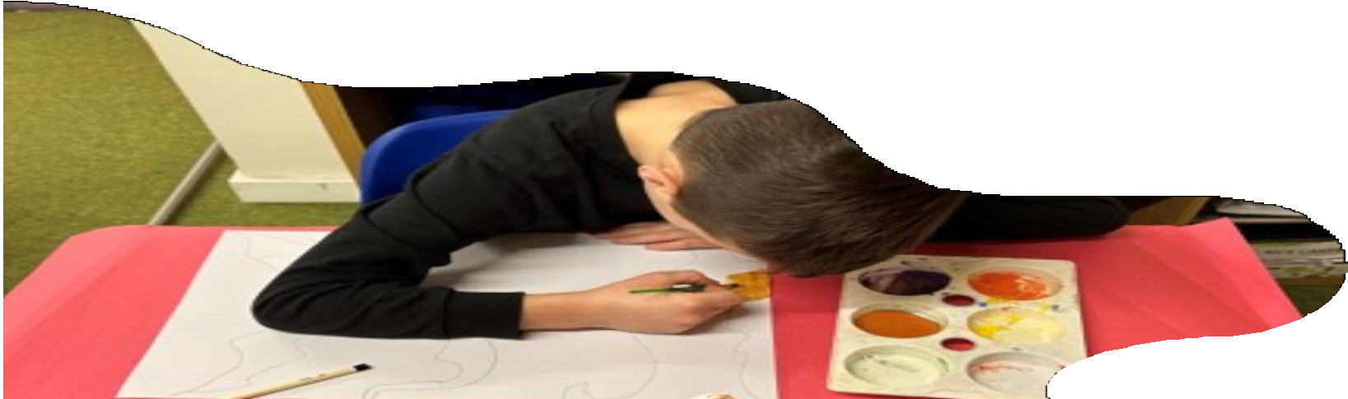


CONTACT DETAILS

We hope that you have enjoyed finding out a little bit more about what it would be like to work at our school.
If you would be interested in arranging a visit to the school, please do not hesitate to contact the school office on 01726 219 472, where one of our administration team would be delighted to arrange a visit for you.
All of our interviews are a full day experience, giving you the opportunity to spend the day with us, find out more about our school, speak to students and staff and really find out what it means to be a part of Red Moor School.
We hope you decide to submit an application and that we get to meet you soon!

23

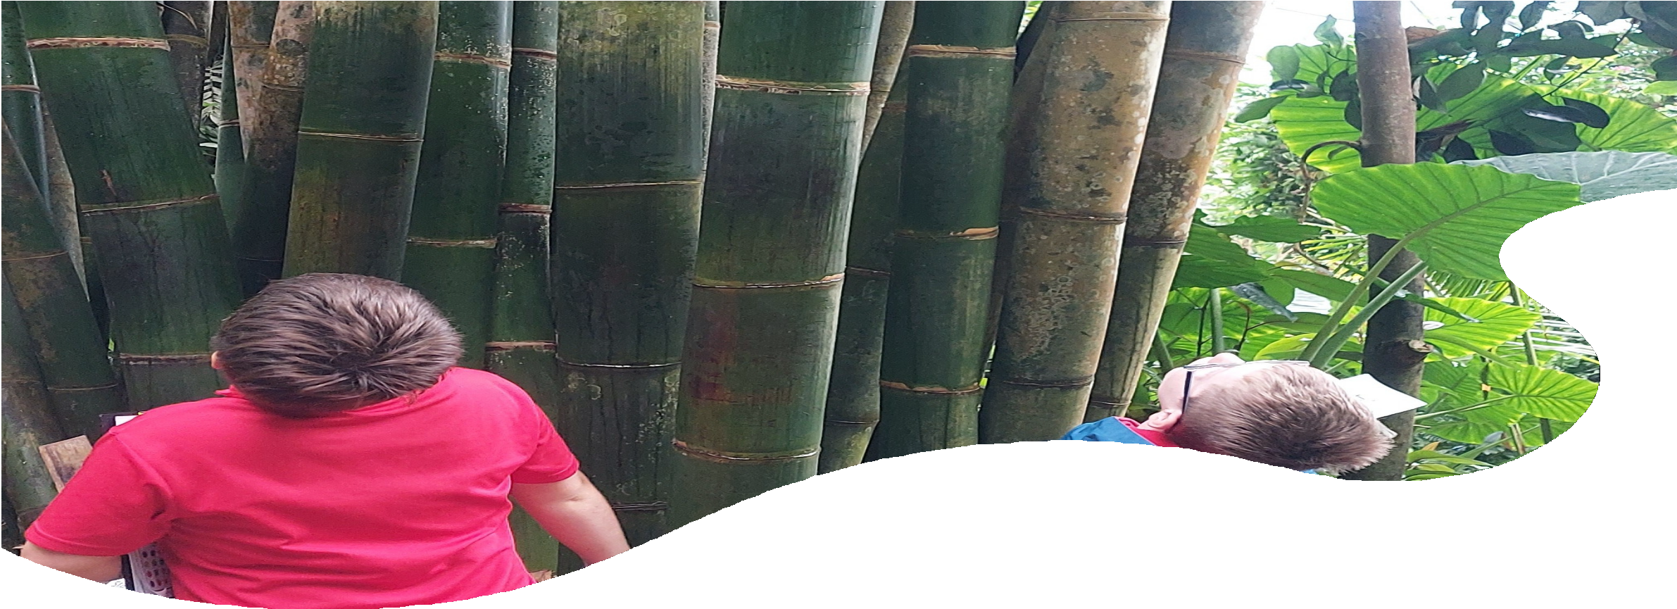

Our site is located amongst the beautiful Cornish Countryside and makes the most of it’s surroundings and has formed strong links with local businesses.

CONTACT US
 01726 219472
 enquiries@redmoorschool.co.uk www.redmoorschool.co.uk
 Red Moor School Churchtown Farm Lanlivery
PL30 5BT

