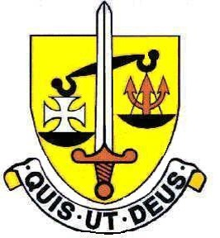
St Michael’s Catholic Grammar School
School Chaplain
JOB DESCRIPTION
- Job Title
School Chaplain (Lay or Ordained)
- Responsibility

The Chaplain is responsible for coordinating and facilitating the liturgical life of the School and reports to the Head of Religious Education.

- Liaison and co-operation

The Chaplain will work in liaison, and co-operation with:
- Other members of staff
- The Loreto English Education Network (As St Michael’s is now part of the Loreto Education Trust, the Chaplain will also work in conjunction with the Loreto English Education Network regarding chaplaincy work across all the Loreto schools)
- Members of the Inspectorate, Advisory and Support Services as necessary
- Parents, governors and the local community

- Tasks and Duties
The role of the Chaplain includes the following:

- Developing meaningful and lively liturgies in conjunction with the Liturgy Committee and the Music, Drama and Dance departments involving pupils from all years. Liturgies for the whole School take place at the end of each term, for the feast of St. Michael and the Holy Days of Obligation.
- Organising and overseeing the Voluntary Mass each Friday lunchbreak in the School Chapel prepared by each form in the School. Supporting the RE department staff in preparing students for this Mass. Staff and Sixth Form students are Eucharistic Ministers.
- Liaising with priests from the Diocese who come to officiate some Masses as well as the Sacrament of Reconciliation during Lent.
- Working with the Head of RE to organise retreats for each year group. Currently we use SPEC retreat in Pinner or the Niland Centre in Bushey as venues.
- Running the Justice and Peace and Integrity of Creation group and working with a small group of students to train them for Catechesis.
- Organise the annual pilgrimage to Lourdes.
- The role will also involve some administrative work as well as taking care of the Chapel and stock requirements for the Chapel.
April 2021

