

**Fairley House School**

DT Teacher and Subject Coordinator for January 2026 or earlier

### 

Vacancy Information

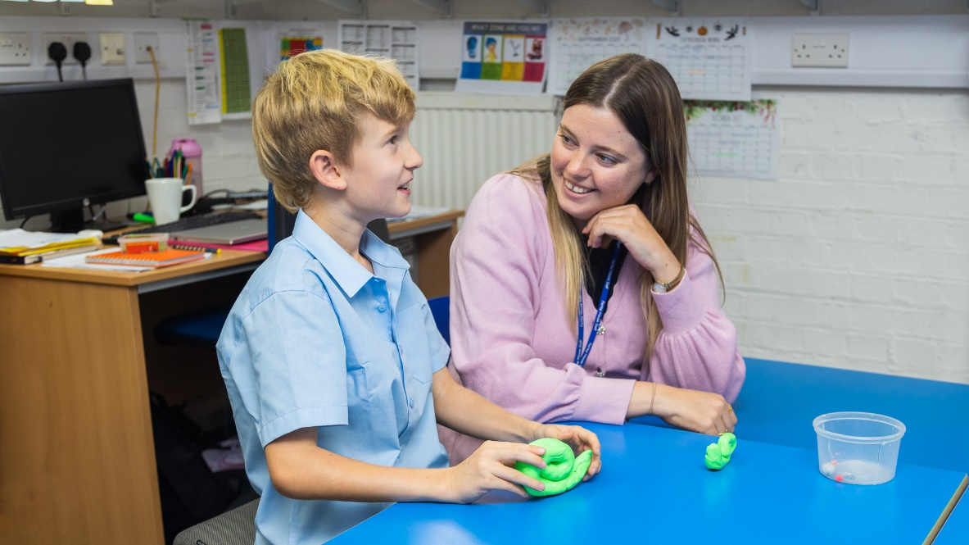

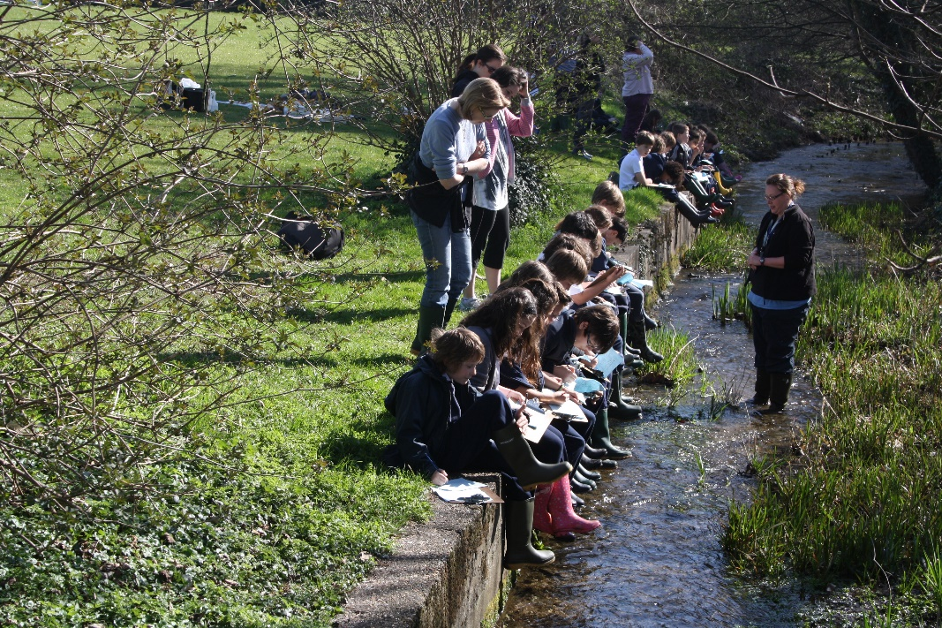London’s leading day school for children with specific learning differences

***and all of a sudden...nothing is impossible.***

**Introduction to Fairley House**

Fairley House is located in central London across two well-connected sites. The senior department (Years 8 to 11) is based in Westminster and the junior department (Years 3 to 6 and currently Year 7) is based in Lambeth. It is approximately 10-15 minutes walk between the two sites.

The school was established in 1982 by Daphne Hamilton-Fairley whose husband was killed by an IRA bomb in 1975. Mrs Hamilton-Fairley was a speech and language therapist who had been providing therapy for dyslexic children at home. As a parent with four children, two of whom were dyslexic, she knew how poorly understood dyslexia was and how badly it was addressed, mainly through hospital clinics.

She resolved to set up a school for dyslexic children as a memorial to her husband, hence the name Fairley House. She aimed to combine a medical focus: speech and language therapy and occupational therapy within a warm and nurturing educational setting. This pioneering, transdisciplinary approach has remained at the core of what we do and is part of our magic formula for success that transforms the learning outcomes of our students.

Currently the school is thriving with around 220 pupils, and we have had recent approval to expand our capacity to 250. We continually look at how we can remain at the forefront of the field of SpLD and our staff frequently contribute to ongoing research and best practice. This knowledge is shared through regular community outreach to local schools and other organisations to help improve the prospects of children in London and around the UK.

As well as being a school we also have an in-house Assessment Centre and offer Teacher Training to teaching professionals who wish to broaden their CV and areas of expertise.

**Distinctive features of the school and its governing structure.**

We are registered with the DCSF as an independent special school for specific learning differences. We have children from a range of socio-economic backgrounds and wide geographical area thanks to our enviable reputation. We have a mixture of privately funded and part-public funded students. Currently around 58% of children have an Education, Health and Care Plan, the vast majority paid for by local authorities (LAs) with some coming from the poorest London boroughs. It is a tribute to our children that this diversity is embraced, and friendships are forged by children from very different backgrounds and circumstances. Children do not arrive in September of Year 2 and stay until the Summer Term of Year 11 because the aim is to equip them with the confidence, skills and knowledge to return to mainstream schooling as and when it is appropriate for that individual child.

The school is a charity and is run by a Board of Governors.

#### **For Spring 2026**

Fairley House School is looking to appoint a Design Technology Teacher for our Senior School based in SW1P 4AU

#### Salary band £38K-£54K plus Subject Coordinators allowance

We are looking for an inspiring, inspirational and highly motivated DT Teacher to work in a setting which really does change pupils’ lives. This is an exciting opportunity to join a supportive and collaborative team in an outstanding independent school catering for students with Specific Learning Differences.

Our Mission Statement is to “transform the lives of children with Specific Learning Differences” by providing a rich and stimulating learning environment, which will engage children and capitalise on their strengths, while helping them overcome any barriers to learning.

The successful candidate will have the opportunity to work alongside Speech and Language Therapists and Occupational Therapists, who will offer support and guidance both in and outside of the classroom. Small class sizes enable teachers to get to know their pupils and provide excellent pastoral care allowing for the development of the whole child.

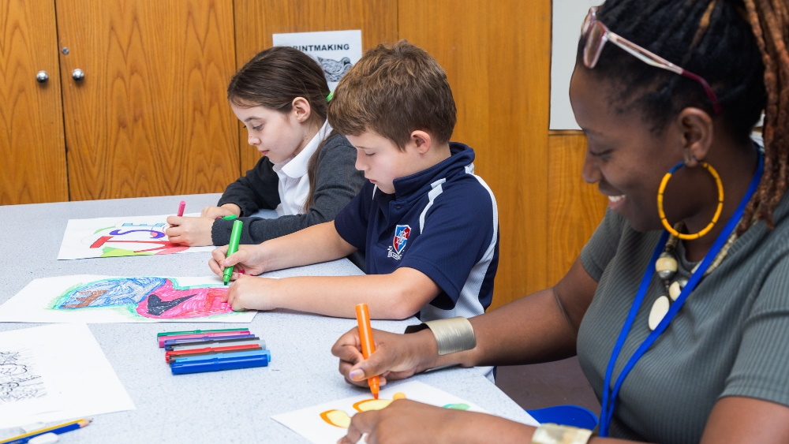

Dear Candidate

We are so pleased that you are interested in applying for the post of Design Technology Teacher and subject coordinator role at Fairley House School. We hope that our application pack gives you all the information you need but if you do have any further questions, please do not hesitate to contact us.

Please see the job description and person specification enclosed in the pack and please address all key areas when submitting your application form and personal statement.

We are a supportive organisation and pride ourselves on our commitment to staff wellbeing, professional development and a welcoming environment.

Our incentive package includes:

* Fairley House operates its own competitive pay scale, and salaries are enhanced to reflect our status as a leading Central London SEN Independent School.
* Stake holders pension scheme with Standard Life
* Small class sizes
* Free school lunch during term time
* Buffet lunches during INSET
* End of Term staff events
* Complimentary tea/coffee and fruit
* Cycle to work scheme.
* Employee assistance line which includes online counselling
* Excellent transport links (close to mainline Waterloo and Vauxhall, numerous central London bus routes)
* The opportunity to work in the centre of London with attractions such as Tate Britain, Westminster Abbey, Lambeth Palace and the London Eye on our doorstep.

We are keen to attract a diverse range of professionals who will contribute to the ongoing success of the school. If you would like a confidential chat about the roles and ambitions of Fairley House, then feel free to contact Sally Fenton on [careers@fairleyhouse.org.uk](mailto:Managercareers@fairleyhouse.org.uk)

**Fairley House is committed to the safeguarding and welfare of children and successful applicants must be willing to undergo an enhanced DBS check,**

**personal and professional reference check and a medical.**

I look forward to receiving your application.

Yours sincerely,

**Michael Taylor**

**Head**

**Job Description**

**Design Technology Subject Coordinator  and Teacher KS3 and KS4**

The post of Design Technology Subject Coordinator  at Fairley House School involves:

1. To promote the teaching and learning of Design Technology throughout Key Stage 3 and 4, taking into account the requirements of the National Curriculum, Schemes of Work and/or any other relevant new initiatives

1. Working with the Director of Studies to evaluate government guidelines and current practice in mainstream schools in Design Technology to establish how closely it meets the needs of the full range of pupils at Fairley House School and whether any adaptation is required

1. Developing a Design Technology subject action plan, annually, linked to the School Development Plan

1. Update any relevant sections of the school website

1. To prepare any documentation required for an inspection of the subject

1. Evaluating, developing and ordering resources for the Design Technology department to meet the needs of the full range of pupils at Fairley House School, and to ensure that their subject area is fully resourced.

1. Developing and maintaining an up-to-date policy and scheme of work for the Design Technology curriculum which:

* enables children to achieve the best work of which they are capable

* takes account of children’s specific learning difficulties and overcomes barriers to learning

* finds creative solutions to the fact that children stay at Fairley House School for varying lengths of time (the average stay being 2 to 3 years) and arrive at different stages in their school careers

* incorporates metacognition and transdisciplinary working

* incorporates successful lesson plans and materials

1. Offer support and advice to colleagues and to be prepared to lead training sessions for staff

1. Monitoring progress in the Design Technology curriculum through lesson observation and scrutiny of work and liaising with the Director of Studies and /or Senior Management on action needed

1. Keeping up to date, through reading and attending INSET courses and by developing links with sources of expertise beyond school

1. Keeping the Director of Studies informed of curricular issues relating to Design Technology

1. Developing cross-curricular links

1. Running lunch time and after school clubs

1. Arranging trips and visitors

The post of Design Technology Teacherat Fairley House School involves:

**Teaching:**

* Identifying the needs of individuals, taking note of individual education plans, and plan lessons to suit the individual needs of a group
* Identifying clear teaching and learning objectives, which build on prior attainment
* Setting tasks which challenge the pupils and ensure a high level of interest, attention, participation and well-being using eclectic, varied and motivating, multi-sensory approaches.
* Setting appropriately high expectations.
* Maintaining an up-to-date knowledge of the National Curriculum in relation to Design Technology
* Following the school policies on classroom management
* Establishing and maintaining a safe environment and purposeful working atmosphere which supports learning and in which pupils feel secure and confident.
* Working as a member of a transdisciplinary team

**Monitoring, Assessing, Recording and Reporting**

* Make accurate and productive use of assessment to monitor the attainment, progress and outcomes of students taught
* Report to parents on a termly basis

**Whole-school organisation, strategy and development:**

* Contributing to the development, implementation and evaluation of the school’s policies, practices and procedures, so as to support the school’s values and vision
* Making a positive contribution to the school’s vision and values
* Working with others on curriculum and/or pupil development to secure coordinated outcomes.

**Health and Safety:**

* Being aware of and comply with policies and procedures relating to child protection, health and safety, confidentiality, security, data protection; and report all concerns to an appropriate person
* Liaise with the Premises Manager and Bursar to carry out necessary checks on machinery and equipment to ensure that they meet safety requirements
* Actively promoting the safety and wellbeing of pupils
* Maintaining good order and discipline among pupils, managing behaviour effectively to ensure a good and safe learning environment.

**Working with colleagues and other relevant professionals:**

* Collaborating and work with colleagues and other relevant professionals within and beyond the school
* Developing effective professional relationships with colleagues.

**Professional development:**

* Taking part in the school’s Staff Development Process
* Fostering and develop areas of interest which can be shared with colleagues.
* Taking part in further training and development in order to improve own teaching and overall performance

**Communication:**

* Communicating effectively with pupils, parents/carers, colleagues, wider school community and governors.

**Other Professional Requirements**

* Maintaining high standards of pastoral care
* Developing a close liaison with parents
* Performing duties required of all members of staff, such as lunch and break supervision.
* Attending INSET Days at the beginning and end of every term, attending after school meetings such as staff briefings, Parents and Professionals evening, Pupil/Parent/Teacher meetings, as well as social events such as prize giving and school plays
* Contributing to extracurricular activities such as lunchtime and after school clubs.

*The duties above are neither exclusive nor exhaustive and the post holder may be required to carry out appropriate duties within the context of the job.*

**Person specification**

|  |  |  |
| --- | --- | --- |
| criteria | Essential | Desirable |
| **Qualifications**   **and training** | * Qualified teacher status * BA / PGCE | * Additional DT/Art qualification/s * Level 5 qualification or equivalent in SpLD |
| **Experience** | * Successful experience of subject leadership * Successful teaching experience within the secondary age range |  |
| **Skills and knowledge** | * Expert subject knowledge * Understanding of high-quality teaching and learning strategies in the subject, and the ability to model this for others and support others to improve * A good understanding of how children learn * Ability to adapt teaching to meet pupils’ needs * Knowledge of monitoring, assessment, recording and reporting of pupils’ progress * Ability to build effective working relationships with pupils * Knowledge of the guidance and statutory requirements relating to Equal Opportunities, Health and safety, SEN/D and Safeguarding. * Knowledge of effective behaviour management strategies * Good ICT skills, particularly using ICT to support learning | * Knowledge and understanding of specific learning difficulties      * Knowledge of Health and Safety and First Aid |
| **Personal qualities** | * A commitment to getting the best outcomes for all pupils and promoting the ethos and values of the school * High expectations for children’s attainment and progress * Ability to work creatively and collaboratively * Ability to work under pressure and prioritise effectively * Commitment to maintaining confidentiality at all times * Commitment to safeguarding and equality * Good communication skills (both orally and in writing) |  |



**Why work at Fairley House School.**

**Comments from current staff**

“What I love most about working at FHS is the team approach to helping our pupils. I believe that this holistic approach of looking at the whole child is what makes us so successful at achieving our ultimate aim, which is to get them back into mainstream schooling, equipped with all the strategies they need to flourish. I find it very insightful to work with a child across different contexts (such as within a speech and language therapy session, a Writing lesson, a Reading lesson or within lunchtime clubs) and this is what enables me, as a speech and language therapist, to be able to ensure that the skills that I am working on are functional to the child within all of their lessons, throughout the school day. I love working collaboratively with the very talented and creative teachers here to plan and co-teach lessons together, where we are both working towards the same common goals.

The children here are also inspirational. Often, they have had very difficult experiences of education prior to coming here, where learning has been such a challenge, and they sometimes have a very low opinion of themselves. However, they are very brave and resilient and willing to give learning another go, and it is amazing to see them succeed and recognise their achievements for themselves. We quickly see their self-esteem soar as they realise what they are capable of, and this gives them the confidence to take more risks with their learning”.

Alex

“I was on my way home from a parents evening and was yet again reminded how fortunate I am to be working at Fairley House. After a particularly emotional meeting, I left close to tears when a mother described how much her daughter had flourished since being at the school. On a daily basis I know that I am contributing to unlocking the potential of children who previously have seen themselves as a failure. I work alongside a fantastic team and together I know we make such a difference to our students and their families, giving them a safe haven in which they can achieve their potential”.

Miriam

###### Ready to apply?

Please contact Sally Fenton, HR Manager, [careers@fairleyhouse.org.uk](mailto:careers@fairleyhouse.org.uk) about this vacancy if you require further information, would like to book a tour or for an application form.

Please see our website for more details about Fairley House

[www.fairleyhouse.org.uk](http://www.fairleyhouse.org.uk)

Closing date: 25 November 2025