

**Castle Donington College**

**Teacher of Science**

**TMR/UPR**

Start date: Autumn Term 2017

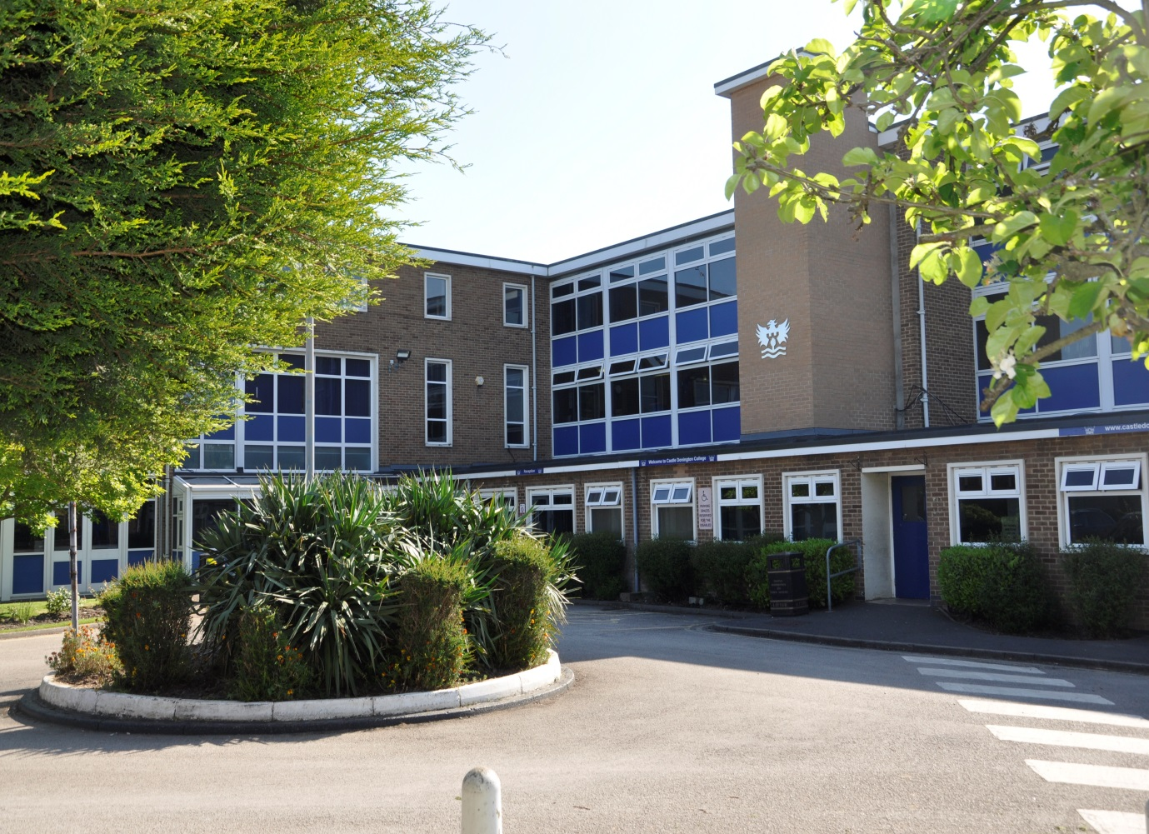

**Information Pack for Applicants**

Teacher of Science

Dear Applicant,

Thank you for your interest in the post of Teacher of Science at Castle Donington College. I hope the enclosed pack will be of interest to you and I look forward to receiving your completed application. We welcome applications from experienced, recently qualified and newly qualified teachers.

Castle Donington College is a small Leicestershire High School currently in our final year of educating students within the 10-14 age range. We welcome our first Year 10 cohort in September 2017 as we make the transition to an 11-16 school. We believe we have the makings of an outstanding school. In March 2015 we received an Ofsted rating of Good with ‘Outstanding Behaviour and Safety’. We are very proud of our community and the students we serve and so are seeking to appoint an inspirational teacher with the highest personal, academic and professional standards to join our growing Science Department.

Science is a key subject within the Castle Donington curriculum. The Science Department is currently housed in 4 specialist rooms, offering the successful candidate their own teaching room. Students study Science for three lessons a week and can engage more widely through extra-curricular activities and Science Club. Science is a well-regarded department, delivering the KS3 curriculum to ability groups.

Head of Department Kevin Leckie

Teacher of Science and Maths James Melvin

Teacher of Science and Vice Principal Nathan Barratt

Teacher of Science Vacancy

Science Technician Caroline Lucas

The successful candidate will be able to operate within a close, dynamic and forward thinking team. The Science department is committed to developing challenging, engaging and exciting learning experiences for our students. All members of the department have a passion for Science and the successful candidate must share this enthusiasm. You will demonstrate a clear understanding of GCSE courses whilst contributing to maintaining and developing the existing KS3 curriculum. You will be able to demonstrate impact in achieving excellent outcomes in attainment and progress for all students.

All our staff have the highest expectations of themselves and the students. They work closely to share best practice and drive school improvement. In a recent staff survey, 100% of respondents said that the school is well led and managed. Our teachers are highly valued, well regarded and fully supported. Castle Donington College is a good place to work and develop. We can offer a coherent programme of induction and we have a strong commitment to professional development through our Professional Learning Programme. Your development will be a key priority for us, regardless of your experience. All teachers at Castle Donington College are also group tutors; we believe the pastoral care and monitoring of progress of students is an essential part of the teacher’s role.

This is a very important appointment at a critical time. We are less than six months away from introducing our first year of GCSE and a KS4 curriculum. We believe that if you are passionate about developing young people and can demonstrate creative and innovative teaching, you will flourish and the rewards will be great.

As Principal, there is no greater priority for me than the recruitment and development of staff. My aim is to create a school which is truly exceptional in everything it does. To do this I need an exceptional team.

We welcome and encourage prospective candidates to arrange a visit to meet staff and students to experience first-hand the ethos and values of the College. Please contact Mrs Lorraine Deley if you wish to do so.

I look forward to receiving your application.

Yours faithfully,

Julie Sheppard

(Principal)

Castle Donington College

At Castle Donington College, we are concerned, first and foremost with people. The staff and Governors are committed to delivering the best possible experience for all of our students. We care passionately about the quality of education we provide.

We consider traditional attitudes and values to be important and so aim to provide individual care and attention for each child and to create a stimulating environment so that effective teaching and learning can take place. Castle Donington College has the highest expectations of its students both academically and socially.

What students can expect from us:

* A challenging inclusive curriculum
* A wide range on curriculum activities
* Good and outstanding teaching everyday
* Targets and timely support
* Outstanding pastoral care
* The highest expectations without exception
* Values rooted in respect, kindness, trust and support
* A safe learning environment free from disruption
* To be well prepared for next stage in education, training or employment and for adult life
* To know the individual strengths and weaknesses of our students

What we expect from students:

* Excellent attitude to learning everyday
* A relentless desire to achieve in all areas
* Excellent attendance
* Impeccable conduct every day
* Curiosity and resilience
* To capitalise on advice and feedback in order to improve
* The highest aspirations for their futures

Person Specification- Teacher of Science

|  |  |
| --- | --- |
|  | Essential / desirable |
| **Qualifications and Knowledge** | |
| Qualified to degree level and above | E |
| Qualified to teach in the UK | E |
| Right to work in the UK | E |
| Knowledge of KS3 and KS4 curriculum in Science | E |
| Understanding of assessment and monitoring of Science | E |
| Understanding of role regarding safeguarding and child protection | E |
| **Experience** | |
| Recent teaching of Science at KS3 and KS4 | E |
| Experience of teaching Science at KS5 | D |
| Experience of teaching in more than one school | D |
| Proficient at using data to monitor , implement appropriate intervention and raise attainment and levels of progress | E |
| A proven track record of excellent outcomes for students | E |
| **Teaching and Learning** | |
| Excellent classroom practitioner | E |
| Willingness to implement strategies to improve and sustain the highest quality teaching, learning and achievement | E |
| Strong communication, planning and organisational skills | E |
| Ability to apply highly effective behaviour for learning strategies | E |
| Ability to demand high standards, using flair and creativity to engage and enthuse students | E |
| Ability to challenge students of all abilities, needs and backgrounds. | E |
| Effective organisational skills including the ability to meet deadlines | E |
| High expectations for accountability and consistency | E |
| Ability to work independently and as part of a team | E |
| Commitment to take a lead in promoting innovations that raise students’ levels of attainment and progress | E |
| **Skills and attributes** | |
| A positive outlook, well-motivated, enthusiastic & energetic | E |
| Commitment to own professional development | E |
| Professional appearance and manner | E |
| Work in ways that promote equal opportunities | E |
| Self-awareness, empathy, ability to manage feelings, motivation and social skills | E |
| The ability to influence and motivate others in a positive way | D |
| Commitment to supporting the full life of the school | D |
| Excellent health and attendance record | E |
| Able to demonstrate resilience, motivation and commitment to driving up standards | E |

Job Description - Teacher of Science

|  |  |  |  |
| --- | --- | --- | --- |
| Job Title: | Teacher of Science | Reporting to: | Head of Department |
| Department: | Science | Line Managing: | - |
| Working with: | Head of Departments, relevant teaching staff, tutor team, support staff, parents | Salary | TMR/UPR |
| Post Type | Permanent / full time |  |  |

# Safer Recruitment Statement

Castle Donington College is committed to safeguarding and promoting the welfare of students and young people and expects all staff and volunteers to share this commitment.

|  |
| --- |
| Responsibilities of all teachers: |
| * Carry out the duties of the teacher in accordance with the national statutory Standard Teacher Pay and Conditions document and Teacher Standards * To ensure all students are safe at all times * Carry out appropriate duties and participate in meetings as defined by the relevant rota and calendar * Personally and collectively support students in becoming confident individuals, successful learners and responsible citizens * Treat all students with dignity, building relationships rooted in mutual respect and at all times observing proper boundaries as appropriate to their professional role within the College * Respond speedily to parental concerns * Act as role models by demonstrating a professional level of dress, appearance and behaviour. * Treat all colleagues with respect * Have a proper and professional regard for the ethos, policies and practices of the College and maintain high standards of punctuality and attendance * Engage actively in the Performance Management process * Show a tolerance of and respect for the rights and beliefs of others * Be expected to comply with any reasonable request from a manager to undertake work at a similar level that is not specified in this job description |
| Role of all teachers: |
| To make the education of students your first concern. To be accountable for achieving the highest possible standards in work and conduct. Teachers at the College act with honesty, integrity and work in the best interests of the students at all times.  All teachers will:   * Encourage good progress and outcomes * Demonstrate good subject knowledge * Plan and teach well-structured lessons * Adapt teaching to respond to the strengths and needs of all students * Make accurate and effective use of assessment information * Be a form tutor * Manage behaviour effectively to ensure a safe and productive learning environment * Fulfil wider professional responsibilities in the College * keep themselves and others safe |
| Responsibilities specific to the post |
| All teachers have a responsibility to inspire and engage students to demonstrate a passion for your subject, continuously improving classroom practice and achieving excellent outcomes for all students by:   * Ensuring teaching, behaviour and outcomes are good or better in your lessons * Demonstrating excellent subject knowledge * Adapting your teaching to respond to the strengths and needs of all students * Participating fully in the College’s quality assurance programme in order to raise standards * by sharing best practice internally and externally to ensure the quality of teaching is good or better * Ensuring all students engage and make progress by making effective use of the available data to plan and deliver engaging lessons * making effective use of resources for learning and using the latest technologies for learning to ensure best pupil outcomes and experience * Ensuring that all students in your lessons achieve at least nationally expected levels of progress and a high proportion exceed them * Identifying, tracking, analysing and responding to data in relation to reporting on outcomes, to ensure that the highest outcomes possible are achieved * Contributing to the creation of schemes of learning that challenge, stretch and fire the imaginations of our students * Challenging students by ensuring behaviour strategies are followed consistently in line with College procedures * Ensuring that incidents of poor pupil behaviour are successfully dealt with to minimise disruption to learning * Being proactive in engaging parents in their child’s learning and potential learning |

The responsibilities listed above are subject to the general duties and responsibilities contained in the statement of conditions of employment and National Teaching Standards.

This job description is current at the date shown, but following consultation with you, may be changed by the Principal to reflect or anticipate changes in the job which are commensurate with the salary and job title.

April 2017

How to apply

|  |  |
| --- | --- |
| **Appointment of** | Teacher of Science |
| **Salary** | TMR/UPR |
| **Start date** | Autumn Term 2017 |
| **Closing date** | Monday 8th May 9.30am |
| **Interview date** |  |

We encourage you to apply for this post online. You can access the pack through our website. Download the application form and once completed send it via email [ldeley@castledonington.leics.sch.uk](mailto:ldeley@castledonington.leics.sch.uk)

Alternatively post or deliver by hand to:

Lorraine Deley

Principal’s PA

Castle Donington College

Mount Pleasant

Castle Donington

DE74 2LN

If you are shortlisted you will be contacted by email or letter with further details prior to interview.

**Please be aware, as the applicant, you are responsible for ensuring your application reaches us before the deadline/closing date. Late applications will not be accepted.**