Bishop Ramsey CE School

Teacher of Religious Education

The Religious Education Faculty

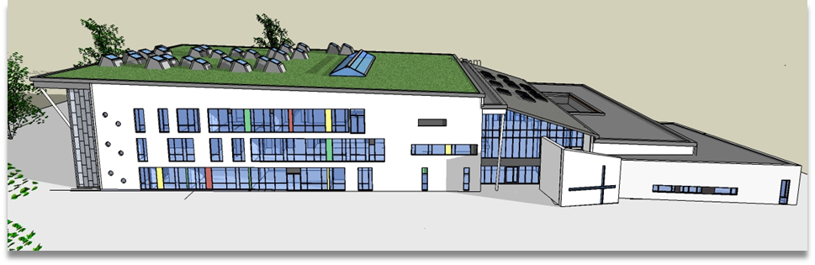

Staff
The Religious Education Faculty consists of 6 staff members:
Malcolm Britton – Deputy Headteacher
Holly Cullum – Head of Subject
Anne Hodgson – Head of KS4 RE
Rhys Ubbi – Teacher of RE
Nick Appel – Teacher of RE
Dharmini Shah – Director of SCITT.
Aims of the Faculty
- To provide, in a non-confessional and open way, a foundation of Christian teaching relevant both to the school and to the needs of the present day.
- To provide students with an appreciation of all that is embraced by the term ‘religion’ in its widest sense, especially in relation to the other world faiths, in such a way that all our students will grow in the virtues of understanding and tolerance.
- To provide a total pattern of religious education within which students can develop an awareness of the spiritual dimension, and grow in their own decisions on belief and lifestyle.
- To help students develop lively, enquiring minds with the ability to question and argue rationally and to promote an inquisitive, critical and sympathetic approach to the study of religion.
The Religious Education Curriculum

Key Stage 3 RE

In KS3 RE students learn about the six major world faiths with additional time given to the study of Christianity. In Year 7 they are taught in form groups, moving to mixed ability groups in Year 8.

Key Stage 4 RE
In KS4 we follow the AQA exam syllabus with Christianity and Islam. This course includes an in depth look at the beliefs and practices of these two religions, as well as thematic studies of life issues through religious and non-religious view points.
All the students at Bishop Ramsey take the full course GCSE.
Key Stage 5 RE
The AS course follows the OCR specification over 2 years that has three major sections. They are Philosophy of Religion, Religion and Ethics and Developments in Christian Thought.

