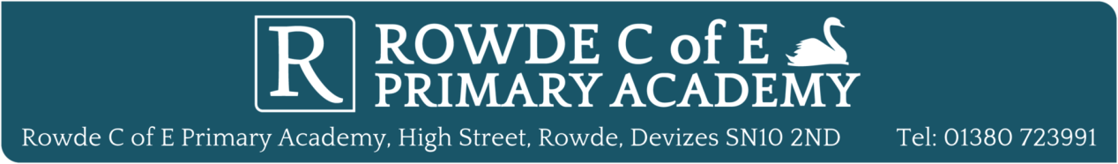
Your word is a lamp to my feet and a bright light to my path (Psalm 119 v105)

A bright start for a bright future

Person specification for the appointment of Headteacher
The following is a summary of some of the main attributes that the Governing Board would wish to see in the successful candidate for Headteacher. Generic qualifications, knowledge, experience, skills and qualities are set out in “National Standards for Excellence of Headteachers” (DfE/00019/2015).

Application statements should reflect how the candidates think they can demonstrate how they fit with the specification.
 | Essential | Desirable
Qualifications and experience | Qualified Teacher Status.  Qualified to at least Degree Level (or equivalent).  Qualified to teach and work in the UK.  Successful teacher in the primary phase, significantly raising the attainment and accelerating progress of children in classes you have taught and subjects you have led. | Readiness for headship – NPQH, or evidence of equivalent level of learning - achieved through senior leadership role within a school.  Is committed and sympathetic to Christian attitudes and values and is committed to support and develop the Christian distinctiveness of the school and its community.
Leadership skills and knowledge | The ability to articulate and communicate a vision for Rowde Church of England Primary Academy as a distinctive and effective church school.  The confidence and ability to lead inspirational Collective Worship appropriate to our school status (1944 Education Act) .  Has the ability to develop others, to lead by example and to support and champion staff and children, creating an inclusive environment that engages all stakeholders and nurtures all children to achieve their potential.  Understanding of and commitment to the protection of children through Safeguarding.  An inspiring leader of change who has successfully used whole school self-evaluation (e.g. lesson observations, work scrutiny and data analysis) to identify weaknesses that need addressing, raise standards and bring about school improvement. | Is able to set a clear strategic vision and direction for the school and communicate it effectively with the school community.  Can demonstrate impact of building effective working relationships beyond a school – e.g. cluster working, trust-wide improvement, research hubs or local authority/diocese work.  The successful use of performance management and professional development of all staff, including the effective management of underperformance where required.  Able to secure effective, transparent governance and to build an effective working relationship with the Governing Board .
Leading teaching and learning | Successful leadership and development of a differentiated, balanced and effective curriculum which develops pupils spiritually, morally, socially and culturally and supports their academic, creative and physical development and well-being.  Awareness and understanding of the current Ofsted and SIAMS processes and framework. | A Leading Teacher who can evidence school improvement through leading, coaching and motivating staff.
Personal characteristics | High personal standards, moral integrity and Christian values.  An inspirational leader who challenges, motivates and empowers teams and individuals to achieve high goals.  Strong interpersonal, written and oral skills and is able to inspire trust, commitment and mutual respect between children, families, staff and the local community.

Rowde C of E Primary Academy is committed to safeguarding and promoting the welfare of children and young people and expects all staff and volunteers to share this commitment. All applicants will be subject to a full Disclosure and Barring Service check before appointment is confirmed.

