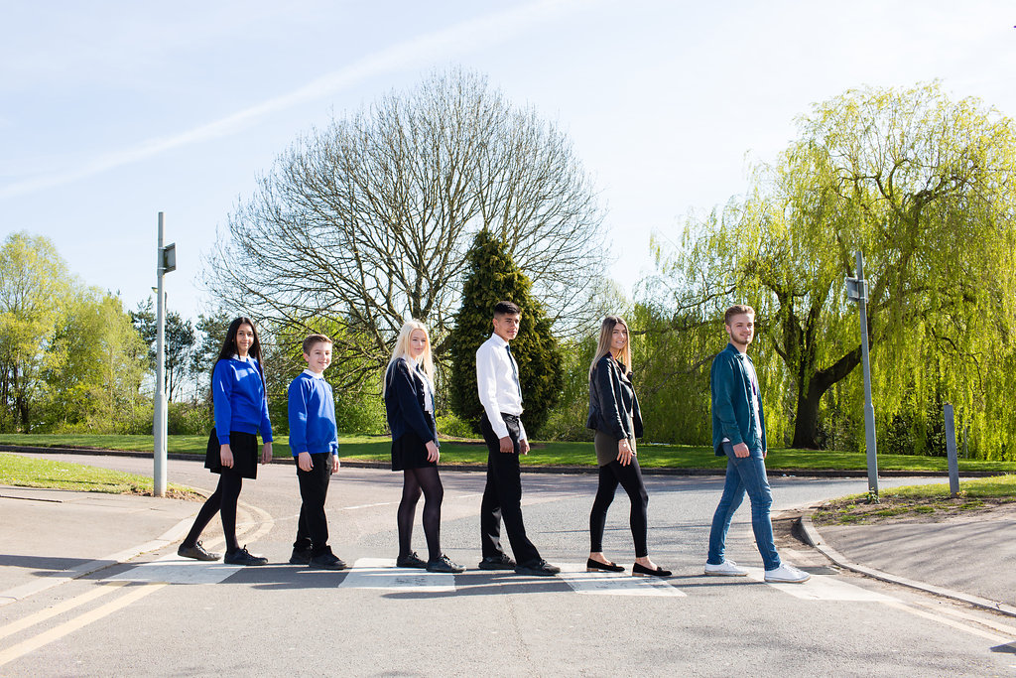

COVER SUPERVISOR

Grade 7, £10.33 per hour - £13,970 per annum
30 hours per week, term time, permanent
Monday – Friday, 8.30am – 3.15pm
Plus 30 additional hours for training, meetings etc.

Content

Vision, Values and Ethos |  | Page 3
Testimonials |  | Page 4
General Information |  | Page 5
The Application Process |  | Page 6
Vacancy Advert |  | Page 7
Letter from the Acting Headteacher |  | Page 8
Job Description |  | Page 9 – 12
Person Specification |  | Page 13-14

Vision, Values and Ethos
The shared vision and values of the Trust underpins all that we do, including the governance arrangements for the Trust.

Our Vision
Valuing Everyone, Achieving Excellence

Our Motto
Work Hard, Be Kind

Our goals
The goals of our trust:
- Outstanding levels of progress and achievement for all
- Outstanding levels of wellbeing for all
- Outstanding preparation for adult and working life
- Outstanding family and community engagement
- Outstanding levels of professional learning for all
Informed by “Schools of Tomorrow”

Testimonials
Extract taken from email correspondence, following a tour of the school by a prospective parent:
‘I would just like to say thank you for the time spent with me today on my tour of the campus, and state how impressed I was with the school. There seems to be a very calm, relaxed and organised approach to how the school operates, and I believe that obviously shows in the way your students behave’.

Written comments from parents following Year 8 Progress Evening (2019):
‘My child goes in happy and comes home happy and enjoys his day to day school life.’
‘It has the caring element of a small school. Children are pushed to achieve targets in a positive way.’
‘The staff at this parents evening have blown me away with their friendly, enthusiastic and knowledgeable manner.’
Written comments from parents following Year 11 Progress Evening (2019):
‘All the teachers I have met tonight know my son very well. I think all of them are interested and care about his progress.’
‘All 3 of our children have thrived through support that the school has given them, so happy with their education.’
‘The school is excellent, helping my child progress and I would recommend it.’
Year 10 student (June 2019):
‘In my opinion, the teachers that teach me are very patient in the sense that if I don’t understand something, they will try their best to ensure that I grasp that piece of knowledge whether it be by a diagram or an acronym etc. Another great thing about the school is that we have so many facilities so that we can excel in whatever we may want to do so.’

Year 7 student (June 2019):
‘I think the best thing about Brookvale Groby Learning Campus is the facilities in every department and the opportunities that are given such as trips and extracurricular sports activities. I have also felt that I’ve been welcomed to this school with so much support from my form tutor and teachers.’

Extract of letter from staff member:
‘I have thoroughly enjoyed my time on campus. It has been a real pleasure working with staff who are always friendly, extremely supportive and willing to share ideas and knowledge. I have really appreciated having a senior leadership team which is so warm towards its staff and open to their comments and new ideas.

The children I have taught have made me smile, laugh and cry! I will miss my relationship with them and that buzz you get from seeing them progress. It does, however, give me great satisfaction to think that I have put into place schemes of work for pupils and created learning opportunities for them which should continue even after I have left.

I am sad to leave a post which I still love. Once more, thank you for all of your support and kindness.’

Extract of letter from staff member:
‘I have had the most positive experience and have enjoyed every day of it.

I have worked in schools for the last 10 years and have never worked anywhere like this. From day 1, I have felt part of something amazing and special....the school has such a positive atmosphere and nothing has been too much trouble for anyone.

I am sad to leave, but now have a great basis for my career ...although I think It will be hard to find a school as good!
I wish you continued success and maybe one day we’ll meet again!’

General Information

The Brookvale Groby Learning Campus is a highly successful 11-19 educational organisation created from the integration of two schools on the same site. Brookvale High School is an ‘outstanding’ 11-14 school and Groby Community College is a 14-19 upper school graded ‘good with outstanding features’ in its last Ofsted. Together, the campus meets the educational needs of 1,600 students with nearly 400 at Post 16. We became a Multi Academy trust together at the beginning of April 2017, and have begun the 2019/20 academic year as one school.

We have a strong ethos of valuing everyone and achieving excellence for all. We set very high standards for our students and ourselves, we work hard, we look after each other, and we are committed to professional learning for all staff. As a consequence the motto we use on a daily basis with our young people is work hard, be kind which we feel symbolises the culture we aim to create on campus.
We have a spacious semi-rural campus location and most of our students live in the surrounding villages with some travelling from Leicester and its western suburbs.
You will be joining a team of enthusiastic Cover Supervisors, who thrive on helping our students to be the very best that they can be. You will be supported along the way, and if you enjoy a busy and varied schedule, working with young people, then this is the job for you.
We look forward to hearing from you.

The Application Process

Completed application forms should be returned to efreeman@brookvalegroby.com

Or by post to

F.A.O. Elaine Freeman
Brookvale Groby Learning Campus
Ratby Road
Groby
Leicester
LE6 0FP

An email will be sent to shortlisted candidates with details of the interview process.

Queries

If you have any queries on any aspect of the application or need additional information please contact Elaine Freeman, PA to the Senior Team, on 0116 2879921.

Thank you.

The Role

Cover Supervisor

Grade 7, £10.33 per hour - £13,970 per annum
30 hours per week, term time, permanent
Monday – Friday, 8.30am – 3.15pm
Plus 30 additional hours for training, meetings etc.

We are seeking to appoint an enthusiastic Cover Supervisor, with previous classroom experience, to join our busy, friendly Cover Supervision team.
If you are considering teaching as a potential future career, then this is the post for you!
As well as providing cover for absent teachers, you could also provide long term cover, should a teacher absence arise during the course of the year, in a curriculum area in which you feel comfortable. This would be after a period of consultation and discussion, where salary would be negotiated for that period.
Full details can be found on our website – www.brookvalegroby.com
For further details, or if you would like to visit us, then please email Elaine Freeman - efreeman@brookvalegroby.com

Closing Date: 9am, Monday 16th September 2019
Interviews will be held within 2 weeks of the closing date

The Brookvale Groby Learning Campus is committed to safeguarding and promoting the welfare of children and young people and expect all staff and volunteers to share this commitment. Applicants must be willing to undergo appropriate child protection screening, including checks with past employers and the Disclosure and Barring Service.

September 2019

Dear Applicant

COVER SUPERVISOR

Thank you for your interest in the Cover Supervisor vacancy within the Brookvale Groby Learning Campus.

We hope the documents provided help you to gain a feel for the school and if you would like to visit us as well, we would be delighted to show you round. Please contact Elaine Freeman on 0116 2879921 or efreeman@brookvalegroby.com to make an appointment.

All the documents to support this application process are available on our campus website – www.brookvalegroby.com.

To apply please complete the following:

- Application Form
- A letter of application, no more than two sides of A4, word processed using font size no smaller than 10

Your letter needs to be addressed to myself, and if you would like to e-mail your application then please send this to Elaine Freeman on the email address above.

The closing time and date for this post is 9am, Monday 16th September 2019. The interviews will be held within 2 weeks from that date. If you have not heard from us by then, please assume that your application has not been successful on this occasion. If this is the case, we would like to thank you for your interest and the time spent in applying.

This post will be subject to an enhanced level Criminal Records Bureau check. All Brookvale Groby employees are expected to promote and safeguard the welfare of students at the school. Our Safeguarding Policy is made known to all and is designed to guide staff, students and parents/carers with regard to Safeguarding issues.

In line with best practice guidance re safeguarding we do not require an additional CV and any included with application forms sent to the school will not be taken forward to the short listing panel.

Yours sincerely
Mandy Bearne
Acting Headteacher

Job Profile

Job Title: |  |  | Cover Supervisor
Grade: |  |  | Grade 7  £10.33 per hour, £13,970 per annum
Responsible To: |  |  | Cover Manager
Responsible For: |  |  | n/a
Key Relationships/  Liaison with: |  |  | Teachers, other classroom support staff
Job Purpose: |  |  | Day to day cover and intervention:  To provide supervision of classes across the curriculum in the event of the absence (planned or unplanned) of the teacher, ensuring that students are engaged in pre-set work, managing student behaviour and ensuring a safe environment.  To provide supervision and support for students in the Inclusion Centre.  To lead intervention activities with small groups.  Cover for longer term teacher absence (if and when required):  To assume the responsibility (following a period of consultation and discussion) for a teacher’s classes and form group, subject to relevant expertise. This enhanced responsibility would be negotiated on an individual basis, and would be supported by the relevant Faculty Leader or Assistant Faculty Leader.
MAIN DUTIES AND RESPONSIBILITIES FOR DAY TO DAY COVER AND INTERVENTION:

1. | In the absence of a teacher, to be solely responsible for a class of students, ensuring they are engaged in learning activity that has been set by a teacher.
2. | In conjunction with the Student Wellbeing Team manage the Inclusion Centre as part of a rotation of staff.
3. | To lead intervention activities with students as required.
4. | To effectively manage instances of poor behaviour and any other immediate issues or emergencies that arise in accordance with school/college policy.
5. | To support students to engage with the work provided, including providing support where necessary with literacy, numeracy and organisational skills.
6. | To liaise with teachers / other relevant staff with regard to work set for a class, and ensure you are suitable equipped and informed to be able to effectively supervise the assigned lesson.
7. | To feedback to the class teacher on student engagement in the set work and also on any issues that may have arisen during the covered lesson(s).
8. | To help prepare, monitor and maintain a safe and secure learning environment in line with the teacher’s lesson plans.
9. | To support the maintenance of an activity bank, contributing general activities as appropriate, and draw upon this in the event that students complete the pre-set work more quickly than expected, in order to ensure that students are engaged in constructive activity.
10. | To contribute to the development and review of relevant policies (e.g. Cover, Behaviour Management, etc).
11. | To assist in the evaluation of the impact of covered lessons on students and throughout the school.
12. | To undertake student registration of a class, as required.
13. |  | To promote positive behaviour and relationships, using effective strategies in a timely manner in accordance with school policy.
14. |  | To develop positive relationships with colleagues, providing consistent and effective support and working constructively as a member of the school staff team.
15. |  | To assist with the organisation of cover for absent colleagues (teachers or support staff), for both planned and unplanned absences.
16. |  | To assist in the creation and maintenance of curriculum resources, and creation of visual displays in order to ensure a relevant physical learning environment.
17. |  | To undertake administrative duties relevant to the role.
18. |  | To invigilate internal and external tests and examinations under formal conditions.
19. |  | To participate in the campus Duty Rota during break and/or lunch times.
20. |  | When not required to undertake any responsibility falling within the above, Cover Supervisors may be directed to provide additional support in the school, in accordance with the duties of other similarly or lower graded jobs for which they are suitably skilled/ qualified e.g. attend trips, support in classes, manage inclusion, mentor students
Optional Extra Responsibilities, not affecting the grade:
- To provide toileting support to students as necessary.*
- To support, as appropriate, in instances where students are unwell whilst on campus.*

*These duties only to be included by negotiation with individual employees, and after appropriate risk assessment and training have been undertaken.

SPECIAL FACTORS:
Subject to the duration of the need, the special conditions given below apply:
- The nature of the post may involve the carrying out of outside of normal working hours.
- The postholder may be required to attend, from time to time, training courses, conferences, seminars or other meetings as required by his/her own training needs and the needs of the campus.
- Expenses will be paid in accordance with the Local Conditions of Service.
- This post is subject to a check being carried out at an Enhanced level by the Criminal Records Bureau regarding any previous criminal record.

WHOLE CAMPUS RESPONSIBILITIES:
- Support current policies and recognised good practice within the campus.
- Be aware of the importance of confidentiality and data protection.
- Participate in annual Performance Management review with Line Manager, based on agreed objectives, ideally one of which should be linked to the campus improvement plan where possible.
- To work as part of a team, to act as a contact in providing basic emergency first aid, if training is provided.
- Willingness to be flexible in both approach & use of time.
- All tasks should be undertaken with due regard to Health & Safety Regulations.
- To undertake such other duties which are within the scope of the job purpose, title of the job and its grade.

All BGLC employees are expected to promote and safeguard the welfare of students at this school.

MAIN DUTIES AND RESPONSIBILITIES FOR LONGER TERM ABSENCE COVER (if and when required):
- To assume the responsibility for a teacher’s classes and duties in the event of a longer term absence, subject to relevant expertise, and as negotiated on an individual basis in accordance with the skills of the post holder.
- To prepare students effectively for qualifications and external examinations
- To fulfil the roles and responsibilities of tutor and support students on an individual basis through academic or personal difficulties. To act as a mentor to specific members of the tutor group in order to raise achievement
- To take responsibility for personal CPD and to participate in campus and external CPD activities by negotiation
- To undertake all of the requirements laid down by the campus Performance Management Policy
- To participate in faculty/department and house meetings
- To participate in parental consultation/student progress evenings as well as the annual target setting evening with Year 10 and 11
- To carry out supervision duties in line with campus arrangements
- To fulfil the “Professional Standards 2012” as laid down by the DFE:

- Set high expectations which inspire, motivate and challenge students – safe and stimulating environment. Set goals and challenge students of all abilities and backgrounds. Demonstrate positive attitudes, values and behaviours
- Promote progress and outcomes by students - accountable for attainment, progress and outcomes
- Demonstrate good subject and curriculum knowledge – including literacy and numeracy
- Plan and teach well structured and engaging lessons – including setting regular homework as per campus policy. Selecting and using a range of different learning resources and equipment, including ICT and where possible the use of interactive whiteboards
- Adapt teaching to respond to the strengths and needs of all students – including differentiation / needs of SEN students
- Make accurate and productive use of assessment – use data / accurate marking / give feedback to students on how to improve / maintaining records of students' progress and development
- Manage behaviour effectively – establish rules / routines. Promote positive behaviour. Have high expectations
- Fulfil wider professional responsibilities – promote a positive contribution to the ethos of the campus. Develop own CPD

The Governing Body are seeking to promote the employment of people with disabilities and will make any adjustments considered reasonable to the above duties under the terms of the Disability Discrimination Act 1995 to accommodate a suitable candidate with a disability.

This Job Description sets out the responsibilities of the post at the time it was drawn up. Such responsibilities may vary from time to time without changing the general character and requirements of the post or the level of responsibility entailed. Variations are a common occurrence and do not necessarily constitute additional responsibilities or warrant a higher grade.

Personnel Specification

 | Essential | Desirable | How assessed
Qualifications:  - Level 2 qualifications in maths/numeracy and English/literacy  OR  - Able to demonstrate competency in literacy and numeracy equivalent to level 2. |  |  | App/Doc/  Ref  App/Doc
Experience:  - Previous classroom experience  - Experience of working with younger people in a social or learning environment |  |  | App/Int/ Ref
Knowledge:  - Knowledge of child protection and health and safety procedures. |  |  | App/Int/ Ref
Skills/Attributes:  - Ability and willingness to undertake professional development.  - Good interpersonal skills.  - Empathy with children and young people.  - Ability to effectively manage student behaviour in accordance with campus policy and procedure.  - Ability to use own initiative to work flexibly and respond positively to a range of situations  - Ability to work effectively as part of a team. |  |  | App/Int  Int/Ref  Int/Ref  Int/Ref  Int/Ref  Int/Ref
General Circumstances:  - Attendance - evidence of regular attendance at university or work.  - An understanding of, and commitment to, Equal Opportunities, and the ability to apply this to day-to-day situations.  - Willingness to dress as a professional, in line with the ethos of the campus. |  |  | App/Ref/  Med  App/Int  App/Int/Ref
Factors not already covered:  Must be able to perform all duties and tasks with reasonable adjustment, where appropriate, in accordance with the provisions of the Disability Discrimination Act 1995. |  |  | Med

App = Application Form
Test = Test
Int = Interview
Pre = Presentation
Med = Medical Questionnaire
Doc = Documentary Evidence (E.g., Certificates)
In addition to candidates’ ability to perform the duties of the post, all Brookvale Groby Learning Campus employees are expected to promote and safeguard the welfare of students at the school, therefore the interview will also explore issues relating to safeguarding and promoting the welfare of children including:

- Motivation to work with children and young people
- Ability to form and maintain appropriate relationships and personal boundaries with children and young people
- Emotional resilience in working with challenging behaviours
- Attitudes to use of authority and maintaining discipline

Please be aware that any relevant safeguarding issues that arise on receipt of references may be discussed at interview.

