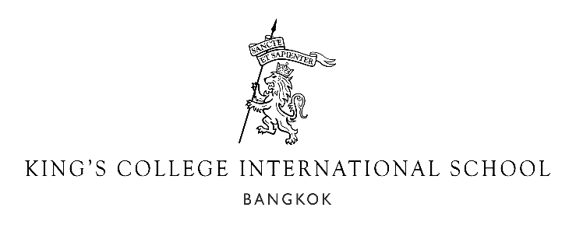

Job Description
“Intellectually exhilarating yet principled…A real golden ticket.”
The Good Schools Guide on King’s College School, Wimbledon

Job title | Teacher of Mathematics

King’s College International School Bangkok is a King’s College School Wimbledon International School. We opened in September 2020 for boys and girls and now open the senior school to cater for students aged 2 -15 in Early Years to Year 10. We currently cater for around 700 students and will grow over time to eventually help 1,500 students aged 2-18, offering IGCSEs, A levels and pathways to the world’s best universities.

We work closely with King’s Wimbledon to provide a well-structured education that aims to instill a love of learning, creativity and interdependence in our students. Our vision is to engage, inspire and extend our students. We want our alumni to be successful in their own ways. We have a strong focus on enquiry-based learning throughout the school and we believe that this helps are students take responsibility for their own learning and become the critical thinkers required in today’s world. We do this with the values of kindness, good manners and wisdom in a friendly, welcoming and attractive environment.

We are looking for outstanding teachers who embody our values, can inspire students and who understand the values of a UK-style education.

The Post

The school wishes to appoint a well-qualified Mathematics teacher to develop and deliver an outstanding learning experience for the students. This position will also play an active role in the co-curricular and pastoral aspects of the school with the opportunity of being a form tutor for the right candidate.

If you value colleagues who will support you, are excited by a start-up environment in which we all work hard for each other and have a nurturing approach to education, we would welcome you to apply for a position with us.

Starts

August 2022

Applications

A full curriculum vitae and cover letter in support of your application should be sent through the Quick Apply function of the TES portal. Early applications are welcome. Some interviews will be held in advance of the closing date if there is a large number of applicants.

All staff are expected, in the spirit of teamwork and for the welfare of the school, to perform any other related tasks, within reason, for the department and from time to time, support other departments as requested by his/her immediate supervisor.
Please note

King’s College International School Bangkok is fully committed to safeguarding and promoting the welfare of children and expects all staff to share this commitment. Any offer of employment will be subject to the receipt of an enhanced DBS disclosure/ICPC, a criminal records check, suitably translated if you teach outside of the UK, satisfactory references, and medical clearance.

Overall
- To ensure that each child makes the maximum possible progress, feels safe and enjoys their time at school.
- To be a role model for the children in the values of kindness, good manners and wisdom, work ethic
and high standards.
- To have a clear understanding of the needs of all students, including those with SEN, EAL or disabilities and to use distinctive teaching approaches to extend and support all children.
- To take an active role in the co-curricular programme.
- To be dedicated to pastoral care.
- To contribute to the effective and efficient running of the school.
- To promote high standards in the use of English as the common language.
- To follow all agreed school policies in the staff handbooks.
- To contribute positively to the ethos of the school.
- To attend meetings and school events, which may take place in the evenings or weekends as required.
- To supervise playtimes and other duties as directed.
- To undertake peer observations.
- To do any reasonable duties as requested by the school.

Professionalism
- To be dedicated to professional development and take part in, and contribute to, Inset.
- To be committed to self-reflection and improvement through the annual review system.
- To go the extra mile to help students in your class with extra support or extension work.
- To work with the other teachers and Learning Enrichment where a student may have special
educational needs to ensure that all students reach their potential.
- To promote high standards of behaviour through being positive, friendly and supportive with students.
- To foster strong relationships with parents so we all work to help our students.
- To liaise with colleagues and be a supportive and cooperative team player.
- To cover lessons for colleagues if required.

Teaching and Learning
- To teach timetabled lessons to Key Stage 3 students and above.
- To plan and prepare well-structured lessons to engage, inspire and extend each student in the class.
- To lead co-curricular activities and house events.
- To work across the whole age range to design and support events and performances.
- To ensure that your teaching space is a positive and exciting place by using positive behaviour
management and producing well-organised displays of student work.
- To be responsible and accountable for the academic progress of each student you teach.
- To ensure that students reflect on their work and progress and set themselves targets to improve.
- To be knowledgeable and interested in the areas you teach and to keep up to date with educational
initiatives.
- To regularly assess, record and monitor the progress of all students according to the school’s policy
to provide accurate information to parents in a variety of forms, as and when necessary.
- To set homework where appropriate and plan out-of-classroom experiences to enrich the learning of the children.

Role-specific
- To help to develop the curriculum for Mathematics in line with the English national curriculum philosophies.
- To set up and support house and whole-school events.
- To help organise and then monitor the provision of high-quality co-curricular activities.
- To be an active part in the pastoral care system of the school which may include being a house and form tutor for students in the senior school.

Qualities, Qualifications and Skills

Essential
- To be kind, well-mannered and wise as a role model for our students.
- To be passionate about helping us replicate this success of King’s College School, Wimbledon in
Bangkok through being committed to teaching the whole child.
- Three or more years of experience in teaching the age range you are applying for.
- Solid and demonstrable teaching experience at Key Stage 3, 4 and 5 following the UK National Curriculum.
- To be able to obtain a clear enhanced DBS check/International Child Protection Certificate and a
criminal records check (or equivalent) from the UK and from all other countries you’ve worked in
with no question regarding suitability to work with children.
- A degree in education, a PGCE or equivalent leading to qualified teacher status.
- Appropriate references from your current and previous employer, enforced by personal phone calls
made to each referee.
- To be an inspirational teacher who knows how to support and extend each student.
- Competent ICT skills.

