Dear Applicant

Re: Temporary Sixth Form Study Centre Supervisor and Administrator (Part Time, Fixed Term)

Thank you for your interest in the above position. I have pleasure in enclosing an application pack as requested.

Please note that the closing date for applications is noon on Monday 27 November 2017.

Completed applications should be returned to the school, for the attention of Sade Onajin, HR Manager.

Your completed application form will be used to decide whether or not you are selected for interview.

If you are shortlisted, you will be contacted within one week of the closing date. If you do not hear from us within this time, please assume that you have been unsuccessful.

Yours faithfully
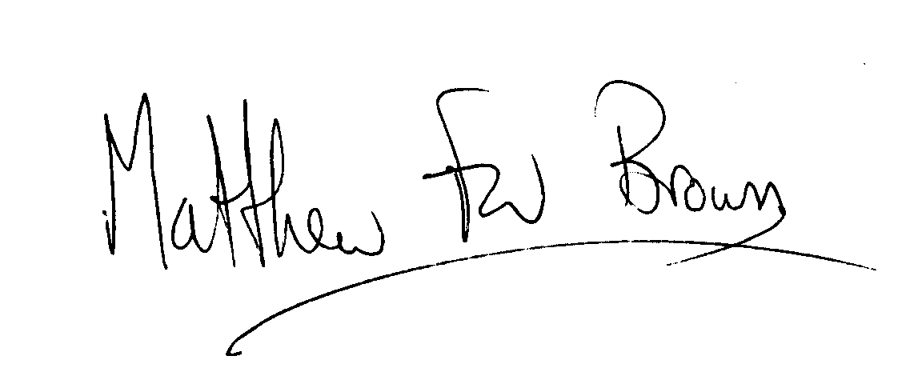
Matthew Brown
HEADTEACHER

Enc

