
job description
content creator
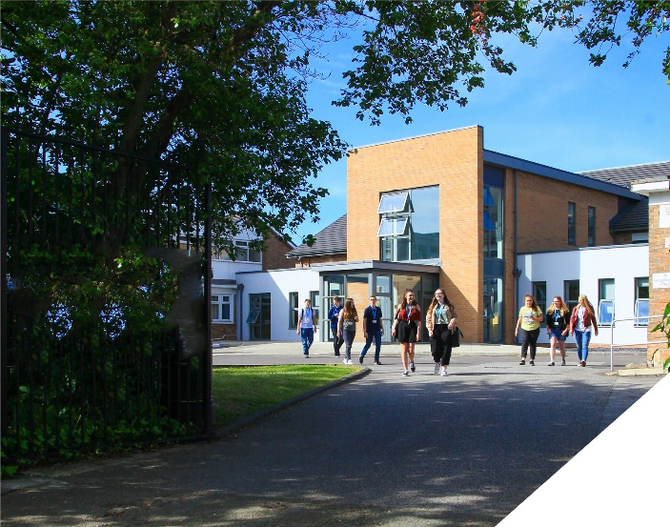
This newly created role is an exciting opportunity for a highly motivated content creator to join our dynamic team.
reports to: Director of Marketing & Management Operations
hours: full-time, full year (with occasional evening work)
salary: SP13 – 16 £27,747- £30,288
start date: Jan/Feb 2025

about the role
We are seeking to appoint an energetic, proactive and inventive Content Creator who will plan, produce and publish content in different formats across multiple channels to inspire our target audience and position the College as the first choice destination for year 11 students seeking an academic route.
The ideal candidate will have experience of delivering high-quality, innovative communications on multiple social media platforms that have demonstrated a measurable impact.
Main responsibilities include:
- Developing a content plan to drive recruitment and conversion to position the College as the best academic choice on Wirral
- Driving and re-invigorating the College’s social media presence
- Developing test & learn campaigns to target prospective students and parents with relevant, timely and engaging content
- Developing engaging written and visual content to be used across all channels
- Building rapport with internal stakeholders to understand and develop the College proposition
- Managing the College website, both in terms of showcasing the College and meeting statutory requirements
- Implementing the College’s paid digital advertising campaigns
- Video production and editing
- Photography

As part of the College marketing team, the Content Creator will also:

- Support the planning and delivery of world class college recruitment and conversion events
- Support internal communications
- Submit award entries
- Provide content for written communications such as the College prospectus

about the College
You will be joining a highly successful, innovative and nationally recognised sixth form college. The College is one of the Top 5 sixth form colleges in the country and was graded outstanding in all areas by OFSTED in April 2024. All staff play a vital role in the experience that students have with us and ultimately their success.

The College currently has a 16 to 19-year-old student population of over 1540. Demand for places for places at the College is very high and we are over-subscribed every year.
The College is committed to its core values of Positivity, Ambition, Resilience and Thoughtfulness, and these values shape everything we do. Our ethos is centred on the scientific evidence that tells us that everyone can achieve success through purposeful hard work as opposed to the talent myth, and this enables learners to make rapid progress unshackled by any limits previously placed upon them.

person specification
Qualifications | essential | desirable
Relevant degree such as Marketing, Media, Journalism etc. |  | 
Marketing qualification |  | 
Experience
Experience of successful content creation | 
Experience of copywriting and editing | 
Experience of digital marketing and managing social media channels | 
Experience of adopting a test & learn approach |  | 
Experience of writing campaign briefs and working within brand guidelines | 
Experience of website content management | 
Experience of working in a demanding environment where high levels of organisation are required | 
Knowledge / Skills / Abilities
Creative flair | 
Professional design experience |  | 
Photography & video production skills | 
Ability to work well under pressure, be part of a team and maintain a sense of humour | 
High level of accuracy and attention to detail | 
Ability to respond flexibly & creatively to new challenges & opportunities | 
Ability to prioritise & meet deadlines | 
Ability to use Information technology effectively | 
Excellent communication, interpersonnel & problem-solving skills | 
To demonstrate a commitment to
The Colleges values of Positivity, Ambition, Resilience & Thoughtfulness | 
Personal development and training | 
Safeguarding & promoting the welfare of students | 
Equality & diversity | 

how to apply
If you are ambitious and determined to make a meaningful difference in one of the country’s leading sixth form colleges then we would be thrilled to have you join our team.

Please complete the Support Staff application form which can be downloaded from the College website: www.bsfc.ac.uk

Please email your completed application to: hrdept@bsfc.ac.uk

closing date: 12 Noon, Thursday 12th December 2024

Interviews will take place on Wednesday 18th December 2024

General Information
Birkenhead Sixth Form College has a commitment to safeguarding and promoting the welfare of students and expects all staff and volunteers to share this commitment. If you are invited for interview, your suitability to work with children will be explored as well as your suitability for the post.
All posts are subject to Enhanced Disclosure Clearance through the Disclosure & Barring Service.
The College is an Equal Opportunities employer and all members of the College have a personal responsibility to implement the policy, to carry out their responsibilities in accordance with it and to maintain an equality of opportunity for all.
The Governors and staff of the College take their duties under the Disability Discrimination Act (as amended by the Special Educational Needs Act 2001) very seriously. They will ensure that all reasonable adjustments are made to ensure that disabled people are treated fairly and that they are not placed at any substantial disadvantage. The College is committed to interview all applicants with a disability who meet the minimum criteria for the post and to consider them on their abilities.

Reference Checking
On the application form, you are asked to provide details of two employment referees (preferably your line manager from your current and previous or most recent employer/s), who can comment on your suitability for the post. References from relatives or individuals writing in the capacity of friends will not be accepted.

The College will seek references on short-listed applicants before interview, and will approach previous employers for information to verify suitability for the post, dates of employment, particular experience or qualifications, attendance / punctuality history and details of any disciplinary offences.

In addition, if you are currently working with children or young people, on either a paid or voluntary basis, your current employer will be asked about your suitability to work with children and any disciplinary offences relating to children or young people. This will include any offences for which the penalty is time expired (that is where a warning could no longer be taken into account in any new disciplinary hearing for example) and whether you have been the subject of any child protection concerns, and if so, the outcome of any enquiry or disciplinary procedures. If you are not currently working with children but have done so in the past, that previous employer will be asked about those issues. Please note providing false information is an offence and could result in your application being rejected, or dismissal without notice if you have been appointed and possible referral to the police.

