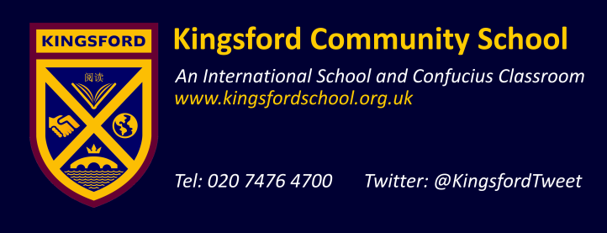

September 2017

Dear colleague,

Re: Your application for a teaching post at Kingsford Community School

I am pleased to send you this information pack in response to your enquiry about this post at Kingsford Community School.

Please complete the application form and submit this with a letter of application / personal statement addressed to the Head Teacher, Joan Deslandes. Your application form and letter of application should be submitted to the school no later than Monday 9th October 2017 by post or email to Lorna Robertson, Recruitment Officer: recruitment@kingsford.newham.sch.uk.

Your letter of application / personal statement should be no more than 2 sides of A4 and should address the following:

- What you believe to be your achievements to date and how your experience / abilities qualify you for the post applied for.
- How you would carry out your role in the post applied for, so as to ensure excellent provision for all pupils and a positive impact on standards, pupil progress and achievement.

Yours sincerely,

Ms Joan Deslandes
Head Teacher

