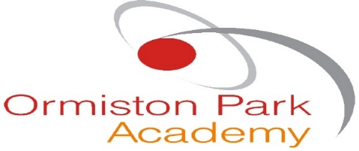
The ASCEND (BESD) Unit
Ormiston Park Academy
Belhus Park Lane
Aveley
Essex
RM15 4RU Website: www.ormistonpark.org.uk

Teacher – IT ASCEND
Start Date: September 2021
Salary: TMS (Fringe) + SEN Allowance
Location: Aveley, Thurrock, Essex
Contract Type: Full Time, Permanent

ASCEND is a centre for students who have specific behavioural, emotional and/or social difficulties. The centre caters for 30 students ranging from years 7-11 and there is a high ratio of staff to students compared with mainstream schools. The high ratio allows for very small teaching groups and a percentage of one to one sessions where necessary. At ASCEND we believe that in order to create an environment of respect, trust and cooperation we have to work as a team. This must include the staff, students, parents and visitors to the centre. Our aim is to create students who can make a positive contribution to the wider community and are confident about themselves. It is vital that we empower and support our student’s to make positive choices while at school and throughout their lives. To create an inclusive, happy, secure and stimulating learning environment, we encourage all members of the ASCEND community to grow in self-esteem, self-governance and develop their potential as human beings.

The successful candidate would be required to teach IT and other subject areas across KS3 and KS4. Having KS2 experience would be advantageous but not limiting as the students enter the school with low levels of literacy.

Benefits: Quality training and professional development. Onsite parking. Use of onsite fitness suite and sports facilities. Next to Country Park and Golf Club. Close to London and M25. Potential subsidised onsite accommodation.

For further details of the post or to arrange a time to visit ASCEND contact Sally Spraggon, PA to the Principal on 01708-865180 or sspraggon@ormistonpark.org.uk. Alternatively, application forms and details are available in the information-vacancies section of the website and on TES. All applications are to be returned electronically or submitted via TES.

Closing date for receipt of Applications: 3rd March 2021 if no-one has already been appointed.
Interviews will be held: WB 8th March 2021 if candidates have not been appointed prior to this date.

The Principal reserves the right to interview an outstanding candidate prior to the closing date without notice.

Ormiston Park Academy is committed to safeguarding and promoting the welfare of children and young people. Appointments will be subject to references and enhanced DBS checks.

