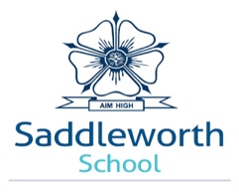

Science Department

The Science department at Saddleworth School works hard as a team to ensure that our students get the best out of their Science lessons both academically and to empower them to use science in their experiences outside school. As a department we share our outstanding and innovative practice and collaborate to produce resources for schemes of learning at both KS4 and KS3. There is a good balance of experience within the teaching team; the Science department also contains staff with responsibility in other areas of the school. There is a balance of subject specialism across the department; all members of the team are expected to teach out of their specialism at KS3 and at KS4 and we support each other with the teaching of this. Saddleworth School offers a dedicate programme for NQTs and within the Science department we have experienced staff that are NQT mentors providing coaching and support.

Science is taught in ability groups at both KS3 & 4. At GCSE students currently take Edexcel Combined or Triple Science; gaining three separate science GCSE’s is possible if pupils ‘top up’ using the option block. This pathway has proved to be very popular again this year, with five groups opting for the course. This has increased year on year for the last three years. At KS3 we follow the Exploring Science scheme which completes the Pearson Edexcel course at KS4.

The department is very well resourced and excellent technical support is provided by two technicians. The subject is taught in nine well equipped laboratories and the department also has use of an additional classroom. There is good access to ICT facilities; all subject labs are equipped with interactive whiteboards and mobile ICT provision is available.

