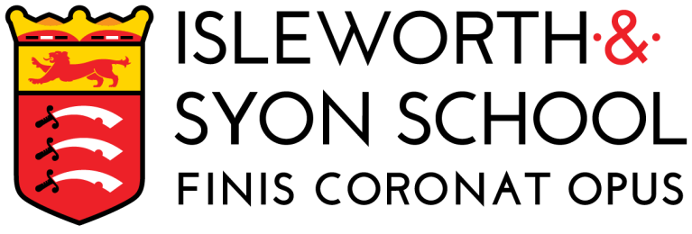 | ADVERT

JOB TITLE | Administrative Assistant
Closing Date: | 09:00 – Tuesday 26 March 2024
Date posted: | 11 March 2024 | Salary: | Scale 5 (Outer London)  £29,583 - £31,440 (pro rata)
Contract type: | Term time only plus INSET Days plus 1 week – 36 hours/week, 40 weeks a year.  7am start | Contract term: | Permanent
Start date: | As soon as possible

“The school succeeds in dispelling the myths and stereotypes that are sometimes associated with boys’ schools.”
[Challenge Partners Report]

We wish to appoint and enthusiastic and highly capable person to join our support staff team. This specific role includes overseeing school cover and requires a 7am start. You will ensure that the staff and students receive excellent administrative support and you will also act as the school receptionist for part of each working day. We are looking for someone who takes pride in their work and who will therefore contribute to our students’ success. You will be accountable to the Office Manager.

We are looking for:
- Relevant and successful experience
- An ability to build excellent working relationships
- Superb clerical and administrative skills
- A hard-working, self-motivated, proactive, organised and reliable individual
- Ability to liaise effectively with visitors, students and staff
- Excellent communication skills.

Isleworth & Syon School:
- is a high performing school
- has students that exhibit outstanding behaviour
- is committed to supporting and developing staff, and
- is a friendly and welcoming school and a great place to work.

Visit Us
You are very welcome to arrange to visit us and you can also view virtual tours of our school on the website. Click here for a full list of Our Benefits.

Application details
Further recruitment details, including a School Information Pack, a role information document and an application form are on our website www.isleworthsyon.org under ‘Staff Recruitment’. Please ensure that all sections of the form are completed.
Isleworth & Syon School is committed to safeguarding and promoting the welfare of children and young people and expect all staff and volunteers to share this commitment. The successful applicant will be subject to an Enhanced DBS check, references, and other pre- and post-employment checks, including, where appropriate police check from other countries. In addition, if shortlisted, we will undertake online searches to ensure the suitability of applicants who aspire to work in our school.
Our Data Protection Policy and our Privacy Notice for applicants, can also be found on the website.

Placement : Local press?
LBH
LinkedIn
Job Centre Plus

More about Isleworth & Syon School
Type: Mainstream School Address: Ridgeway Road, Isleworth, Middlesex, TW7 5LJ
Phase: Secondary with Sixth Form Telephone: +44 20 8568 5791
Funding status: State – Academy http://www.isleworthsyon.org
Gender: Boys and mixed Sixth Form email: school@islewothsyon.org
Age range: 11-19 years

