Teacher of English
Permanent

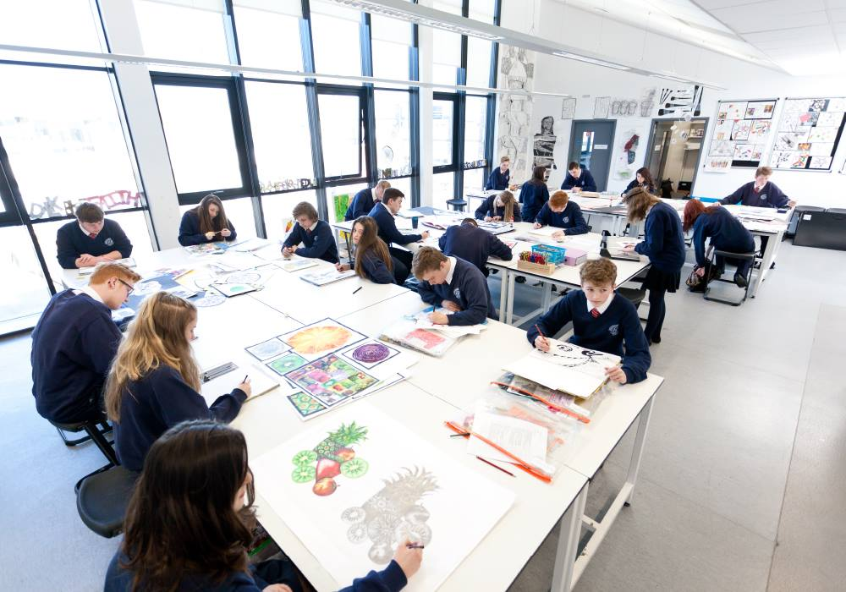

Candidate
Information Pack

Are you an inspirational, creative and driven teacher who endeavours to be better in all areas of your practice? If the answer is yes, Southlands High School is the place for you to be successful and our students deserve you.

Southlands High School, a school in the newly formed Mosaic Academy Trust with Southlands High School, is seeking to appoint a Teacher of English for Key Stages 3 and 4. The successful candidates will join our ever-growing English faculty which recorded improvements in examination results in 2018 which were rewarded as the 3rd most improved English scores at 4+ in Lancashire.

This post will be a permanent contract for the suitable candidate from September 2020.
Salary is on the Main Pay Spine/Upper pay scale point dependent upon experience.
Candidates should be hugely enthusiastic, passionate about their subject and have an excellent knowledge of English and how to effectively deliver it to instil a love of English in young people. The ability to develop very positive working relationships with students and staff and to be a team-player is essential.
All candidates should complete the application form and attach a letter indicating their suitability for the post.
Closing Date: Monday 24 February at 9am.
Interviews tbc.
Please return the completed application form by email to aldredb@southlands.lancs.sch.uk

Southlands is an Equal Opportunities Employer welcoming applications from all sections of the community.
This post is covered by the Rehabilitation of Offenders Act 1975. If successful, you will be required to apply to the Disclosure and Barring Service (DBS).

General Information for Applicants

Southlands High School is on a journey to excellence. Our motto ‘Endeavour for Excellence’ demonstrates that we expect all stakeholders, staff and students to work hard. Southlands High School is striving to be ‘Better’ than ever before as a successful and inclusive school that works in close partnership with families and the community to achieve the best for our young people.

In December 2017, we were designated as a converter academy within the Mosaic Academy Trust with Standish High School (Standish High School as the lead) and look forward to going from strength to strength in our partnership. The Mosaic Academy Trust as an organisation seeks to value each and every member of the community and to become a family of schools that will welcome other schools and be a Trust whose chief aim is to become stronger as a whole than by the sum of its parts. The Trust has a Trade Union Recognition Agreement in place.

In 2017 Southlands High School was the 8th most improved school in Lancashire and the fastest improving school in Chorley. In 2018 we were in the top 5 schools in Lancashire for improving English and English scores at 4+.
We expect to continue our journey of improvement further.

We strive to meet the needs of the individual child so that they feel safe, secure and happy and enjoy their time at Southlands. We also aim to provide the highest standards of teaching and learning so that students are able to progress and fulfil their potential. We believe that every child should be given opportunities to develop their leadership skills as part of their growth and development in order to prepare them for adult life. Many of our students go on to be very successful in all aspects of life with a number attending some of the leading universities in the country. We are committed in our drive for academic excellence whilst offering a wide range of extra-curricular activities and opportunities so that our students can achieve educational success and develop fully as individuals.

We recognise that all students have the right to the highest quality education that will equip them with the qualifications they need to progress to college, university or their chosen career. Every decision we take to create our successful school comes from a firmly held staff belief that we can always strive to be ‘better’ than before.

The school was last inspected by Ofsted in June 2013 and was judged as good in every aspect. Parental responses to our latest Kirkland Rowell survey consider the school outstanding and student responses to the Pupil Attitude Questionnaire were also very good. Our school priorities for 2019-20 clearly focus on our culture for improvement: improving the quality of education, student outcomes, the development of teaching, learning and assessment, strong personal development, behaviour and welfare and effective leadership at all levels.

There are 890 young people on roll. The intake profile in both socio-economic and academic terms is that of a fairly typical comprehensive school.

At Southlands we are very proud of our caring school community and place great emphasis on high standards of behaviour and respect for all through our Southlands Standard.

Hopefully, this has inspired you to take a serious look at Southlands.

I look forward to receiving your application form.

Kerry Millar
Headteacher

EXAM RESULTS

Overall Progress 8 | 2017 | 2018 | 2019
Attainment 8 | 42.2 | 44.23 | 44.66
Overall | -0.41 | -0.34 | -0.44

Southlands | 2017 | 2018 | 2019
English Grade 9 – 4 (A* - C) | 66% | 80% | 75%
English Grade 9 – 5 | 51% | 60% | 58%
Maths Grade 9 – 4 (A* - C) | 56% | 69% | 70%
Maths Grade 9 – 5 | 40% | 43% | 40%

The English Faculty

Thank you for considering Southlands High School English Faculty. We are a professional and supportive department which consists of a Curriculum Leader an Assistant Curriculum Leader and five experienced main scale teachers.

We are looking for an outstanding classroom practitioner with high expectations and a passion for developing each and every student’s potential. The successful candidate will demonstrate the ability to think innovatively, be adaptable and show that they can really push our well-behaved, bright and capable students.

The successful candidate will:
- Commit to and maintain the very highest standards in the classroom
- Contribute to the team ethos in the department
- Strive to develop our learners’ love of English
- Have strong skills to support the development and success of the subject
- Possess both strong discipline and the ability to enable our students to make rapid progress.

Candidates who are able to innovate, engage students with their passion for the subject and take part in the rich overall life of the school are strongly encouraged to apply.

We will offer:
- A well established and comprehensive mentor programme
- Strong links with other local schools for partnership working and support
- A well-resourced department with 6 recently refurbished specialist classrooms.
- A strong community spirit
- An opportunity to work with a staffing body that is very supportive towards each other, with a great reputation for camaraderie in the department and in the school.

I would be delighted to support the appointment of a teacher who can engage and inspire pupils through innovative teaching and a love for their subject. I am extremely proud of my department and if you would like to get in touch to speak more about the post or even come in to visit, I would love to hear from you.

James Boylan
Head of English

JOB DESCRIPTION: MPS/UPS ENGLISH TEACHER
Post Title: | TEACHER
Purpose: | - To implement and deliver an appropriately broad, balanced, relevant and differentiated curriculum for students and to support a designated curriculum area as appropriate.  - To monitor and support the overall progress and development of students as a teacher/Personal Tutor.  - To facilitate and encourage a learning experience which provides students with the opportunity to achieve their personal excellence.  - To contribute to raising standards of student achievement and attainment.  - To share and support the school’s responsibility to provide and monitor opportunities for personal and academic growth.  - To promote actively the school’s policies by engaging in teamwork in pursuit of the school’s vision statement.
Reporting to: | Curriculum Leader/Assistant Curriculum Leader
Responsible for: | The provision of a full learning experience and support for students.
Liaising with: | Head/Deputies, teaching/support staff LEA representatives external agencies and parents.
Disclosure level | Enhanced
Working Time | 195 days per year. Full Time
MAIN (CORE) DUTIES
Operational/ Strategic Planning | - To assist in the development of appropriate specifications (syllabuses), resources, schemes of work, marking policies and teaching strategies in the Curriculum Area and Department.  - To contribute to the Curriculum area taught in, and the department’s development plan and its implementation.  - To plan and prepare courses and lessons.  - To contribute to the whole school’s planning activities.
Curriculum Provision: | To assist the Curriculum Leader/Assistant Curriculum Leader and SLT to ensure that the curriculum area provides a range of teaching which complements the school’s aims.
Curriculum Development: | To assist in the process of curriculum development and change so as to ensure the continued relevance to the needs of students, examining and awarding bodies and the school’s Vision Statement and aims.
Staffing  Staff Development:  Recruitment/ Deployment of Staff | - To take part in the school’s staff development programme by participating in arrangements for further training and professional development.  - To continue professional development, including subject knowledge and teaching methods.  - To engage in the Performance Management Review process.  - To ensure the effective/efficient use of classroom support  - To work as a member of a designated team and to contribute positively to effective working relations within the school.
Quality Assurance: | - To help to implement school quality procedures and to adhere to those.  - To contribute to the process of monitoring and evaluation of the curriculum area/department. To seek/implement modification and improvement where required.  - To regularly reflect and evaluate methods of teaching and programmes of study.  - To take part, as may be required, in the review, development and management of activities relating to the curriculum, organisation and pastoral functions of the school.
Management Information: | - To maintain appropriate records and to provide relevant accurate and up-to-date information for management information systems, registers, etc.  - To complete the relevant documentation to assist in the tracking of students.  - To track student progress and use information to inform teaching and learning.
Communications | - To communicate effectively and professionally with the parents of students as appropriate.  - Where appropriate, to communicate and co-operate with external agencies.  - To follow agreed policies for communications and confidentiality in the school.
Management of Resources: | - To contribute to the process of the ordering and allocation of equipment and materials.  - To assist the Curriculum Leader/Assistant Curriculum Leader to identify resource needs and to contribute to the efficient/effective use of physical resources.  - To co-operate with other staff to ensure a sharing and effective usage of resources to the benefit of the School, department and the students
Marketing and Liaison: | - To take part in marketing and liaison activities such as Open Evenings, Parents’ Evenings, Review days and liaison events with partner schools.  - To contribute to the development of effective subject links with external agencies.
Teaching: | - To teach according to school policies and procedures.  - To teach, students according to their educational needs, including the setting and marking of work to be carried out by the student in school and elsewhere.  - To assess and report on the attendance, progress, development and attainment of students and to keep such records as are required.  - To provide, or contribute to, oral and written assessments, reports and references relating to individual students and groups of students.  - To ensure that ICT, Literacy, Numeracy and school subject specialism(s) are reflected in the teaching/learning experience of students  - To undertake a designated programme of teaching.  - To ensure a high quality learning experience for students which meets both internal and external quality standards, and provides a stimulating environment throughout.  - To prepare and update subject materials.  - To use a variety of delivery methods which will stimulate learning appropriate to student needs and demands of the course.  - To apply the school Behaviour Policy so that effective learning can take place, and to encourage good practice with regard to punctuality, standards of work and homework.  - To undertake assessment of students as requested by external examination bodies, departmental and school procedures.  - To mark, grade and give written/verbal and diagnostic feedback as required.
Pastoral System: | - To be a Form Tutor to an assigned group of students. To promote the general progress and well-being of individual students and of the Form Tutor Group as a whole.  - To liaise with a Pastoral Leader to ensure the implementation of the school’s Pastoral System.  - To register students, accompany them to assemblies, encourage their full attendance at all lessons and their participation in other aspects of school life.  - To evaluate and monitor the progress of students and keep up-to-date student records as may be required.  - To contribute to the preparation of Action Plans and progress files and other reports.  - To alert the appropriate staff to problems experienced by students and to make recommendations as to how these may be resolved.  - To communicate as appropriate, with the parents of students and with persons or bodies outside the school concerned with the welfare of individual students, after consultation with the appropriate staff  - To contribute to PHSE and citizenship and enterprise according to school policy
Other Specific Duties:
- To support the school community, its distinctive vision statement and ethos and to encourage staff and students to follow this example.
- To support the school in meeting its legal requirements for worship.
- To comply with the school’s Safety, Health and Environment Policy and undertake risk assessments as appropriate.
- To actively follow and contribute to all school policies and procedures.
- To undertake any other duty as specified by STPCB not mentioned in the above.
- Following consultation employees may be reasonably requested by a manager to undertake work of a similar level that is not specified in this job description.
- Employees are expected to be courteous to colleagues and provide a welcoming environment to visitors and telephone callers.
- The school will endeavour to make any necessary reasonable adjustments to the job and the working environment to enable access to employment opportunities for disabled job applicants or continued employment for any employee who develops a disabling condition.
- Whilst every effort has been made to explain the main duties and responsibilities of the post, each individual task undertaken may not be identified.
This job description is current at the date shown, but following consultation with you, may be changed by Management to reflect or anticipate changes in the job which are commensurate with the salary and job title.

Southlands is committed to safeguarding and promoting the welfare of young people and expects all staff and volunteers to share this commitment. The successful applicant will be required to undertake an enhanced CRB check.
Date:  February 2020 | Headteacher

MPS/ UPS English Person Specification

 | Essential | How Identified
1. Education & Qualifications | - Appropriate Degree  - Qualified Teacher Status  - Recent participation in relevant professional development  - Obtain Local Authority CRB Clearance and satisfactory references | - Application form  - Application form  - Application form, references  - Application by successful candidate & referees
2. Relevant Experience | - Evidence of successful teaching experience or teaching practice | - Application form, letter, references, interview/presentation.
3. Specialist Knowledge | - Knowledge of effective teaching and learning strategies with the ability to teach English and any other subjects as a subsidiary  - Subject specific knowledge and knowledge of latest curriculum development  - Knowledge of Assessment for learning procedures and subject specific assessment procedures  - Ability or potential to use and interpret data  - ICT skills | - Application form, letter, references.  - Application form, letter, references.  - Letter, Interview/Presentation, references.  - Interview/Presentation, references.  - Interview/Presentation references.
4. Interpersonal Skills | - Ability to relate to teachers, other professionals, parents and pupils.  - Ability to find solutions and overcome problems.  - Ability to liaise with members of Department/Faculty/Senior Leadership teams within school  - Possess both tact and determination coupled with excellent interpersonal skills. | Application form/letter, references, interview/presentation.
5. Other | - Ability to relate to and promote the ethos of the school.  - Willingness to undertake training as required.  - Excellent attendance and punctuality.  - Ability to work under pressure and meet deadlines.  - Commitment to raising of standards and achievement.  - Ability to be able to work effectively as a form teacher and to support the development of pastoral work within school. | - Letter, interview  - Interview/letter  - Letter, references, interview.  - Interview/letter  - Interview/letter  - Application form/letter, references.

