Receptionist
Wren Academy Finchley

Closing Date: 9.00am, Monday 8 July 2024

Interview Date: Thursday 11 July 2024





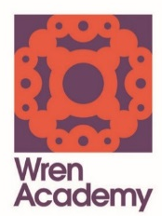

Contents

Secondary Principal’s Letter

Advertisement

Job Description

Person Specification

Academy Information

Selection Process Details


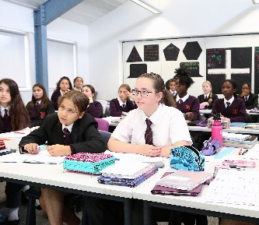
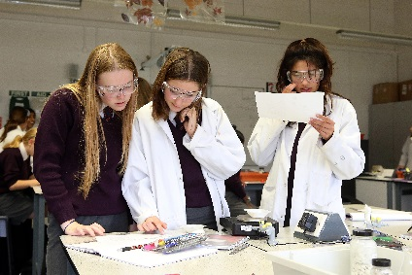



June 2024

Dear Colleague

Wren Academy Finchley – Receptionist

Thank you for your interest in this post at Wren Academy Finchley and the position of receptionist.

The information given in the documentation here and more general information elsewhere on our website should give you a clear understanding of the Academy. However, if you wish to find out more, please contact Penny Culmer on 020 3150 4604.

If you decide to apply, please follow this guidance carefully. Your completed application form must be received by the Academy by 9.00am, Monday 8 July 2024, however applications will be considered as they are received. A hard copy of your application can be posted to the address above or e-mailed to recruitment@wrenacademiestrust.org.

Finally, thank you for taking on the demanding and time consuming task of preparing your application to work with us. I look forward to meeting you if you are selected for interview.

Yours sincerely

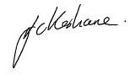
John Keohane
Secondary Principal

The Wren Academes Trust is committed to the highest standards of safeguarding and promoting the welfare of children and young people and expects all staff and volunteers to share this commitment. A Disclosure and Barring Service Certificate will be required for all posts which will be subject to enhanced checks.

The Trust embraces diversity and promotes equality of opportunity. We wish to further develop a diverse community and encourage applications from all sections of society.



Receptionist

NJC Scale Points 6-9

Working for 40 Weeks per Year, 36 hours per week

Paid salary for the above: £24,459 - £25,583

Start date: As soon as possible

An exciting opportunity has arisen to work as part of a welcoming, talented and highly motivated reception team at Wren Academy. The successful candidate will act as gatekeeper to the Academy and its systems as well as carrying out a number of important administrative, display and organisational responsibilities.

The successful candidate will be working with visitors, students, staff and parents and liaising as necessary with outside agencies, so an ability to interact on a number of levels is also important. A professional manner, good telephone and communication skills are essential. The role is varied and interesting with opportunities to develop additional skills as necessary.

The Academy has been judged to be Outstanding by OFSTED. It has over 1,600 students. A Primary phase has opened and the Academy has become an ‘All Through’ School. High standards have been set and as the Academy continues to grow we expect that the Administration team will develop further.

We require someone who is forward thinking, with relevant experience, able to work on their own initiative and within a team, and who will bring enthusiasm to the role.

The daily working hours for this position will be Monday to Thursday 7.15am – 3.00pm and 7.15am – 2.45pm on Friday.

The detailed Job Description, additional information about the Academy and the post and the application form are available to download from our website: www.wrenacademy.org/recruitment

Please note that we require the Wren Academy application form to be completed before we are able to consider your application. We do not accept CVs.

Closing date: 9.00am Monday 8 July 2024

The Wren Academes Trust is committed to the highest standards of safeguarding and promoting the welfare of children and young people and expects all staff and volunteers to share this commitment. A Disclosure and Barring Service Certificate will be required for all posts which will be subject to enhanced checks.

The Trust embraces diversity and promotes equality of opportunity. We wish to further develop a diverse community and encourage applications from all sections of society.

WREN ACADEMIES TRUST

Wren Academy Finchley

Job Description – Receptionist

Purpose

The purpose of the job is to be a key part of the reception and administrative teams of the
Academy.

The colleague in this role needs to be able to deal effectively and professionally with visitors, carry out general administrative tasks and have a flexible and positive attitude.

Working Time

36 hours per week, for 40 weeks of the year (term time plus the last week of the summer
holidays)

Contract Type

Permanent

Reporting to

Senior Administrator

Duties

- To act as receptionist, greeting, assisting and directing visitors to the Academy, ensuring that entry is welcoming, safe and secure.
- To deal with the gate entry-systems, answer the telephone, and liaise with Site Services as necessary.
- To monitor the Academy camera system to support the safeguarding of the Academy students and staff.
- To help oversee the work of the Academy’s student receptionists.
- To be responsible for all external communication to parents and carers, including letters and text.
- To ensure that the Reception area is kept in an appealing and appropriate condition.
- To help organise tours of the Academy, as necessary.
- To deal with Academy post.
- To carry out typing and spreadsheet work, including updating student contact details in-line with GDPR for the all through school.
- To undertake other general administrative tasks as directed by line managers or the Academy Leadership Team.
- To assist the Attendance Officer with primary attendance.
- To manage lost property for the all through school ensuring lost items are returned.
- To liaise with Academy staff to organise effective procedures for hosting visitors.
- To cover the role of other reception staff when necessary.
- To assist with preparation of display materials and be responsible for the community board.
- To ensure that all staff badges are created and ready for Academy events.
- To be a First Aider.
- To take part in the Academy’s staff duty rota as appropriate.
- To be available for occasional work at Academy events, such as Open Evening.

Professional Behaviour

- To maintain high standards of professional behaviour towards colleagues and students.
- To lead by example and to follow the Academy’s dress code and code of conduct.
- To carry out duties in a friendly, helpful and professional manner.
- To have a flexible approach and to be prepared for the unusual.
- To uphold and actively support the Academy’s policies and procedures on the safeguarding of young people.

Assessment

- To continue personal development as agreed in performance management.
- To engage actively in the performance review process.
- To address the performance management targets set by the line manager.

Other Specific Duties
- To play a full part in the life of the Academy community, to support its distinctive aim, ethos and policies, and to encourage staff and students to follow this example.
- To support the Academy in meeting its legal requirements as a Church School.
- To have a record of excellent health, attendance and punctuality.

This Job Description is current at the date shown but, in consultation with you, may be changed by the Executive Principal, to reflect or anticipate changes in the job commensurate with the salary and job title.

July 2024

WREN ACADEMIES TRUST

Wren Academy Finchley

Person Specification – Receptionist

Professional Skills and Experience

- Experience in a similar role in either a school or other large organisation.
- A professional manner, good telephone and communication skills are essential
- An adaptable approach to work.
- Good information technology skills. High level typing skills are essential.
- Be able to demonstrate an understanding of secondary school systems.
- A friendly, calm personality and excellent interpersonal skills.

People, Relationships and Communications

- Be committed to maintaining a distinctive and inclusive Christian ethos in the Academy.
- Be able to relate to all students and staff in a positive and constructive way.
- Be part of a whole Academy team which seeks and develops a variety opportunities to support and work with students.
- Have qualities which earn the trust and respect of students, staff, parents and governors.
- Possess integrity, optimism, credibility, resilience, calmness and a sense of proportion.
- Possess good written and verbal communication skills.
- Be able to build constructive working relationships with local schools and colleges, employers and the local authority.
- Appreciate the balance between academic and social development of young people, needed to create an outstanding school.

Selection Process Details
Application deadline

Completed application forms must be received by 9.00am, Monday 8 July 2024.

Completing your application

Candidates are asked to read the details in this pack carefully, especially the Job Description and Person Specification. Please ensure your application fulfils all the criteria set out in the Person Specification and you present evidence of this. Please complete all the standard information required on the application form. Failure to provide information requested may lead to your application being rejected.

Your completed application should be emailed to recruitment@wrenacademiestrust.org. Please note CVs will not be accepted.

Selection process

The selection process will consist of a combination of tasks and interview. Further details will be provided to the candidates shortlisted for interview.

References

Candidates are advised that references may be taken up immediately after shortlisting. Candidates are asked to ensure that their referees are warned of the need to respond within the timescale set. The post will be offered subject to satisfactory completion of pre-employment checks.

Safeguarding children

Prior to appointment, formal checks will be made in accordance with the current statutory requirements relating to child protection.

July 2024

