

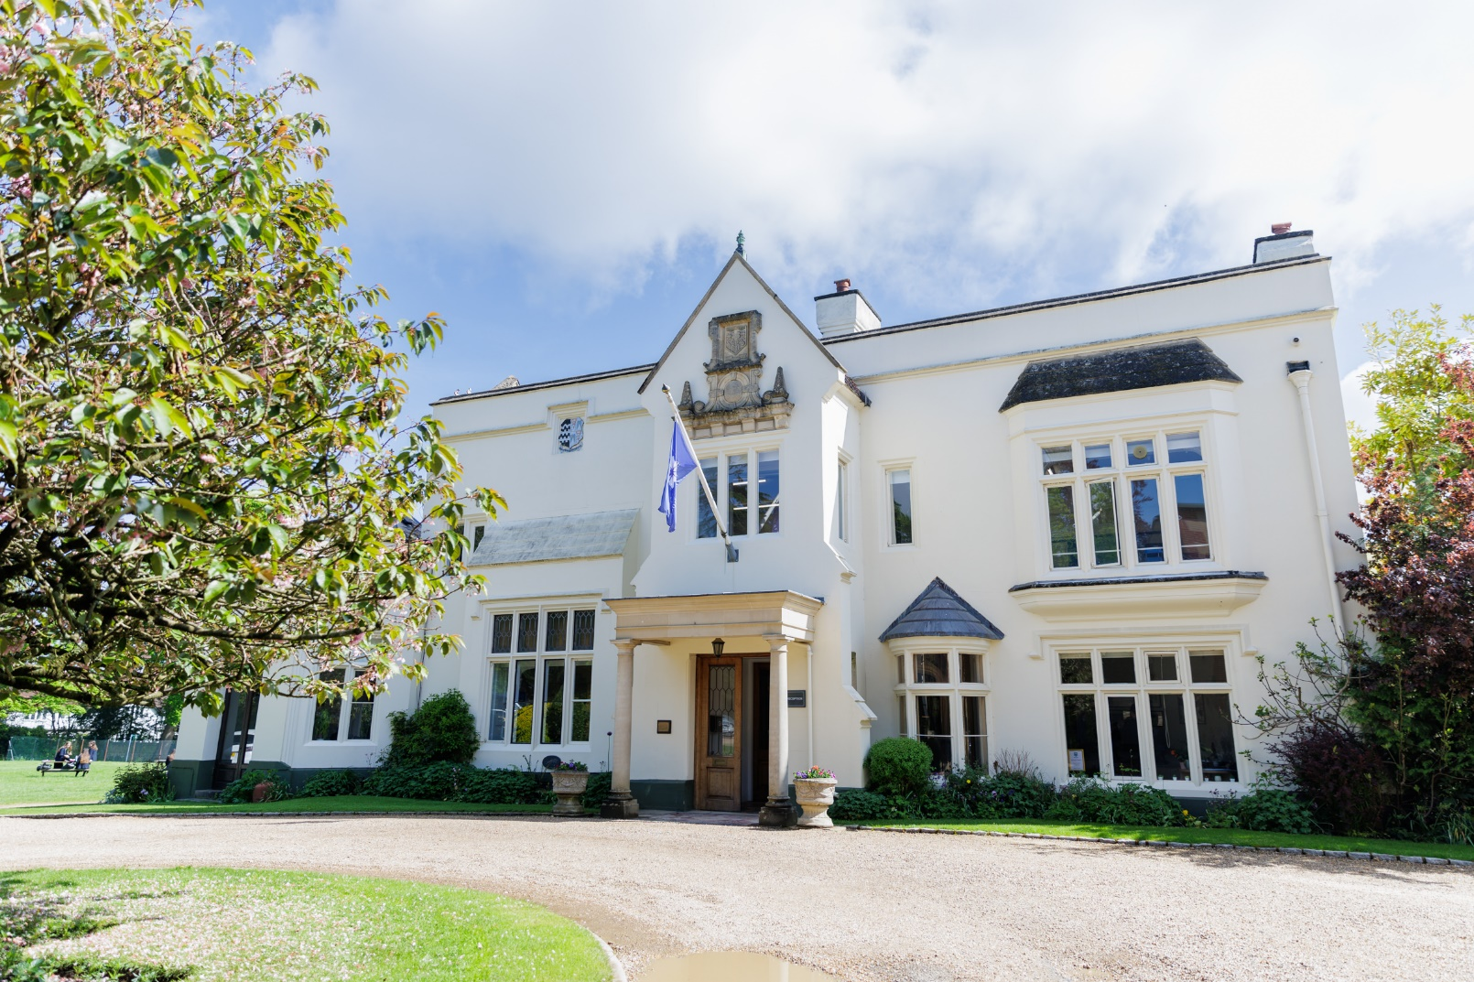
Application Pack
Job Role: Learning Support Teacher
Start Date: September 2024
Closing Date: 9:00am on Friday 30th August 2024
Interview Date: W/C Monday 8th September 2024
Welcome from Headmistress

St Mary’s is quite simply a wonderful school. The experience of each individual student is at the heart of all that we do. Our warm and inspiring environment encompasses a supportive framework where our students, whether in Pre-Prep, Prep, Senior House or Sixth Form, are encouraged to take risks, be creative, think for themselves, learn to make good choices and to embrace a challenge.
All of our students are encouraged to aim for excellence in all of their pursuits, to be kind to each other and look for opportunities to make a difference in the wider world. Students here ‘dream big’ we prepare our students for their future lives and careers to be compassionate, caring and confident young women.
The opportunities at St Mary’s, including those for leadership and co-curricular activities, are wide ranging, the academic and pastoral focus unsurpassed and the ability to tailor your daughter’s education unrivalled.
Please visit our website to give you a brief insight into our wonderful school, I do hope you will come and meet us to discuss this teaching role.

Mrs. Patricia Adams, Headmistress


About St Mary’s School

St Mary’s is an independent day school for girls aged 3-18 in the heart of Gerrards Cross, Buckinghamshire.
Founded in Paddington in 1872, the school moved to its present site in 1942. Class sizes average 16-18 and academic outcomes are excellent.
St Mary’s School is warm friendly community where parents, staff, students, and governors work together to ensure that every student exceeds her potential whilst having the time of her life, making memories, and building skills to equip her to be successful through her future years.
Our students leave with the resilience to take on the next challenge, the ambition to follow their dreams and the confidence in themselves to go from success to success in their future careers. Through the pastoral and classroom support she has received at St Mary’s, she knows her worth, who she is as an individual, and what she wants to go on to do.
Well-being and happiness of staff and students alike is at the heart of our success – a happy school is a successful school!
Joining St Mary’s staff community, you would be welcomed into a supportive, close knit community who can regularly be found spending lunch times in the Senior or Prep staff room, enjoying social time outside of school, competing in the teacher’s relay, performing in the school orchestra or at an open mic event, and can even be caught on a space hopper on the lawn on the last day of term!

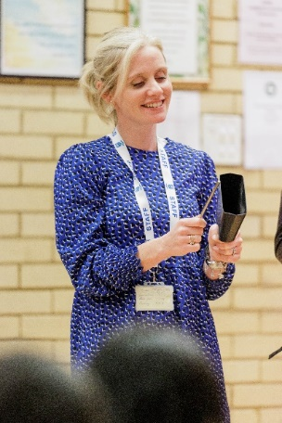

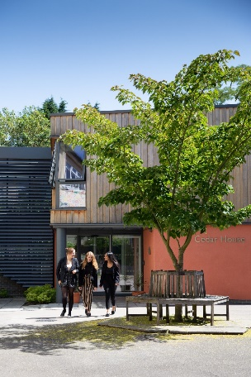

St Mary’s School Values
St Mary’s is committed to providing an excellent education in a caring, happy environment, where each girl develops self-confidence and exceeds her potential.
Staff and students, alike, are encouraged to find their own SMS Spirit by exploring our huge range of Co-Curricular activities to try new skills and meet new people, explore different learning or teaching techniques in small classes and make friends from Nursery right through to Sixth Form through our House System and whole school opportunities that brings.
Staff are supported in their roles through Department Heads, and SLT links, with wellbeing at the heart of staff satisfaction and the positive morale which we pride ourselves on. A comprehensive CPD programme allows for staff members to grow personally and professionally and broaden their skills in their specialist areas finding their very own SMS Spirit in their own individual ways.
Our whole school community operates under our Take Care acronym which ensures each individual reaches his or her potential in a supportive and challenging environment.
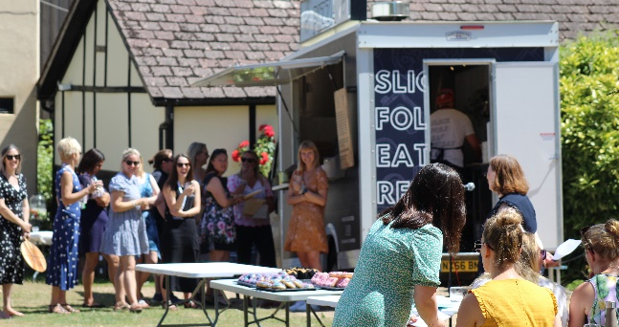
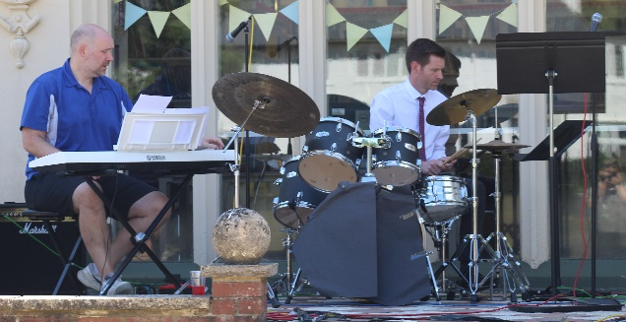

T – Team Work – we work together to ensure we achieve the best outcomes for our students, pastorally and academically, and that as a staff community we work in a supportive, collaborative caring team who have each other’s backs.
A – Ambition – we go above and beyond in everything we do. We look for the WOW factor at every opportunity.
K – Kindness – through our ethos runs the theme of kindness. Everything our staff and students do should consider kindness first.
E – Enthusiasm – staff and students alike bring the energy and desire to succeed.
C – Curiosity – we always ask why.
A – Adventure – work should be exciting, satisfying and thrilling – we are spending time doing what we feel passionately about.
R – Resilience – we carry on in the face of challenge, and come out stronger and wiser.
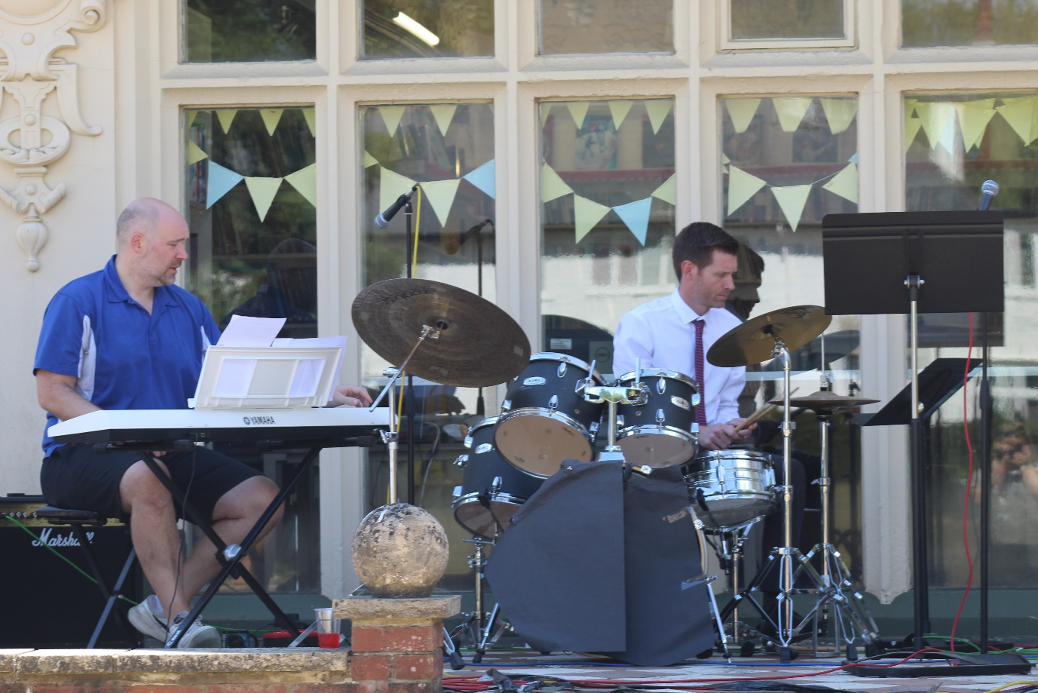
E – Excellence – aim for the highest quality in all that we do.

Why Work at St Mary’s?
- Competitive Salary
- Pension Scheme
(TPS or TPT support staff)
- 30% fee Remission at St Mary’s
- 25% fee Remission at Thorpe House
- Subsidized staff socials
- Annual pay review

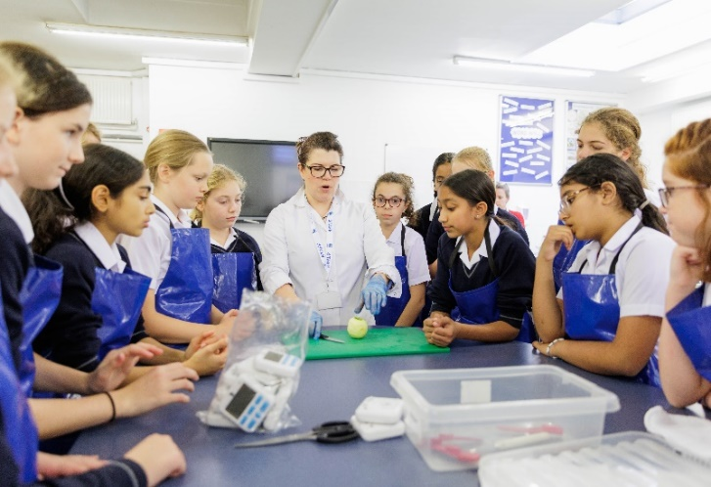


- Hot daily meal
- Use of fitness suite
- On-site parking if available
- Free annual flu vaccine
- Electric Car purchase Scheme
- Cycle to work Scheme

- Full staff induction in Term 1
- Staff buddy system
- Full training and development program
- Equal opportunities for all
- Well-being committee to share ideas
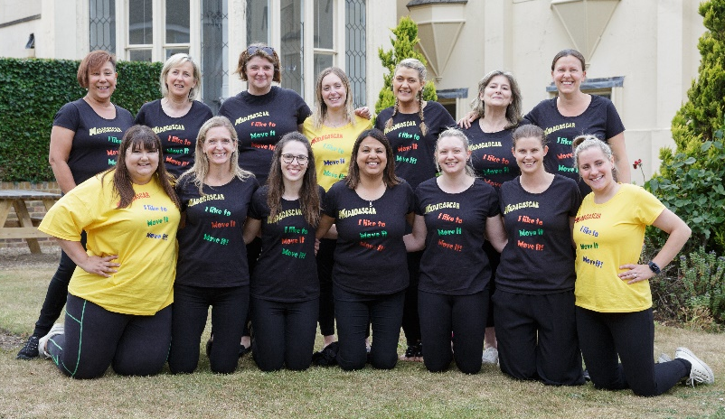

All staff share responsibility for promoting and safeguarding the welfare of our pupils and mush adhere to, and comply with, the School’s safeguarding and Child Protection Policy at all times.

Teaching and Learning at St Mary’s

Professional trust and teacher autonomy are important to us. There is some flexibility when it comes to how and what you teach, and you will have more occasions to invest in creative planning and teaching, taking opportunities to follow the passions of the class whist delivering an effective curriculum. We do not expect you to adhere to explicit and directed lesson formats, writing lesson objectives on the board or following a prescribed lesson order. When our students change class, they move in an orderly fashion to their next lesson, taking responsibility for their own behaviour. Our students are taught in an environment where engagement and quality work is expected of everyone. In addition, there are pedagogical benefits to smaller class sizes. You will get to know the unique attributes of each student, giving them increased levels of attention and building productive classroom relationships that enable your students to excel.




Staff professional development is given a high priority at St Mary’s. The professional development process is aimed at cultivating great teachers who can flourish in our environment and meet our pedagogical standards. You will have the opportunity to contribute to working parties, a Teaching and Learning forum, speak at the regular ‘Gold Nugget’ best practice slot, write for the T&L newsletter and enjoy the buzz around our Open Classroom events. CPD is encouraged and generously funded. We want our teachers to be the best they can be and recognise that a culture of continuously learning is a crucial component of supporting and developing our staff.

The Role – Learning Support Teacher (Prep & Senior House)

Working closely with the LEAPS Team, Pastoral Leaders and other teaching professionals, your role will be to:
- Provide specialist teaching of learners across Prep and Senior House on a 1:1 and small group basis.
- Create sequences of individually tailored multi-sensory lessons and teaching resources.
- Set appropriate short term targets for learners in receipt of additional learning support.
- Contribute to the setting of Support Plan and EHCP Outcomes, and Annual Reviews.
- Maintain accurate records pertaining to the learners for whom you are responsible.
- Read specialist reports & make recommendations regarding appropriate support.
- Meet with learners and prepare / review Provision Passports, to communicate the learners’ individual needs clearly to teachers and make recommendations for adaptive teaching.
- Coordinate the delivery of and monitor & assess impact of specific interventions (e.g. Lexia).
- Assist with social skills development opportunities.
- Communication with parents as required.
- Support the referrals process through liaising with learners/staff/parents and in-class observation where necessary.
- Assist with internal/public examinations processes as necessary.
- Promote and support the use of assistive technology amongst learners.
- Advocate for learners where necessary.
- Encourage acceptance and inclusion of learners with additional needs amongst their peers.
- Promote awareness of SpLDs amongst the SMS community.
- Understand and apply school policies in relation to health, safety and welfare to include the school’s safeguarding and reporting procedures.
- Keep up to date with own current practice & developments in relation to SpLD.
- Undertake specific training where required, to uphold accreditation commitments and to further the expertise of the department.
- Attend relevant school meetings as required.
- Attend Parents’ Evening as required.
- Contribute to the school’s strategic objectives.
- Fulfil any other reasonable request made by the Headmistress.

Candidate Specification

Qualifications | L5 qualification in Teaching Learners with SpLD
Qualifications | Willingness to attend relevant training courses.

Knowledge and Skills | Thorough knowledge of the principles of teaching neurodivergent learners.
Knowledge and Skills | Strong understanding and empathy with the needs/concerns of primary/secondary learners.
Knowledge and Skills | Confidence in working with a range of year groups to deliver a range of support – including literacy and study skills.
Knowledge and Skills | Knowledge and experience of the EHCP process including the setting of short-term support plan targets to correspond with Outcomes.
Knowledge and Skills | Experience of coordinating and monitoring the delivery of interventions and their impact.
Knowledge and Skills | Knowledge of the use of Assistive Technology to support learning.
Knowledge and Skills | Experience of developing social skills for learners.
Knowledge and Skills | Pastoral skills to support the emotional needs and wellbeing of learners.
Knowledge and Skills | Understanding of child protection policies and procedures.
Knowledge and Skills | Knowledge of relevant codes of practice and school policies.
Knowledge and Skills | Excellent organisation and administrative skills.
Knowledge and Skills | Strong ICT skills.
Knowledge and Skills | Excellent communication skills, verbally and in writing.
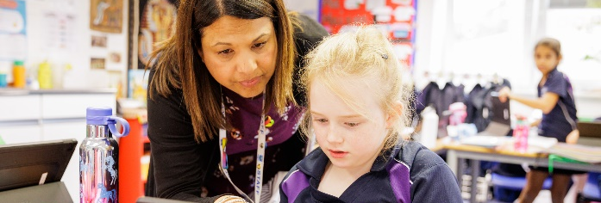

Experience | Recent experience of teaching and supporting learners with a range of SEN/SpLD on a 1:1 and small group basis.
Experience | Experience of writing IEPs/Pupil Passports.
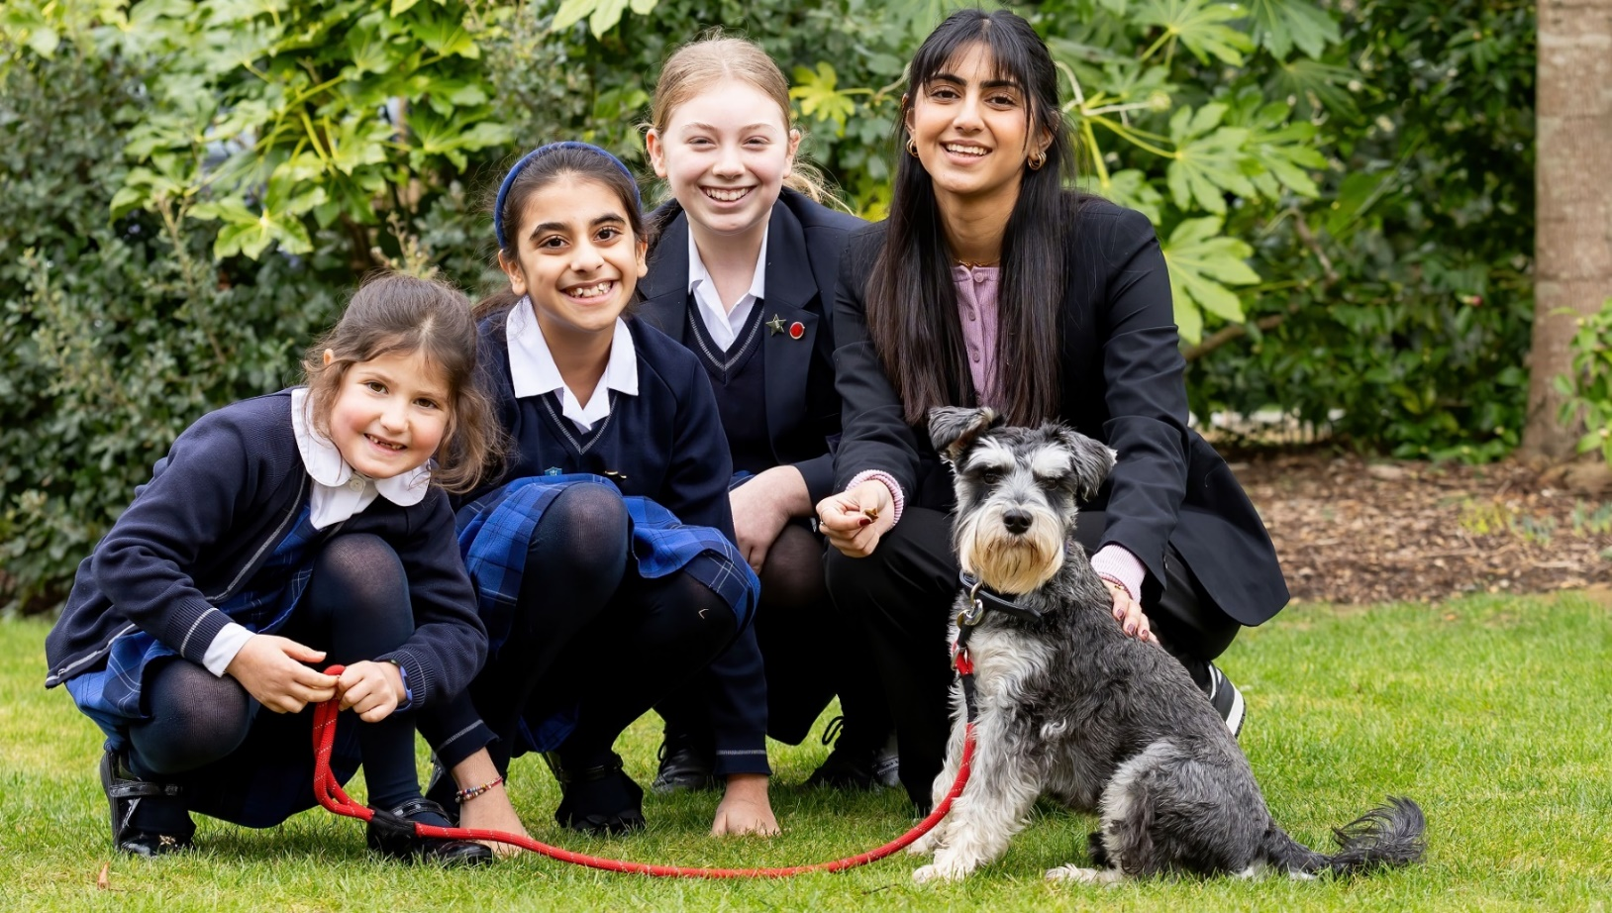
Attributes | Demonstrable interest in raising awareness/understanding of neurodivergent conditions, to break down barriers to learning and empower learners.
Attributes | Innovative, creative and flexible.
Attributes | Ability to build rapport with adults and children.
Attributes | Strong interpersonal skills (parents/staff/learners).
Attributes | Ability to work effectively and constructively as part of a team.
Attributes | The ability to work independently, use own initiative and be proactive.
Attributes | Commitment to achievement for all, regardless of background or ability.
Attributes | Motivate, inspire and have high expectations of learners.
Attributes | Ability to adapt quickly and effectively to changing circumstances/situations.
Attributes | Committed to personal and professional development.

St Mary’s School is committed to safeguarding and promoting the welfare of children and young people in its recruitment and selection of job applicants. The school expects all staff and volunteers to share this commitment and be willing to undergo checks with the Disclosure and Barring Service.
Safeguarding


How to Apply

Please complete an application form which can be obtained from the HR Administrator at hradmin@stmarysgx.co.uk or from our website www.stmarysschool.co.uk
Early applications are advised as the School reserves the right to appoint at any stage during the application process. Completed application forms and cover letters must be emailed to hradmin@stmarysgx.co.uk
Interviews will take approximately three hours and will be held at the school. As part of the process you will be given a tour of the school and attend a panel interview. You will also be asked to provide documentation confirming your identity and qualifications and a search of an online social media presence may also be conducted as part of due diligence checks.
There is no need to visit St Mary’s before applying, as the school website contains plenty of information, photos and all the school’s policies. However, if you’d like to see the school in person, you are most welcome to arrange a visit. Interviews will, of course, include a tour. All applications will be acknowledged and interview dates are provided below. References will be requested for all those invited to interview.
Closing date for applications: 9:00am on Friday 30th August 2024
Interview date: W/C Monday 8th September 2024
Hours: Full-Time
Salary: Competitive

