KS1 Class Teacher
(Maternity Cover)
Job Description

Introduction

Chigwell School opened a Pre Prep School in September 2013 and is seeking to appoint a new teacher to join the existing team in delivering an outstanding curriculum. This is an exciting opportunity for a teacher who is enthusiastic and passionate about education and teaching.

In the Pre Prep there are two classes of twenty children in each of the three years; Reception, Year 1 and Year 2. The Pre Prep is self-contained, on an enclosed site within the large Chigwell campus, with its own facilities including a hall for assemblies, P.E. and dining, library and music, science and D&T room. Well-resourced classrooms are light and spacious, and there is a mix of dedicated play facilities.

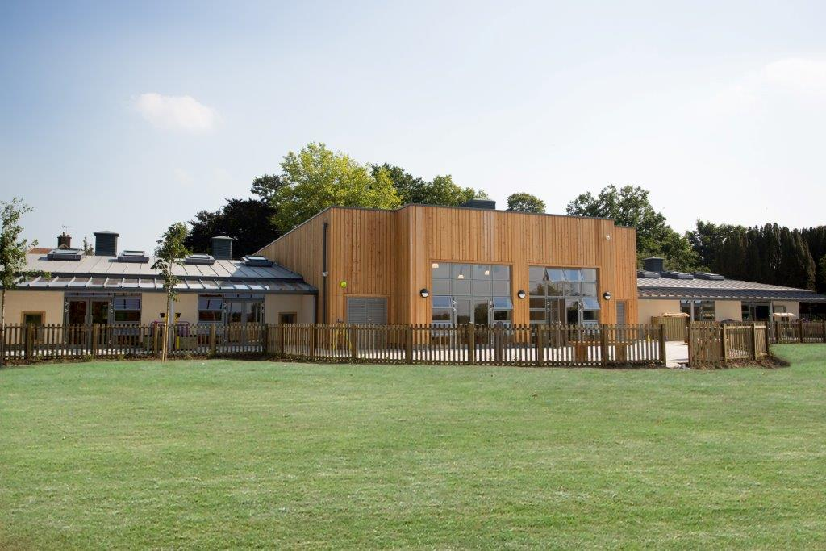
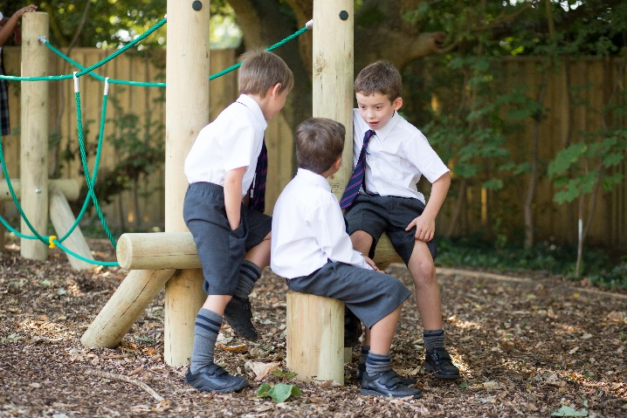
The School

Chigwell is an independent HMC school which was founded in 1629. The Founder, Samuel Harsnett, was a one-time Vicar of Chigwell, who subsequently became Vice-Chancellor of Cambridge University and Archbishop of York. The tiny school he founded (some 20 boys) has grown to one of 880 pupils aged 4 to 18. The School is now fully co-educational with roughly equal numbers of girls and boys. The Pre Prep allows a continuous challenging and creative education for children throughout their schooling and enables families to have siblings in different sections of one school.

Chigwell School lies in one hundred acres of beautiful, well-kept grounds at the north end of Chigwell village. Although set in rural surroundings, it is only twelve miles from the middle of London which is easily accessible by the Central Line underground enabling full enjoyment of the cultural life of the capital.

A particular feature of the Chigwell system is the closeness between the pre prep, junior and senior sections. The current Junior School (330 pupils aged 7 to 13), has its own classroom block, but shares the same site and facilities as the Senior School (420 pupils aged 13 to 18) and the self-contained Pre Prep (118 pupils aged 4 to 7). There is a highly beneficial overlap of teaching staff and skills across all areas of the School.

We place considerable emphasis on life outside the classroom as well. Members of staff are expected to involve themselves fully in the life of the School, helping with games and other activities outside the classroom.

Chigwell is a Church of England foundation which warmly welcomes those of other faiths. No-one will be excluded from appointment on religious grounds. Members of staff are expected to attend Chapel services and assemblies on a regular basis.

The School has excellent facilities and the Governors have an ambitious plan to develop the School still further and there is a commitment to continuing to provide the best possible teaching and learning facilities. They work hard on behalf of the School.

The Role

To carry out professional duties and to have responsibility for an assigned class of 20 pupils.
To be responsible for the day-to-day work and management of the class and the safety and welfare of the pupils, during on-site and off-site activities.

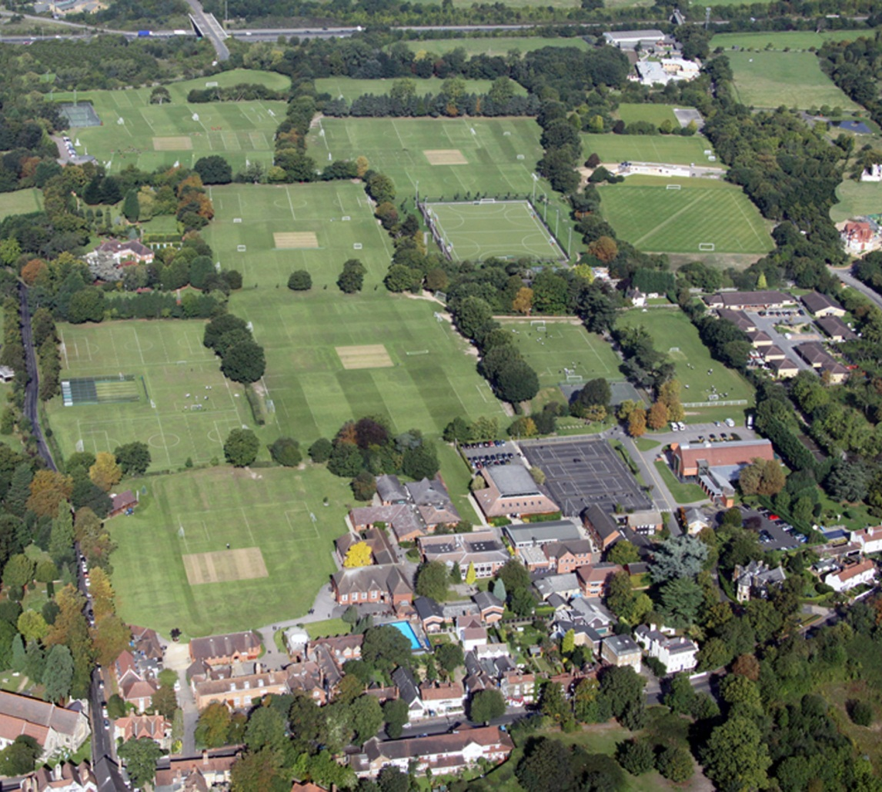

Main Duties and Responsibilities

- To create and manage a caring, supportive, purposeful and stimulating environment which is conducive to children’s learning.
- To lead by example as a teacher, establishing high expectations, achieving high standards of pupil attainment, behaviour and motivation, through effective teaching.
- To ensure consistent, high quality planning and delivery of a creative, stimulating, differentiated, broad and balanced curriculum.
- To identify clear teaching objectives and learning outcomes, with appropriate challenge and high expectations.
- To maintain good order and discipline among the pupils, safeguarding their health and safety and in accordance with the school’s behaviour policy.
- To organise and manage groups or individual pupils ensuring differentiation of learning needs, reflecting all abilities.
- To plan opportunities to develop the social, emotional and cultural aspects of pupils’ learning.
- To actively support the school’s Outdoor Educational Programme
- To maintain a regular system of monitoring, assessment, record-keeping and reporting of children’s progress.
- To ensure AFL strategies are embedded in practice and inform learning and teaching.
- To use data analysis to improve standards of achievement through targeted professional development and enhanced curriculum provision.
- To be accountable for standards of attainment, achievement and progress of all students in your class.
- To use homework effectively, according to school policy, to reinforce and extend learning and achievement.
- To prepare appropriate records for the transfer of pupils.
- To deploy support staff and other adults effectively in the classroom, involving them, where appropriate, in the planning and management of pupils’ learning.
- To participate in weekly staff meetings which relate to the school’s leadership, curriculum, administration and organisation.
- To attend such meetings and activities as may be necessary as part of school policy and in accordance with the school calendar.
- Contribute to the development and co-ordination of a particular area of the curriculum.
- To be part of a whole school team, actively involved in decision-making on the preparation and development of policies and programmes of study, teaching materials, resources, methods of teaching and pastoral arrangements.
- To implement agreed school policies and guidelines and to ensure that these are reflected in daily practice.
- To communicate and report to parents on the development, progress and attainment of students in line with the school assessment policy.
- To attend parent consultation meetings as scheduled in the school’s calendar.
- To liaise with outside agencies when appropriate e.g. Educational Psychologist.
- To take responsibility for personal professional development in accordance with the school’s professional development policy and budget restraints, setting objectives for improvements, and taking action to keep up to date with research and developments in pedagogy.
- To support the Head teacher in promoting the ethos of the school.
- To promote the welfare of children and to support the school in safeguarding children though relevant policies and procedures.
- To promote equality as an integral part of the role and to treat everyone with fairness and dignity.
- To recognise that health and safety is a responsibility of every employee, to take reasonable care of self and others and to comply with the school’s Health and Safety policy and any school-specific procedures / rules that apply to this role.
- To lead, be involved in promoting and participate in extra curricular activities and events, as agreed with the Head of the Pre Prep, for example after-school clubs, school performances and fund-raising events.
- To take an active role in promoting the school through open days.

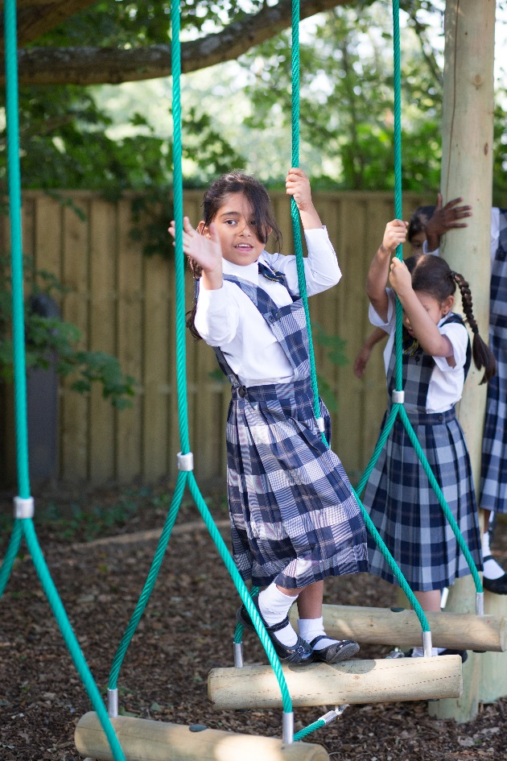

Person Specification

The successful candidate is likely to have some, or all, of the following attributes:
- Qualified Teacher Status
- Evidence of consistently good and outstanding teaching
- Recent, relevant in-service training
- Ability to work as part of a team and engage professionally in activities such as moderation and collaborative planning
- Ability to effectively manage pupils’ behaviour in a positive manner with consistent, clear boundaries following the whole school behaviour policy
- Ability to identify pupil needs and act upon them in order to raise standards
- Ability to lead a subject area if required
- Be highly motivated with high standards and expectations
- Well-developed personal IT skills used effectively in teaching
- To demonstrate a high level of written and oral communication skills
- Able to apply a creative approach to the curriculum
- A warm and friendly nature with a good sense of humour

Remuneration

The salary is on offer is competitive and based on National Pay Scales with a Chigwell enhancement.

Chigwell is a very happy place to work, the environment is pleasant and colleagues are supportive of each other. There are good relationships between teaching and support staff, staff and pupils, and between staff in different sections of the School. There is an induction programme and an annual appraisal system linked to INSET.

Other benefits of working at Chigwell School include:

- Access to the School Pension Scheme  - Free lunch and refreshments during term time  - Childcare Vouchers  - Personal Accident Cover  - Employee Assistance Support Programme  - On site parking and cycle racks  - Use of School Library | - Medical Centre on site  - Free use of School’s sports facilities outside of the School day  - Commitment to professional development  - A supportive community of highly motivated students and staff  - A beautiful working environment - 100 acres site beautifully landscaped with a number of listed buildings

Appointment Process

The closing date for applications is Monday 20th November and interviews will be held in the week beginning 27th November. However, we reserve the right to vary this if the need arises.

To apply, please complete an application form which is available on our website (www.chigwell-school.org – Vacancies). In addition, applicants should submit an accompanying letter outlining their suitability for the position. Electronic applications would be welcome and the Head of Pre Prep, Mrs Evelyn Gibbs, will be glad to speak to any prospective applicants; she can be contacted on 020 8501 6101

Chigwell School is committed to safeguarding and promoting the welfare of children and young people and expects all staff and volunteers to share this commitment. Applicants must be willing to undergo child protection screening including checks with past employers and DBS.

