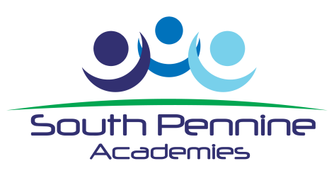

Waterhead Academy, Oldham,
Part of South Pennine Academies requires a;

Purchase Ledger Clerk

Salary Scale point 7 to 11 £19,554 to £21,166 (full year)
depending on experience

To start as soon as possible

Looking for a new challenge?
Looking to build your career in an Outstanding Multi Academies Trust?
Looking for an employer with excellent benefits including a staff wellbeing package and free gym?

This is an exciting opportunity for an enthusiastic self- starter who will be an integral part of a team dedicated to delivering excellence.
Applications can be made via TES or by visiting South Pennine Academies website www.southpennineacademies.org or the Waterhead Academy website www.waterheadacademy.co.uk.
Closing Date: 12pm on Thursday 12th December 2019
Interview Date: Week commencing 16th December 2020
Interviews to be held at Waterhead Academy, Huddersfield Road, Oldham, OL4 3NY
The Academy is committed to safeguarding and promoting the welfare of all students and staff must share this commitment. Appointment is subject to a satisfactory enhanced Disclosure & Barring service check.

