Application Pack for the
position of

Second

in
Mathematics

Harrogate

High School

Page 1

Northern Star Academies Trust

Thank you very much for requesting the details for the post of Second in Mathematics at Harrogate High School.
Harrogate High School (HHS) was one of the founder schools of Northern Star Academies Trust (NSAT) formed in April 2015.
Our mission is to support and benefit our member academies to foster and promote educational excellence whilst celebrating the distinctive character of each school in their local community.
NSAT is a small Multi-Academy Trust of two secondary schools and four primary schools. We have a strong ambition to build three geographical Hubs over the next three years in Skipton, Harrogate and Keighley, in order to grow a robust and sustainable school improvement network that delivers powerful education for every child we educate.

In July 2014, prior to the creation of Northern Star Academies Trust, sponsor approval to support the development of a MAT was received. Now that the MAT is formed with a small but value-for money central executive team, the foundation structure is in place and the trust is well placed for more growth. All schools within the trust are judged by Ofsted as good or outstanding.

Leaders and staff across all schools share their expertise in leadership and management and have an unwavering dedication to making sure that all children, regardless of their background, have access to a great education and real choices in life.

Strong leadership is vital to the success of the trust. Northern Star Academies Trust would like to appoint an ambitious, energetic and highly collaborative Second in Mathematics who will maintain the schools’ ethos in line with the vision and values of the Trust Board.

Apply: Please send your completed application to Mrs Judi Sinclair, Senior Administrator (HR) at js@harrogatehighschool.co.uk no later than noon, Monday 18 February 2019.

We look forward to hearing from you.

Page 2

VISION: Embedding world class aspirations

Lead an innovative, dynamic, academic environment which is free from gender stereotypes.
- Unleash aspiration. Empower Student Voice and Student Leadership to contribute to and have ownership of school improvement.
- Promote a belief that ‘talent isn’t fixed’- Learn, unlearn, relearn. Insist on a growth mind-set outlook inside and outside classrooms.
- Build and support ‘brave’ learners and prepare them with skills for life beyond school as a ‘Citizen of the World’ and a ‘Digital Learner’.
- Push the boundaries to promote STEM education.
Collaborate and partner within and beyond the school
- Positively impact on students beyond our school. Continue to build and embed the capacity, capability and commitment to work beyond HHS to support and promote System-Leadership and a fully inclusive school-led system.
- Be at the cutting edge as a ‘school improvement’ pathfinder and embrace national collaborative research based projects.

Prioritise Inclusion, diversity, equality and equity and place these at the heart of our learning community.

- Maximise every opportunity to promote the fundamental British values of democracy, the rule of law, individual liberty, and mutual respect and tolerance of those with different faiths, beliefs, cultures and lifestyles through the effective spiritual, moral, social and cultural development of students.

- Engage students in activities which enrich their academic studies in order to develop their self-knowledge, self-esteem and self-confidence.

Deliver strong communication to all stakeholders

- Further develop and embed structures within school so that the impact of teaching on learning and progress is maximised.

- Embrace every opportunity to effectively communicate with external stakeholders to improve our local, national and international reputation and connectivity.

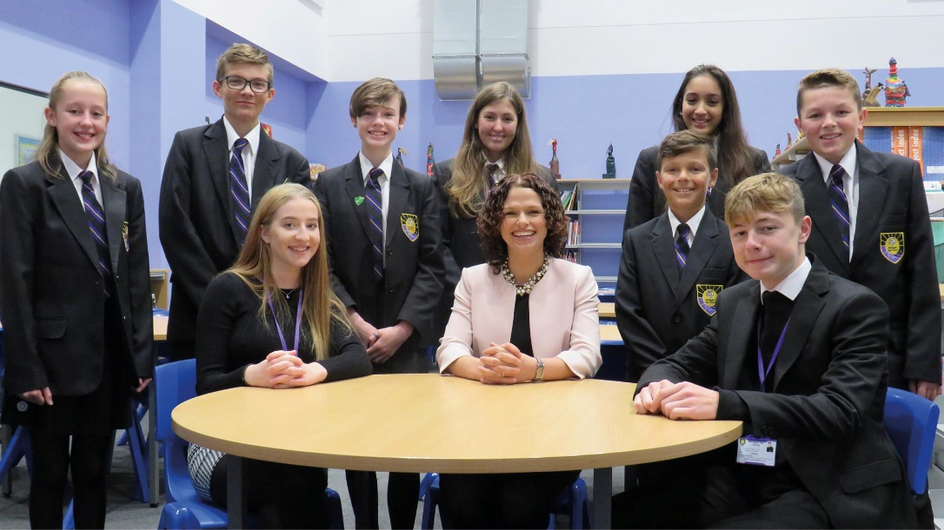

Page 3

