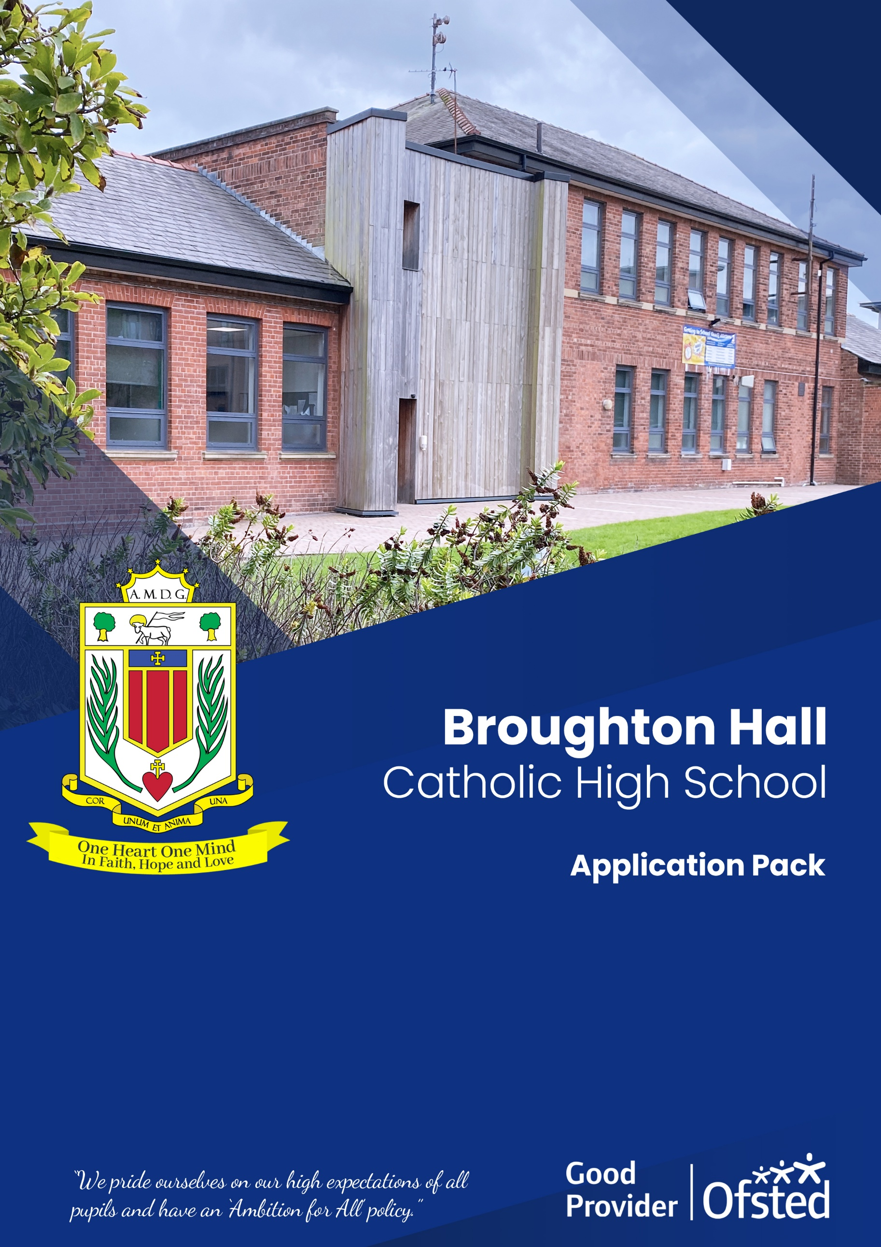
ROLE: School Operation Manager

START DATE: As soon as possible
CLOSING DATE: Friday, 2nd May 2025 at 12 noon
INTERVIEW DATE: 13th May 2025
SALARY SCALE: NJC Point Range 38 to 41 = £47,754 to £50,788 (depending
on experience)

CONTRACT TERM: Permanent – Full-Time
Broughton Hall Catholic High School

Founded in 1928 under the trusteeship of the Sisters of Mercy, Broughton Hall Catholic High School, an all-girls Catholic secondary school in Liverpool, provides the very best in modern education based on the Gospel values of mutual respect and care.
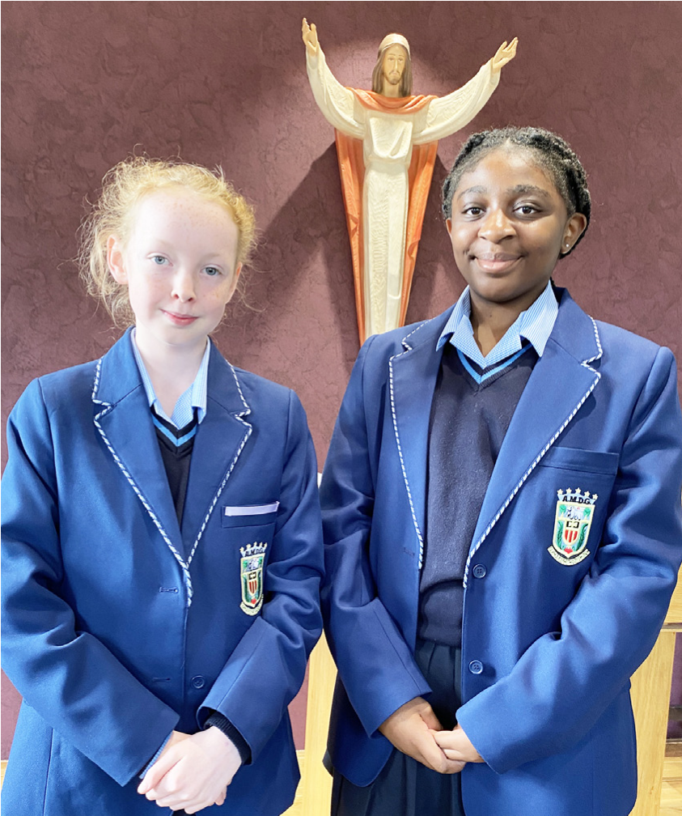
The central aim of our school is to provide excellent educational opportunities enabling each pupil to develop their God given talents, to grow in confidence and self-esteem and to fulfil their potential.

As a Catholic school Broughton Hall centres its mission on the person of Jesus Christ, and promotes the Gospel values throughout the school community and in all aspects of school life: spiritual, academic, pastoral, and personal. By proclaiming and living out the faith of the Catholic Church, we support each other in shared experiences of teaching and learning, prayer, worship and charity. Our mercy values permeate throughout our community.

Broughton Hall is Ofsted rated as a “Good” provider (November 2022).

Our facilities are bright, spacious, high tech and designed to meet the needs of all our pupils. We have a separate 6th Form facility, which is shared with our neighbouring boys school Cardinal Heenan Catholic High School. A full range of extra-curricular activities are provided to further the creative, sporting and academic talents of each pupil and offer Outward Bound and Duke of Edinburgh Award schemes as well as the opportunity to attend educational visits and residential trips.

We pride ourselves on our high expectations of all pupils and have an ‘Ambition for All’ policy. Whatever your role within the school, you will share these values and be able to encourage and motivate pupils with your passion, presence and personality.

Our school motto ‘Cor Unum et Anima Una’ - One Heart and One Mind, reflects the strong sense of community amongst pupils, staff, parents and Governors.

School has a weekly Newsletter – please click here to view our latest edition. https://www.broughtonhall.com/newsletter/

Welcome

Thank you for your interest in the position of School Operations Manager.

This pack has been designed to help you should you choose to submit an application form, which we sincerely hope you do. We hope it answers your initial questions, but if not, please do not hesitate to contact us and we will endeavour to help you through your application process.

Broughton Hall Catholic High School is the largest all-girls school in Liverpool and serves many different areas making us a vibrant a diverse school. Our aim is to be a good school in all areas and we are seeking staff to apply to work with to be of that journey. Ofsted rated the school as “Good” in November 2022.

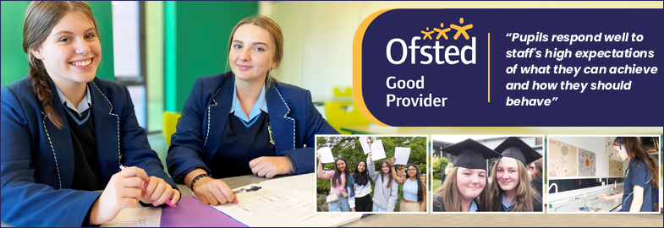

We work hard to ensure Broughton Hall Catholic High School remains a friendly and welcoming environment for all those who work, study or visit here and hope that you are the person we are looking for to bring creativity and innovation to the role.

The school actively supports the training of staff and opportunities for professional development exist for all. Our staff are passionate about supporting our students to achieve their personal and academic potential.

We look forward to hearing from you.

Sarah O’Rourke
Head Teacher

We Offer

- Pensions Scheme – Teacher Pension Scheme for teaching staff or Merseyside Pension Fund for support staff
- Regular training and development programme
- An enhanced Occupational Health & Well-Being App (Smart Clinic) with access to a wide variety of services e.g.
- Virtual GP
- 24 hour employee assistance line
- Physiotherapy
- Mental Health Services
- Self-support and guidance tools
- Cycle2Work Scheme
- Tax Free Childcare Vouchers
- Supportive work environment where all staff are valued
- Continuous professional development for all staff and follow a whole school approach to staff performance and development

And that’s not all, we place the outcomes of the children in our school at the heart of everything we do, so you’ll wake every day in the knowledge that your role will have a significant positive impact on the lives of others.

Equal Opportunities

Broughton Hall Catholic High school is an equal opportunities employer.

We welcome applicants from all backgrounds and value everyone as an individual. We are committed to organisational practices, which promote diversity and inclusion for all employees and volunteers regardless of age, gender reassignment, marriage or civil partnership status, pregnancy and maternity status, disability, race (including colour, nationality, ethnic or national origin), religion or belief, sex, or sexual orientation. Connecting these differences creates a productive environment in which everyone feels valued.

Monitoring information in relation to job applicants will be to assist us in equality monitoring. The recruitment panel will not have access to job applicant’s monitoring information.

To assist us in monitoring the operation of equal opportunities policy, and for no other reason, please ensure you complete and submit the Equal Opportunities Monitoring Form with your application form.

Safeguarding & Enhanced DBS Checks

Broughton Hall Catholic High School is committed to safeguarding and promoting the welfare of young people and expect all pupils, staff, volunteers and visitors to share this commitment

All posts are subject to an enhanced DBS check and full pre-employment checks to comply with the current Keeping Children Safe in Education statutory guidance for schools.

All staff will be expected to follow Broughton Hall Catholic High School’s child protection policies, code of conducts and managing allegations against staff procedures.

All roles in school, including this post, are exempt from the Rehabilitation of Offenders Act (ROA) 1974. The Ministry of Justice’s guidance on Rehabilitation of Offenders Act 1974 and the Exceptions Order 1975 provides information about which convictions must be declared during job applications and can be accessed here.

All applicants must therefore declare all previous convictions and cautions, including those which would normally be considered ‘spent’ except those received for an offence committed in the United Kingdom if it has been filtered in accordance with the DBS filtering rules. Information about filtering offences can be found in the DBC Filtering Guide, which can be accessed here.

By engaging in this recruitment process, shortlisted candidates consent to an online search in line with the Keeping Children Safe in Education Statutory Guidance 2022.

A copy of our Child Protection Policy and Procedures can be access at https://www.broughtonhall.com/documents/BroughtonHall_CP_Policy.pdf

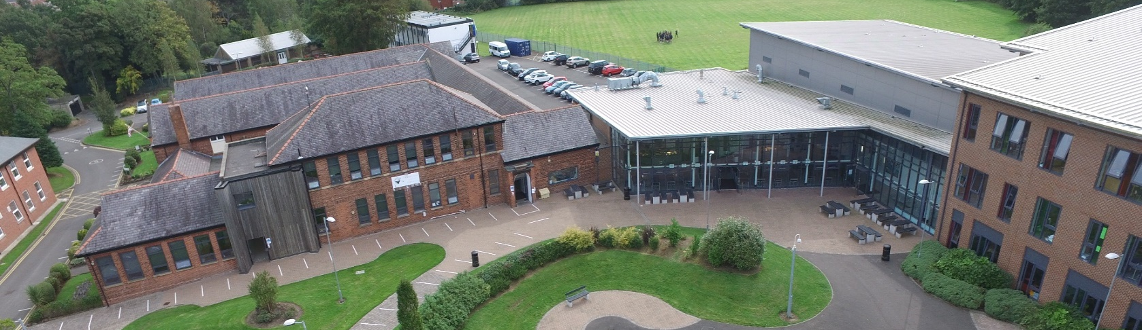

Advert

SCHOOL OPERATIONS MANAGER

SALARY: NJC Scale Point Range 38 – 41 £47,754 to £50,788 (depending on experience)
CONTRACT TYPE: Permanent/Full Time
CLOSING DATE: Friday, 2nd May 2025
INTERVIEWS TO BE HELD: 13th May 2025
START DATE: As soon as possible

Broughton Hall Catholic High School is seeking a proactive, highly organised School Operations Manager to join our dedicated team. This is a key leadership role within the school’s support staff, responsible for ensuring the effective delivery of operational, administrative, and compliance functions – allowing our teaching team to focus on what matters most: delivering outstanding education.

Working closely with the Headteacher, Site and Finance Manager, you’ll oversee core areas including HR, administration, IT, statutory compliance, marketing and promotion, and project coordination. You’ll also play a strategic role in identifying funding opportunities and supporting wider school development.

Key Responsibilities:
- Human Resources Management: Oversee the full employee lifecycle including recruitment, onboarding, staff induction, contracts, absence management, and performance records. Maintain a fully compliant Single Central Record (SCR) and ensure all DBS requirements are met.
- Statutory Compliance & GDPR: Lead on data protection and ensure full compliance with GDPR, safeguarding, health & safety, and all legal obligations.
- Administration: Manage and develop the school’s administrative team to provide efficient, professional support across all departments.
- Project Coordination: Lead on tenders, funding bids, and school improvement projects. Liaise with contractors and key stakeholders to ensure timely delivery.
- Marketing & Promotion: Develop and implement the school’s marketing and communication strategy. Oversee social media, newsletters, website content, and event promotion to raise the school’s profile.
- Collaboration: Work in close partnership with the Site and Finance Manager and senior leaders to support operational planning and budget management.
- Income Generation: Research and pursue additional sources of income, including grants, partnerships, and community initiatives.

What We Are Looking For:
We are looking for a solutions-focused, professional leader with:
- Strong experience in HR, administration, or operations management
- A sound understanding of GDPR, safeguarding, and school statutory requirements
- Proven experience in project management, funding bids or tender processes
- Excellent communication and organisational skills
- Confidence in working across teams and managing multiple priorities
- A background in marketing or school communications (desirable but not essential)
- Ideally, experience in an educational setting, though not essential

Why Join Us?
At Broughton Hall, you’ll be part of a vibrant, inclusive community that values excellence, compassion, and service. We are proud of our rich heritage, our commitment to Catholic values, and our ongoing drive to improve and innovate.

We offer:
- A supportive leadership team and collaborative working environment
- Opportunities for professional development
- A chance to make a real impact on school life and student outcomes
- An enhanced Occupational Health & Well-Being App (Smart Clinic) with access to a wide variety of services e.g.
- Virtual GP
- 24 hour employee assistance line
- Physiotherapy
- Mental Health Services
- Self-support and guidance tools

How to Apply: Please complete the school’s Application Pack and email to recruitment@broughtonhall.com

Visits to the school are warmly welcomed – please contact Mrs G Smith at smithg@broughtonhall.com to arrange a tour and conversation with our Headteacher.

Our Trustees are the Sisters of Mercy.

Broughton Hall Catholic High School is committed to safeguarding and promoting the welfare of children and we expect all staff and volunteers to share this commitment to keeping children safe. Any offer of employment will be subject to statutory pre-employment checks including satisfactory references and Enhanced DBS and Barred List checks. This post is exempt from the provisions of the Rehabilitation of Offenders Act 1974 (as amended in 2013 & 2020) and shortlisted candidates will be required to disclose any relevant criminal history prior to interview.

‘By engaging in this recruitment process, shortlisted candidates consent to an online search in line with the Keeping Children Safe in Education Statutory Guidance 2024’

Job Description

JOB PURPOSE

 | The School Operations Manager will play a vital role in ensuring the smooth and efficient operation of Broughton Hall Catholic High School’s support functions. Working closely with the Headteacher, Site and Finance Manager, the post-holder will lead on key operational areas including HR management, administration, statutory compliance, project coordination, and funding strategy. They will also oversee marketing and promotion activities to enhance the school's public profile and student recruitment. This role ensures that all non-teaching aspects of the school support its educational mission in line with legal, financial, and safeguarding obligations.
REPORTS TO

 | Headteacher
KEY RESPONSIBILITIES
Human Resources (HR) Management: | - Manage all aspects of the employee life cycle, including recruitment, contracts, absence monitoring, and HR records.  - Oversee the Single Central Record (SCR), ensuring it is accurate and fully compliant with safeguarding regulations.  - Ensure all staff have up-to-date DBS checks and that documentation is maintained in line with statutory guidance.  - Coordinate and deliver induction programs for new staff.
Administration & Compliance: | - Lead the administration team, ensuring a high-quality, professional support service across the school.  - Ensure GDPR compliance, managing data protection policies and procedures in collaboration with the school’s Data Protection Officer.  - Monitor compliance with all statutory obligations including safeguarding, health and safety, safer recruitment, and information management.  - Maintain up-to-date records, policies, and documentation as required by law and best practice.
Project Coordination & Strategic Development: | - Coordinate the delivery of operational projects, including the development and submission of tenders and bids.  - Liaise with contractors, consultants, and internal teams to ensure projects are completed on time, within budget, and in line with school priorities.  - Investigate and pursue opportunities for additional income streams, including grants, sponsorships, and partnerships.
Marketing and Promotion: | - Lead on the development and implementation of the school’s marketing and communications strategy.  - Oversee promotional materials, website content, social media channels, and community engagement.  - Support student recruitment and retention by showcasing the school’s achievements, values, and opportunities.  - Organise and promote open days, newsletters, and events to increase the school’s visibility and reputation.
Cross-Team Collaboration: | - Work closely with the Site and Finance Manager to support facilities management, budgeting, procurement, and risk assessments.  - Oversee the ICT team to ensure digital systems support operational efficiency and data security.  - Contribute to strategic planning and decision-making in line with the school’s development plan.

Whilst every effort has been made to explain the main duties and responsibilities of the post, each individual task undertaken may not be identified.

This job description is current at the date shown, but, in consultation with you, may be changed by the Head Teacher to reflect or anticipate changes in the job commensurate with the grade and job title.

Person Specification
SCHOOL BUSINESS MANAGER

Abilities | Essential | Desirable
Strong understanding of GDPR, safeguarding, and statutory school obligations | ✓
Experience in HR management and school administration.
Excellent organisational, leadership, and communication skills.
Experience managing projects, tenders, and/or funding bids.
Experience in marketing, communications, or public relations.
Ability to work collaboratively with diverse teams and external stakeholders.
High attention to detail, particularly in maintaining compliance records (e.g. SCR, DBS).
Skills | Essential | Desirable
Experience in a school or educational setting.
CIPD qualification or equivalent HR experience.
Knowledge of school management systems (e.g., SIMS, Arbor).
Experience in income generation or fundraising within the education sector.
Motivation | Essential | Desirable
Willing to be fully engaged in the whole life of the school
Committed to the personal professional development of themselves and of others.
Committed to teamwork and working collaboratively with colleagues.
A commitment to the safeguarding and welfare of all pupils.
Attributes | Essential | Desirable
The ability to enthuse and inspire others.
Passion, resilience, maturity and optimism to lead through day-to-day challenges while maintaining a clear strategic vision and direction.
Confidence and self-motivation to work well and be decisive under pressure.

