

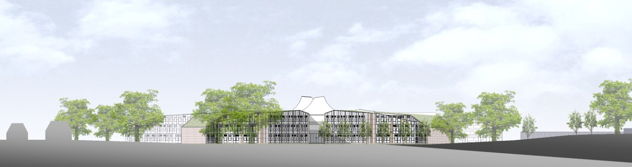

# ST. BARTHOLOMEW'S SCHOOL

# TEACHER OF SCIENCE

Full-time, permanent

# Required for 1 September 2019

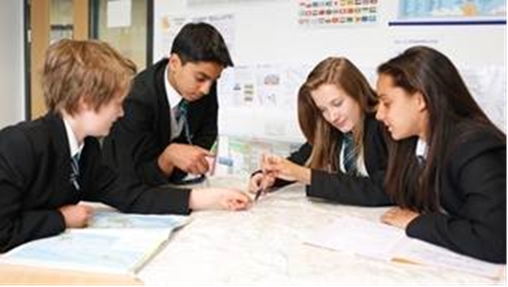

**Andover Road**

**Newbury RG14 6JP**

**Tel: 01635 521255**

**Fax: 01635 576320**

**Email:** [**recruitment@stbarts.co.uk**](mailto:recruitment@stbarts.co.uk)

[**www.stbarts.co.uk**](http://www.stbarts.co.uk)

Dear Colleague,

Thank you for your interest in the position of Teacher of Science at St Bartholomew’s School. I hope that the details contained in this pack will provide you with a clear picture of this post and give you a flavour of the school and its values. This post really is an exciting opportunity for the successful candidate who will be joining a highly achieving faculty in the school with outstanding facilities.

St Bartholomew’s prides itself on its academic success. For the last 3 years St Bart’s has secured the best GCSE and A level results in West Berkshire state schools. This year 84% of our students achieved both English and Mathematics at level 4 or better and 40% of all grades were 9 – 7 (A*/A). Our Progress 8 score is 0.66 which puts St Bartholomew’s in the top 8% of schools nationally which we are very proud of. A level results were strong with 33% of all grades A*/A and 82% of all grades A* – C.

This is an important appointment for the school at an exciting time when we are working towards becoming outstanding as recognised in our recent short Ofsted Inspection. At St Bartholomew’s we all work together as a team to share good practice, and really develop outstanding teaching and learning to ensure every student makes expected or greater than expected progress. Every member of staff is part of an Action Research Group and you will also contribute to whole school development in this way. The staff at St Bartholomew’s care very much about the community and are ambitious for the school in terms of learning and enrichment opportunities for all the students.

Teaching at St Bartholomew’s School is a rewarding experience. Our students are eager to learn, well behaved and proud of their school, and this was reflected in our last Ofsted inspection which judged students’ behaviour and safety as outstanding. As a school we are committed to ensuring that all the students and staff realise their full potential. Students leave the school as good citizens and this is underpinned by an exceptional house system and a vast range of extra curricular activities.

The professional development of staff is a significant factor in ensuring that we achieve our aim of improving on our previous best and there are rich professional development opportunities at St Bartholomew’s (see CPD offer on our website under Job Opportunities) at all levels. Our induction and NQT programme for new staff is supportive and thorough and coaching is available for all staff across the school upon request.

All staff are issued with their own laptop and the Governors currently kindly offer a subsidised meal at Activity time. All faculties have their own workrooms.

I know that anyone applying for this post will find working at St Bartholomew’s very rewarding, and the Governors and I look forward to hearing from you if you feel you have the qualities and experience we are looking for.

If you would like to have a discussion with me or the Head of Science about this post, or require any further information please contact Human Resources on the above number or [recruitment@stbarts.co.uk /](mailto:recruitment@stbarts.co.uk%20/).

Yours faithfully,

Julia Mortimore

Headteacher

**THE FACULTY**

The Science faculty has a policy of providing stimulating, relevant, balanced and high quality Science courses which fulfil the National Curriculum, provide valuable qualifications, encourage a responsibility for the environment in a technological world and give each pupil knowledge, understanding and skills which enable them to lead satisfying and useful lives.

The faculty is based in a suite of 13 ICT-rich and fully equipped laboratories, a psychology classroom, an ICT room and two well stocked prep rooms. The faculty is well resourced and 7 technicians provide support.

At KS3 we have a scheme of work that uses a practical investigative approach to teach both knowledge content and scientific skills. KS3 at St Bart’s is completed in Year 8 and we begin KS4 teaching in Year 9. At the end of Year 9, the most able students are invited to complete the course for Separate Science whilst the majority of students continue to study for and certificate in AQA Science Combined Science.

Teaching of all the courses at KS3 and KS4 is shared between the Biology, Chemistry and Physics department.

In 2018-2019 there are a large number of students in the Sixth Form studying Science based A-levels:

Biology (AQA) 8 sets

Chemistry (AQA) 5 sets

Physics (OCR Advancing Physics) 5 sets

Psychology (AQA) 8 sets

The average set size is approximately 15 – 20.

There is also a small group of sixth form students studying towards BTEC level 3 Science [ one set in Year 12 and one set in Y13].

All members of the department teach at all levels in the school and are involved with the development of courses throughout the age range.

**THE POST**

* We are seeking to appoint a suitably qualified inspiring Teacher of Science to join the Science department with effect from 1 September 2019 on a permanent basis.
* The position is full-time.
* Applications are welcome from newly qualified and experienced teachers.

###### THE SALARY

* The successful candidate will be appointed to the main or upper pay scale in accordance with her/his experience and qualifications.

**HOW TO APPLY**

Full post details, an application form and instructions on how to upload your completed application are available via the Jobs & Training / Job Opportunities section on the School’s website:

[**www.stbarts.co.uk**](http://www.stbarts.co.uk)

(Please note that curriculum vitae and covering letters cannot be accepted)

Successful candidates will be subject to a DBS enhanced check along with other relevant employment checks.

## Closing date: Sunday 20 January 2019

Thank you for considering St Bartholomew’s School.

Julia Mortimore

Headteacher