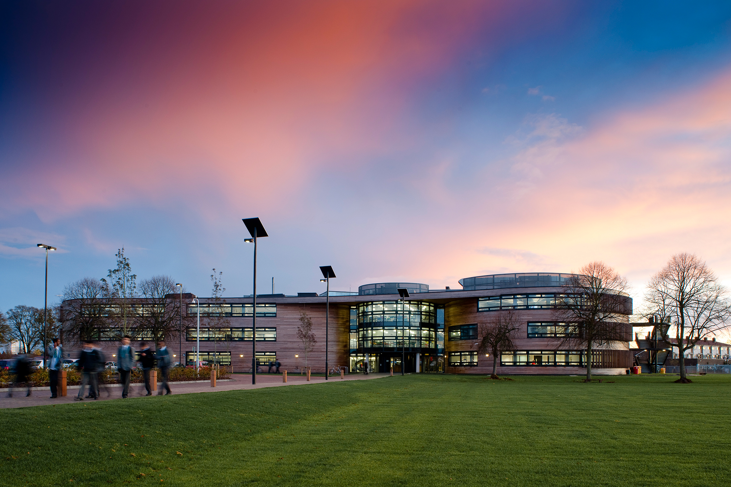

The Langley Academy Secondary
Slough, Berkshire
Teacher of Science
Application Pack

Thank you for your interest in the Teacher of Science post at The Langley Academy Secondary.

This pack contains:
- Letter to candidates
- Details about the Sponsor and The Annabel Nicoll Foundation
- Information about The Langley Academy Secondary
- Information about The Langley Academy Primary and the Parlaunt Park Primary Academy
- The job description and person specification
We hope that you find the pack informative and useful. If you do have any further questions, then please contact The Langley Academy Trust via the details below:
Sarah Friend
sarah.friend@langleyacademy.org
01753 214468

Deadline for application: we will consider applications as they arrive day 29 Ap2:0
Interview date: at a mutually convenient time

If you wish to visit the academy prior to application then please contact Sarah Friend sarah.friend@langleyacademy.org

You can also visit our Trust website at www.langleyacademytrust.org

Contents
`

Dear Applicant
I am delighted that you are showing an interest in the Teacher of Science position here at The Langley Academy Secondary. I want to set out the reasons why we think it is so exciting. The Multi-Academy Trust (MAT) encompasses The Langley Academy Secondary, the Langley Academy Primary and the Parlaunt Park Primary Academy. Our vision is to ensure we provide an outstanding education for every child in the Trust through high aspirations and quality learning through curiosity, exploration and discovery. By 2021, when The Langley Academy Primary has a full complement of year groups, we will have approximately 2,500 students and 350 staff working in the Trust.
We are looking for someone who is looking to be part of this vision and has ambitions to further their career. The Trust is in its third year and therefore very much still in its infancy and the continued development of an appropriate infrastructure is vital if we are to meet our strategic objectives. The quality of leadership is therefore critical in helping us achieve these objectives. Both Primaries will be the main feeder schools with right of entry as part of the admissions policy. This means that the curriculum, assessment and pedagogy will be developed as a Trust to ensure our young people make rapid progress throughout.
A significant advantage of our approach is the capacity to provide outstanding in-house CPD as we will have excellence in each academy that can support professional development for those starting their careers or for those wishing to gain further responsibility. This capacity is further enhanced by understanding the significant resource the student body provides. Students in the secondary develop programmes of study for their careers whilst providing an invaluable service at each Primary. This might take place through the Duke of Edinburgh programme, our community service programme or the Child Development NVQ. In essence an academy improvement programme ‘on tap’ for each academy in the Trust. This will also give us the ability for each academy to respond to problems quickly. For example, staff across the Trust are able to lead on INSET days allowing us to access best practice.
One of the greatest qualities of the Trust is the Sponsors. Having worked with them since my appointment as Principal of The Langley Academy in April 2012, I cannot praise them highly enough. Annabel Nicoll is the Chair of the Trust and as the Sponsor, has boundless energy and enthusiasm, all directed at giving youngsters a better life. As a result of her work, students here have quite simply been afforded opportunities that many young people elsewhere in the country just would not get. The successful applicant will be able to draw on this support and networking opportunity to develop their own career and importantly offer a better education for the young people.
We are aspirational and want to be the best MAT in the country with each school rated outstanding as soon as possible. We believe the economies of scale, the cross-phase opportunities for students and staff development, the ability to respond to each other’s needs quickly and the ‘can do’ approach to everything we do, will make the working environment simply extremely exciting. Please come and visit us to truly understand what we are trying to achieve and whether you would like to be a part of our journey.
Yours sincerely

Rhodri Bryant
Executive Principal

About the Sponsor and the Trust
The Annabel Arbib Foundation is a registered charity. Originally named The Arbib Foundation it was established in 1987 to support the philanthropy of Sir Martyn Arbib and his direct family. The Foundation provides charitable donations and financial support to organisations and causes around the UK with a focus on the Thames Valley. The Foundation took a leading role in establishing the River & Rowing Museum in Henley-on-Thames which opened in 1998 and attracts over 100,000 visitors per year. The Foundation continues to be the main sponsor of the educational side of the museum.
The other principal beneficiary of the Annabel Arbib Foundation is The Langley Academy Trust. The Foundation is the sponsor of the Trust, created through Department for Educations Academies Programme, and The Langley Academy opened in September 2008.
In 2015 Sir Martyn Arbib retired as Chairman of The Arbib Foundation and his daughter Annabel took up the Chair and uses the Foundation, which has been renamed The Annabel Arbib Foundation, to support her own philanthropy continuing the focus on The Langley Academy Trust. In September 2016, Oona Stannard became our new Chair of the Trust, allowing Annabel time to focus on the things she really wants in the Trust, working and talking with children. Oona comes with a wealth of experience in the education sector as do a majority of our Trustees and Governors, indeed this is a real strength. You can find out more about the team on our website.
The Langley Academy Trust is a unique Trust that serves the young people of Langley, Slough and further afield. Our Trustees are a Board of interesting and experienced professionals who bring energy, enthusiasm and wisdom to their role. They share the ambitions of the Trust senior leaders to achieve the best possible outcomes for all children and students within the Trust.
The Langley Academy Primary is a three-form entry Free-School, sponsored by The Langley Academy Trust. It opened in September 2015 with 90 very excited Reception children and parents; the intake will grow year on year until it reaches capacity of 630 children in September 2021. In September 2016, we opened the new build which now serves 2 year groups with 180 children in total and an ever increasing nursery.
The Trust’s strong vision, high aspirations and determination to succeed in providing an outstanding education for children in the community are clearly evident throughout The Langley Academy Primary’s positive learning environment. Our supportive ethos, child-centred approach, rich curriculum based on first-hand experiences have ensured children are confident, independent learners, displaying Curiosity, Exploration and Discovery.
Although still in our early days, we have received very positive feedback from our latest DfE monitoring visit in March 2017 and the Local Authority Early Years Team. The visits confirmed the Trust’s review of the school and highlighted that the likely judgment in any future Ofsted inspection would be outstanding.
Throughout their growth period, under the guidance of The Trust and by working closely with Parlaunt Park Primary Academy, The Langley Academy Primary looks forward to shaping a new 21st Century Educational Experience.
Parlaunt Park Primary Academy is a popular school with recently modernised buildings that converted to a sponsored Academy within The Langley Academy Trust in September 2014.
Parlaunt Park Primary Academy caters for children between the ages of 3 and 11 years. The school was originally built in 1952 as a separate Infant and Junior School. The two schools were amalgamated in 1987 under one Headteacher. Major works were undertaken to enlarge its buildings following an expansion to a three- form entry school in 2009. The school has 635 children on roll plus a part time 39 fte Nursery provision.
The pupils come from diverse ethnic backgrounds which is typical for Slough, with the major groups being White British, Indian and Pakistani. There are smaller proportions of pupils from a wide range of other minority ethnic groups including Eastern European as well as a small group of Traveller children. The proportion of pupils with learning difficulties and/or disabilities is average. Just over a third of pupils speak English as an additional language. The proportion of pupils known to be eligible for free school meals is average. There is a breakfast and an after-school club.
Every child who attends Parlaunt Park Primary Academy is viewed as unique and treated as such. Children are encouraged to become independent thinkers with a love for life and learning. Their enthusiasm is stimulated by dedicated staff members who share the ambitions of The Langley Academy Trust to motivate the pupils to be inquisitive and thoughtful learners who will go on to success at Secondary School and beyond.
Parlaunt Park Primary Academy has developed holistically since it joined the Trust in September 2014. The curriculum has been honed to reflect the learning needs of the children and the strengths of the staff. RWI and T4W [Read Write Inc/Talk for Writing] are two key components of our literacy pathway. The wider curriculum is under review with both The Langley Academy Primary and Parlaunt Park Primary Academy embarking on an exciting journey over the next six years to map a new Primary curriculum and educational direction for the children encompassing first hand experiences, based on a thematic approach to learning and linked to visits and journeys and encompassing Museum Learning.
About The Langley Academy Secondary
The Langley Academy is housed in an iconic building, and bases its curriculum model on curiosity, exploration and discovery. We specialise in Science and strive to be at the forefront of Science education. We pioneer the use of museum learning and have developed links with national and regional museums to add an external dimension to learning. We aim to become a centre of excellence for sports, notably rowing and cricket. We have won our first rowing competition on the water and we have several National and European indoor champions. We are the only state school that runs an MCC Foundation Hub to spot cricket talent in Slough. At the heart of our vision, we aim for the highest achievement for all and to provide a welcoming, imaginative and creative environment which enriches the lives of all involved. You will see this in our building. We aspire to instil traditional values and promote respect for other beliefs. We are proud of what we and our students have achieved and we are confident that we will continue to achieve high standards for all our students and our local community.
In our most recent Ofsted inspection in February 2013, The Langley Academy was rated “good with outstanding elements”. The Ofsted report states that:
The main reason why achievement is good is because the majority of teaching is typically good and sometimes outstanding, and it is well matched to the needs of most students. Students have outstanding attitudes to learning. Behaviour is excellent. Relationships throughout the academy are extremely positive and this ensures that the academy is a calm, purposeful environment in which to learn. The sponsors’ vision permeates all aspects of academy life and the Principal, Leadership team and those who lead subjects and house groups are relentless in driving improvement.
We recognise this report is 4 years old but the above statement remains very accurate today.
Our results in each Key Stage are strong. At KS4 we achieved 67% A*-C including English and Maths with a progress 8 score of +.22 placing us in the top 20% of schools. KS5 results were ALPS 3 in 14/15 with a slight dip in performance in 15/16 although we are confident we will move back to our high standards this year. Overall our VA data for the last 4 years have been sig+ with 9 out of the 18 KPI as significantly above the national average. You will be able to find out more about our results and trends if you are invited for interview.
Benefits of working across the Trust
- We have a Wellbeing Group who meet on a regular basis. The group consists of teaching and non-teaching staff. Staff Wellbeing is very important to us.
- We have a generous Staff Absence Policy that reflects strong staff attendance and a can-do attitude
- Access to a weekly CPD programme that includes various Leadership programmes eg Across the Trust, NPQH, NPQSL, NPQML
- A subsidised Christmas Party is offered to all staff across the Trust.
- Flu vaccinations are offered every September to all staff across the Trust.
- PPA periods are on timetables and cannot be used for cover purposes.
- We have 4 Cover Supervisors reducing the amount of cover required by teachers.
- A very strong Behaviour for Learning Policy in place supports staff. Poor behaviour is not tolerated.
- A generous contribution is made towards pensions.
- Free eye tests are provided for staff who are eligible.
- Enhanced sick pay arrangements.
- Free car parking.
- Lunch provided for staff on INSET days.
- Working in a very modern environment.

Job Description
Teacher of Science

Post Title
Teacher of Science

Salary/Grade
Main Scale plus London Fringe

Purpose of the job
To provide high quality teaching, and enable effective use of resources and high standards of learning and achievement for students, within an atmosphere in which students feel challenged, valued and secure.

Reporting to
Head of Faculty

Liaising with
Executive Principal, Head of School, Directorate, Leadership Team, Heads of Faculty, Raising Standards Leaders, SENCO, Subject Leaders, Student Support Managers, Teachers and Support Staff, External Agencies and Parents.

KEY FUNCTIONS

- To teach the subjects, classes and groups as allocated by the Head of Faculty for Science and the Leadership Team

- To ensure that high quality teaching and learning takes place in all allocated classes

- To support and participate in the curriculum development work of the Science Curriculum Area, including the writing of schemes of work and programmes of study

- To assist the Head of Faculty for Science in the maintenance of high standards of work and behaviour within Science

- To be a House Tutor or 6th Form Tutor and to carry out the specified duties in accordance with the job description of a House or 6th Form Tutor

- To support the Leadership Team in the effective operation of the Academy

SPECIFIC RESPONSIBILITIES

The main responsibilities of the post are to:
- teach the classes allocated, and provide a well-planned, challenging and purposeful learning environment for students

- support and carry out policies and practices to promote positive student behaviour and achievement in Science within the framework of the Positive Discipline policy

- set homework on a regular basis and mark student work promptly

- assess, monitor, record and report on student achievement in line with Academy and Curriculum Area policy, including writing student reports and attending parents meetings

- assist in the identification of student special educational needs, and support the work of the Learning Support Team, including participation in the writing and review of individual education plans

- share in the development of course outlines, syllabuses and schemes of work in Science

- follow the course outlines, syllabuses and schemes of work agreed by the Science Curriculum Area

- make effective use of student performance data, and student and staff target-setting; and provide relevant information to the Head of Faculty, Heads of House and Academy Directors

- monitor and record student attendance in line with Academy and Curriculum Area policy, and support the Head of Faculty and Academy Directors in the maintenance of high levels of student attendance

- prepare for and attend Science Curriculum Area and House or 6th Form Team meetings and support the work of the Science Curriculum Area and the House or 6th Form Team

- actively support and participate in the museum learning programme

- participate in and support the Performance Management Policy

- assist in the development of the Academy Improvement Plan and its review mechanism

- undertake specific duties within the Science Team as agreed with the Head of Faculty

- undertake such other duties as reasonably required by the Executive Principal or Head of School

Person Specification
Qualifications and experience | Essential | Desirable
QTS, Degree or equivalent teaching qualification in Science or other relevant subject
Relevant CPD Training Courses
A first class teacher with a track record of 3 years of successful teaching experience
Proven track record in raising standards of student achievement
Experience of constructive cooperation with parents
Leading /Managing an Science Faculty initiative/change
Experience of working with staff on whole school initiatives/change
Professional Knowledge & Understanding  The successful applicant will need to demonstrate knowledge and understanding of: | Essential | Desirable
Strategies for raising student achievement
Effective practice and approaches to Teaching and Learning
Current educational trends and thinking
Current developments in Science teaching
Sound understanding of assessment, tracking and analysis
Personal Qualities and Skills  Ideally, we are looking for someone who: | Essential | Desirable
Can lead, motivate, enthuse and inspire staff and students, and win the confidence of parents and governors
Has the ability to think strategically with imagination, vision and originality
Is reflective, self-critical and open
Is self-confident, motivated and ambitious
Has passion and believes that every student can succeed
Is an effective communicator and presenter
Can plan, organise and delegate effectively
Possess excellent interpersonal skills
Can make tough decisions
Has sound judgement, especially when working under pressure
Has a life outside school
Has a fantastic sense of humour
Safeguarding | Essential | Desirable
Staff uphold public trust in the profession and maintain high standards of ethics and behaviour, within and outside school by;
- treating students with dignity, building relationships rooted in mutual respect, and at all times observing proper boundaries appropriate to a teacher’s professional position
- having regard to the need to safeguard students’ well-being, in accordance with statutory provisions
- showing tolerance of and respect for the rights of others
- not undermining fundamental British Values, including democracy, the rule of law, individual liberty and mutual respect, and tolerance of those with different faiths and beliefs
- ensuring that personal beliefs are not expressed in ways which exploit students’ vulnerability or might lead them to break the law

Staff must have a proper and professional regard for the ethos, policies and practice of the academy and maintain high standards in their own attendance and punctuality
Staff must have an understanding of, and always act within, the statutory frameworks which set out their professional duties and responsibilities

How to apply

Please send your completed application to:
Sarah Friend
The Langley Academy Trust
Langley Road,
Langley,
Berkshire, SL3 7EF

Or email it to:
sarah.friend@langleyacademy.org
If you wish to visit the Academy prior to application then please contact Sarah Friend on the above email address.

Applications will be considered as they arrive, therefore your early application is advised.

References will be sought when we shortlist. Your application will be treated in the strictest confidence.
The Arbib Foundation and The Langley Academy Trust is committed to safeguarding and promoting the welfare of children and young people and expects all staff and volunteers to share this commitment. This post is subject to Funding Agreement and subject to pre-employment checks. References will be sought and successful candidates will need to undertake an enhanced Disclosure & Barring Service (DBS) check. LAT is an equal opportunities employer.

