MOUNT ST MARY’S CATHOLIC HIGH SCHOOL
SENIOR SCIENCE TECHNICIAN - JOB DESCRIPTION

Salary Scale B3 £18,870-£20,541 per annum, pro rata

Reporting to Faculty Director

Hours 37 per week, term time only plus 10 days

Staff Management
- To lead, supervise and deploy the Assistant Science Technician.
- To promote and maintain a co-operative and flexible working relationship between technicians and teaching staff.
- Maintain stock records of consumables, equipment and text books for the department. Undertake annual departmental stock checks.
- Maintain records of, and monitor, departmental expenditure against budget, liaising with the Faculty Director as necessary.
- Maintain the departmental inventory, disposing of unwanted/obsolete items appropriately.

Health and Safety
- In conjunction with the Faculty Director, ensure the proper implementation of the safety policy and the preparation and application of risk assessments within the Science Department. Ensure compliance with COSHH regulations.
- Arrange safe disposal of chemical and biological waste materials and residues.
- Monitor and ensure the regular servicing of equipment, including electrical safety testing and pressure vessel checks. Remove defective equipment from use pending repair/replacement.
- Regularly inspect the services in the laboratories and preparation room, acting upon and reporting any problems as appropriate.
- Ensure that the laboratories and equipment therein are safe for use.

Co-ordination and development of practical resources and facilities.
- Provide guidance and support to staff and students in meeting the practical requirements of the Science curriculum.
- Ensure the availability of suitable materials and equipment for lessons, in consultation with the teaching staff.
- Organise proper storage and monitor condition of chemicals and equipment.

Laboratory Organisation
- Prepare resources, assemble apparatus and deliver equipment to lessons.
- Carry out demonstrations as required and assist in practical lessons where requested.
- Provide technical advice for teachers and technicians.
- Conduct risk assessments for technician activities.
- Design, construct and/or modify apparatus as needed.
- Prepare standard solutions as needed.
- Keep up to date with all relevant Health & Safety information.
- Ensure all laboratories are supplied with standard equipment (glassware, bunsens etc) and stationery.
- Maintain standard laboratory stock in good condition.
- Care for plans and animals within the Science department.
- Ensure, by regular checks, that sinks are clean and unblocked; electric sockets, water and gas taps are operating correctly; safety spectacles are fit for use.

Management Information and Administration
- To log details of accidents and other incidents and to deal with any Health & Safety defects immediately and report details to the Facilities Manager.

Communications
- To communicate and consult with other staff.
- Where appropriate, to communicate and co-operate with internal/external individuals and bodies as appropriate.
- To attend meetings regarding the department as required.

Management of Resources
- To ensure a sharing and effective use of resources to be benefit of the school and its students.
- To contribute to the process of ordering and allocation of equipment and materials.

Other specific duties
- To carry out the duties in the most effective, efficient and economic manner available.
- To support the school’s Mission Statement and ethos.
- To maintain confidentiality at all times.
- To carry out and communicate Mount St Mary’s Catholic high school values in all aspects of work.

In order to deliver services effectively, a degree of flexibility is needed and the postholder may be required to perform work not specifically referred to above. Such duties, however, will fall within the scope of the post at the appropriate grade.

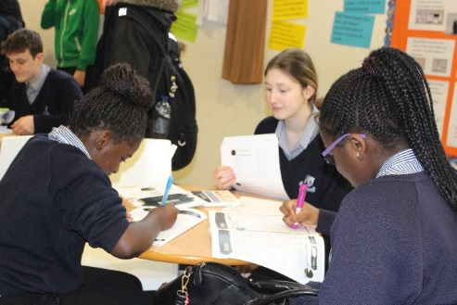
Employees are expected to be courteous to colleagues and provide a welcoming environment to visitors and telephone callers.

