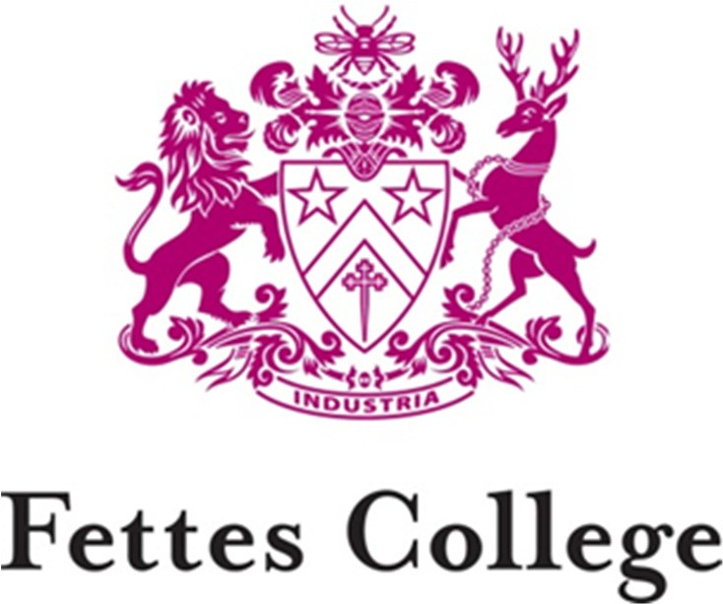

Development Officer (Fundraising & Stewardship)

THE ROLE

An opportunity has arisen for a Development Officer (Fundraising & Stewardship) to join the Development Team at Fettes College. Reporting to the Director of Development and working alongside four other members of the Development Team, you will be responsible for ensuring the long-term fundraising success of the Fettes Foundation by supporting the Director of Development to devise, promote and deliver compelling income generating programmes aligned to strategic priorities including annual giving, capital campaigns and legacy fundraising. You will also manage the Stewardship Strategy for the Fettes Foundation.

The Fettes Foundation was formed in 1998 to raise philanthropic income for the benefit of Fettes and its pupils. Since then, the Foundation has received donations from over 2400 generous donors to support the provision of bursaries, a number of capital developments and other key projects.
Donations from our engaged community of Old Fettesians, Parents and Friends of Fettes transform the lives of pupils who come to Fettes and will continue to do so for generations to come.
The main duties and responsibilities of the role include:

- Developing, or supporting the development of, innovative, cost-effective and successful fundraising appeals, initiatives and events aligned to priority projects such as capital campaigns and legacy fundraising.

- Managing the Fettes Foundation annual giving, in particular, the Annual Appeal including all direct mail materials, e-mail and web copy and fulfilment materials.

- Developing new and engaging campaigns, materials and promotions to increase both the number of donors to the Fettes Foundation and the level of giving from existing donors to the Fettes Foundation.

- Providing a high standard of stewardship and supporter care to Fettes Foundation donors, including fulfilment of fundraising appeals and effective verbal and written communications.

- Managing our processes for thanking, renewals and upgrades and on an ongoing basis, ensuring these are the best they can be.

- Delivering the Fettes Foundation Stewardship Events Programme.

- Managing relationships with US Trustees and activities in the US.

- Managing budgets aligned to key responsibilities.

General responsibilities of all members of the Development Team include:
- Attending events, as necessary, out of regular office hours and, from time to time, travelling to these events.
- Using the Development Team database, The Raiser’s Edge, to exacting standards and in line with workflow and data entry procedures and our data protection policy.
- Working with colleagues across Development and Marketing to ensure consistent and timely messages are delivered to all members of the Fettes community.
- Attending independent school sector regional meetings, conferences and workshops, relevant to the role and share learnings with team.

PERSON SPECIFICATION

Knowledge and Experience

Essential | Desirable
Degree or equivalent level of qualification | Legacy Fundraising
Relevant and proven experience in a comparable environment (charity/ fundraising) with specific experience of Annual Giving | Capital Campaigns
Event management | Interest in, and an understanding of, education and the independent sector, in particular the benefits of a boarding education
Excellent verbal and written communication, presentation and facilitation skills, with fluency in the English language | Working within an education environment
Producing, editing and proofreading content for print publications and online channels
Managing design and print processes
Knowledge of a relationship management database and extracting value from its use
Proven ability to manage a workload with competing deadlines and priorities
High degree of digital literacy
Knowledge of mass e-mailing packages
Managing and reconciling budgets
Good general knowledge

Skills and Attributes

Ambition to make a career in fundraising
Attention to detail
Creative and flexible approach to work challenges, demonstrating vision, innovation and personal resilience
Strong planning and project management skills
Excellent interpersonal skills to manage, build and develop relationships with members of the Fettes community
Self-motivation and the ability to work under pressure
Team-player
Tact, diplomacy and empathy
Energy and enthusiasm for the job and a good sense of humour

BENEFITS

The remuneration package will be competitive and will, to an extent, depend on the experience of the successful candidate.

You will be entitled to 30 days’ holiday during the School Year (September to August) plus 8 designated Public Holidays providing they fall outside of term time. Holidays will therefore ordinarily be taken outside term time and only during the term by exception and by prior agreement with the Director of Development.

You will be opted in to the Fettes Trust Non-Teaching Staff Pension Scheme after 3 months service. This scheme is a money purchase one and full details of it and your options will be made available to you prior to your opt-in date. The Fettes Trust will contribute to the scheme and your contribution will be subject to the minimum overall combined employer and employee contribution limits set by the Pensions Regulator. Further details will be outlined in the contract of employment.

Lunchtime meals may be taken in the Dining Hall free of charge during term time and when catering is provided and at other times, when catering is provided and you are on duty. Parking is free of charge within the campus grounds. Gym membership at Westwoods Health Club is also available. The hours of work are 9.00 am – 5.00 pm Monday to Friday, with one hour for lunch.

New staff at Fettes join a friendly and supportive team with a vibrant mixture of age and experience. We value every member of staff’s contribution to the life of the School.

APPLICATION PROCESS

To apply please submit your CV and a covering letter outlining your suitability for the role via email to: recruitment@fettes.com

If you would like further information prior to applying for this role, please contact Mrs Wendy Davidson, HR Manager on 0131 241 1005.

An offer of employment will be subject to two satisfactory references being obtained from your referees and a clean report being obtained on you from the Disclosure Scotland PVG Scheme in view of the contact you will have with children during your normal duties.

Closing date for applications is 19th April 2019. First interviews will take place on 7th May 2019 at Fettes College.

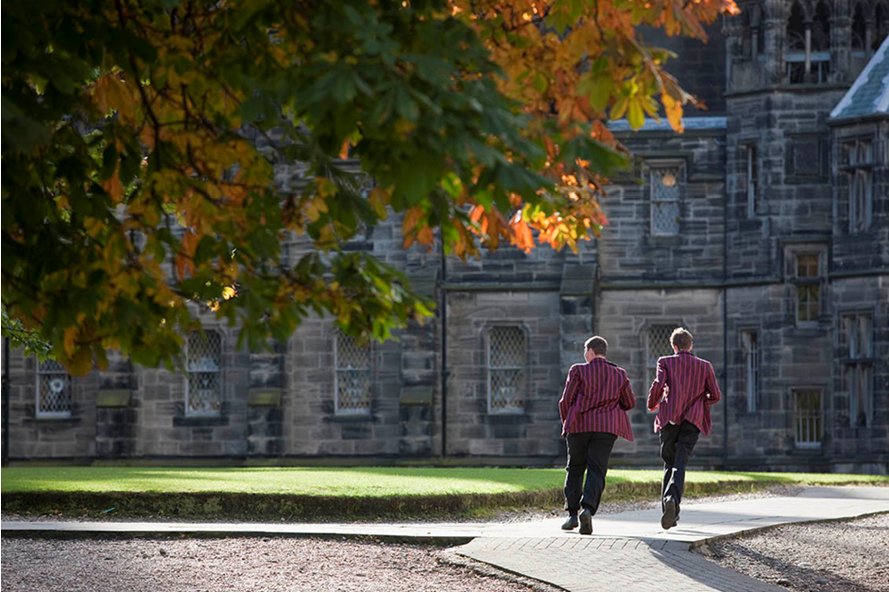

ABOUT FETTES

Fettes College is a leading HMC co-educational boarding and day school close to the heart of Edinburgh. It has a strong tradition of academic, sporting and cultural excellence underpinned by outstanding pastoral care. Fettes opened its doors in 1870 and became fully co-educational in 1980: it is now an Independent school of some 760 boys and girls. There are 550 pupils in the Senior School (13-18 years) and 210 pupils in the Preparatory School (7-13 years). The academic staff in the College consists of the Headmaster and 80 full-time members of the Common Room. Our Prep School shares the same site and consists of a further 25 full-time teaching staff.

The School stands on a magnificent site of approximately 100 acres, but still within walking distance of Edinburgh’s city centre. The historic main building holds the Chapel, Library, the English, Classics and History Departments as well as the Medical Centre and two boarding houses. A large newly built teaching block (the Spens Building) houses Art, Modern Languages, Mathematics, Economics, Geography, and Music. The Theatre, Science Laboratories and Dining Hall are adjacent. The Preparatory School and seven further boarding houses (including a purpose-built U6th House) are also on the campus. Our sports facilities (including extensive playing fields, two all-weather pitches and a private Health Club) are excellent.

As well as our teaching staff we employ over 220 Non-Teaching Staff across the many departments, including: Development, Estates, Security, Housekeeping, Finance, Admissions and Marketing with a pervading sense of community amongst staff, pupils and parents alike.

The Aims of the College

Fettes College aims to nurture the individual while fostering a happy, well- ordered and caring community with strong family values at its core.
To this end, we will do our utmost to ensure our students:
- Receive the highest possible quality of education within a boarding environment
- Feel safe, valued, have a sense of personal worth and are thoughtful and considerate of the needs of others, possessing a willingness to take on responsibility
- Develop their self-confidence, integrity, emotional resilience, loyalty, good manners and humour, leadership skills and team-work
- Value a sense of community and service, and develop a clear sense of right and wrong, equipping them for life beyond Fettes
- Are provided with equal opportunities regardless of gender, sexuality, ethnic origin or religion
- Are encouraged to stretch and challenge themselves in everything they undertake

